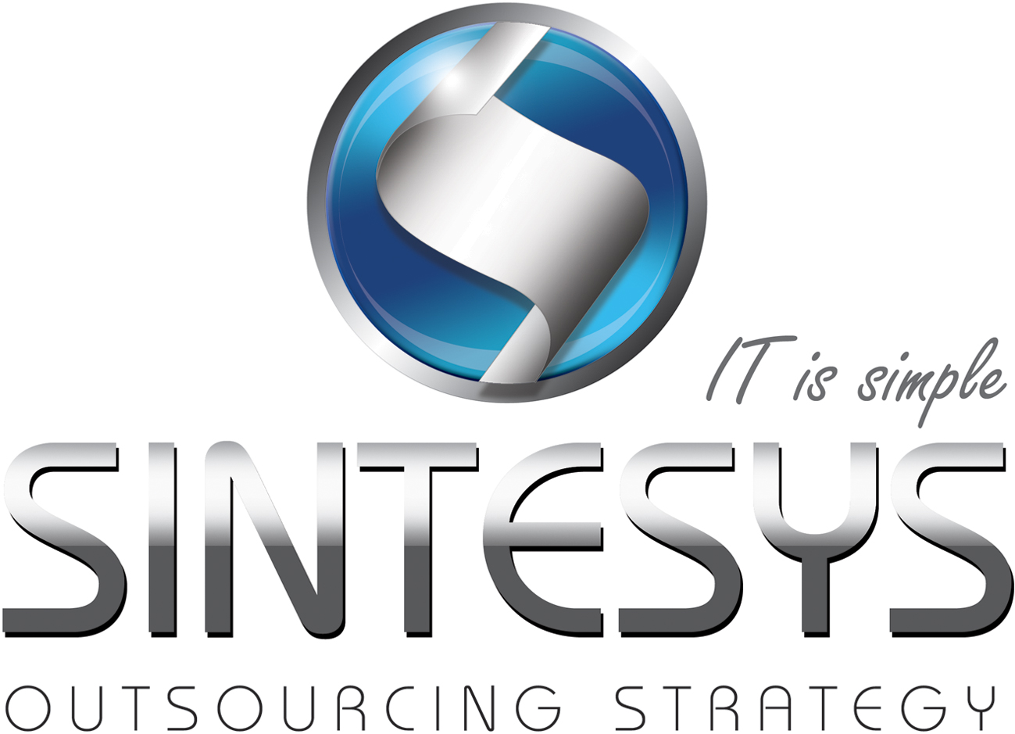Salvador Bravo

ServiceNow Administrator

Manage ServiceNow instances with 1+ year of experience in successfully manage and safe sandbox to perform fundamental administration and configuration tasks.

# Certifications

GE Six Sigma Green Belt (DMAIC)

Brainbench Java Server Pages (JSP 2.1)

Brainbench Java 2

Brainbench Web Design Concepts

Brainbench Dynamic HTML

Brainbench JavaScript 1.5

# Professional Experience

|  |  |  |  |
| --- | --- | --- | --- |
| Consultant Services (Sr Developer & Administrator) | | | |
| Company: | iGate |  | |
| Client: | GE Corporate | Date: | June 2011 to date |
| Role: | Sr Sw Developer & Operations | Services: | Specialist, Advisory, Operations |
| Technologies: | JavaScript, DHMTL, HTML/CSS, JQuery, Java, XML | | |
| Activities: | * Operations Management of the different instances of Service-Now application. * View all nodes of the instances working properly and not have problems with the servers. * Analysis of response times, transaction levels and records to the database. * Implementation of new forms within the tool. * Handling different areas in ITIL Service Center including: Incident, Problem & Change, Assets, CMDB, Team Meetings, Integrations (Web Services), PaaS, Projects, Releases and SDLC. * Remote Management team. * Analysis with remote client of requirements. * Implementation and use of ITIL methodology. * Using the SDLC for Software Development process. | | |

|  |  |  |  |
| --- | --- | --- | --- |
| Compudirecto S.A. de C.V. | | | |
| Client: | Internal / Avira | Date: | October 2009 – June 2012 |
| Role: | Development Engineer / Technical Support Engineer Level 2 | Services: | Enhancements, Support & Development |
| Technologies: | Avira AntiVir. (SMC, Exchange, MailGate, Professional, Server, Linux). vTiger CRM (php / MySQL), API interaction with external CRM to automate processes. Website Management (joomla, php / MySQL) | | |
| Activities: | * Technical Support Level 2 for Canada, USA, Latam, Brazil and Australia for Avira AntiVir. * VTiger CRM System Improvements to fit the internal workflow, creating workflows. * Creation for an interaction to use Avira API to automate the license register and deliver to the reseller and final client. * Administration, design and tuning company's Web site (compudirecto.com). * Managing E-mail Marketing. * High administration and transfer of domains, hosting and customer service. * Community Manager for different brands (Compudirecto, Avira Latam, Rojo Manzana Agency) | | |

|  |  |  |  |
| --- | --- | --- | --- |
| IPTV | | | |
| Company: | Sigtao Software S.A. of C.V. | | |
| Client: | Telmex | Date: | November 2007 - October 2009 |
| Role: | Programmer Analyst | Services: | Development, maintenance and enhancement. |
| Technologies: | JSF and implementations (Apache MyFaces, Tomahawk and Tobago)  JasperReports for printing reports in the formats required (PDF, Word, CSV). Hibernate. | | |
| Activities: | Creating and maintaining an infrastructure for the IPTV project portals, Manager SOA (Service-Oriented Applications), LTM (Line Telmex Mobile), SIRE (Registry Information System Equipment) | | |

|  |  |  |  |
| --- | --- | --- | --- |
| Portal implementation | | | |
| Client: | Ingenet | Date: | June 2008 - December 2008 |
| Role: | Technical Leader | Services: | Analysis and Concept testing |
| Technologies: | Portal Server and portlets. Liferay CMS. Portlets such as: Google gadgets, Google Maps, MediaWiki, chat, blogs, RSS, Multimedia (Video, audio), Banners (events and pay-per-click), Calendar of Events. | | |
| Activities: | * Creation and maintenance of infrastructure for the portal iDEAL Infrastructure and Engineering Infrastructure and Engineering. WEB 2.0 Portal to create a community of civil engineers engaged in the construction of roads and bridges in LATAM. ([www.ingenet.com.mx](http://www.ingenet.com.mx)) | | |

|  |  |  |  |
| --- | --- | --- | --- |
| CMMi Level 5 Sigtao Software S.A. of C.V. | | | |
| Client: | Internal | Date: | February 2005 - November 2007 |
| Role: | CM Manager (Configuration Management) | Services: | Sw Management |
| Technologies: | Microsoft Visual SourceSafe and CVS. | | |
| Activities: | * Managing all the safeguarding of Software Management projects. * Administration Server Setup (Microsoft Visual SourceSafe). * CVS Server Management * Configuration and migration from Microsoft Visual SourceSafe to CVS. | | |

|  |  |  |  |
| --- | --- | --- | --- |
| Sigtao Software S.A. of C.V. | | | |
| Client: | Telmex | Date: | November 2004 - November 2007 |
| Role: | Programmer Analyst | Services: | Analysis and Development |
| Technologies: | J2EE, Struts, Spring. | | |
| Activities: | * Development of the entire process (review of requirements, analysis, design, construction, testing) of new requirements and maintenance to existing applications within the existing management. * Using the CMM quality system for application development. * Knowledge management applications Inventory Control for Local and LD company Telmex. | | |

|  |  |  |  |
| --- | --- | --- | --- |
| Axiem, Engineering Services S. of R.L. of C.V. | | | |
| Client: | GE Energy | Date: | May 2002 - November 2004 |
| Role: | IM Engineer | Services: | Analysis and Development |
| Technologies: | CASPER, JSP, J2EE, Oracle | | |
| Activities: | * Designing Web pages, database applications on web. * Knowledge of Java Technology for Building Web Applications with the J2EE standard. * MVC methodology was used for developing applications with front-end JSP's and Oracle as the database engine. * Gas Turbine Course for application development at General Electric Power Systems, Gas Turbine Service Engineering Division, the Gas Turbine Technology Center in Greenville, North Carolina, USA | | |

|  |  |  |  |
| --- | --- | --- | --- |
| RDS, National Engineering Services, S.A. of C.V. | | | |
| Client: | GE Energy | Date: | April to September 2001 |
| Role: | Graphic Designer "A" | Services: | Document translation |
| Technologies: | Word, Page Maker, Photoshop, Adobe Acrobat. | | |
| Activities: | * Create and Design Manual for matching the original. * General knowledge of steam turbines, gas, nuclear and mixed. * Design of manuals | | |

|  |  |  |  |
| --- | --- | --- | --- |
| Alpham Consulting S.A. of C.V. | | | |
| Client: | Various | Date: | April 1999 to April 2001 |
| Role: | Programmer – Analyst | Services: | Analysis, Development |
| Technologies: | GeneXus, GX Workflow, GX Data Warehouse, Access, VisualBasic. | | |
| Activities: | * Analysis, Design and Implementation of Information Systems. * Analysis, Design and Implementation of Networks. * Analysis, Design and Implementation of Intranets. * GINSA Integral System (Automation and Control System for the creation and delivery of clothes to the IMSS.) * MELCO Storage System (Control System Inputs and Supplies Tools in the Warehouse.) * School Control System (System Administration and Control students in schools.) * Shoe Store System (Control System for Shoe Stores.) * Point of Sale System (POS System for self-service stores SuSazón.) * Traffic System Sw (Control and Automation of records PITEX program for imports and exports) | | |

# EDUCATION

|  |
| --- |
| Contemporary University - UCO (Queretaro, Mexico)  Bachelor in Computer Management.(2002 - 2005) |
| Technological University of Queretaro - UTEQ (Queretaro, Mexico)  Professional Technical Degree in Telematics (1998 – 2000) |

# HIGHLIGHT OF QUALIFICATIONS

|  |
| --- |
| Java, J2EE and JavaScript expert |
| Good analysis and design skills |
| JDBC, Hibernate development specialist |
| Struts, Spring, iReport, Jasper Reports development specialist |
| Advanced English level |