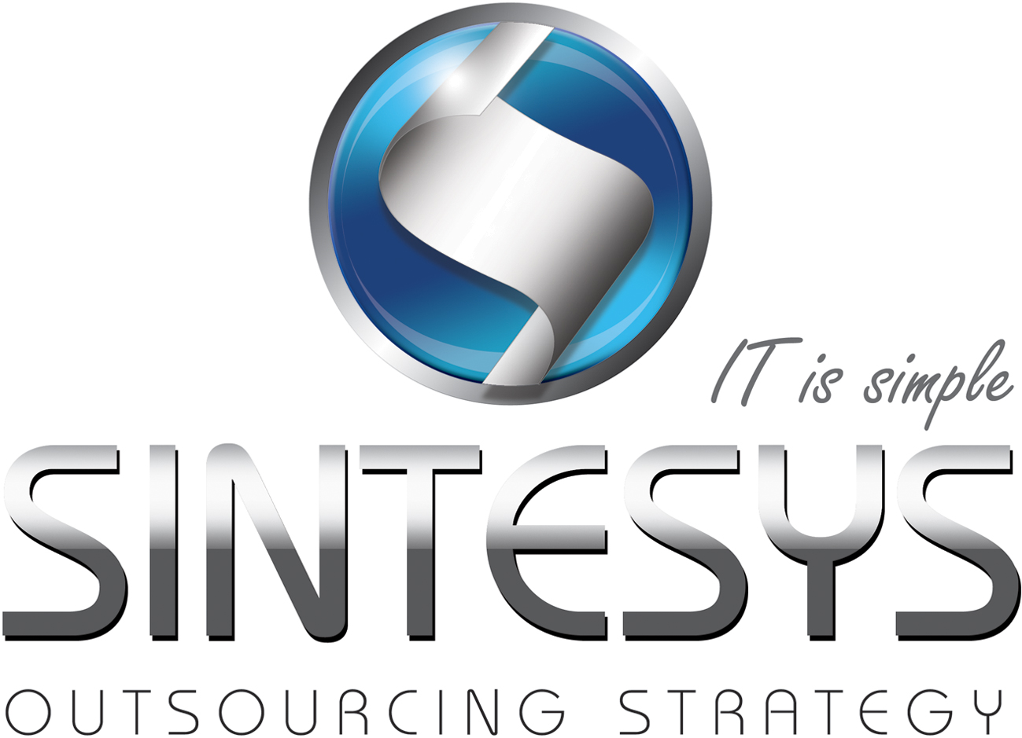Sergio Paniagua

IDM CONSULTANT

Planning, Coordination and Execution of IT projects. Defining project scope analysis and documentation requirements identifying and providing solutions.

# Trainings

CA Access Control Administration and Implementation

Business Process Management - Interfacing EPC

Software development process based on UML

# Professional Experience

**PWC (2007- to date)**

|  |  |  |  |
| --- | --- | --- | --- |
| Identity Management | | | |
| Company: | PwC México |  | |
| Client: | Casas GEO | Date: | September 2011 to December 2012 |
| Role: | IDM Consultant | Services: | Resource Provisioning Services |
| Technologies: | One Identity Manager, Oracle Databases | | |
| Activities: | Configuration of forms for the resource provisioning in Oracle Identity Management / Configuration of process  definitions in OIM design console / Testing of users resource provisioning from People Soft / Configuration of SIEBEL, Mapguide  and OBIEE systems for the resource provisioning / Creation of generic connectors in Oracle Identity Manager, automation and  resource provisioning roles using Java classes. / Massive loading of users resources based on defined schemas in Oracle Identity  Analytics. | | |

|  |  |  |  |
| --- | --- | --- | --- |
| Identity Management | | | |
| Company: | PwC México |  | |
| Client: | Mabe | Date: | October 2010 – March 2011 |
| Role: | IDM Consultant | Services: | Resource Provisioning Services |
| Technologies: | SAP, SQL Server Databases | | |
| Activities: | I created web services for upgrading users from Peoplesoft. / Development of scripts for the creation of SAP and AD users based on SQL functions. | | |

|  |  |  |  |
| --- | --- | --- | --- |
| Identity Management | | | |
| Company: | PwC México |  | |
| Client: | KUO | Date: | June 2012 to Present |
| Role: | IDM Consultant | Services: | Resource Provisioning Services |
| Technologies: | BMC, Oracle | | |
| Activities: | User Accounts provisioning based on scripts. / Requirement analysis for the user provisioning. / Upgrading of user information based on SQL Functions. | | |

|  |  |  |  |
| --- | --- | --- | --- |
| Business Process Management | | | |
| Company: | PwC México |  | |
| Client: | UNAM | Date: | January 2012 - September 2012 |
| Role: | Project Leader | Services: | Implementation |
| Technologies: | BMC, Oracle | | |
| Activities: | Mapping process / Implementation and administration of EPC Interfacing tool / Web Services development for process automation, database management, creating functions and triggers in SQL Server. Mapping process and implementation of process tools. / Creation of user manuals for application use. | | |

|  |  |  |  |
| --- | --- | --- | --- |
| Software Development | | | |
| Company: | PwC México |  | |
| Client: | Nissan Mexicana /Tecnolite Iluminación | Date: | Aug 2010 to Present |
| Role: | Project Leader | Services: | Development |
| Technologies: | ADO.NET, ASP.NET, AJAX, Web Services, SQL Server | | |
| Activities: | Negotiation, business engagement and business requirements analysis. / Human, Material and Financial resources management. / Estimation and organization requirement and scope definition . / Dependencies and change control. / Staff training and profiles definition./ Workflow  Design / Risk analysis of Information security. / Implementation and deployment of SEEC System on windows servers. | | |

# EDUCATION

|  |
| --- |
| Universidad de Londres (México) |
| Computer Science (2003 to 2006) |
| Instituto Tecnológico de Estudios Superiores de Monterrey ITESM (México) |
| Post grade in Java for Electronic Business (2010) |

# HIGHLIGHT OF QUALIFICATIONS

|  |
| --- |
| Identity Management consultant |
| Planning, Coordination and Execution of IT projects. |
| Web development, standalone systems and applications powered by Windows Mobile. |
| Data base management with SQL Server, MySQL, Oracle, ACL. |
| Analysis and modeling of system development. |
| Business process management. |
| Management and reviewing of analysis and payment recovery projects. |
| Software development process based on UML. |