Exploring Encryption Methods
Objectives
Part 1: Decipher a Pre-Encrypted Message Using the Vigenère Cipher
Use an encrypted message, a cipher key, and the Vigenère cipher square to decipher the message.
Part 2: Create a Vigenère Cipher Encrypted Message and Decrypt It
- Work with a lab partner and agree on a secret password.
- Create a secret message using the Vigenère cipher and the key.
- Exchange messages and decipher them using the pre-shared key.
- Use an interactive Vigenère decoding tool to verify decryption.
Background
The Cisco IOS password encryption service uses a Cisco-proprietary algorithm that is based on the Vigenère cipher. Vigenère is an example of a common type of cipher mechanism called polyalphabetic substitution.
Note: Students can work in teams of two for this lab.
Required Resources
End-user device with Internet access
- Decipher a Pre-Encrypted Message Using the Vigenère Cipher
In Part 1, you will analyze an encrypted message and decrypt it using a cipher key and the Vigenère cipher square.
    - Review the encrypted message.
The following message has been encrypted using the Vigenère cipher:
VECIHXEJZXMA
    - Review the cipher keyword.
The cipher keyword TCPIP was used to encrypt the message. The same keyword will be used to decrypt or decipher the message.
    - Review the structure of the Vigenère square.
A standard Vigenère square or table is used with the keyword to decipher the message.
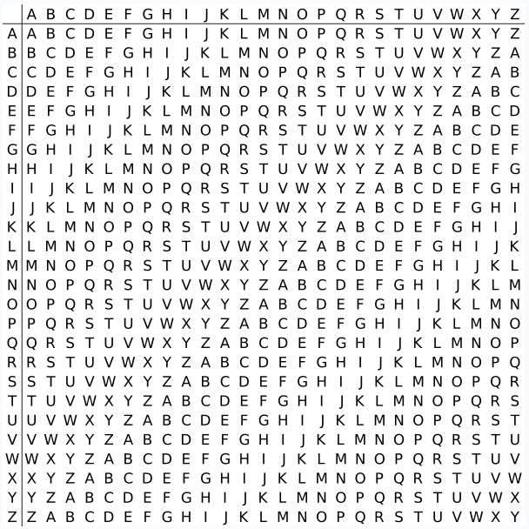
    - Decrypt the message using the keyword and Vigenère square.
      - Use the table below to help you decrypt the message. Start by entering the letters of the encrypted message in the second row of cells, from left to right.
      - Enter the keyword TCPIP in the top row, repeating the letters until there is a keyword letter for each letter of the encrypted message, even if the keyword letters at the end do not represent the complete keyword.
      - Refer to the Vigenère square or table shown in Step 3 and find the horizontal row that starts with the first letter of the keyword (the letter T). Scan across that row and locate the first letter of the encrypted message in the row (the letter V). The letter at the top of the column where the encrypted message letter appears is the first letter of the decrypted message (the letter C).
      - Continue this process until you have decrypted the entire message and enter it in row 3 of the following table.
Cipher Keyword | T | C | P | I | P | T | C | P | I | P | T | C
Encrypted Message | V | E | C | I | H | X | E | J | Z | X | M | A
Decrypted Message | C | C | N | A | S | E | C | U | R | I | T | Y
- Create a Vigenère Cipher-Encrypted Message and Decrypt It
In Part 2, work with a lab partner and agree on a secret password to use as the pre-shared key. Each lab partner creates a secret message using the Vigenère cipher and the key. Partners exchange messages and decipher them using their pre-shared key.
Note: If you do not have a partner, you can perform the steps yourself.
    - Determine the cipher keyword.
TUDOSEGURO
___________________________________________________________________________________
    - Create a plain text message and encrypt it (both partners).
      - Create a plain text (decrypted) message to be encrypted by your partner.
GODS DO CURSO _________________________________________________________________________________
      - You can use the following table to help you encrypt the message. You can enter the unencrypted message and cipher keyword here, but do not let your partner see it.
      - In the Vigenère table, locate the row that starts with the first letter of the cipher keyword. Next locate the first letter to be encrypted at the top of the column in the table. The point (cell) at which the table row (key letter) and column (message letter) intersect is the first letter of the encrypted message. Continue this process until you have encrypted the entire message.
Note: This table is limited to messages of 12 characters. You can create longer messages if desired. Message encryption and decryption are not case-sensitive.
Cipher Keyword | T | U | D | O | S | E | G | U | R | O
Encrypted Message | Z | I | G | G | V | F | I | O | I | G | H
Decrypted Message | G | O | D | S | D | O | C | U | R | S | O
    - Decrypt the message from your partner.
      - You can use the following table to help you decrypt your partner’s encrypted message. Enter the encrypted message from your partner and the cipher keyword.
      - Use the same procedure described in Part 1, Step 4.
Note: This table is limited to messages of 12 characters. You can create longer messages if desired.
Cipher Keyword | T | U | D | O | I | N | S | E | G | U | R | O
Encrypted Message
Decrypted Message
    - Use an interactive decryption tool to confirm decryption.
      - An Internet search for “Vigenère decode” shows that various cipher encryption and decryption tools are available. Many of these are interactive.
      - One interactive tool is located at http://sharkysoft.com/vigenere/1.0/. At this site, enter the encrypted message from your partner in the top part of the screen and the cipher key in the middle. Click Decode to see the clear text version of the message. You can also use this tool to encrypt messages.
      - The following example uses Sharky’s Vigenère Cipher tool to decode the encrypted message from Part 1.
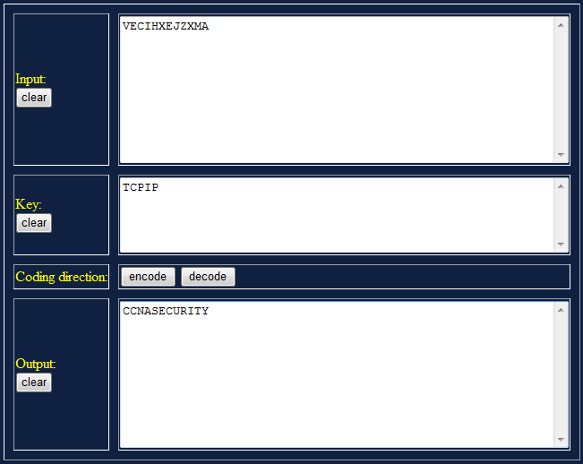
Reflection
  - Could the Vigenère cipher be used to decode messages in the field without a computer?
Yes you just need to use the table and the keyword to decrypte the message.
  - Search the Internet for Vigenère cipher cracking tools. Is the Vigenère cipher considered a strong encryption system that is difficult to crack?
Its easy to crack if you have the keyword if you don’t have the keyword it will take a lot of time.

Part 3: Use Steganography to Embed a Secret Message in a Graphic
In Part 4 of this lab, you create a secret message for your partner, embed it into a graphic file, and then give it to your partner to retrieve it. You embed the message in a graphic file using S-Tools. S-Tools is a steganography tool that hides files in BMP, GIF, and WAV files. You start by opening S-Tools and then drag graphics and sounds into the blank window. To hide files, you drag them into open graphics or sound windows. Data is compressed before being encrypted and then hidden.
Note: The following steps should be performed by both partners, one at PC-A and the other at PC-B. If you do not have a partner, you can perform the steps by yourself.

Step 1: (Optional) Download and install S-Tools.
If the S-Tools application is not installed on the PC, download it from http://www.spychecker.com/program/stools.html or another site and unzip the files to a folder.

Step 2: Create a secret message text file (both partners).
- On PC-A or PC-B, open the Windows Notepad application and create a message.
- Save the message in a folder on the desktop and name it secret.txt.
- Close the Notepad application.

Step 3: Create a simple .bmp graphics file.
- Open the Windows Paint application and create a simple graphic. For example, you can write your first name using the pencil tool or text tool and apply some color using the spray can or fill tool.
- Save the graphic as a .bmp file in a folder on the desktop and name it graphic.bmp.
- Close the Paint application.

Step 4: Create a secret password using the Vigenère cipher.
- Choose a passphrase to be encrypted using the Vigenère cipher and record it here. ______________ Do not share the passphrase with your partner. This passphrase will be used later to protect the text file when it is embedded in the graphics file.
- Choose a cipher keyword to be used when encrypting and decrypting the passphrase and record it here. _________________________
- Encrypt the passphrase using the cipher keyword and the procedure described in Part 3, Step 2. Record the encrypted passphrase here. ________________________________________________

Step 5: Embed the message into a graphic image file.
- Open the S-Tools.exe application.
- Locate the file named graphic.bmp, which you saved previously. Determine its size by right-clicking the file and selecting Properties. Record the file size, for example 2,359,350 bytes. ______________
- Drag the graphic.bmp file into the S-Tools window.
- Drag the file secret.txt, which you created in Step 2, and place it inside the graphic.bmp window. The image should still be displayed. A dialog box is displayed showing the number of bytes being hidden. You can enter a passphrase and select the encryption algorithm to be used. The default algorithm is IDEA.
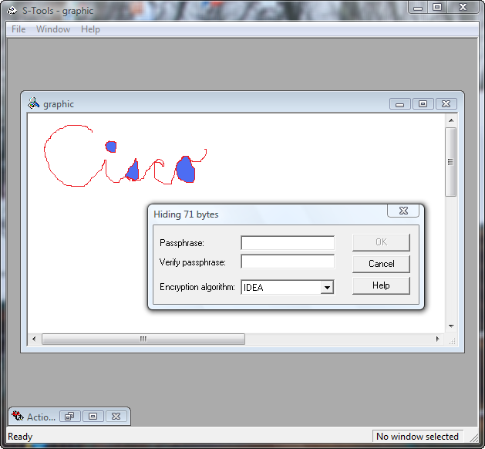

Step 6: Use the unencrypted passphrase to protect the embedded text file.
- Enter the unencrypted passphrase from Step 4 in the Passphrase and Verify passphrase fields.
- Choose Triple DES from the Encryption Algorithm field and click OK. This creates a second image with the name “hidden data”.
- Right-click the hidden data graphic image and choose Save As from the menu. Name the file graphic2 and save it as a bmp file.
- Close the S-Tools application.

Step 7: Provide the graphic2.bmp file to your partner.
- Provide a copy of your graphic2.bmp file to your partner. You can do this by sharing folders (if PCs were cabled together and IP addresses were assigned in Part 1 of the lab). You can also copy the file onto a removable drive (flash drive or floppy disk), or send it as an email attachment if you are performing the lab remotely.
- Provide your partner with the Vigenère-encrypted passphrase from Step 4 and the cipher keyword that you used to create it.

Step 8: Decrypt the Vigenère password from your partner.
Decrypt your partner’s passphrase using the procedure described in Part 1, Step 4. This is done so that you can use it with S-Tools to reveal the hidden message embedded in your partner’s graphic.

Step 9: Reveal the embedded message from your partner.
- Open the S-Tools application.
- Locate the graphic2.bmp file from your partner, and determine how large it is using the same method as in Step 5. Record the file size here. _______________________________________
- Has the file size changed? _____
- Drag the file into the S-Tools window. The image should be displayed. Can you tell that there is a secret message embedded in the graphic image? _____
- Right-click the image and choose Reveal from the menu.
- Enter the Vigenère passphrase decrypted in Step 8 into the Passphrase field.
- Choose Triple DES from the Encryption Algorithm field and click OK. This displays a revealed archive.
- Right-click the hidden message file and choose Save As from the menu. Name the file secret2.txt.
- Close the S-Tools application.
- Open the secret2.txt file from your partner to reveal the hidden message and write it here. _____________________________________________________________________________

Step 10: Reflection
- Could the Vigenère cipher be used to decode messages in the field without a computer? _____________________________________________________________________________
- Do an Internet search for Vigenère cipher cracking tools. Is the Vigenère cipher considered a strong encryption system that is difficult to crack? _____________________________________________

Part 4: Use Diffie-Hellman algorithm to calculate a Pre shared Key

8 – Private Key – Collegue A 12 – Private Key – Collegue B
21 - Public Key – Collegue A 69 - Public Key – Collegue B

k=?
Phase 1:
21^8 mod 69=3
21^12 mod 69=48
Phase 2 :
48^8mod 69=3
3^12mod69=3

