Answers to questions in

Lab 2: Edge detection & Hough transform

Name: Arturs Kurzemnieks Program: Computer Science

**Instructions**: Complete the lab according to the instructions in the notes and respond to the questions stated below. Keep the answers short and focus on what is essential. Illustrate with figures only when explicitly requested.

Good luck!

___________________________________________________________________________

**Question 1**: What do you expect the results to look like and why? Compare the size of *dxtools* with the size of *tools*. Why are these sizes different?

Answers:

The task of the difference operators is to calculate first order partial derivatives. For this is chose Sobel operator, respectively for x and y direction. We treat the image as a function, i.e. in places where the pixel values change the fastest, the derivative is the highest. Naturally, this happens on the edges in the image.

If we take a look at, for example, partial derivative with respect to *x* (image as *f(x,y)*), when we walk horizontally from left to right and, coming from the lighter background, encounter the edge of the darker instrument handle, the pixel intensity values drop here. Similarly, when we walk off on the right side from the darker instrument handle onto the lighter background again, the pixel intensity values jump up. Now, as the filter kernel is flipped when doing the convolution, I made the x and y kernels preflipped so that the filter response corresponds to the value changes, i.e. so that the *left-side* edges of the objects appear blacker (as pixel values drop there) and *right-side* values appear whiter in *dxtools*. Similarly, in *dytools* the *top-side* edges are blacker and *bottom-side* are whiter. Also, naturally, the more orthogonal the edge is to the direction we’re looking at, the more accented edge is produced in the filter response.

The filtered version of the image is slightly smaller, respectively 254x254 pixels compared to the original 256x256.

We perform the convolution with ‘valid’ shape argument, which is described to “return only parts of the convolution that are computed without zero-padded edges”. As I used a Sobel operator with a 3x3 kernel, it means we can’t place it on the edge pixels without zero padding on the outer side, therefore we lose one pixel on each side of the image as we only use the pixels on which the kernel can be placed on fully without using any extra zero-padding.

___________________________________________________________________________

**Question 2**: Is it easy to find a threshold that results in thin edges? Explain why or why not!

Answers:

Not particularly. The lower the threshold, the wider the edges are. The more we increase the threshold, the more we leave only the peaks of the curves that describe the edge points, resulting in thinner edges. Noise and a lot of small fine features are present in the images, which have lower magnitudes than the bigger, better defined structures, so an increased threshold also starts to filter these out, so technically we’re getting more of the main features we’re probably interested in. Unfortunately, the magnitudes are quite varying on the main edges, so eventually we start losing the weaker parts of the edges, resulting in discontinuities. Due to this we really have to look at each image separately to find the right threshold where we still have the main edges unbroken, while trying to minimize the noise.

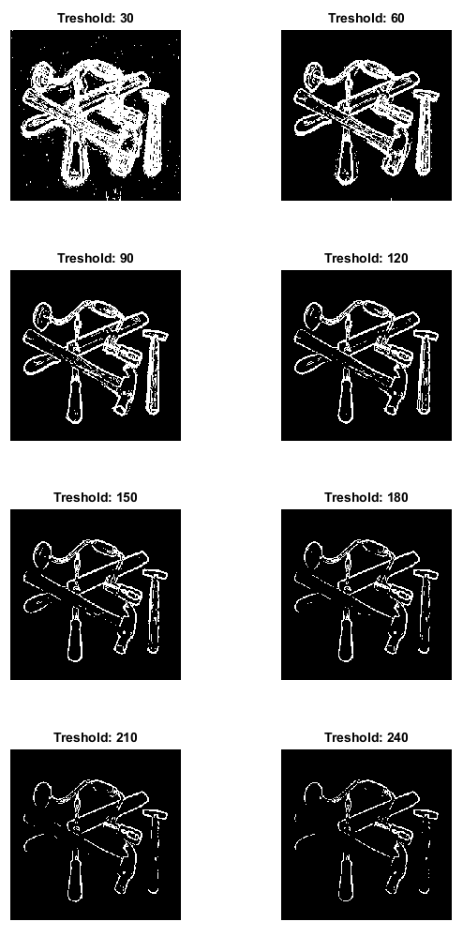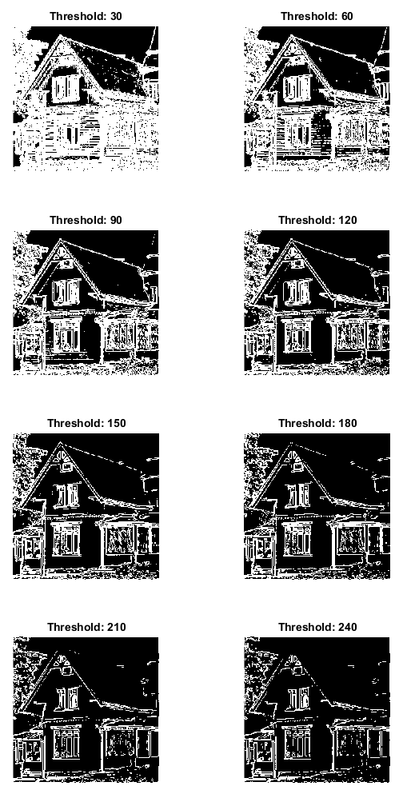

___________________________________________________________________________

**Question 3**: Does smoothing the image help to find edges?

Answers:

Yes, it filters out noise and all the smaller, finer details in the image, while leaving the bigger features more or less intact. While it helps getting rid of the smaller features and a lot of false edges, and allows to use a lower threshold, it must be noted that the resulting edges for the bigger features are thicker, as the pixels are blurred out and the transitions are less sharp, and therefore might be less precise and distorted. As we’re blurring, we also flatten out the magnitudes and get discontinuities on lower thresholds than for the non-filtered versions, but since the smaller features are blurred out, we can just use a lower threshold all together. It is definitely a good choice to pre-smooth the image if we’re interested in only the main structures in the image.

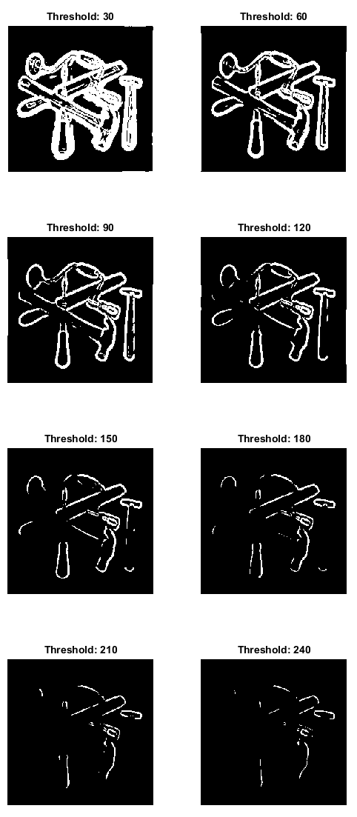­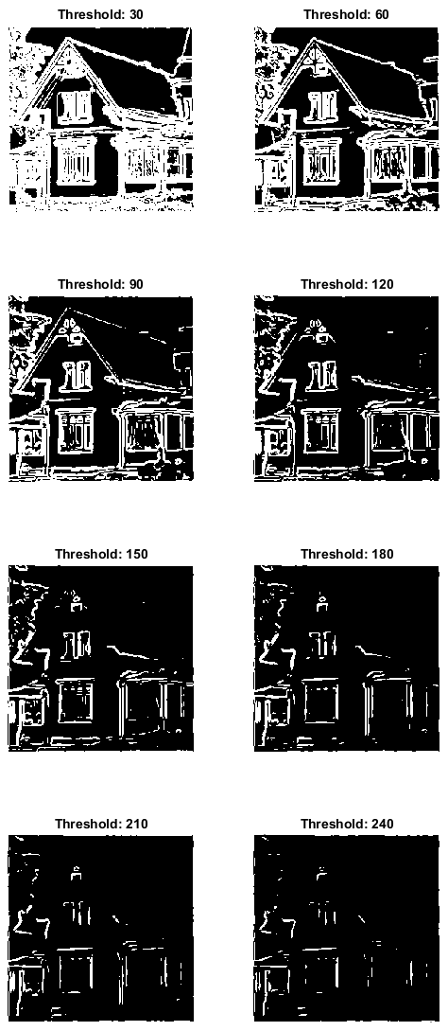

___________________________________________________________________________

**Question 4**: What can you observe? Provide explanation based on the generated images.

Answers:

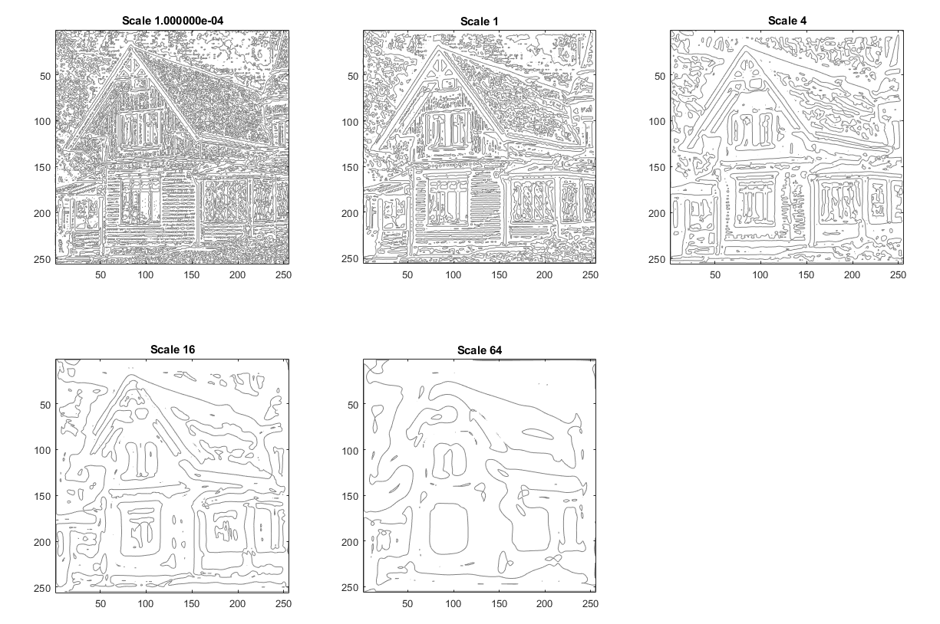

For this image we generate the second order derivative (technically not the full derivative, only the numerator part) at each point with respect to the gradient direction. If we look at the second order derivative near an edge point, we get a peak followed by a valley (since we get a peak in the first order derivative), so the middle point of the edge is represented at the zero-crossing point in the second order derivative, where the value comes down from the peak to proceed down to the valley. With this, we can retrieve an exact midpoints, resulting in thin well-defined edges, something which wasn’t easy to do with first order derivatives, where maximum points of the peaks had different magnitudes and we could only filter out the bottom values by thresholding.

To obtain these images, Matlab’s *contour* function is used to plot isolines between different value regions at zero-level, therefore the isolines follow the points where the second order derivative is at zero-crossing, which happens to be the edges we’re interested in.

This is done at different scales, corresponding to different levels of Gaussian blur. For the larger scale images smaller features and noise are blurred out, therefore most of the local maximum and minimum points and the respective zero-crossings they produce at lower scale levels are removed. Unfortunately, the larger structures are blurred out as well, so sharp edges and straight lines can be heavily deformed, resulting in a rounded, inflated look for the final edges.

___________________________________________________________________________

**Question 5**: Assemble the results of the experiment above into an illustrative collage with the *subplot* command. Which are your observations and conclusions?

Answers:

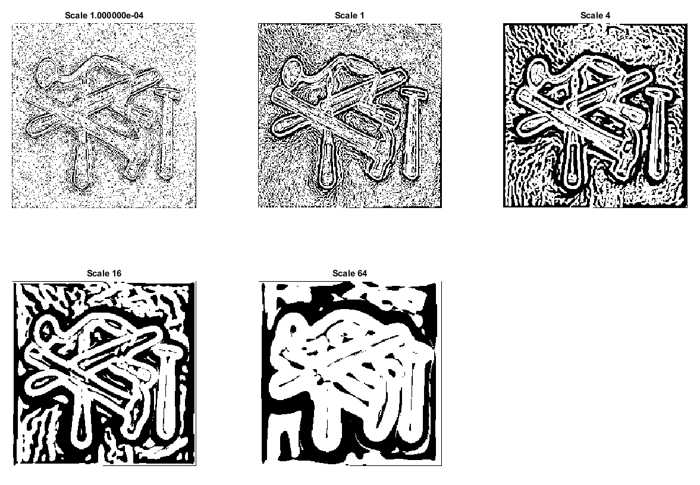

___________________________________________________________________________

**Question 6**: How can you use the response from *Lvv* to detect edges, and how can you improve the result by using *Lvvv*?

Answers:

___________________________________________________________________________

**Question 7**: Present your best results obtained with *extractedge* for *house* and *tools*.

Answers:

___________________________________________________________________________

**Question 8**: Identify the correspondences between the strongest peaks in the accu-mulator and line segments in the output image. Doing so convince yourself that the implementation is correct. Summarize the results of in one or more figures.

Answers:

___________________________________________________________________________

**Question 9**: How do the results and computational time depend on the number of cells in the accumulator?

Answers:

___________________________________________________________________________

**Question 10**: How do you propose to do this? Try out a function that you would suggest and see if it improves the results. Does it?

Answers:

___________________________________________________________________________