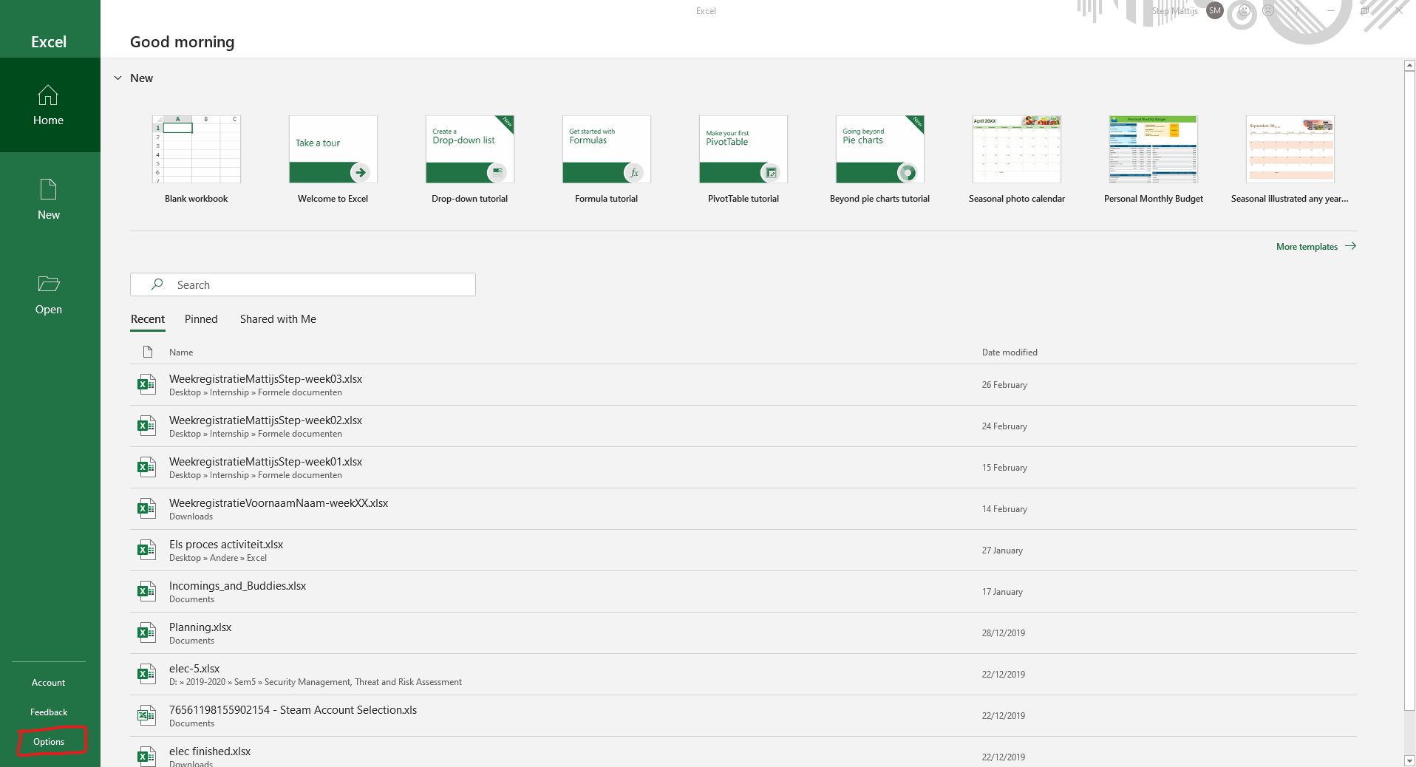

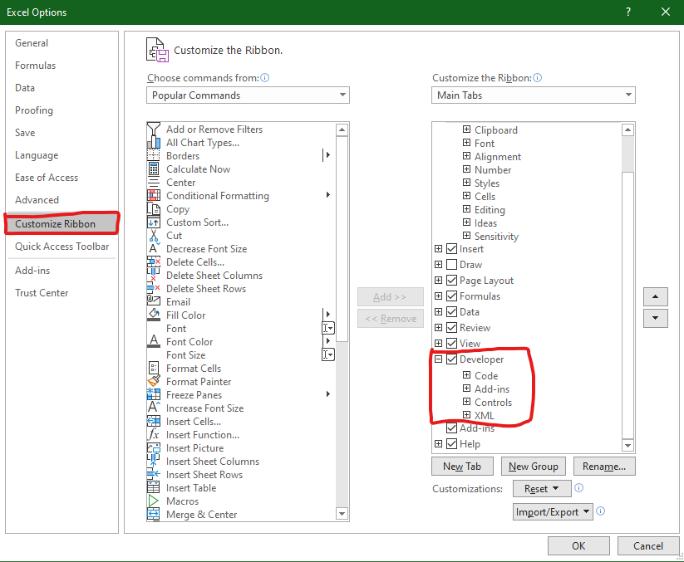

Create/ Open Excel sheet

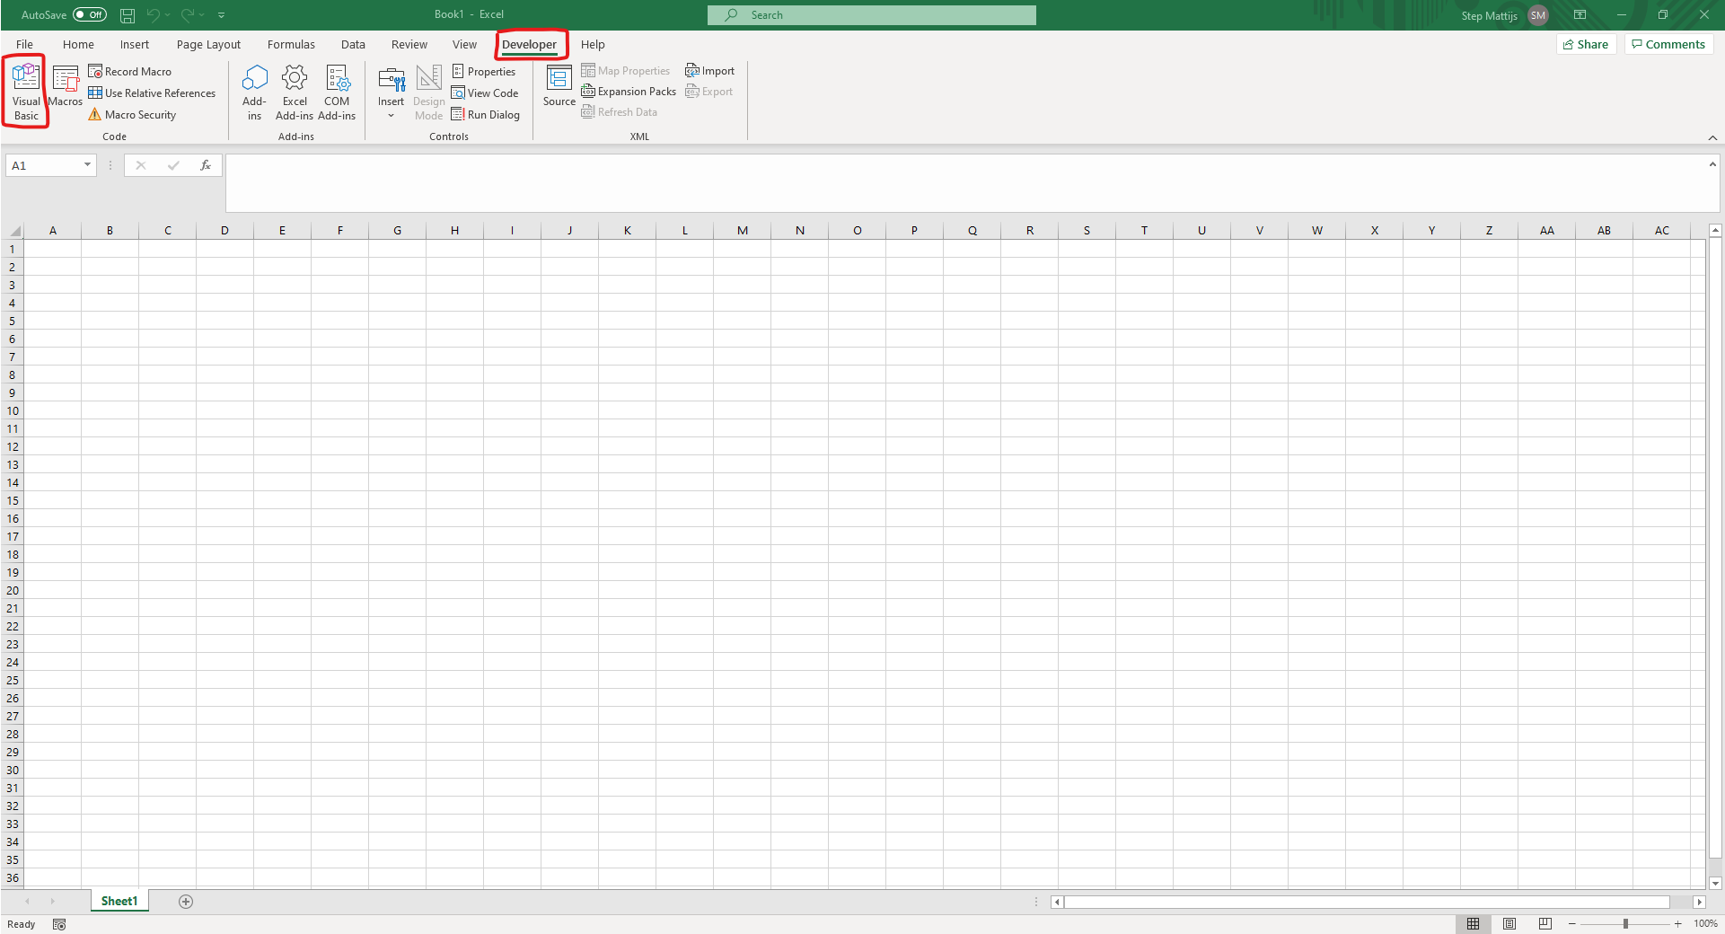

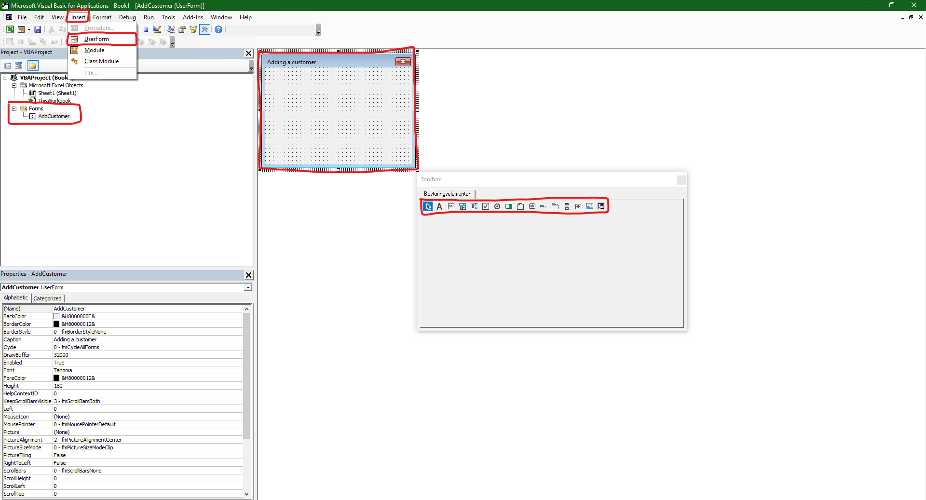

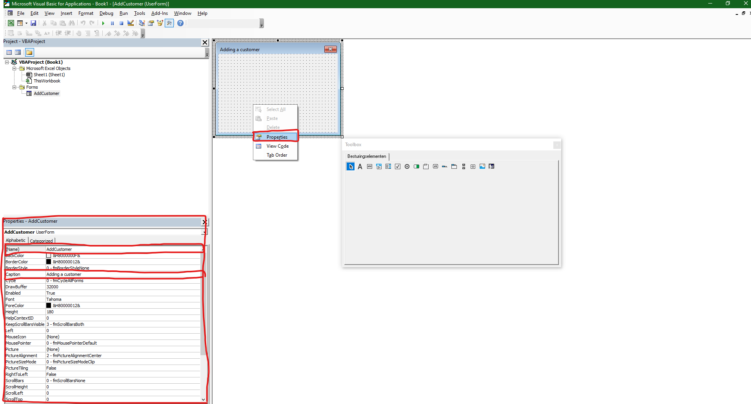

F7

Shift F7

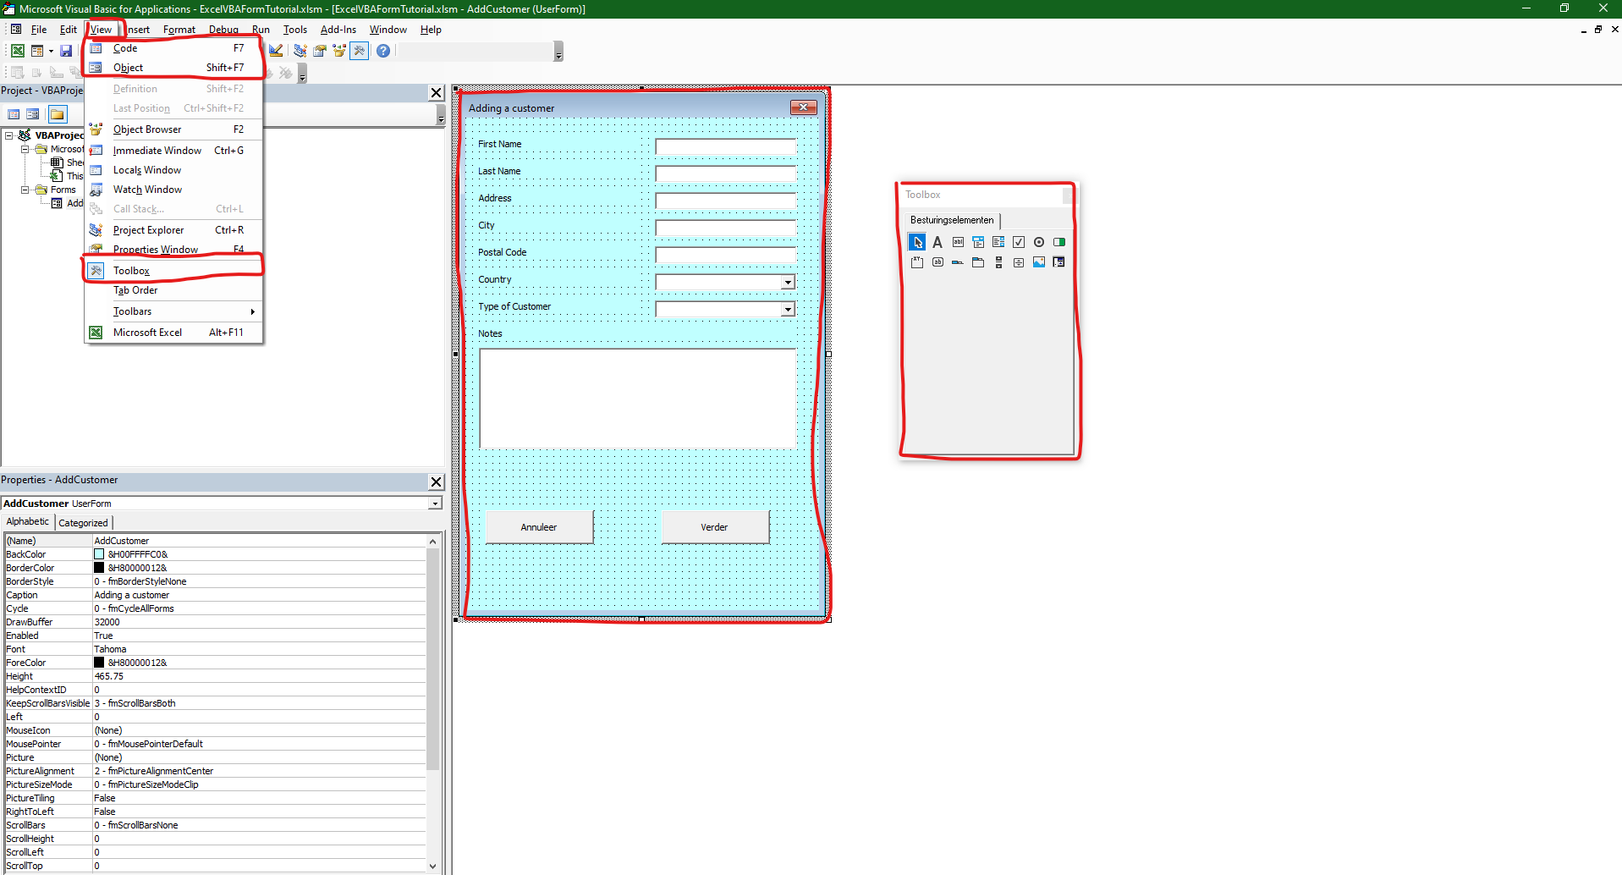

Sheets("ExtraLists").Range("Dyn_Countries").Select

Sheets("ExtraLists").Range("Dyn_TypesOfCustomers").Select

Expand

List

=COUNTA(List)

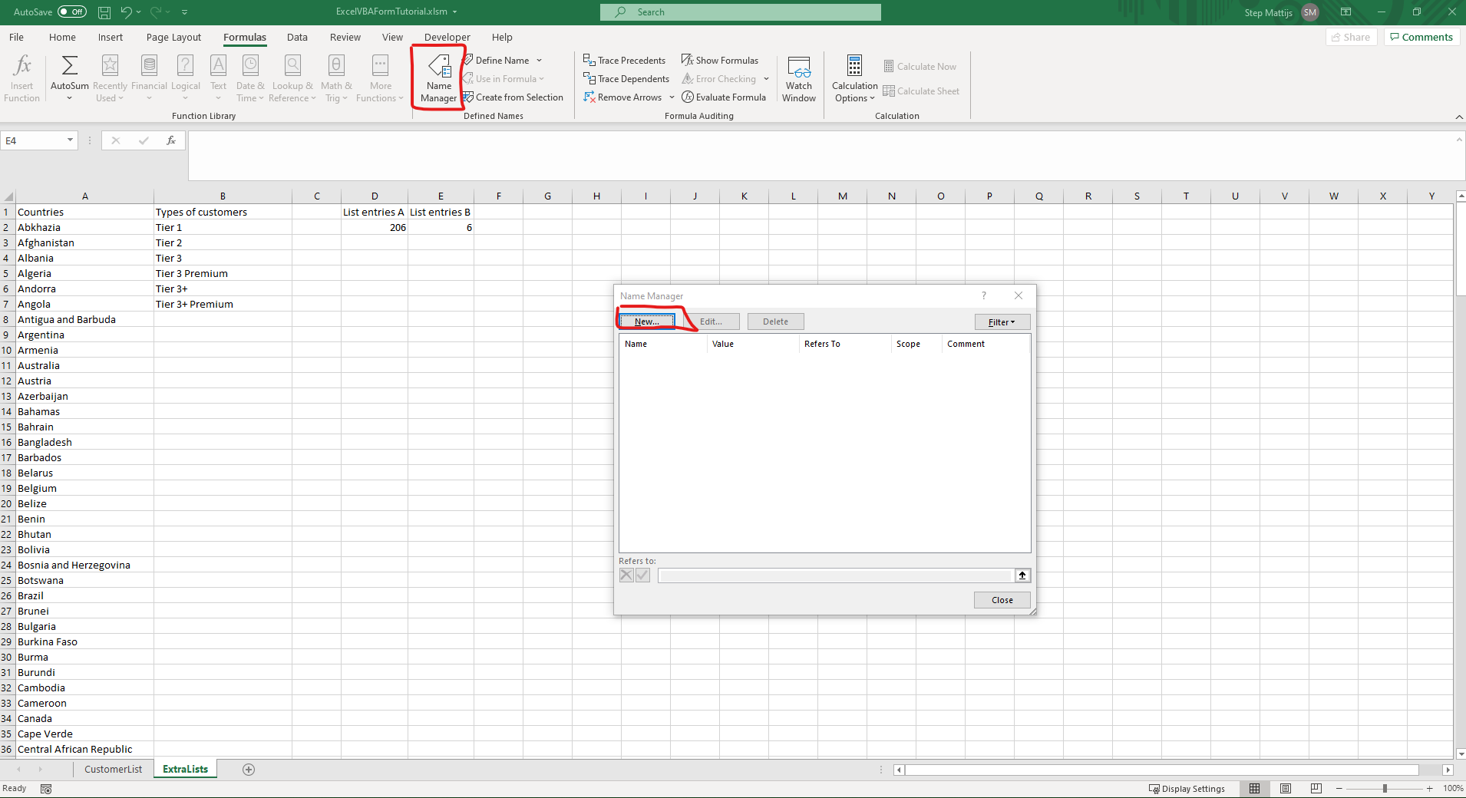

Dyn_Countries =OFFSET(ExtraLists!$A$2,0,0,ExtraLists!$D$2,1)

Dyn_TypesOfCustomers =OFFSET(ExtraLists!$B$2,0,0,ExtraLists!$E$2,1)

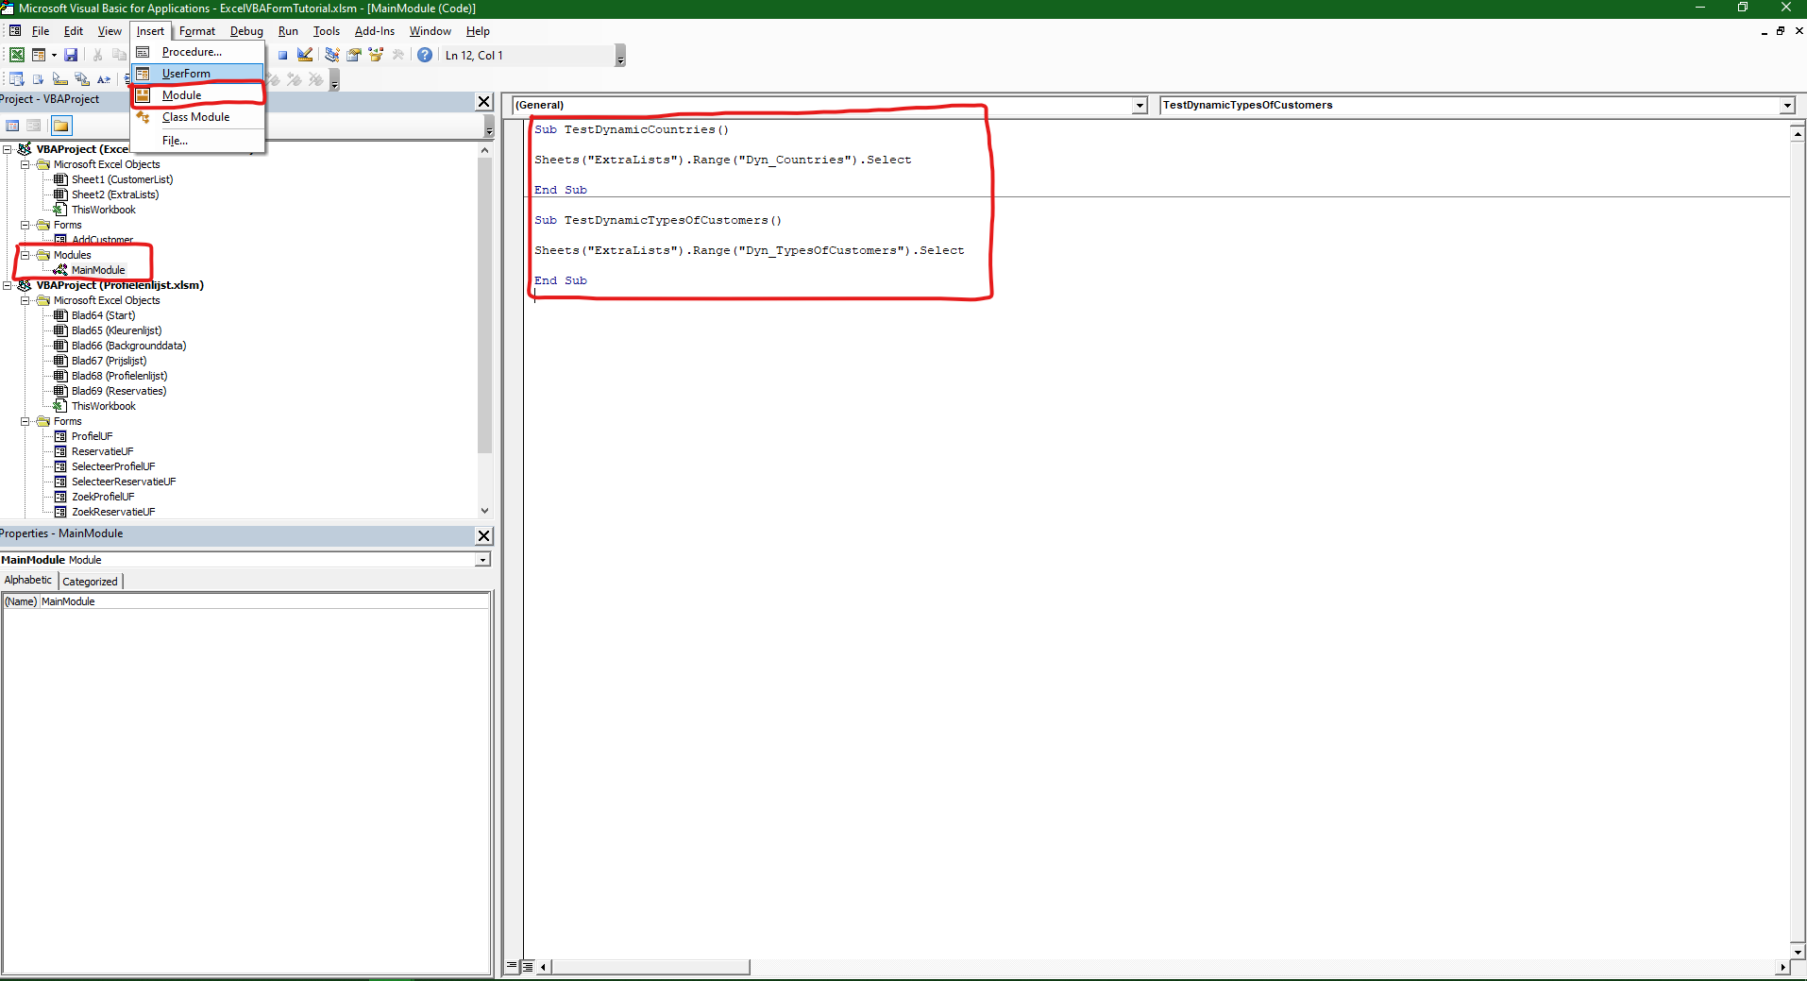

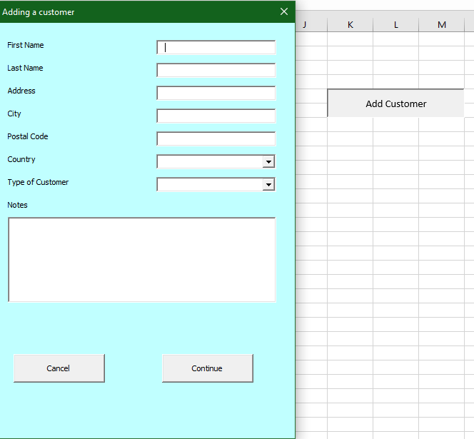

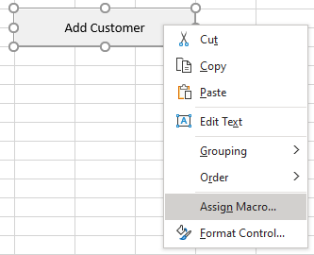

Sub ShowAddCustomer()

AddCustomer.Show

End Sub

Private Sub Button_Cancel_Click()

Unload AddCustomer

End Sub

RowSource dynamic ranges

Names

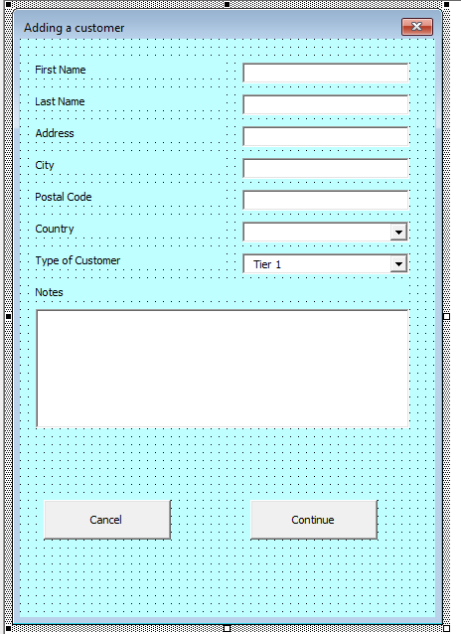

Private Sub Button_Continue_Click()

TargetRowCustomer = Sheets("ExtraLists").Range("F2") + 1

Txt_FirstName

Txt_LastName

Txt_Address

Txt_City

Txt_PostalCode

Combo_Country

Combo_CustomerType

Txt_Notes

TabIndex

///

Private Sub Button_Continue_Click()

TargetRowCustomer = Sheets("ExtraLists").Range("F2") + 1

If ((Txt_FirstName <> "") And (Txt_LastName <> "") And (Txt_Address <> "") And (Txt_City <> "") And (Txt_PostalCode <> "") And (Combo_Country <> "") And (Combo_CustomerType <> "")) Then

Sheets("CustomerList").Range("Customer_start").Offset(TargetRowCustomer, -1).Value = TargetRowCustomer

Sheets("CustomerList").Range("Customer_start").Offset(TargetRowCustomer, 0).Value = Txt_FirstName

Sheets("CustomerList").Range("Customer_start").Offset(TargetRowCustomer, 1).Value = Txt_LastName

Sheets("CustomerList").Range("Customer_start").Offset(TargetRowCustomer, 2).Value = Txt_Address

Sheets("CustomerList").Range("Customer_start").Offset(TargetRowCustomer, 3).Value = Txt_City

Sheets("CustomerList").Range("Customer_start").Offset(TargetRowCustomer, 4).Value = Txt_PostalCode

Sheets("CustomerList").Range("Customer_start").Offset(TargetRowCustomer, 5).Value = Combo_Country

Sheets("CustomerList").Range("Customer_start").Offset(TargetRowCustomer, 6).Value = Combo_CustomerType

Sheets("CustomerList").Range("Customer_start").Offset(TargetRowCustomer, 7).Value = Txt_Notes

Unload AddCustomer

Else

Dim errorlist(1 To 7) As String

If (Txt_FirstName = "") Then errorlist(1) = "First Name"

If (Txt_LastName = "") Then errorlist(2) = "Last Name"

If (Txt_Address = "") Then errorlist(3) = "Address"

If (Txt_City = "") Then errorlist(4) = "City"

If (Txt_PostalCode = "") Then errorlist(5) = "Postal Code"

If (Combo_Country = "") Then errorlist(6) = "Country"

If (Combo_CustomerType = "") Then errorlist(7) = "Custromer Type"

MsgBox "Pleas fill in the following:" + vbNewLine + errorlist(1) + " - " + errorlist(2) + " - " + errorlist(3) + " - " + errorlist(4) + " - " + errorlist(5) + " - " + errorlist(6) + " - " + errorlist(7), vbCritical

End If

End Sub

///