**General Order**

The General Order Application comprises of two core applications.

1) The **'General Order Importing**' application that allows the user to import/update General Order Word document into a staging Database. It also allows the User to Upload the document once they are satisfied with the results.

2) The **General Order Update**' application which allows the user to open the currently existing General Order and make changes to it. It also has reporting functionality. This will be part of ILD tab

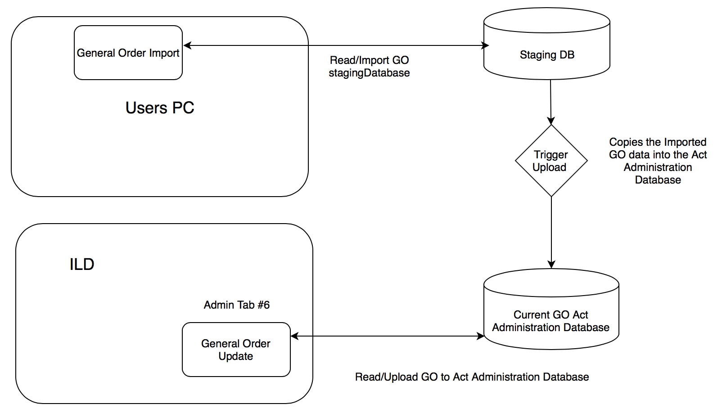

**General Order Importing** Application is opened via a shortcut on a user's computer as a standalone product and enables users to select a General Order (full or supplement) word document and import it into various staging SQL server Database tables.

The Admin user can make amendments to the General Order document and preview the work before uploading it to the Act Administration Database table making the General Order 'current'.

These amendments can come in via other Word documents 'Supplements' or other means such as email, phone call etc in which the user can enter this information into the application

This application will enable the users to save time in making manual changes to the 'current' General Order via the user interface.

1. General Order (GeneralOrder.exe)

This application allows the user to import one General Order Full or partial (supplement) document.

When the application is executed, it will read the Database to get the General Order status (check if there's already an imported General Order record).

If there is a record that has already been imported but not uploaded, it will only give the user the ability to

a) Discard the record which will then delete the General Order from the staging Database or

b) To proceed with it by viewing the record and its contents.

Process - A file is selected and the Import Button has been clicked, the application will start to read (process) the

document a paragraph at a time checking for specific parameters to determine if it's a Portfolio, Act or comment.

When a Portfolio or Act is being processed, it will check to see if it's valid. If it's not valid, it will write the details to an 'Error Log' document selected by the user and will be ignored by the application.

Once the complete document is read, it will prompt the user to import the correct Portfolios/Acts or to stop the import process and let the user manually correct the importing document before trying again

If the user decides to import the correct portions of the document, the user will need to 'Upload' the data before 'Importing' another document.

Once the user is satisfied with the results, they can then proceed to upload the record to finalize it into the Act Administration Database tables which will be available to authorised users via a tab within ILD

All actions processed within the application gets logged in the **System Log/Message** console located at the bottom of the screen. Also, it will write major events such as uploading or errors to an Application Logger database.

A wiki window is also available on the right of the application and it will give the user information about the current object by placing the mouse cursor over it.

NOTE: The Wiki has its own application in which the user can manage the content and styling

|  |
| --- |
|  |
| User:  a) Selects a document. This can be done by pressing the 'Select File' button or by entering it manually  b) Ticks the **File Type** (Full or Partial) radio button  c) Click **Select Date** of the General Order  d) Click the **Import File** button |
|  |

|  |
| --- |
|  |
| If the General Order document conatins erros, it will prompt the user to print a report listing the errors  If the user selects 'YES', it will prompt the user to save a document. If the user selects 'NO', it will continue on to the next step. |
|  |

|  |
| --- |
|  |
| Once the user has selected an option above, the application will then give the user the ability to continue to import ONLY the correct data (YES) or to cancel the import (NO). This will give the user an opportunity to fix the selected document and try again. |
|  |

|  |
| --- |
| User:  a) If there is a record in the DB that has been imported, user can view or discard that record. The 'Select file' and 'Discard Incomplete File' button will be enabled.  b) Can only import a new file once the current record load is uploaded to the Act Administrations Database tables or the imported record discarded. |
|  |

|  |
| --- |
|  |
| User  a) Can view the GO file that has already been imported  b) Has the ability to make changes to the Acts Comments and save the changes.  c) Can generate a General Order based on the changes for reviewing  d) Can make changes to the comments and save for later reviewing  e) Can select the Effective Date of the Act |
|  |

|  |
| --- |
|  |
| When uploading the general Order  a) When there are multiple departments to a portfolio the user can select the department as there should only be one department associated to a Portfolio |
|  |

1. General Order Update Details (GeneralOrderUpdateDetails.dll)

This application (library)

|  |
| --- |
| User:  a)Select a different Act from the default one provided by ILD.  b)Can edit a comment from the Current List or from the pending List. This will create a new pending record and will replace the selected record upon 'Upload'  b)Can delete a comment from the Current List. This will flag the record by setting the background/foreground colour to RED in the Current List. A user can click the delete button to 'Undelete' the record  c)Can delete a comment from the Pending List. This will remove the record from the 'Pending List'  d)Can add a new record/Comment to the Act. (See 'Add New Entry'). This will insert the record in the 'Pending List' |
|  |

|  |
| --- |
|  |
| User:  a) Can import new supplements of full General Orders or enter new acts manually  b)Entries in the Current List that have a Department and Portfolio entry in the Pending List will show the record background/foreground colour RED as duplicate and therefore to be replaced by the pending record.  c) Can delete the record from the current list or from the pending list. If a record is deleted from the pending list and has a duplicate record pending delete in the current list, it will remove the 'delete' flag and the background/foreground colour RED. |
|  |

**Current List Box:**

If a user clicks the delete  button, the following warning message box will appear for the user to confirm

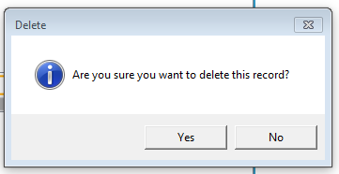

If the user clicks YES, the record will be flagged as delete by having the background/foreground colour change to RED

If the user clicks the delete  button when the record is already pending delete, the following warning message box will appear for the user to confirm

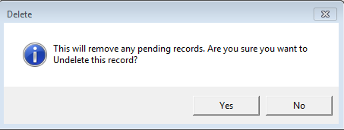

If the user clicks YES, the record will remove the pending delete state and the background/foreground colour RED will be removed. If the user clicks NO, it will cancel the transaction

If the user clicks the Edit button, the record will be opened into a separate page to enable editing. When the user clicks save, it will save the record into the Pending List box and flag the Current record as pending delete

**Pending List Box:**

If a user clicks the delete  button, the following warning message box will appear for the user to confirm

.

If the user clicks YES, the record will be removed. If the user clicks NO, the transaction will be cancelled.

If the user clicks the Edit button, the record will be opened in a separate window for editing.

If the user clicks the button, the application will open a page for the user to create a new record which when saved, will be placed in the Pending List box.

**Edit, Delete and Add new record**

If the record saved is the same as a Current List record, it will change the Current List record to pending and the background/foreground colour to RED (As a previous diagram that shows Attorney General as a record in the Current List and Pending List. If the user wants to keep the Current List record, the user can either delete the Pending Record or click the delete  button of the Current List record to Undelete. In either case, the Current List record will be set as current and the background/foreground colour RED removed

|  |
| --- |
| User:  A) Edits a record/comment  b) Can change the Portfolio by using the drop down list  c) Can edit the comments. The textbox will automatically add the required spacing and bullets by pressing the 'TAB' key  d) Can delete comments and bullets by pressing the delete key. The textbox will automatically change the type of bullet on delete  e) Can set the Effective Date |
|  |

1. Add a new record

|  |
| --- |
| User:  a)Can add a new record. All new records are saved in the pending list. If a new record has the same *Act, Portfolio and Department* as one in the current list, it will flag that record Red and pending delete. If a new record has the same *Act, Portfolio and Department* as an already existing pending record, it will replace that record.  b) Record will prompt to save if there are changes when the user clicks Cancel |
|  |