Ministry of Education and Culture of Kyrgyz Republic
Kyrgyz State Technical University
named after I.Razzakov

Computer Systems Software Department

Course Work

In a subject: Technology of development of the software
Engineering.
Theme: An automation of restaurant business

Prepared by student: Tankiev K., IVT 1-03

Checked up by: Musina I.R.

Bishkek 2007

Content

I. The Purpose of development.

II. A stage of formation of requirements.

A. The Functional Requirements:
1. The Description of a subject domain.
2. Performance of the structural analysis of activity of the organization (model AS - IS):
2.1. Initial contextual diagram DFD or IDF0, full contextual diagram DFD or IDF0 with the detailed elaboration executed in BPWIN;
2.2. Construction of conceptual model of the data used in the organization
In the form of ERD (the diagram "essence-communication"{-connection"}).
3. The Analysis of existing similar systems.
4. The Substantiation of necessity of development.

B.Nonfunctional Requirements:
1. Requirements to a product.
Demanded resources (OS, RAM, volume on a disk, a video card, the processor, the convenient interface, time of the answer, protection of data, etc.)
2. Organizational requirements (the programming language, protection against failure in system, presence of the help information, etc.).

III. The Design stage.
1. Construction of architecture of system:
1.1. Diagram USE CASE.;
1.2. The diagram of classes (UML Static structure);
1.3. The diagram of interaction (UML sequence);
1.4. The diagram of activity (UML activity)
The used literature.

The purpose of development of the software.

The main goal of development this kind of software is:
- To simplify restaurant business process by automation a lot of things
- To create “transparent” movement of processes
- To produce addition marketing step, by creating unique system
- To improve business process speed
- To create absolutely exact cash movement

I. The Stage of formation of requirements.

A) Functional requirements

1. The description of a subject domain
The system description:
The system description will have two main parts, 1-st is hardware part, 2-nd is software part

1-st part: Just imagine yourself fully automated system calculation and administration of business logic.
In the restaurant instead of usual menu you will see Portable PC (image 1). All orders you will do by clicking on a sensor with a pen, you will see all assignable products, their cost, ingredients, images and so on. The hardware specific of Portable PC will be: CPU - Intel U2500 1,06Ghz, 4Gb DDR2 RAM – more than enough to do daily operations, also Portable PC has HDD 100Gb SATA and support of WiFi, Ethernet, Bluetooth.
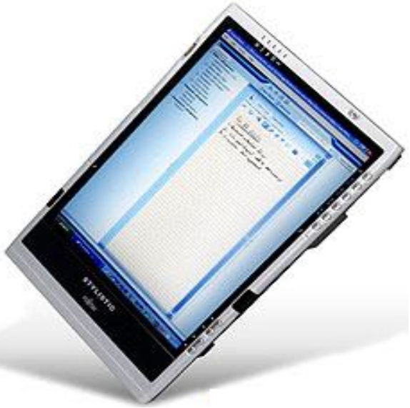 Image. 1 Fujitsu Stylistic ST5100

All PC will communicate this the main server by WiFi connection.

2) Software part of description: To all PC I will install special software (assume it will .NET Framework). Software will consist of lot of parts (components): Client- component, waiter-component, cook-component, barkeeper-component, provider-component, accountant-component, administrator-component and audit-component. Client-component will present simple, usable, intuitive measuring software with detailed description of all available service of the restaurant. It’s mean: dishes (availability of the dish), description of the dish, cost, images, history, on-line video of preparation of dish. Waiter-component is communicating with cook and barkeeper components, the system is: client gives an order -> order sorting, redistribution an order between cook and barkeeper -> (…order complete…) -> notification waiter about order completing. Provider-component is charged with on-time delivery of raw-materials and calculation of how many dishes will be produced, if there is not enough raw-material, a dish in the client-component will be inactive. Administrator, accountant and audit component is management part of system.

2. Performance of the structural analysis of activity of the organization (model AS - IS):
2.1. Initial contextual diagram DFD and full contextual diagram DFD with the detailed elaboration executed in MS Visio 2003:

Initial contextual diagram DFD linked with automation business system. In this case whole system has 2 external essences, first one is personal of restaurant and second one is supply.

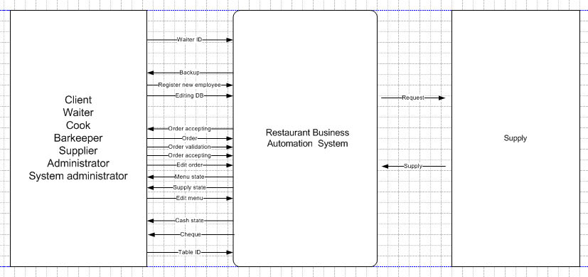

image 2. Initial DFD

Full contextual diagram DFD with detailed elaboration on image 3.

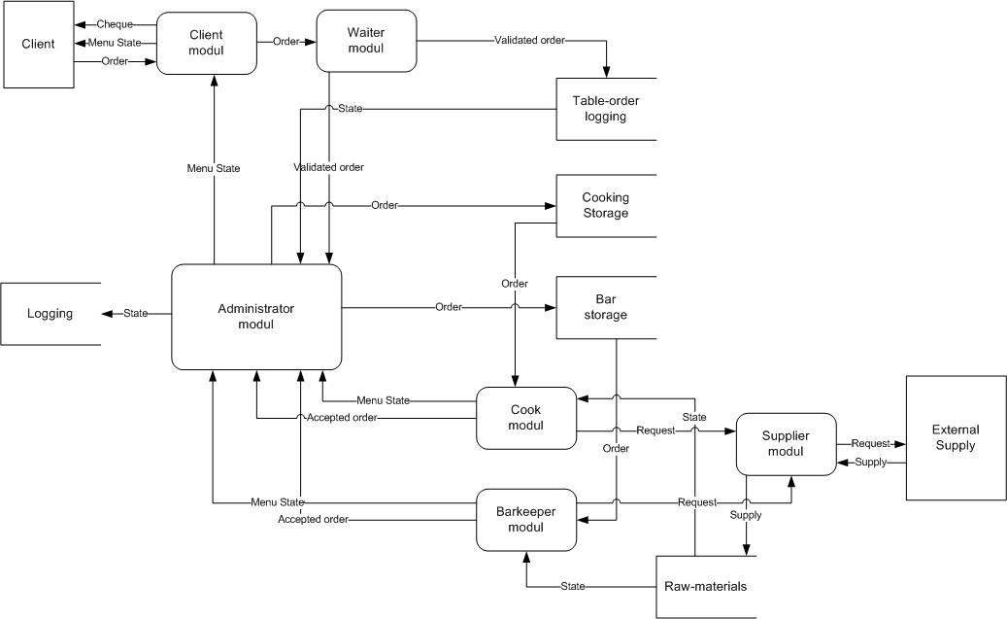

Image 3. Full DFD.

As you can see on image 3 I have some kind of system components, described before.
When physical (legal) person make an order (by touching sensor display), order moves to waiter-component, waiter accepts, validates (it means that waiter sends the information about table ID and waiter ID). Than our order moves to administrator – component, where it’s sorting and redistributing to cook and barkeeper component, when cook and barkeeper end their order, they send an alarm to waiter component, that the order is done.
Supplier component provide raw-materials to warehouse. If some ingredient is missing, the system automatically switches off this dish from menu.

3. Analysis of existing alternatively systems

As I know, there are no such systems. I read about alike systems, they used in large restaurants. The idea is: the system is registering only busy\free tables.

4. Explanation of system necessity
We all live in 21-th sentry, in sentry of information technologies. Before long all human work will be automated. That’s why if we want to do real success business, we must pay attention to information systems. The system like this one never say: “OOuu… I’m sick” or “I’m tired” or “give me more money!!” and so on. The system will never trick you, system will work accurate and stable. Also ordinary people trust to computer technologies more that another human.

B. Nonfunctional requirements

- The given system interface should be easy to understand and convenient in use.

- The user at an intuitive level should understand what to do for performance of this or that operation.

-Each query should be executed quickly, without failures, therefore for normal functioning the system should be tested for a maximum quantity of variants of use and a maximum quantity of times.

-Protection of system has also huge value in what both parties - the user and the party giving services are interested. It is necessary to protect system from breaking as much as possible.

1. Requirements to a product.
Its necessary to purchase Portable PC, RAM memory must be minimum on 512 Mb, CPU must be alternatively to Pentium 4 – 2.4Ghz or higher, there must be .NET Framework version 2 or higher and Portable PC must have WiFi.
III. A design stage.
1. Construction of architecture of system:
1.1. Diagram USE CASE:

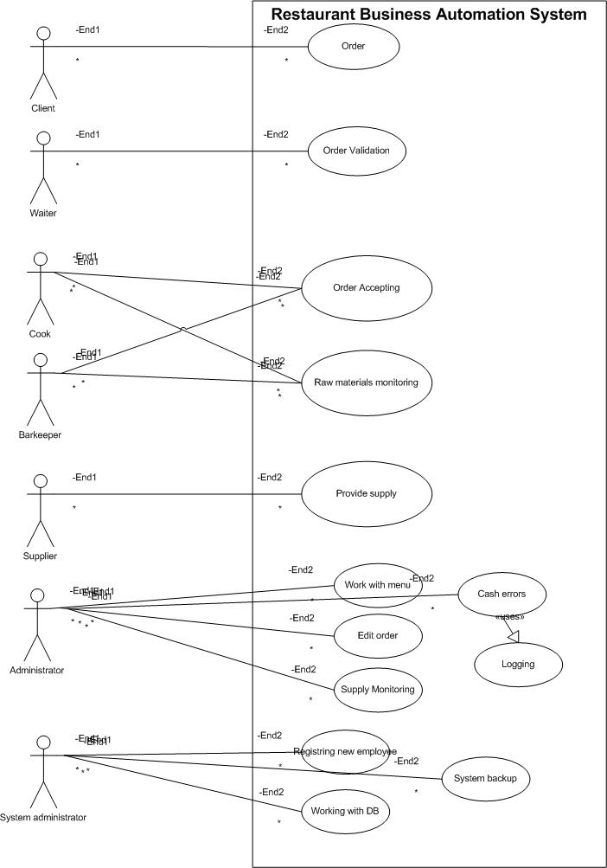

Image 4.Use Case diagram.

Diagram Use Case image 4.is used by:
1. the client, for viewing the menu and to go an order.
2. the waiter, for order validation.
3. the cook, for order acceptation and warehouse monitoring.
4. the barkeeper, for order acceptation and warehouse monitoring.
5. the supplier, for maintenance of delivery of the necessary goods.
6. administrator, for menu creating\editing, orders editing, supply monitoring and errors tracking.
7. System administrator, for working with DB, registering new employee and system backup.

1.2 UML Static structure (the diagram of classes)
For realization of functions determined in scripts, in classes properties and operations are added. By results of formation of properties and operations of classes content of diagrams of sequence which already describe objects of classes of their communication and the relation in more detail is updated.

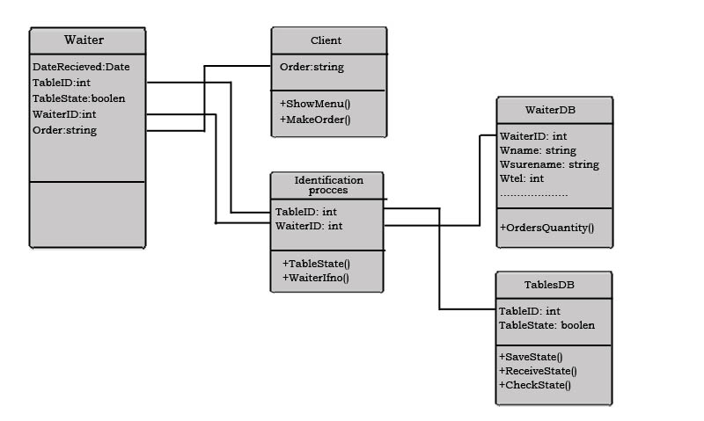

Image 5. the Diagram «Static Structure»

The client - the physical person who is make out the order of goods. Interface of client shows him the state of menu, and make-order form.
The waiter – the physical person who validates the order received from client. Interface of waiter is sends the information about tables, waiter, date of order and order.
The Identification process – The process that get the state of table (free-busy) and information about waiter.
Waiter DB – the database of waiters who working at restaurant.
Table DB - the database of tables, saves the state of present table, receive present state of table by ID and checks the status of table.

1.3 UML Sequence
The diagram of sequence illustrates the script of succession of events within the framework of a variant of use.

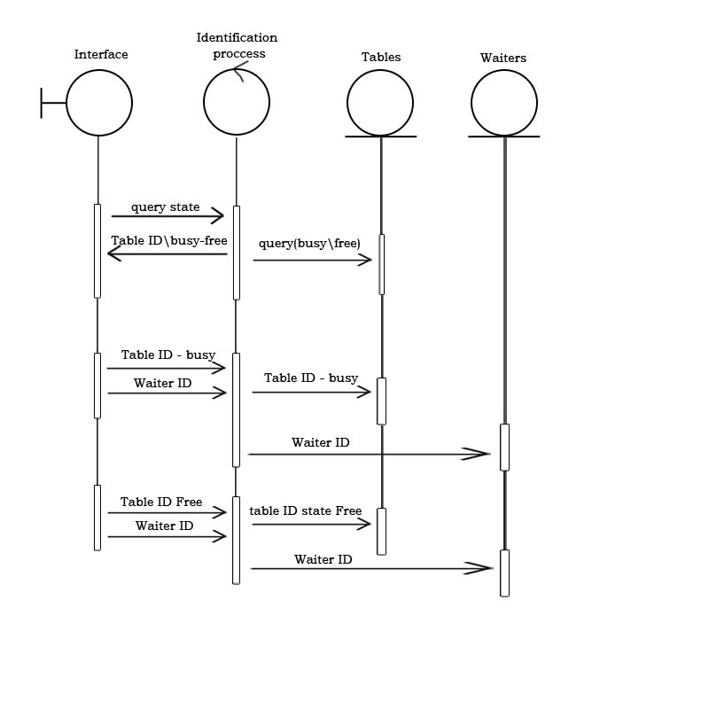
Image 6. The Diagram «Sequence»

On this diagram I represent the case of use of Client accepting process.
First, when client came to our restaurant, waiter sends a query about state of free-busy tables. Than waiter analyze free tables and escort the client to free table and send package that that table is busy now. Identification process automatically sends to server information about waiter (waiter ID). When client is finish, waiter sends the package that table is free now.

1.4 UML Activity (the diagram of activity)
The given kind of diagrams shows a condition of actions, process of calculations and streams of works carried out in system. Each action begins with initial unit and finishes activity in final unit.
If action is equivalent accordingly, process of sample is necessary. The system should provide an opportunity of reusable granting of necessary services, i.e. the iterative approach is provided.

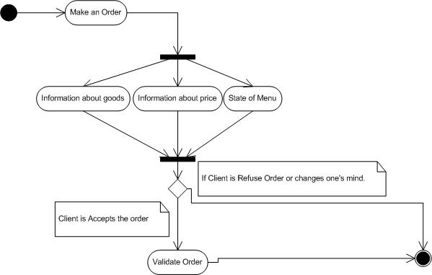

Image 7. the Diagram «Activity»

This diagram of activity shows the process of making Order. What kind of actions is take place, how many branches we have? In this case I represent only one case of my system. Let’s see what process is flowing more attentively:
1. First, Client starts make an order.
2. Second, Client sees the information of a state of menu, information about goods, about prices and additional required information.
3. If the Client accepts this information, price and so on, he can validate his order, that’s mean that the order is send to the next component in system hierarchy.
4. If the Client refuses the order, the system is break, and we make step to the final unit.

The used literature:
1. http://devnull.wplus.net Unified Modeling Language (UML) Tutorial
2. Martin Fowler, Kendall Scott: UML Distilled Addison-Wesley 2000
3. Kent Beck, eXtreme Programming.
4. http://umlcenter.visual-paradigm.com/ UML 2.0
5. Gaas I.G.

