Ministry of Education and Culture of Kyrgyz Republic
Kyrgyz State Technical University
named after I.Razzakov

Computer Systems Software Department

Course Work

In a subject: Technology of development of the software
Engineering.
Theme: Row-material base.

Prepared by student: Kim M., gr.IVT 1-03

Checked up by: Musina I.R.

Bishkek 2007

Content

I. The Purpose of development.

II. A stage of formation of requirements.

A. The Functional Requirements:
1. The Description of a subject domain.
2. Performance of the structural analysis of activity of the organization (model AS - IS):
2.1. Initial contextual diagram DFD or IDF0, full contextual diagram DFD or IDF0 with the detailed elaboration executed in BPWIN;
2.2. Construction of conceptual model of the data used in the organization
In the form of ERD (the diagram "essence-communication"{-connection"}).
3. The Analysis of existing similar systems.
4. The Substantiation of necessity of development.

B.Nonfunctional Requirements:
1. Requirements to a product.
Demanded resources (OS, RAM, volume on a disk, a video card, the processor, the convenient interface, time of the answer, protection of data, etc.)
2. Organizational requirements (the programming language, protection against failure in system, presence of the help information, etc.).

III. The Design stage.
1. Construction of architecture of system:
1.1. Diagram USE CASE.;
1.2. The diagram of classes (UML Static structure);
1.3. The diagram of interaction (UML sequence);
1.4. The diagram of activity (UML activity)
The used literature.

The purpose of development of the software.

The software of system - "Commodity-raw-material base", is developed for optimization of work of base, namely: for simplification of process of purchase by the client of the goods necessary for it. System “Commodity-raw-material base” gives catalogues of the goods to the client.

I. The Stage of formation of requirements.

Functional requirements:
Granting of the necessary information on available goods to the client.
-To organize system of orders;
-To order the goods;
-To give the goods;

1. The description of a subject domain
Necessity of development of automated system «Commodity-raw-material base» has arisen for: simplifications of conducting the accounting reporting, simplification of registration of clients, automation of data flows.

2. Performance of the structural analysis of activity of the organization (model AS - IS):
2.1. Initial contextual diagram DFD and full contextual diagram DFD with the detailed elaboration executed in BPWIN:

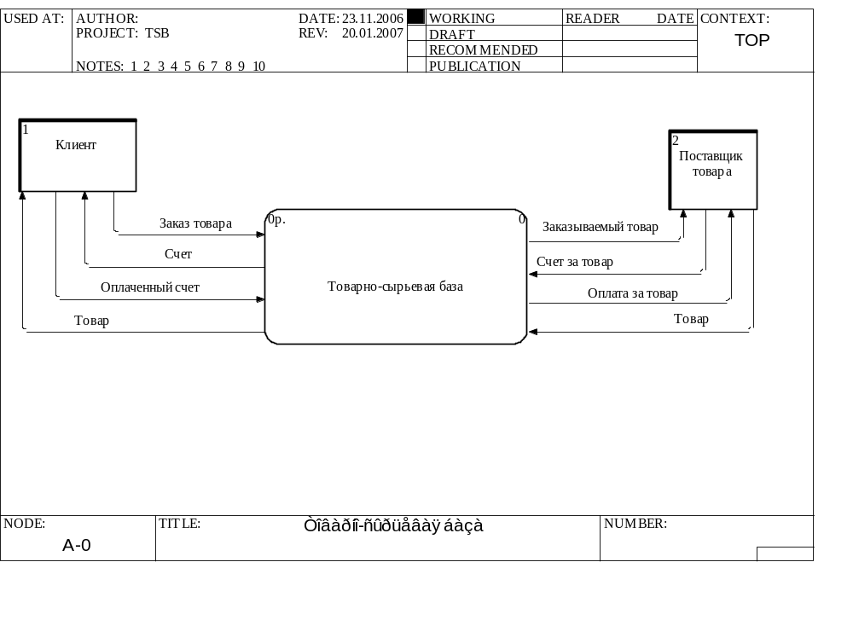

Fig. 1.1 the Diagram "Commodity-raw-material base"

Commodity-raw-material base is the system containing all necessary information for acceptance and realization of orders.
The supplier of the goods is an external essence which carries out delivery of the ordered goods.
The client is an external essence, namely the customer of the goods (the physical, legal person).

On рис.1.1 two external objects are displayed: the Client, the Supplier. The client orders the goods, ТSB gives to it’s the account, after payment ТСБ gives out the goods. The information on the ordered goods is given to the supplier.
It provides ТSB: the necessary goods also shows the account for the goods, ТSB pays the goods which was put by the supplier.
Process of service of the client by system " ТSB " is described by the following diagram:
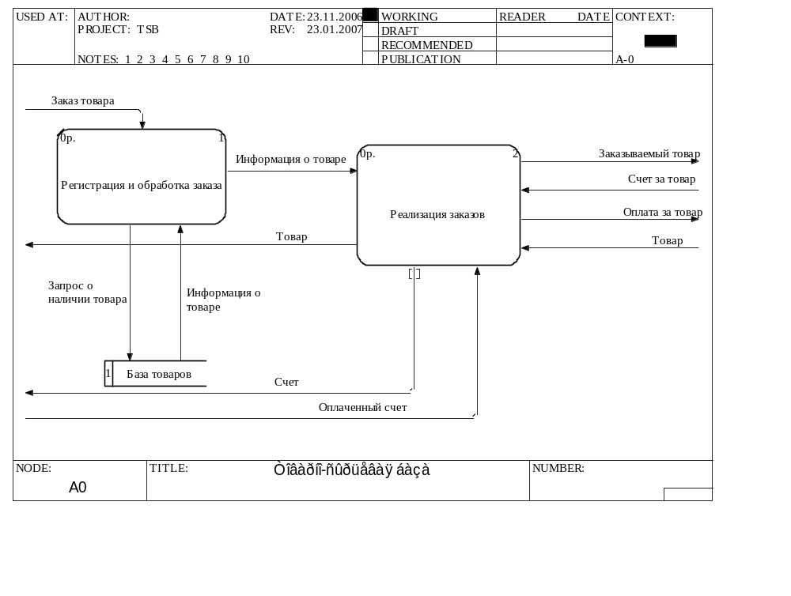
Fig. 1.2. Detailed elaboration "Commodity-raw-material base"

The ordered goods is registered and processed, requested on presence of the goods in base of the goods. The base gives out the information which is necessary. This information is transferred in realization of orders, and already realization of orders sends data: the name of the goods, amount of the goods and term of delivery - to the supplier. The supplier gives the account for the goods. In realization of orders there is a recalculation, and the account sends to the client. The paid account the client, is brought in realization of orders. The system pays to the supplier the put goods. The goods pass realization of orders and it is given to the client.
Further we detail « Realization of orders ».
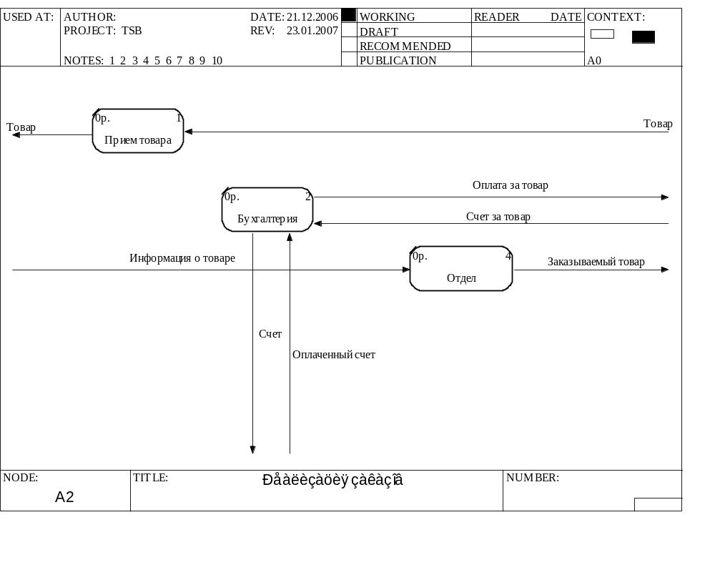

Fig. 1.3. Detailed elaboration « Realization of the order »

The delivered goods to be on object « reception of the goods » while it will be not demanded by system. The account paid by the client to be brought in accounts department. The account given by the supplier is paid by accounts department. The department "reception-order" provides reception of the information on the goods and sends the information on the ordered goods to object "Supplier".
2.2. Construction of conceptual model of the data used in the organization in the form of ERD (the diagram "essence-communication").

Client
Supplier
Orders
Goods
It’s used for storage
Warehouse
Arrangement
Fig.2.1. the Diagram "essence-communication".

In the given diagram (objects) and associations between them are displayed essence. The essence is understood as set of real or abstract objects, each of which possesses identical characteristics. Essences are connected by relations, which determine the given system as uniform.

Nonfunctional requirements

The given system should be easy and convenient in use.
The user at an intuitive level should understand what to do for performance of this or that operation.
Each inquiry should be executed quickly, without failures, therefore for normal functioning the system should be tested for a maximum quantity of variants of use and a maximum quantity of times.
Protection of system has also huge value in what both parties - the user and the party giving services are interested. It is necessary to protect system from breaking as much as possible.
The interface should be convenient. And service maximum comfortable.

Requirements to a product.
As to OS, RAM, borrowed memory - depends on requirements of the customer, but in any case it should be taken into account, that the product which will correspond to all above-stated requirements will use the maximal demand.
III. A design stage.
1. Construction of architecture of system:
1.1. Diagram USE CASE:

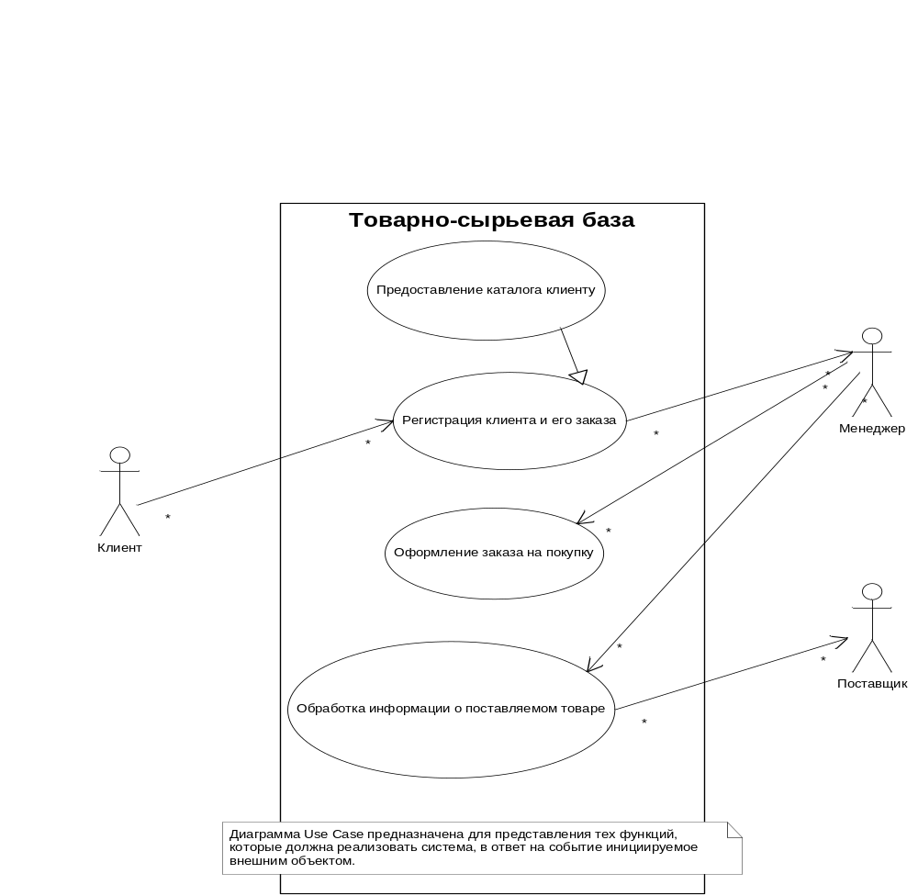

Fig.3.1.The Diagram “Use Case”

On the diagram it is shown, what variant of use this system has:
￘  To give the catalogue to the client
￘  Registration of the client and his order
￘  Registration of the order for purchase
￘  Processing the information on the delivered goods

Diagram Use Case fig. 3.1. is used:
1. The client, for viewing the catalogue and the order of the goods.
2. The manager, for registration of the new client and his order, registration of the order for purchase and processing of the information on the delivered goods
3. The supplier, for maintenance of delivery of the necessary goods.

1.2 UML Static structure (the diagram of classes)
For realization of functions determined in scripts, in classes properties and operations are added. By results of formation of properties and operations of classes content of diagrams of sequence which already describe objects of classes of their communication and the relation in more detail is updated.

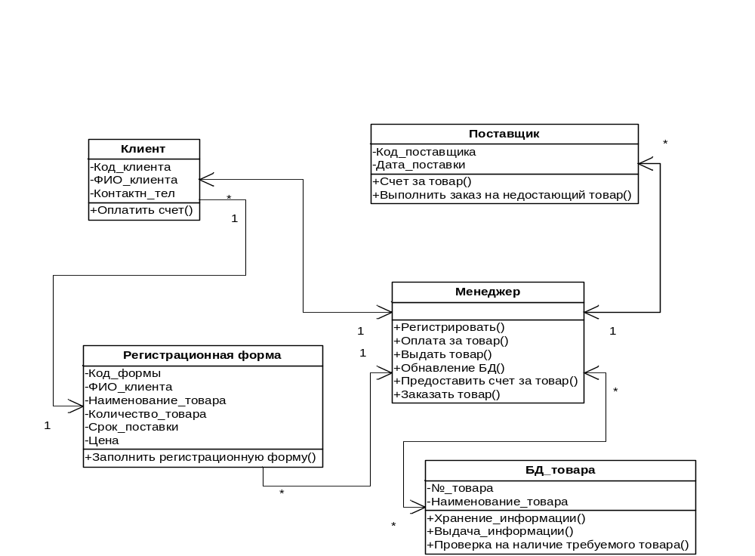

Fig.3.2 the Diagram «Static Structure»

The client - the Physical person who is carrying out the order by studying of the catalogue and filling of the registration form. Attributes of a class the Client are: the code of client, name of client, telephone, i.e. the data on. Functions which are carried out by the client: Pays the account. Objects of a class are: the person.
The supplier - the Enterprise which produces the goods, delivers the goods on base, gives the account for the goods, receives payment for the goods, and carries out additional delivery of the absent goods to base. Attributes of a class the Supplier are: the code of supplier;
The registration form - the Form filled with the client. Containing: the code of form, name of client, the Name of the necessary goods, Amount of the goods, the Price. I.e. in one form it can be specified not only one goods, but also if necessary the whole inventory.
The manager - System TSB. Recording the registration form, carrying out the order at the supplier, if it’s necessary, the updated DB of goods, gives the account for the goods to the client, pays the put goods, and gives out the goods to the client.
Database of goods - a DB of the goods of system TSB. Containing with the catalog of name of the goods, its amount in a warehouse and the price.

1.3 UML Sequence
The diagram of sequence illustrates the script of succession of events within the framework of a variant of use.

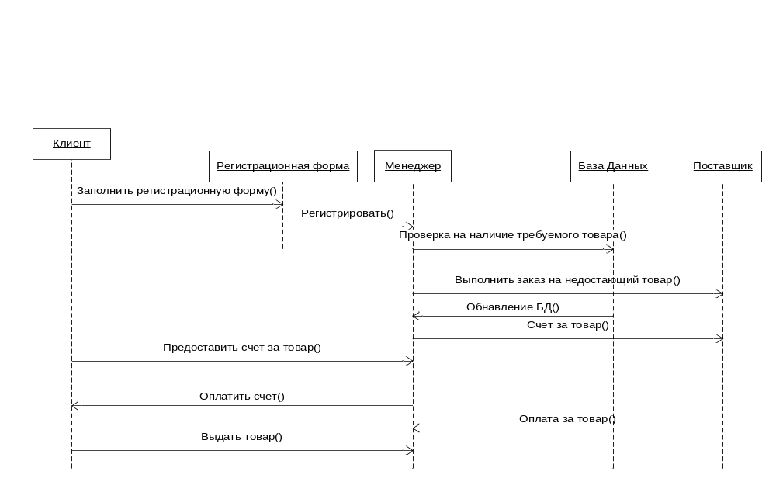Fig.3.3 the Diagram «Sequence»

The client fills in the registration form, brings the required data on, on the goods, his{*its*} quantity{*amount*}, the price, term of delivery. The manager considers{*examines*} the registration form which was filled by the client, containing: code of form, name of client, name of goods, amount, the price.
If the ordered goods are on TSB the account for the goods is given the client, after payment, the ordered goods are given out to the client. Otherwise, there is an order of the missing goods at the supplier. The supplier gives the account with the specified sum to the manager, after performance of the order. The manager gives the account for the goods to the client. The client pays the account. The manager gives out the goods to the client.

1.4 UML Activity (the diagram of activity)
The given kind of diagrams shows a condition of actions, process of calculations and streams of works carried out in system. Each action begins with initial unit and finishes activity in final unit.
If action is equivalent accordingly, process of sample is necessary. The system should provide an opportunity of reusable granting of necessary services, i.e. the iterative approach is provided.

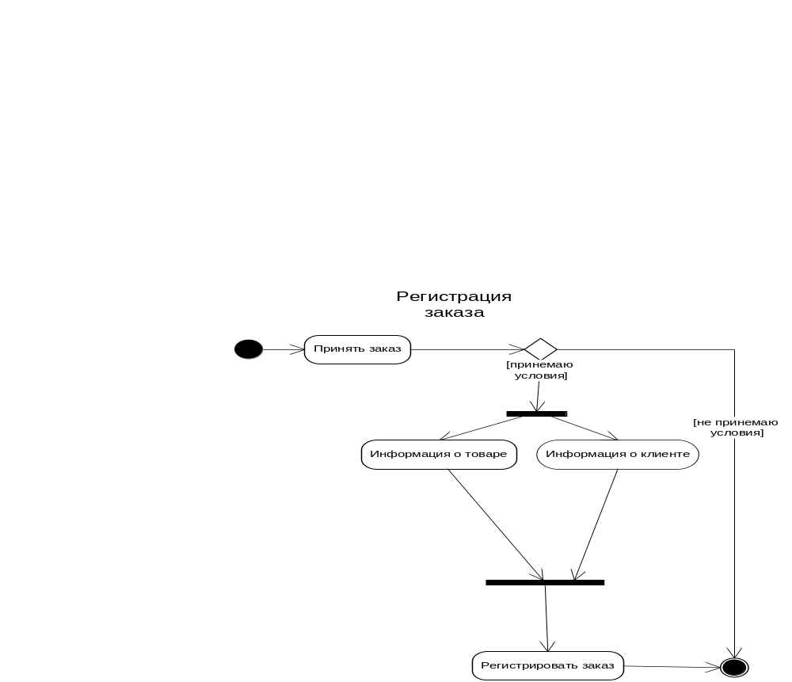

Fig.3.4. the Diagram «Activity»

The diagram of activity of registration of the order shows, what actions are made since that moment as there is a question on acceptance of the order and until when the order will be registered? Between these events a number of other events take place:
1. If the client does not accept a condition the further activity stops.
2. If the client accepts conditions it is necessary for it{*him*} to give the information on and the goods necessary for it{*him*} as these actions are parallel, it is necessary to take advantage of unit a fork.
3. Association of events of granting of the information on and about the necessary goods demands application of unit of connection, further we add the order and is registered it; activity at the given stage is ended.

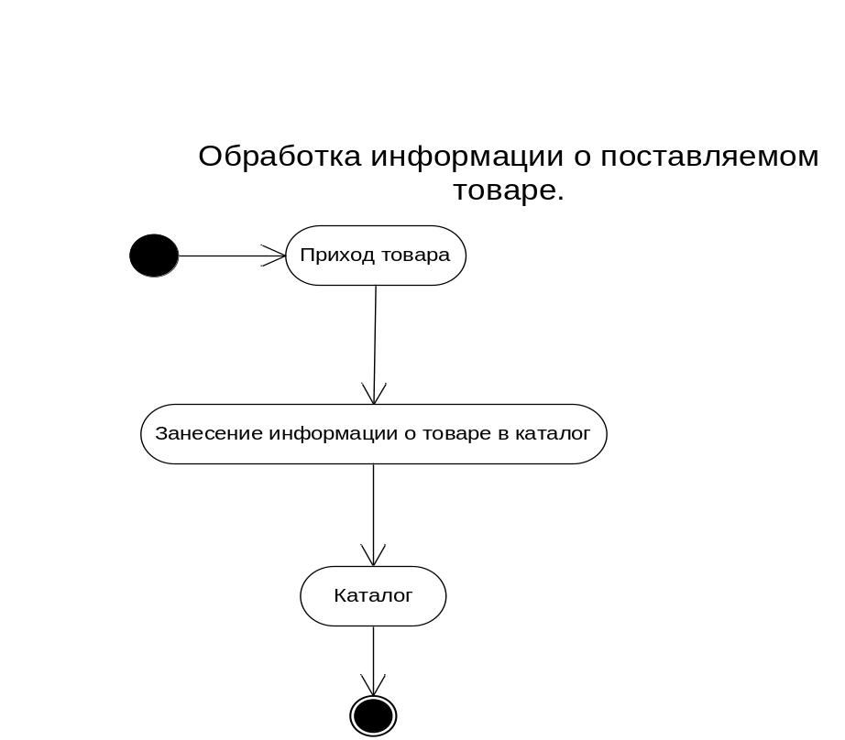

Processing of the information on the delivered goods is displayed on the given diagram in system TSB. Arrival of the goods on ТСБ from the supplier, then entering of the information on the received goods in the catalogue on it activity comes to an end.

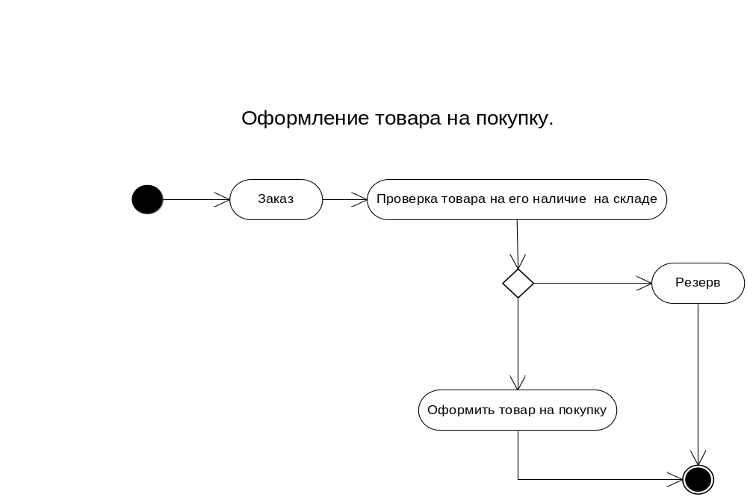

The order means a choice the client from the given catalogue, the information on the goods for the order. Check of a condition on presence of the goods. If the specified name of the goods and his{*its*} quantity{*amount*} is present in a warehouse to execute action to issue the order for purchase, differently to put on a reserve, i.e. to order the missing goods to the supplier.

The main purpose of diagrams consists in formalization of functional requirements to system, with the help of concepts of a corresponding package and an opportunity of the coordination of received model with the customer on an early design stage.
Diagrams play the important role in realization of algorithms of performance, operations, classes and streams of management in modeled model. Construction of the diagram of classes depends on skill correctly to choose classes and to establish between them interrelations and depends not only success of process of designing, but also productivity of performance of the program.

The used literature:
1. Orels С.А. « Technology of development ON » the textbook and the grant{*manual*} for high schools.
2. Koljanov G.N. "Case" structurally system analysis.
3. Leonenkov А. « Self-instruction manual UML »
4. Braude Eric Dzh. « Technology of development of the software ».

