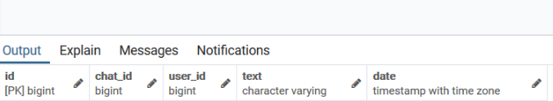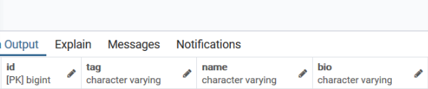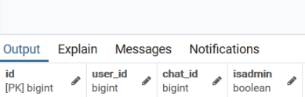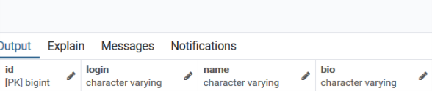

message:

chat:

user_chat:

user: