Comparing Lateral Control Algorithms for Long Rigid Vehicles in Urban Environments

Artyom E. Boyarov (student)

Whitgift School, Haling Park, London, CR2 6YT, United Kingdom

Corresponding author email: artyom.boyarov@gmail.com

Abstract

An Abstract is required for every paper; it should succinctly summarize the reason for the work, the main findings, and the conclusions of the study. It should not exceed 200 words. Please insert your abstract on this page.

This paper compares the performance of lateral control algorithms when applied to rigid vehicles of large length, such as buses, in urban environments. Existing research is largely focused on the performance of controllers when applied to cars, and buses have not been investigated7. The control algorithms investigated were the Stanley and pure pursuit controllers, as well as two new controllers which aim to improve upon the weaknesses of both controllers. Research was carried out in a kinematic simulation where the vehicles had to follow pre-defined trajecories with roads and maneuvers similar to those in an urban setting, such as tight turns and roundabouts. The simulation recorded the steering angle change and crosstrack errors for the front and rear axles for each controller at 30 km/h and 50km/h. The stanley controllers resulted in a large crosstrack error but a low rear crosstrack error. The stanley controller, the hybrid stanley and pure pursuit controller and the stanley controller with lookahead had a large change in steering angle. The pure pursuit controller performed wuite well, with a low change in steering angle and very low frontal crosstrack error, however it still gave a large rear crosstrack error.

Keywords

Robotics and Intelligent Machines; Robot Kinematics; Buses and Truck Kinematics; Lateral Control

Introduction

Self-driving cars have been developing at an increasing rate over the past few decades, starting with basic highway driving in the 1980s to almost full autonomous driving capability showcased in the DARPA Grand Challenges of the 2000s4. An autonomous vehicle’s software architecture is made up of perception, navigation and control modules5. Perception modules use sensor data, such as from cameras and LiDARs, to produce a map of the environment surrounding it. The navigation modules use this map as well as other sources of information to construct a route to follow for the robot. Navigation modules consist of mission and motion planners – the mission planner finds the route the car should take to reach its destination, while the motion planner generates a trajectory for a car to follow locally to reach the next waypoint that the mission planner has given. For example, the BOSS vehicle from Carnegie Mellon University uses a model predictive trajectory generator as its motion planning module5. The controller of the car consists of lateral and longitudinal control. Lateral control ensures that the vehicle follows the given trajectory and at each step the control algorithm used returns the steering angle needed. The longitudinal controller ensures the car follows the given speed, ususally via a PID controller.

Multiple algorithms for lateral control have been developed, based mainly on kinematic models and predictive models. Algorithms based on kinematic models use a bicycle model to represent the vehicle, whereby the car is represented as a two-wheeled body with the front wheel providing turning (Figure 1)6. Kinematic model-based controllers are simple to implement, involve a low computation overhead and provide reasonable performance in fixed scenarios at a moderate speed, such as in urban settings where the speed usually does not exceed 30 miles per hour1. Kinematic controllers were used by multiple vehicles in the DARPA Urban Challenge, including the winning vehicle, Stanley. A further three vehicles used the pure pursuit kinematic controller in the same challenge1.

A lot of research has already been conducted on comparing the effectiveness of such algorithms, however the research focuses on the control algorithms when applied to conventional cars. Not much research focuses on autonomous buses, however they can be more beneficial for the environment and could improve public transport7. If full autonomous capability is to be achieved, especially in urban environments, vehicles such as buses or trucks also need to be tested. Buses and trucks have a longer length and therefore the kinematic model will behave differently. For example, the angular velocity will decrease as the length between the two axles increases. Investigating the performance of existing kinematic control algorithms on longer vehicles would give valuable insights on how the algorithms could be adjusted to cope with longer lengths (such as altering gain parameters) or whether new algorithms need to be designed. Eisele and Peng have considered control models for heavy vehicles and trucks already3, however the effectiveness of control algorithms for their models was not investigated, which is the basis of my investigation. My investrigation will compare the Stanley and pure pursuit lateral control algorithms, as well as two algorithms based on the stanley and pure pursuit controllers which aim to counteract their shortcomings, on how effectively they can lead a vehicle of 10m around a trajectory similar to one of an urban environment. My investigation could also be extended to environments similar to an urban one, such as a warehouse where space is limited and paths are fixed, or in an airport where transit buses and other vehicles have designated roads for them to travel on.

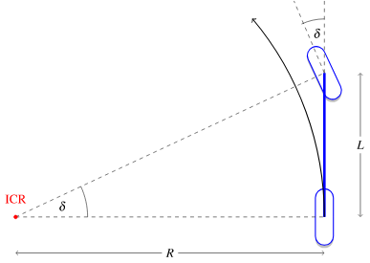Figure 1: The Kinematic model of a car

Methods

The research was conducted in a simulation written in the Python programming language. The simulation used a kinematic model of the car with the speed set to 30 km/h and 50km/h, as is common in most urban environments. The model assumed that the car implements a perfect longitudinal controller, hence the speed is constant. Each lateral control algorithm was implemented as a function which would return the needed steering angle at each step. To simulate a bus or truck, the length of the vehicle was set to 10 meters. Lateral control algorithms were implemented from various pieces of literature and from the *PythonRobotics* GitHub repository2,8-9.

The first lateral controller implemented was the pure pursuit controller. The pure pursuit controller selects a waypoint on the trajectory which is at a certain distance away from the car’s rear axle. Using the instantaneous center of rotation, the controller then calculates the needed steering angle for the car to reach the waypoint10.

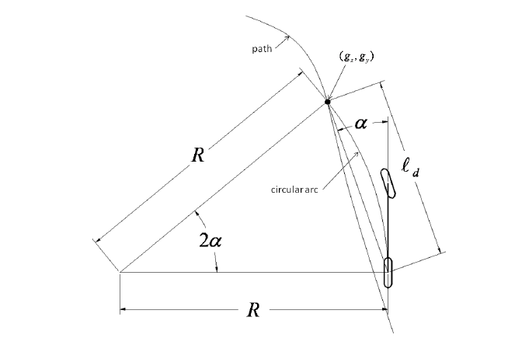Figure 2: The pure pursuit controller

The Stanley controller was also implemented (Hoffmann et al., 2007). This controller keeps the wheels aligned by setting the steering angle to the heading error, while using a nonlinear feedback function of the crosstrack error and velocity to mitigate the crosstrack error9.

The first new controller that was implemented was a combined pure pursuit and stanley controller. The stanley controller can effectively follow roads with a moderate curvature, however it takes a long time to resolve a crosstrack error and return to the trajectory. The hybrid controller therefor uses stanley control when the crosstrack error is within an acceptable boundary, and when the crosstrack error becomes too large it uses pure pursuit control to quickly return to the trajectory.

The last controller implemented is a stanley controller which is adjusted to use the heading of a point in front of the car instead of the heading of the trajectory right next to the car. In reality, there will be a slight delay between the steering angle being set and the wheels turning, and so the car may miss the heading, and this effect will be felt if the car is travelling at a high speed. Also, when going round tight turns, being able to start turning early will help the controller.

The controllers were all tested for a trajectory in Figure 2. This trajectory involves multiple tight turns and navigation round a whole roundabout, half of a roundabout and three quarters of a roundabout. Points on the trajectory were interpolated finely so that the car could always find an accurate point to follow.

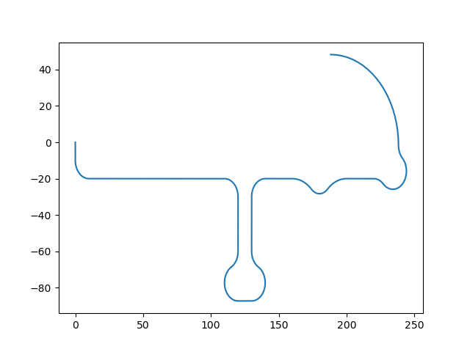**Figure 3.** The trajectory for the bus.

The lateral controllers were evaluated on multiple data points. Firstly, the crosstrack error and the crosstrack error from the rear of the vehicle were compared. This is to judge how well the controller can follow the given trajectory. Secondly, the steering angle and the change of steering angle were also investigated. For large, heavy vehicles, having a large steering angle is risky as the vehicle may tip over. Also, the steering angle change is important, as having large sudden changes in steering angle will reduce comfort and compromise safety.

Results and Discussion

The simulation was carried out on the vehicles at speeds of 50 km/h and 30 km/h.

Turning and straight track course

This course involved three straight segments and two turns.

50 km/h

Conclusion

For the 30km/h test, the stanley with lookahead and stanley controllers had the largest crosstrack error . The pure pursuit and stanley with lookahead controllers had the largest rear crosstrack error. The rear crosstrack error was lower than the front crosstrack error for most of the controllers (Figure 3). For the steering angle change, the hybrid stanley with pure pursuit, stanley and stanley with lookahead controllers had large changes in steering angle. The pure pursuit controller had a much lower change in steering angle (Figure 4). Overall, although the pure pursuit controller had one of the highest rear crosstrack errors, the frontal crosstrack error was low and the change in steering angle was also low, and so it has the best performance at 30 km/h.

For the 50km/h test, the stanley and stanley with lookahead controllers showed the largest crosstrack error, and the stanley with lookakead and pure pursuit controllers showed the largest crosstrack error from the rear. The overall crosstrack error from the rear for all controllers was also quite low(Figure 5). In terms of the steering angle change, the stanley with lookahead and normal stanley controllers show a lot of large changes in steering angle. The hybrid controller showed lower changes of steering angle, but the pure pursuit controller had very low changes in steering angle (Figure 6). Therefore the pure pursuit controller performed best for 50km/h, as it had a low crosstrack error and no excessive steering.

Overall, the pure pursuit controller has shown itself to be a strong choice for longer vehicles in an urban environment. Controllers involving stanley control were shown to have large changes in steering angle, making them not such a good choice as this would impact safety and comfort. However, a large crosstrack error remains for the pure pursuit controller. The controller could be improved upon by integrating it with a longitudinal controller, so that a bus would slow down while going round a bend. Predictive controllers, such as model predictive control, could be investigated, as they integrate lateral control with longitudinal control, hence would make a good choice for a bus or truck which needs to slow down while going round a bend.

Acknowledgements

I would like to thank my parents for funding a course for me to learn more about this subject as well as providing me with support while I was developing the simulation and writing the research. I would like to thank my father specifically for suggesting to consider how other types of vehicle might perform instead of investigating an ordinary car.

References

References and notes in the text should be indicated by superscript numerals that run consecutively through the paper and appear after any punctuation. Authors should ensure that all references are cited in the text and vice versa. Authors are expected to check the original source reference for accuracy. References should follow the American Chemical Society guidelines (The ACS Style Guide; [accessible here](http://pubs.acs.org/doi/pdf/10.1021/bk-2006-STYG.ch014)). In-text citation should be OUTSIDE of punctuation. See our prior issues for guidance.

1. Paden, B., Cap, M., Yong, S., Yershov, D. and Frazzoli, E., 2016. A Survey of Motion Planning and Control Techniques for Self-Driving Urban Vehicles. *IEEE Transactions on Intelligent Vehicles*, 1(1), pp.33-55.
2. Hoffmann, G. M.; Tomlin, C. J.; Montemerlo, M.; Thrun, S. Autonomous Automobile Trajectory Tracking for Off-Road Driving: Controller Design, Experimental Validation and Racing. In *2007 American Control Conference*; IEEE, 2007.
3. Eisele, D.; Peng, H. *VEHICLE DYNAMICS CONTROL with ROLLOVER PREVENTION for ARTICULATED HEAVY TRUCKS*.
4. Campbell, M.; Egerstedt, M.; How, J. P.; Murray, R. M. Autonomous Driving in Urban Environments: Approaches, Lessons and Challenges. *Philos. Trans. A Math. Phys. Eng. Sci.* **2010**, *368* (1928), 4649–4672. <https://doi.org/10.1098/rsta.2010.0110>.
5. Urmson, C.; Anhalt, J.; Bagnell, D.; Baker, C.; Bittner, R.; Clark, M. N.; Dolan, J.; Duggins, D.; Galatali, T.; Geyer, C.; Gittleman, M.; Harbaugh, S.; Hebert, M.; Howard, T. M.; Kolski, S.; Kelly, A.; Likhachev, M.; McNaughton, M.; Miller, N.; Peterson, K.; Pilnick, B.; Rajkumar, R.; Rybski, P.; Salesky, B.; Seo, Y.-W.; Singh, S.; Snider, J.; Stentz, A.; Whittaker, W. “red”; Wolkowicki, Z.; Ziglar, J.; Bae, H.; Brown, T.; Demitrish, D.; Litkouhi, B.; Nickolaou, J.; Sadekar, V.; Zhang, W.; Struble, J.; Taylor, M.; Darms, M.; Ferguson, D. Autonomous Driving in Urban Environments: Boss and the Urban Challenge. In *Springer Tracts in Advanced Robotics*; Springer Berlin Heidelberg: Berlin, Heidelberg, 2009; pp 1–59.
6. Kong, J.; Pfeiffer, M.; Schildbach, G.; Borrelli, F. Kinematic and Dynamic Vehicle Models for Autonomous Driving Control Design. In *2015 IEEE Intelligent Vehicles Symposium (IV)*; IEEE, 2015.
7. Mouratidis, K.; Cobeña Serrano, V. Autonomous Buses: Intentions to Use, Passenger Experiences, and Suggestions for Improvement. *Transp. Res. Part F Traffic Psychol. Behav.* **2021**, *76*, 321–335. <https://doi.org/10.1016/j.trf.2020.12.007>.
8. Sakai, A.; Ingram, D.; Dinius, J.; Chawla, K.; Raffin, A.; Paques, A. PythonRobotics: A Python Code Collection of Robotics Algorithms. *arXiv [cs.RO]*, 2018.
9. Snider, J. M. Automatic steering methods for autonomous automobile path tracking https://www.ri.cmu.edu/pub_files/2009/2/Automatic_Steering_Methods_for_Autonomous_Automobile_Path_Tracking.pdf (accessed Jan 8, 2022).

Authors

Artyom Boyarov is a student at Whitgift School studying the International Baccalaureate. Artyom is very passionate about self-driving cars, computer architecture, operating systems and developing innovative solutions to climate change. Artyom would like to study a major in electrical or computer engineering and a minor in chemical engineering. Beware of his hubris.

General guidelines:

1- Please read these instructions carefully and follow the suggested style.

2- If all contributors are from the same institution (high school) in that case no need to number each contributor.

3- Leave a space after corresponding author email and main text.

4- There is 8 pt after text spacing after each title. Please make sure to keep the template as it is.

5- Headings, such as Abstract, Introduction, etc, must be bold, Arial, 14 size with 8 pt after text spacing (Style 1).

6- The body text font size is 10 Arial and single spaced (Style Normal)

7- The following headings must be included: Abstract, Keywords, Introduction, Results and Discussion, Conclusion, Acknowledgements, References, Authors. Other subsections are optional and can be added by following the guidelines.

8- If you would like to add subheadings, their title should be italized and bold in 12 font size with 8 pts after text spacing (Style 2).

9- Figures and tables can be in single column or double column. Figures and tables should be located at the top or bottom of the column following their first citation in the text (unless they are equations, which appear in the flow of the text). **All figures, images, and formulas need to be emailed as a separate attachment saved in .png format in high resolution.**

10- Table caption should be placed on top of the table (see sample):

**Table 1.** Caption of the table (font 11, with 8 pts after text spacing), keep only first word capitalized, and end with a period.

P.S. Tables must be referred in the article text with their numbers (see examples in common mistakes section below)

11- Figure caption should be placed after the figure graph (see sample)

**Figure 1.** Caption of the figure (font 11, with 8 pts after text spacing), keep only first word capitalized, and end with a period.

P.S. Figures must be referred in the article text with their numbers (see examples in common mistakes section below)

12. When ready, research article should be named as “**LastName_FirstName**” or “**LastName_LastName_LastName**” (if multiple authors) and submitted as single pdf. Any images should be included in article as well as the originals should be attached to email separately in high resolution and .png format.

13. You may suggest reviewers for your paper. Please submit the following page with your paper.

**Common Mistakes:**

1. Include the School Address in addition to School Names on the article,

2. Include an email address of the corresponding author (one email) after the address on the article.

3. Keyword selection: The first two keywords MUST be from the [category list](https://terra-docs.s3.us-east-2.amazonaws.com/IJHSR/IJHSR_categories.pdf). The first keyword should the general category and the second keyword should be subcategory, and other three should your own keywords. There should not be more than FIVE keywords.

4. All Tables and Figures MUST be referred in the text, at least like in parenthesis where the table figure data is discussed (Table XX).

5. Table and Figure names in texts must start with capitalized letters. Eg. As shown in Table 3, cats are better than dogs, but Figure 1 shows that dogs can be as cute as cats. There is other evidence (Table 4) which may suggest that fish in a tank can be a good home pet for kids.

6. Reference numbers in text MUST be placed after period or comma and MUST be superscript. Also, when continuous numbers are used as reference in the text, instead of putting all in, they should be places in using dash, such as 3-5 (instead of 3, 4, 5).

7. If you are not sure, please check our published articles as you prepare your manuscript for guidance.

Reviewer Suggestions

IJHSR requires authors to recommend 3 - 6 qualified reviewers in the same discipline the research is conducted in.

Please provide the first and last name, institution, city/state/country of institution, and email address for each suggested reviewer.

Recommended Reviewers must:

* Be fluent in English
* Be from different institutions (limited to 1 person per institution)
* Have not collaborated with the author’s work
* Not be affiliated with the author’s institution
* Should have PhD in the research area or more than ten years of experience in the field

First Name and Last Name Institution City/State/Country Email

1.

________________________________________________________________________________

2.

________________________________________________________________________________

3.

________________________________________________________________________________

4.

________________________________________________________________________________