

Distributed Systems

Assignment

TU856
BSc in Computer Science

Artyom McNiff
C20394301

School of Computer Science
Technological University, Dublin

23/11/2023
Declaration

I hereby declare that the work described in this dissertation is, except where otherwise stated, entirely my own work and has not been submitted as an exercise for a degree at this or any other university.

Signed:

Artyom McNiff____________________
Artyom McNiff

12/11/2023

Application Architecture
The program uses client/server architecture, with a server that maintains a list of multiple clients. Clients take turns sending messages to the server. When the server receives a message, depending on the message it sends the received message to the other clients. It achieves this via multi-threading. Uses sockets to connect clients with the server.

The main thread in the server allocates individual threads to incoming clients. The thread allocated to each individual client then handles all subsequent interaction between client and server via the thread’s run method. The main thread passes a reference to the socket that was opened for the associated client.
The threads are sometimes put to sleep to allow other threads to be executed. When the sleeping time expires, the sleeping thread returns to a ready state, waiting for the processor.

Setup, code directory structure, screenshots
All files are stored in the src folder.
Steps To Run
Compile the following files:


Open a command prompt. To run the server, run the following command:
To run the client, open a command prompt. Run the following command:
Afterwards, to join as a seller, choose the appropriate command according to the menu prompt. The same applies to join as a buyer.
To add more clients, open a command prompt for each client.
The starting output of the server will look like this:
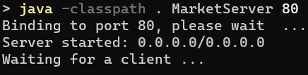

The starting output when joining as a seller will look like this:
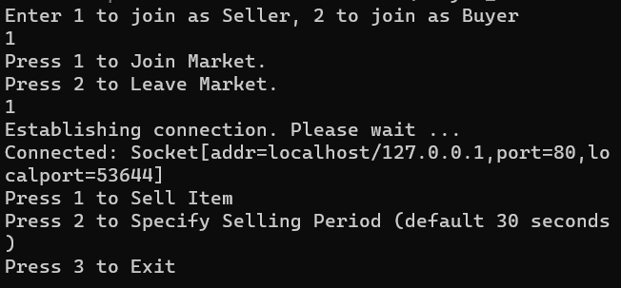

The starting output when joining as a buyer will look like this:
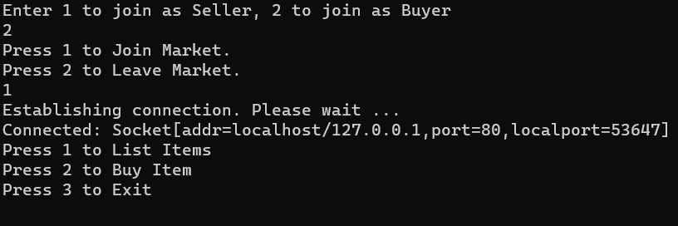

Alternative Design
Java Remote Method Invocation (RMI)
A distributed object model for Java. Lets you create distributed applications in Java. Allows an object to invoke methods of remote Java objects running on another Java Virtual Machine (JVM). Remote interfaces are defined in the Java language.
RMI uses object serialization to marshal and unmarshal parameters. Object serialization is concerned with the flattening and data representaiton of any single object or tree of objects that may need to be transmitted in a message or stored on a disk.
Marshalling is the processing of taking a collection of data items and assembling them into a form suitable for transmission in a message. It works by translating structured data items and primitive values into an external data representation.
Unmarshaling is the process of disassembling them on arrival to produce an equivalent collection of data items at the destination. Consists of the generation of primitive values from their external data representation and the rebuilding of data structures.
This could have been used instead of writing information to text files.
Importing the java.rmi package allows a client/server relationship to form.
For the server process, the server class has a main method that creats an instance of the remote object implementation, exports the remote object, and then binds that instance to a name in a Java RMI registry.
The class that contains the main method could be the class itself or another class. The main method would create and export a remote object, and then regsiter the remote object with a Java RMI registry.
For the client process, the client program obtains a stub for the registry on the server’s host, looks up the remote object’s stub by name in the registry, and then invokes the sayHello method on the remote object using the stub.
The client first obtains the stub for the registry by invoking LocateRegistry.getRegistry method with the hostname specified on the command line. If no hostname is specified, then null is used as the hostname indicating that the local host address should be used.
Next, the client invokes the remote method lookup on the registry stub to obtain the stub for the remote object from the server’s registry.
Finally, the client invokes the method on the remote object’s stub, which causes the following:
The client-side runtime opens a connection to the server using the host and port information in the remote object’s stub and then serializes the call data. The server-side runtime accepts the incoming call, dispatches the call to the remote object, and serializes the result to the client. The client-side runtime receives, deserializes and returns the result to the caller. The response message returned from the remote invocation on the remote object is then printed.

