## Group Members:

C20394301 Artyom McNiff

C20730175 Conan O’Hara

## Domain Types

|  |  |  |  |
| --- | --- | --- | --- |
| Domain Type Name | Type Definition | Reason Introduced | Example |
| ID | NUMERIC (7) | For attributes that are identifiers | bookid in bookingreceipt |
| Number | NUMERIC (7) | For attributes which represent generic numbers | numberofcust in bookingreceipt |
| Date | DATE | For attributes which represent dates | startdate in employmentdetails |
| Minutes | NUMERIC (7) | For attributes which require the number to be specified as minutes | durationspent in bookingreceipt |
| Bill | FLOAT (7) | Represents the restaurant bill | bookbill in bookingreceipt |
| Address | VARCHAR (30) | For attributes that represent addresses | custaddress in customer |
| Phone | VARCHAR (30) | For attributes that represent phone numbers | custphonenumber in customer |
| Name | VARCHAR (30) | For attributes that represent the names of customers and employees | custname in customer |
| Email | VARCHAR (30) | For attributes that represent an email address | bcustemail in customerbooking |
| Age | NUMERIC (3) | For attributes that represent the age of a person | Bcustage in customerbooking |
| Description | VARCHAR (30) | For attributes which represent a simple description | tabletype in restauranttable |
| Time | DATE | Represents the time the customer books a table | bookingtime in bookingreceipt |

## Major Decisions

Have a section per decision. This can include decisions such as where to place particular attributes, whether to have an entity, what type of relationship to use. Anything you had to discuss you should include in this section.

Entities

bookingreceipt

Two attributes are of interest here, timeduration and durationspent. timeduration specifies the amount of time the customer plans to spend, whereas durationspent specifies how much time the customer ends up actually spending in the restaurant. This is done in order to calculate the fine if a customer spends too long in the restaurant, as they cannot book for longer than two hours. timeduration and durationspent are also presented in integer format, in order to make it feasible to calculate the fine. Incidentally, the fine is calculated using an SQL update query.

customer and customerbooking

We decided to separate the customer making the booking and the customers attending the restaurant into two separate tables, as it is possible to be an accompanying guest to the restaurant to the person making the booking.

Attributes

bcustage has a precision of 3, as people can’t (yet) live to be a thousand years old. All other number data types have an arbitrary precision of 7, and all varchar2 data types have an arbitrary precision of 30.

# Present ERD

Screenshot of Logical Model

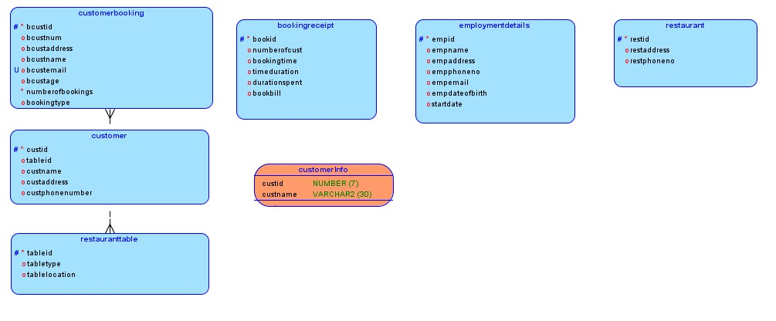

Screenshot of Physical Model

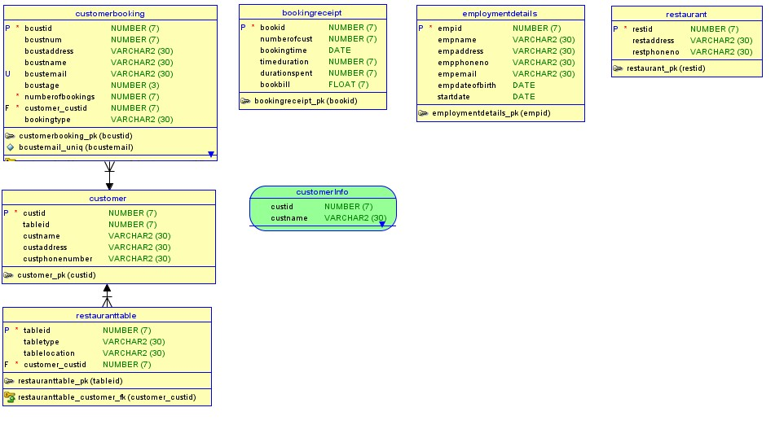

Unique Constraints

