Load using tJavaRow

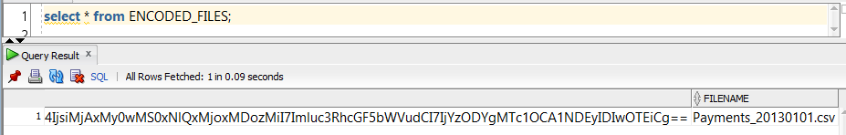

Load using routines

