
STUDENT PROGRESS REPORT — SEMESTER 1 (TERMS 1&2) — Period: August 18 - December 20, 2025
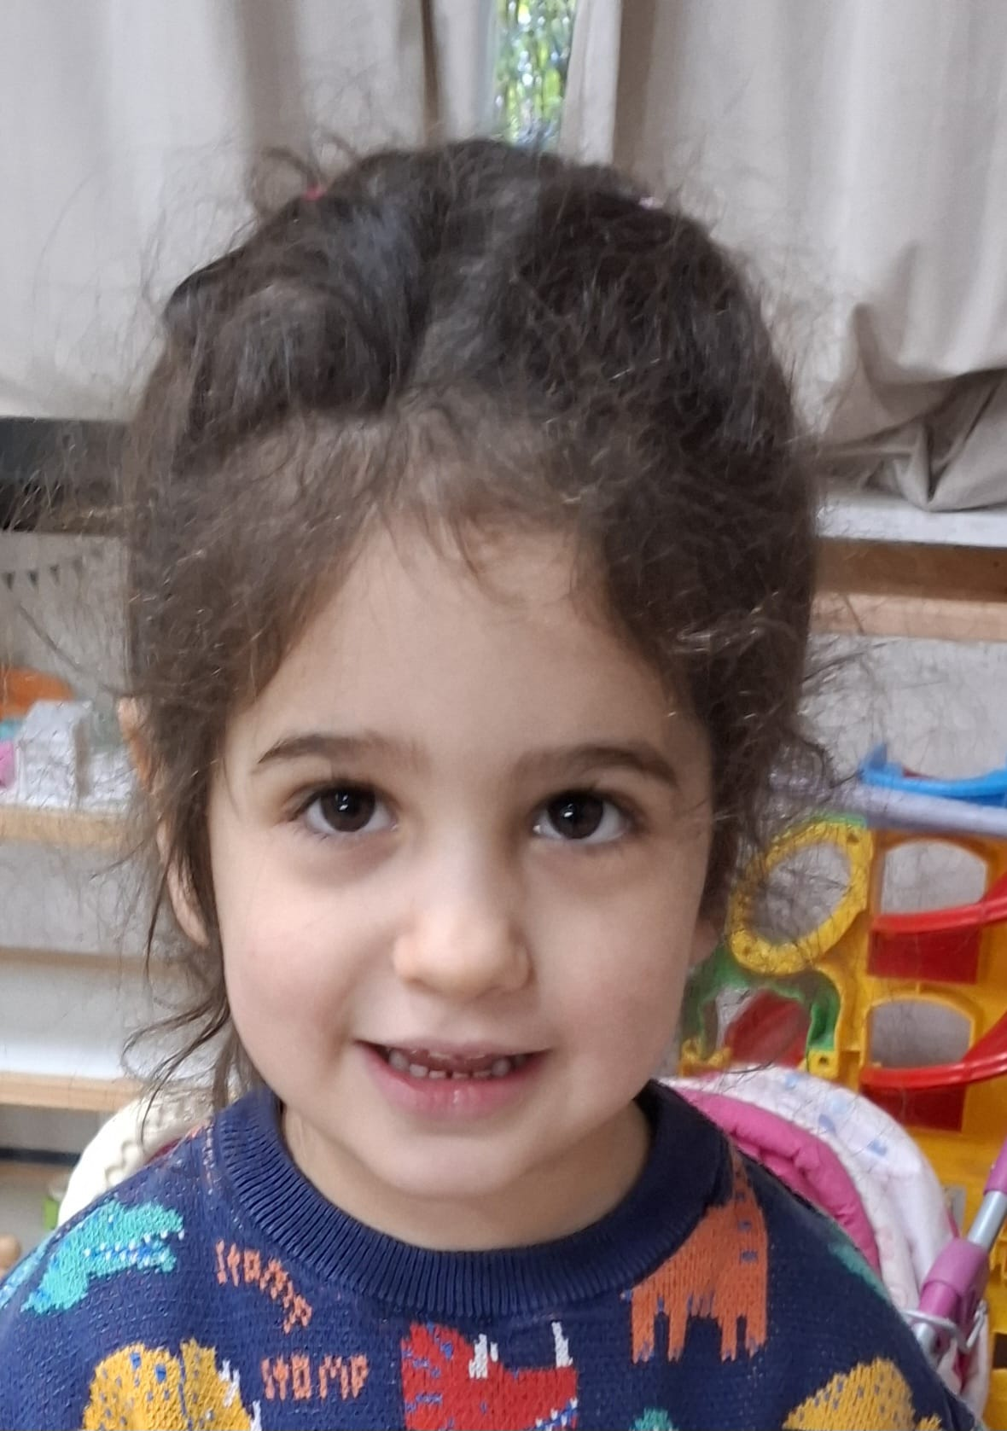 | STUDENT INFORMATION
 | Full Name | Adriana Martinez Kudari
 | Name Used | Adriana
 | Grade Level | 0/1
 | Date of Birth | 19-07-2022

TEACHER INFORMATION
CORE PROGRAMME | Classroom teacher | Ms Carin
CORE PROGRAMME | English | Ms Carin
CORE PROGRAMME | Math | Ms Carin
CORE PROGRAMME | Science | Ms Carin
CORE PROGRAMME | Social Studies | Ms Carin/Ms Natalia
CORE PROGRAMME | Dutch | Ms Carin
CORE PROGRAMME | Literature | Ms Carin/Ms Natalia
CORE PROGRAMME | Mental Math | Ms Carin
CORE PROGRAMME | Art | Ms Tetiana
CORE PROGRAMME | Drama | Ms Natalia
CORE PROGRAMME | Jiu Jitsu | Mr Sam
PROFESSIONAL TRACKS | STEAM, Robotics | Mr Roman
PROFESSIONAL TRACKS | CAD, Music (Choir) | Ms Arina
PROFESSIONAL TRACKS | CAD, Music (Piano) | Ms Arina

School Mission Statement

OUR MISSION
At TISA School, we empower each student to achieve academic and holistic excellence, develop their natural talents, and become globally-minded citizens who are socially responsible and successful.

STATEMENT
Tisa empowers each student to
- Respect themselves and others;
- Develop a lifelong love of learning;
- Contribute as a globally-minded citizen to achieve individual academic and holistic excellence.

OUR VISION
- We inspire student learning:
- Through a dynamic and caring environment;
- With innovative and effective instructional strategies;

- In collaborative relationships;

OUR VALUES
- Respect
- Integrity
- Courage
- Curiosity
- Care

Learner Profile
Grading Key:
⭐⭐⭐ - Mostly
⭐⭐- Usually
⭐- Rarely

PYP Criteria | Student Assessment (Comment from teacher)
Communicator | ⭐⭐⭐
Thinker | ⭐⭐⭐
Inquirers | ⭐⭐⭐
Courageous | ⭐⭐⭐
Knowledgeable | ⭐⭐⭐
Principled | ⭐⭐⭐
Caring | ⭐⭐⭐
Open-minded | ⭐⭐⭐
Balanced | ⭐⭐⭐
Reflective | ⭐⭐⭐

Work Habits
Criteria (Student …) | Assessment
Displays enthusiasm in the classroom | ⭐⭐⭐
Exhibits self-discipline | ⭐⭐⭐
Participates in class discussions | ⭐⭐⭐
Follows class procedures and instructions | ⭐⭐⭐
Interacts well with peers | ⭐⭐⭐
Is attentive during classes | ⭐⭐⭐
Follows directions | ⭐⭐⭐
Is polite and courteous | ⭐⭐⭐
Is neatly dressed and follows dress code | ⭐⭐⭐
Independently works during self-study sessions | ⭐⭐⭐
Follows academic integrity | ⭐⭐⭐

% | Mark | Description | Description (SKILLS)
100-98 | A+ | Exceptional | The student is highly skilled in demonstrating their understanding through different contexts. The student is able to teach others with accuracy.
97-93 | A | Outstanding
92-90 | A- | Excellent
89-87 | B+ | Very good | The student is competent in demonstrating their understanding through different contexts. The student requires little or no guidance.
86-83 | B | Good
82-80 | B- | Above average
79-77 | C+ | Average | The student has made some progress in their understanding. Attempts are made to apply understanding in different contexts. The student requires some teacher or peer guidance.
76-73 | C | Satisfactory
72-70 | C- | Minimally satisfactory
69-67 | D+ | Acceptable | The student demonstrates little or no understanding. The student needs clear direction and frequent support to develop their understanding.
66-63 | D | Deficient
62-60 | D- | Underperforming
59-0 | F | Unacceptable | The student demonstrates no understanding.

ATTITUDE TOWARDS LEARNING AT TISA
Emerging | Developing | Applying | Independent
The student has difficulty sustaining effort and motivation, requiring support from the teacher and their peers to remain on task. | The student shows motivation at times and requires some support from the teacher and peers to remain on task. | The student consistently shows motivation and sustained effort, sometimes supporting others. | The student is highly motivated and sustains effort even in challenging situations. The student encourages others frequently.

UNITS OF INQUIRY

Units of Inquiry
Unit of Inquiry 1
Transdisciplinary Theme | Who we are
Central Idea | Through play we learn more about ourselves, what we can do and build relationships
Key Concepts | Function, Form, and Perspective
Related Concepts | Identity, Similarities and Differences
Subject Integration | Math, English, Science, Social Studies,
Unit of Inquiry 2
Transdisciplinary Theme | Where we are in place and time
Central Idea | Previous generations help us understand the past
Key Concepts | Form, Causation and Connection
Related Concepts | Time, Continuity and Modification
Subject Integration | Social Studies, Science, English, English Literature, Dutch and Art

General Comment: Adriana is still in the process of adapting to her new school, and so far, this is going very well. Although she missed the first Unit of Inquiry (Who We Are), she has participated in Where We Are in Place and Time and is beginning to show understanding of how previous generations help us learn about the past. She is curious about the topics and enjoys exploring ideas across subjects such as Social Studies, English, Dutch, and Art. Adriana is very proud of her family and enjoys sharing this with others during class activities.
She is still a bit shy during group discussions, but with time and support, she will gain more confidence in expressing her ideas. Adriana is also gradually building positive relationships with her peers and teachers.
Overall, Adriana is a thoughtful and motivated learner. Her curiosity, growing understanding of the unit, and positive attitude toward learning and relationships show that she is making steady progress socially and academically.

Best regards,
Ms Carin
Attitude towards learning:

Core Programme

ENGLISH
ENGLISH - Term 1
Writing
Trace letters | ⭐⭐⭐
Match letters to pictures | ⭐⭐⭐
Write missing parts of letters | ⭐⭐⭐
Listen and write sounds they hear | ⭐⭐⭐
Correct pencil grip | ⭐⭐⭐
Reading
Listen to and recognise sounds | ⭐⭐⭐
Say the first sound they hear in a word | ⭐⭐⭐
Blend sounds together to make a full word | ⭐⭐⭐
Read simple words by themselves | ⭐⭐⭐
Match what they read to what it means | ⭐⭐⭐
Understands simple written text | ⭐⭐⭐
Speaking and listening
Listen carefully to instructions | ⭐⭐⭐
Responds to questions clearly | ⭐⭐⭐
Shares ideas or retell stories | ⭐⭐⭐
Uses new vocabulary in conversation | ⭐⭐⭐
Viewing and presenting
Talks about what they see in pictures | ⭐⭐⭐
Connects pictures to words or ideas | ⭐⭐⭐
Draws or uses pictures to share ideas | ⭐⭐⭐
Attitude towards learning:

ENGLISH - Term 2
Writing
Trace letters | ⭐⭐⭐
Listen to and write the sounds I hear | ⭐⭐⭐
Correct pencil grip | ⭐⭐⭐
Use sentence COPS (Capital letters, Organisation, Punctuation, Spacing) rules | ⭐⭐⭐
Reading
Segment simple words into sounds | ⭐⭐⭐
Read and understand a sentence | ⭐⭐⭐
Match what they read to what it means | ⭐⭐⭐
Blend sound together to make words | ⭐⭐⭐
Speaking and listening
Share ideas with peers | ⭐⭐⭐
Listen to and add to stories | ⭐⭐⭐
Talk clearly when telling a story to the class | ⭐⭐⭐
Viewing and presenting
Look carefully at pictures to understand ideas | ⭐⭐⭐
Talk about what they see in pictures | ⭐⭐⭐
Connect what they see to what they hear or read | ⭐⭐⭐
Teacher’s comment: Adriana is a bright and eager learner who is steadily settling into the school routine. Although she missed the first term, she still shows a great understanding of the topics covered when given the needed support. She already has a good grasp of letter and phonics recognition and is beginning to show signs of blending. She is still developing her writing and fine motor skills, which will improve in good time, and with continued guidance, she is sure to make excellent progress.

Best regards,
Ms Carin
Attitude towards learning:

MATH
MATH - Term 1
Numbers and Counting
Recognise and trace numbers up to 50 | ⭐⭐⭐
Count objects or verbally from 1–10 and beyond | ⭐⭐⭐
Match objects to numerals | ⭐⭐
Shapes and Patterns
Recognize and name basic shapes | ⭐⭐⭐
Identify and extend simple patterns | ⭐⭐⭐
Sort objects by shape and color and understand simple spatial relationships | ⭐⭐⭐
Attitude towards learning: Applying

MATH - Term 2
Measurement, Comparison and Comparing Quantities
Compare and describe objects as big or small | ⭐⭐
Identify and compare objects as long or short | ⭐⭐⭐
Arrange objects or pictures from shortest to tallest | ⭐⭐⭐
Compare groups to show which has more, less, or if they are equal | ⭐⭐⭐
Spatial Awareness and Positional Language
Understands and uses words like above, below, next to, behind, in front | ⭐⭐⭐
Draw or place objects correctly to show spatial understanding | ⭐⭐⭐
Teacher’s comment: Adriana is just overcoming her adaptation period, but she is very bright and shows great interest in math. Although she missed Term 1, she demonstrates good understanding of the topics covered. She is still developing her fine motor and writing skills, as well as number recognition, and often needs guidance; however, with support, she is able to complete all tasks correctly and will become more independent in time.

Ms Carin
Attitude towards learning: Applying

SCIENCE
SCIENCE - Term 1
Light and Shadow, Sound
Understand that a shadow is formed when light hits an opaque object | ⭐⭐⭐
Understand that the shadow changes with the light source direction | ⭐⭐⭐
Explore how shadows change with object position | ⭐⭐⭐
Understand that sound is made by vibrations | ⭐⭐⭐
Test that sound is made by vibrations
Show interest in the idea of visualizing vibrations
Attitude towards learning:

SCIENCE - Term 2
Animals and Plants
Understand the basic needs of animals | ⭐⭐⭐
Distinguish between animals that eat plants, meat, or both | ⭐⭐⭐
Recognize animals that live nearby and their habitats | ⭐⭐⭐
Understand that plants need sunlight, water, and soil | ⭐⭐⭐
Understand how environmental changes affect plants | ⭐⭐⭐
Understand that plants can look different to survive in different places | ⭐⭐⭐
Teacher’s comment:
Adriana is very interested in science and enjoys exploring shadows, sound, and plants and animals. She shows some understanding of the topics and, with continued curiosity and practice, she is developing her confidence and knowledge.
Best regards,
Ms Carin
Attitude towards learning:

SOCIAL STUDIES
SOCIAL STUDIES - Term 1 Who we are: Our characteristics and interests make us who we are
Talk about their identity | ⭐⭐⭐
Choose between their favorite ways to play | ⭐⭐⭐
Can build relationships with classmates | ⭐⭐⭐
Can reflect on themselves | ⭐⭐⭐
Attitude towards learning:

SOCIAL STUDIES - Term 2 Where we are in place and time: Previous generations help us understand the past
Identify and name family members. | ⭐⭐⭐
Understand relationships between family members. | ⭐⭐⭐
Express what is unique about their family. | ⭐⭐⭐
Participate in group discussions about families.
Recognize that families can be similar or different.
Teacher’s comment: Adriana has made a good start in Social Studies since joining in Term 2. She shows some understanding of topics like talking about herself and her family and is beginning to participate in group discussions. With continued support and encouragement, she will build more confidence and develop her understanding further.
Attitude towards learning:

DUTCH
Dutch - Term 1
Introduction to Dutch - Written
Trace letters | ⭐⭐⭐
Match letters to pictures
Write missing parts of letters
Listen and write sounds they hear
Correct pencil hold
Introduction to Dutch - Oral
Listen to and recognise sounds | ⭐⭐⭐
Say the first sound they hear in a word | ⭐⭐
Blend sounds together to say a whole word | ⭐⭐
Read simple words by themselves | ⭐⭐
Match what they read to what it means

Dutch - Term 2
Introduction to Dutch - Written
trace letters | ⭐⭐⭐
use sentence COPS(Capital letters, Organisation, Punctuation, Spacing) rules | ⭐⭐
read and understand the sentence | ⭐⭐
listen and write sounds they hear | ⭐⭐
hold their pencil carefully
read simple words by themselves | ⭐⭐⭐
segment simple words | ⭐⭐
share their ideas with their friends | ⭐⭐
listen to their friends and add to ideas | ⭐⭐
talk clearly when they tell the story to the class
Teacher’s comment:

Kind Regards,
Ms Carin
Attitude towards learning:

LITERATURE
Literature - Term 1
Listening & Speaking
Listen and recall story events | ⭐⭐⭐
Show understanding of story order | ⭐⭐⭐
Connect emotions and friendship to the poem | ⭐⭐
Recognise key story and poem words | ⭐⭐⭐
Express understanding of the texts
Attitude towards learning:

Literature - Term 2
Listening, Comprehension & Speaking Skills
Recall details from the story | ⭐⭐⭐
Arrange story events in the correct order. | ⭐⭐⭐
Recall and recite a familiar rhyme | ⭐⭐⭐
Demonstrate understanding through drawing and verbal expression | ⭐⭐⭐
Teacher’s comment:

Best regards,
Ms Carin
Attitude towards learning:

MENTAL MATH
MENTAL MATH - Term 1
Name parts of the abacus and what it is used for | ⭐⭐
Recognise numbers up to 9 on the abacus | ⭐⭐
Count objects and show it on the abacus using correct finger placement | ⭐
Add and subtract numbers up to 4 on the abacus using correct finger placement | ⭐
Use mental abacus skills with numbers up to for | ⭐
Attitude towards learning:

MENTAL MATH - Term 2
Abacus Knowledge | ⭐⭐⭐
Number Recognition | ⭐⭐
Counting Objects | ⭐⭐
Simple Addition/Subtraction | ⭐⭐
Mental Visualization with Abacus | ⭐
Teacher’s comment:

Best regards,
Ms Carin
Attitude towards learning:

VISUAL ARTS
VISUAL ARTS - Term 1
Can copy, recognise, and name different types of lines (straight, wavy, zigzag, curly) | -
Can combine lines to create and identify basic shapes | -
Understands the difference between geometric and organic shapes and uses them in artwork | -
Can observe real objects and represent basic form, size, and simple details | -
Attitude towards learning: Developing

VISUAL ARTS - Term 2
Can draw simple objects such as a tree, lantern, or animal | ⭐⭐
Knows the main colours of the rainbow and can recognise them in artworks | ⭐⭐
Can name and use warm and cold colours in painting | ⭐
Can mix primary colours to create simple secondary colours with guidance | ⭐
Knows how to use different art materials such as watercolours, gouache, soft pastels, and oil pastels | ⭐⭐
Teacher’s comment:
Adriana shows her interest in art. Since she is still quite young, she needs more time to complete her work, and we will continue helping her develop patience and confidence in her skills
Best regards,
Ms Tetiana
Attitude towards learning: Developing

DRAMA
DRAMA - Term 1
Body expression | Please, act given animals using the body expression
Reciting poetry | Please, recite nursery rhymes (ba-ba black sheep, Hickory Dickory dock) loudly and clearly
Imagination | Please “turn” pencil into something else
Attitude towards learning:

DRAMA - Term 2
Rehearsal and staging |  | ⭐⭐
Performing on the stage |  | ⭐⭐⭐
Reciting poetry “Hug or war” S. Silverstein |  | ⭐
Teacher’s comment:Adriana is taking her very first steps in Drama, and it has been a joy to watch her explore movement, music, and imaginative play. Performing on stage was a very big achievement for her, and she showed great bravery and enthusiasm. Adriana is beginning to engage with activities with curiosity and confidence, and this experience marks a wonderful start to her Drama journey.

Best regards,
Ms Natalia
Attitude towards learning: Applying

JIU JITSU
JIU JITSU - Term 1
⭐⭐
⭐⭐
⭐⭐⭐

Attitude towards learning:

JIU JITSU - Term 2
⭐
⭐⭐⭐
⭐⭐
Teacher’s comment:

Best regards,
Mr Sam
Attitude towards learning:

PROFESSIONAL TRACKS

TRACK 1 — STEAM

ROBOTICS
ROBOTICS - Term 1
Parameters | Description | Result
Knowledge of parts | Knows the names of parts very well. | ⭐
Ability to assemble | Excellent assembly, with no teacher’s help | ⭐
Teamwork | Gets along well with a teammate, helps a teammate if necessary | ⭐
Attitude towards learning:

ROBOTICS - Term 2
Parameters | Description | Result
Can assemble according to instructions | Excellent assembly, with teacher’s help | ⭐⭐
Ability to assemble | Excellent assembly, with no teacher’s help | ⭐⭐
Teamwork | Gets along well with a teammate, helps a teammate if necessary | ⭐
Teacher’s comment:
Attitude towards learning:

TRACK 2 — CAD

MUSIC, PROFESSIONAL CHOIR
Term 1
Creation and exploring of sound | The ability to hear sound and reproduce it clearly. Simple vocal exercises. Legato and staccato performance. | ⭐⭐⭐
Breathing technique | Ability to perform basic breathing exercises, elements of breathing exercises | ⭐⭐⭐
Diction and articulation | The ability to fully reproduce all consonant sounds clearly, all elements of speech therapy exercises. | ⭐⭐⭐
Performance and stage attitude | High concentration and focus on stage. Vivid performance and emotional response to music of various content. | ⭐⭐⭐
Attitude towards learning: Applying

Term 2
Creation and exploration of sound | The ability to distinguish between high and low pitches. Practice basic vocal exercises to produce clear and steady tones. | ⭐⭐⭐
Breathing technique | The introduction to basic breathing concepts. Practice calm nasal inhalation and gentle exhalation without raising shoulders. Performing basic breathing exercises. | ⭐⭐⭐
Diction and articulation | Focus on clear pronunciation of vowels and consonants. Practice articulation exercises through games and speech drills. | ⭐⭐⭐
Performance and stage attitude | Ability to stand in formation, walk on stage, and face the audience. Developing initial comfort in stage settings. | ⭐⭐⭐
Teacher’s comment: Adriana is very active in music lessons, she has good musical abilities. Successfully masters breathing exercises, as well as vocal warm-up exercises. quickly masters new musical skills, such as rhythm, melody and movement to music, and has a very good emotional response to music of various contents.
Recommended to listen to classical music of various genres.

Best regards,
Ms Arina
Attitude towards learning: Applying

Tests and Exams Results

Term 1
Date | Title of test/exam | Subject | Grade (result)
10/2025 | Assessment of term skills | English | ⭐⭐⭐
10/2025 | Assessment of term skills | Math | ⭐⭐⭐
10/2025 | Assessment of term skills | Science | ⭐⭐
10/2025 | Assessment of term skills | Social Studies | ⭐⭐⭐
10/2025 | Assessment of term skills | Dutch | ⭐⭐⭐
10/2025 | Assessment of term skills | Literature | ⭐⭐
10/2025 | Assessment of term skills | Mental Math | ⭐⭐⭐
10/2025 | Assessment of term skills | Art | ⭐⭐⭐
10/2025 | Assessment of term skills | Drama
10/2025 | Assessment of term skills | Choreography | ⭐⭐⭐
10/2025 | Assessment of term skills | Jiu Jitsu | ⭐⭐
10/2025 | Assessment of term skills | STEAM, Robotics | ⭐
10/2025 | Assessment of term skills | CAD, Music (Choir) | ⭐⭐⭐

Term 2
Date | Title of test/exam | Subject | Grade (result)
12/2025 | Assessment of term skills | English | ⭐⭐⭐
12/2025 | Assessment of term skills | Math | ⭐⭐⭐
12/2025 | Assessment of term skills | Science | ⭐⭐⭐
12/2025 | Assessment of term skills | Social Studies | ⭐⭐⭐
12/2025 | Assessment of term skills | Dutch | ⭐⭐⭐
12/2025 | Assessment of term skills | Literature | ⭐⭐
12/2025 | Assessment of term skills | Mental Math | ⭐⭐⭐
12/2025 | Assessment of term skills | Art | ⭐⭐⭐
12/2025 | Assessment of term skills | Drama | ⭐⭐
12/2025 | Assessment of term skills | Choreography | ⭐⭐⭐
12/2025 | Assessment of term skills | Jiu Jitsu | ⭐⭐⭐
12/2025 | Assessment of term skills | STEAM, Robotics | ⭐⭐
12/2025 | Assessment of term skills | CAD, Music (Choir) | ⭐⭐⭐

General Report

Parent's Reflection

Student’s Reflection

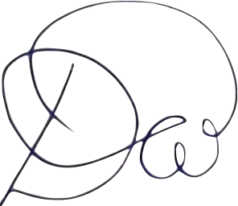  __________________  Sofia Dubenskaia  Classroom Teacher | 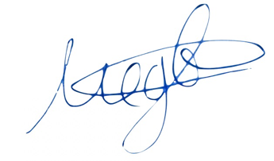  __________________  Karina Medvedeva  Head of School

