>> Bank of America Merrill Lynch

>> Equity volatility trends and global derivative trading ideas

>> 2010/03/23

This report is very informative, and requires a lot of related readings to get to understand its ideas.

Implied Volatility: <http://en.wikipedia.org/wiki/Implied_volatility>

Volatility Smile: <http://en.wikipedia.org/wiki/Volatility_smile> (Which includes “Term structure of volatility”)

Greeks: <http://en.wikipedia.org/wiki/Greeks_(finance>)

Volatility Skew: <http://www.investopedia.com/terms/v/volatility-skew.asp>

Black-Scholes model: <http://en.wikipedia.org/wiki/Black%E2%80%93Scholes>

Stochastic model: <http://en.wikipedia.org/wiki/Stochastic_volatility>

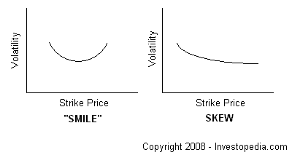

The difference in implied volatility (IV) between out-of-the-money, at-the-money and in-the-money options. Volatility skew, which is affected by sentiment and the supply/demand relationship, provides information on whether fund managers prefer to write calls or puts.

Also known as "vertical skew".

A situation where at-the-money options have lower IVs than out-of-the-money options is sometimes referred to as a volatility "smile", due to the shape it creates on a chart (as above). In markets such as the equity markets, a skew occurs because money managers usually prefer to write calls over puts.

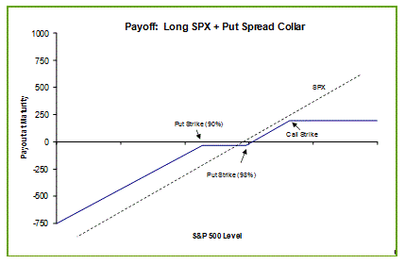

General note for the US volatility part of reading:

There are 2 kinds of volatility: 1. Historical volatility 2. Implied volatility

Although implied volatility is related to historical volatility, however they are distinctive. Historical volatility is a direct measure of the movement of the underlying’s price (realized volatility) over recent history. Implied volatility, in contrast, is determined by the market price of the derivative contract itself, and not the underlying.

Implied volatility might be significantly impacted by maturity and price of derivatives. Because people have different interests in derivatives with different maturity and price, therefore different level of demand & supply will cause volatility swing.

Term structure of volatility is a common way to represent the implied volatility, it is usually a 3D surface, with x-axis: DTM (day to maturity), y-axis: Price, z-axis: Vol. And by specify certain price or maturity, the surface could be sliced into a 2D curve. All charts in this paper only show 2D charts, because it is much easier to understand.

The first part of report analysis the characteristics of recent volatility movement in US market, the major trend is VIX down and SPX up. Meanwhile because short term derivatives has very high volatility, which means holding short term instead of long term derivatives might have higher exposure to the risk of loss. So the major adjustment of the position is to keep "rolling up the put", which means sell the short term options and buy long term options. In detail, the paper present 2 strategies: 1. BofAML Flex Hedge 2. Put-spread collar.

Then the report compare the efficiency of BofAML Flex Hedge and Put-spread collar. By analyzing the historical cases (4 cases, which Jenny already provide great summary in her post) and conclude the criteria that Flex Hedge could under-perform or out-perform. And they suggest current situation is better to use Flex Hedge to achieve higher efficiency.

Jenny’s review:

This research has two important part the first part shows the benefits of rolling longer dated puts in the current environment. The BofAML explains Flex Hedge strategy that is rolls a 12-month put every three months and offsets the cost by selling a 3-month out-of-the-money call and put that are allowed to expire. However, being long vega and short gamma, the Flex Hedge performs better in systemic market shocks vs. short-term transient sell-offs.

To illustrate, the research shows performance of flex hedge and it risks of being both short gamma and long vega in 4 case studies.

Case 1: If short term crisis happened. They give example of the 9/11 terrorist attacks that extremely type shock caused large and fast move in S&P 500. As a result, the long vega position of the Flex Hedge did not help cushion losses of being short gamma. This leads to conclude that the Flex Hedge will underperform in an extreme type shock where risk is concentrated in the short-term.

Case2: Long term crisis (Ex.credit crisis during 2008,it takes long term than case 1). For example, The bankruptcy of Lehman Brothers and the intensifying of the credit crisis caused both large and fast down moves in theS&P500. This time the entire implied vol curve shifted upwards over this period, unlike the 9/11 crisis. As a result, the long vega position cushioned the losses from being short gamma and the Flex Hedge performed mostly in-line with the put-spread collar. Because there were losses in the Flex Hedge due to the short gamma position but this time longer-dated implied vols moved up as the risks of the credit crisis were more systematic, far-reaching, and longer dated.

Case3. When market was rallying significantly ( it has trend) . This period maket has low volatility causing the Flex Hedge to underperform via its long vega position. So, It’s not useful to use Flexhedge strategy in this kind of market.

Case4 Sideways market-> mkt has no direction,->high volatility.These conditions are optimal for the flex and are seen in Flexhedge’s outperformance over this period.

From Feb 2007 through Aug 2007, the Flex Hedge performed its best as the spread in the back end of the term structure stayed relatively flat.

These cases were explained by chart 4-7.

In second part of this research is quite mathematically but chart 11is interesting.