|  |  |  |  |  |  |  |  |
| --- | --- | --- | --- | --- | --- | --- | --- |
| **SCHOOL OF COMPUTER SCIENCE AND ARTIFICIAL INTELLIGENCE** | | | | **DEPARTMENT OF COMPUTER SCIENCE ENGINEERING** | | | |
| **Program Name:** B. Tech | | | **Assignment Type: Lab** | | | **AcademicYear:**2025-2026 | |
| **Course Coordinator Name** | | | Venkataramana Veeramsetty | | | | |
| **Instructor(s)Name** | | | 1. Dr. Mohammed Ali Shaik 2. Dr. T Sampath Kumar 3. Mr. S Naresh Kumar 4. Dr. V. Rajesh 5. Dr. Brij Kishore 6. Dr Pramoda Patro 7. Dr. Venkataramana 8. Dr. Ravi Chander 9. Dr. Jagjeeth Singh | | | | |
| **Course Code** | | 24CS002PC215 | **Course Title** | | AI Assisted Coding | | |
| **Year/Sem** | | II/I | **Regulation** | | R24 | | |
| **Date and Day of Assignment** | | 06-08-2025 | **Time(s)** | |  | | |
| **Duration** | | 2 Hours | **Applicable to Batches** | |  | | |
| **AssignmentNumber:4.5**(Present assignment number)/**24**(Total number of assignments) | | | | | | | |
|  | | | | | | | |
| **Q. No.** | **Question** | | | | | | ***ExpectedTime to complete*** |
| 1 | **Lab 4: Advanced Prompt Engineering: Zero-shot, one-shot, and few-shot techniques**  **Objective:** To explore and compare Zero-shot, One-shot, and Few-shot prompting techniques for classifying emails into predefined categories using a large language model (LLM).  Suppose that you work for a company that receives hundreds of customer emails daily. Management wants to automatically classify emails into categories like "Billing", "Technical Support", "Feedback", and "Others" before assigning them to appropriate departments. Instead of training a new model, your task is to use prompt engineering techniques with an existing LLM to handle the classification.  Tasks to be completed are as below  1. **Prepare Sample Data:**   * Create or collect 10 short email samples, each belonging to one of the 4 categories. * **Billing** * *“I was charged twice for my subscription this month.”* * *“Can you send me the invoice for last quarter?”* * *“Why was my credit card declined during payment?”* * **Technical Support**   4. *“My login credentials are not working anymore.”* | | | | | | 08.08.2025 EOD |

**NAME**:B.ARUNKUMAR

**BATCH**_**NO**:04

**ROLL**_**NO**:2403A510A0 **LAB** **ASSIGNMENT**:**4**.**5**

1. *“The website keeps showing an error code 500.”*

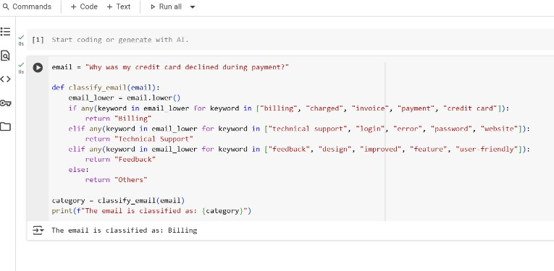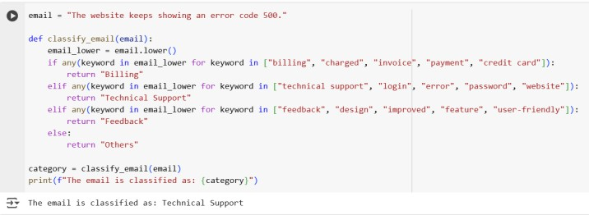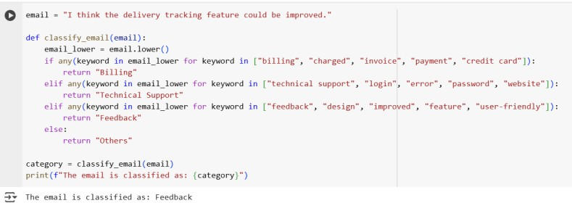

1. *“How can I reset my password?”*

# Feedback

1. *“Your app’s new design is very user-friendly. Great work!”*
2. *“I think the delivery tracking feature could be improved.”*

# Others

1. *“Are you hiring interns for the summer?”*
2. *“I’d like to unsubscribe from your newsletter.”*

# Zero-shot Prompting:

* + Design a prompt that asks the LLM to classify a single email without providing any examples.
  + Example prompt:

*“Classify the following email into one of the following categories: Billing, Technical Support, Feedback, Others. Email: ‘I have not received my invoice for last month.’”*

**Prompt1:** Classify the following email into one of the categories: Billing, Technical Support, Feedback, Others.

Email: "Why was my credit card declined during payment?"

**Prompt2:** Classify the following email into one of the categories: Billing, Technical Support, Feedback, Others.

Email: "The website keeps showing an error code 500."

**Prompt3:** Classify the following email into one of the categories: Billing, Technical Support, Feedback, Others.

Email: "I think the delivery tracking feature could be improved."

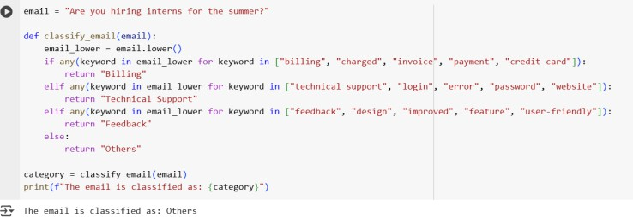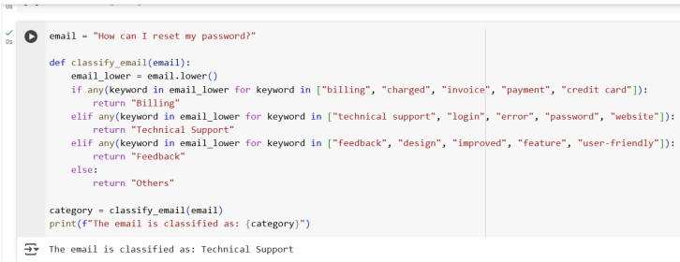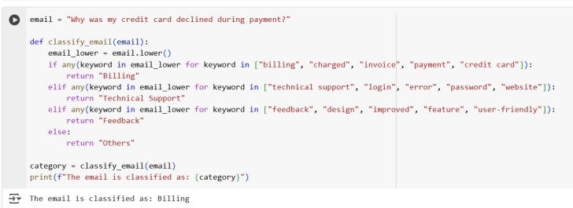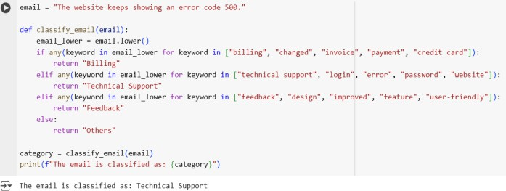

**Prompt4**: Classify the following email into one of the categories: Billing, Technical Support, Feedback, Others.

Email: "Are you hiring interns for the summer?"

**Prompt5**:Classify the following email into one of the categories: Billing, Technical Support, Feedback, Others.

Email: "How can I reset my password?"

# One-shot Prompting:

* + Add one labeled example before asking the model to classify a new email.

**Prompt1:** Example:

Email: "I was charged twice for my subscription this month." → Category: Billing

Now classify this email:

Email: "Why was my credit card declined during payment?"

**Prompt2:** Example:

Email: "I was charged twice for my subscription this month." → Category: Billing

Now classify this email:

Email: "The website keeps showing an error code 500."

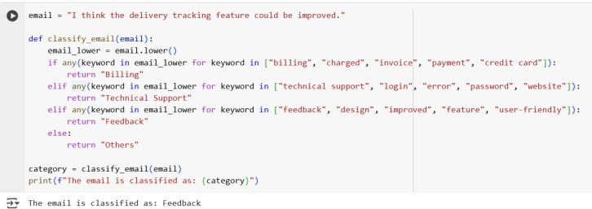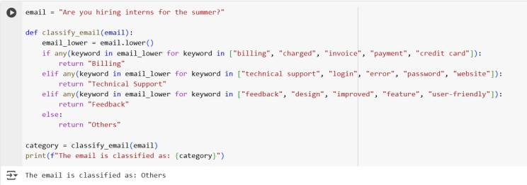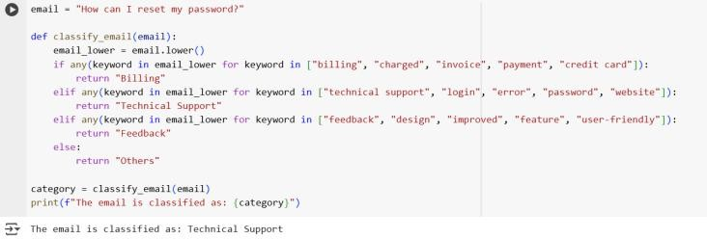

**Prompt3:** Example:

Email: "I was charged twice for my subscription this month." → Category: Billing

Now classify this email:

Email: "I think the delivery tracking feature could be improved."

**Prompt4**: Example:

Email: "I was charged twice for my subscription this month." → Category: Billing

Now classify this email:

Email: "Are you hiring interns for the summer?"

**Prompt5:** Example:

Email: "I was charged twice for my subscription this month." → Category: Billing

Now classify this email:

Email: "How can I reset my password?"

# Few-shot Prompting:

* + Use 3–5 labeled examples in your prompt before asking the model to classify a new email.

**Prompt1:** Examples:

Email: "I was charged twice for my subscription this month." → Billing Email: "How can I reset my password?" → Technical Support

Email: "Your app’s new design is very user-friendly." → Feedback Now classify this email:

Email: "Why was my credit card declined during payment?"

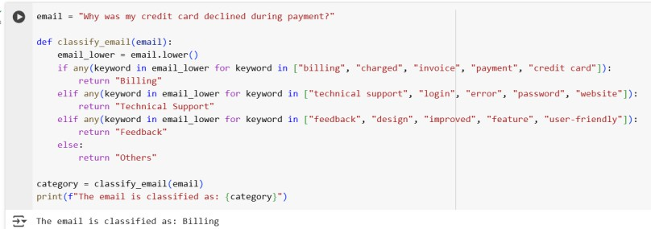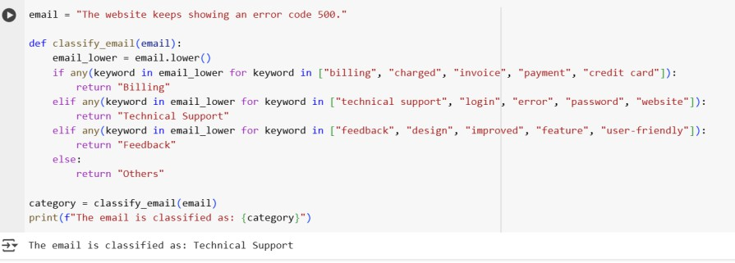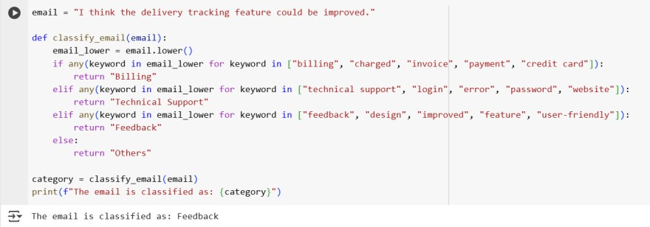

**Prompt2:** Examples:

Email: "I was charged twice for my subscription this month." → Billing Email: "How can I reset my password?" → Technical Support

Email: "Your app’s new design is very user-friendly." → Feedback Now classify this email:

Email: "The website keeps showing an error code 500."

**Prompt3:** Examples:

Email: "I was charged twice for my subscription this month." → Billing Email: "How can I reset my password?" → Technical Support

Email: "Your app’s new design is very user-friendly." → Feedback Now classify this email:

Email: "I think the delivery tracking feature could be improved."

**Prompt4:** Examples:

Email: "I was charged twice for my subscription this month." → Billing Email: "How can I reset my password?" → Technical Support

Email: "Your app’s new design is very user-friendly." → Feedback Now classify this email:

Email: "Are you hiring interns for the summer?"

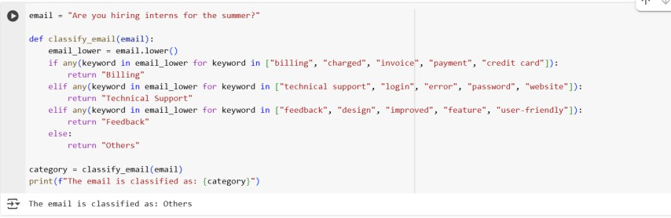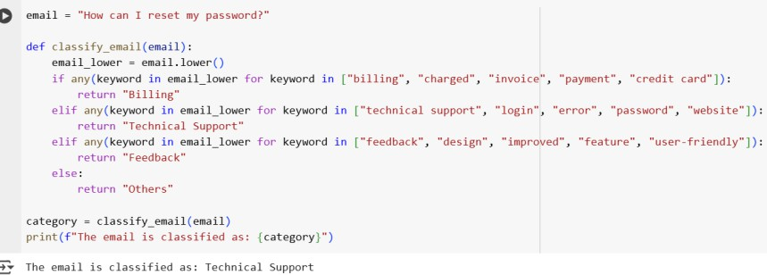

**Prompt5:** Examples:

Email: "I was charged twice for my subscription this month." → Billing Email: "How can I reset my password?" → Technical Support

Email: "Your app’s new design is very user-friendly." → Feedback Now classify this email:

Email: "How can I reset my password?"

Comparison Table

|  |  |  |  |  |
| --- | --- | --- | --- | --- |
| **Email** | **True Category** | **Zero- shot** | **One- shot** | **Few- shot** |
| Why was my credit card declined during payment? | Billing | Correct | Correct | Correct |
| The website keeps showing an error code 500. | Technical Support | Correct | Correct | Correct |
| I think the delivery tracking feature could be improved. | Feedback | Incorrec t | Correct | Correct |
| Are you hiring interns for the summer? | Others | Incorrec t | Correct | Correct |
| How can I reset my password? | Technical Support | Correct | Correct | Correct |

# Evaluation:

* + Run all three techniques on the same set of 5 test emails.
  + Compare and document the accuracy and clarity of responses.

# Requirements:

* + VS Code with Github Copilot or Cursor IDE and/or Google Colab with Gemini

# Deliverables:

* A .txt or .md file showing prompts and model responses.
* A comparison table showing classification accuracy for each technique.
* A short reflection on which method was most effective and why

.