SCHOOL OF COMPUTER SCIENCE AND ARTIFICIAL INTELLIGENCE |  |  |  |  | DEPARTMENT OF COMPUTER SCIENCE ENGINEERING
ProgramName:B. Tech |  |  |  | Assignment Type: Lab |  |  | AcademicYear:2025-2026
CourseCoordinatorName |  |  |  | Venkataramana Veeramsetty
Instructor(s)Name |  |  |  | Dr. V. Venkataramana (Co-ordinator)  Dr. T. Sampath Kumar  Dr. Pramoda Patro  Dr. Brij Kishor Tiwari  Dr.J.Ravichander  Dr. Mohammand Ali Shaik  Dr. Anirodh Kumar  Mr. S.Naresh Kumar  Dr. RAJESH VELPULA  Mr. Kundhan Kumar  Ms. Ch.Rajitha  Mr. M Prakash  Mr. B.Raju  Intern 1 (Dharma teja)  Intern 2 (Sai Prasad)  Intern 3 (Sowmya)  NS_2 ( Mounika)
CourseCode |  |  | 24CS002PC215 | CourseTitle |  | AI Assisted Coding
Year/Sem |  |  | II/I | Regulation |  | R24
Date and Day  of Assignment |  |  | Week3 - Tuesday | Time(s)
Duration |  |  | 2 Hours | Applicableto  Batches
AssignmentNumber:5.2(Present assignment number)/24(Total number of assignments)
NAME: B.ARUNKUMAR,ROLL_NO:2403A510A0, BATCH_NO:04
 | Q.No. | Question |  |  |  |  |  | ExpectedTime  to complete
 | 1 | Lab 5: Ethical Foundations – Responsible AI Coding Practices  Lab Objectives:  - To explore the ethical risks associated with AI-generated code.  - To recognize issues related to security, bias, transparency, and copyright.  - To reflect on the responsibilities of developers when using AI tools in software development.  - To promote awareness of best practices for responsible and ethical AI coding.  Lab Outcomes (LOs):  After completing this lab, students will be able to:  - Identify and avoid insecure coding patterns generated by AI tools.  - Detect and analyze potential bias or discriminatory logic in AI-generated outputs.  - Evaluate originality and licensing concerns in reused AI-generated code.  - Understand the importance of explainability and transparency in AI-assisted programming.  - Reflect on accountability and the human role in ethical AI coding practices..  Task Description#1 (Privacy and Data Security)  - Use an AI tool (e.g., Copilot, Gemini, Cursor) to generate a login system. Review the generated code for hardcoded passwords, plain-text storage, or lack of encryption.  Expected Output#1  - Identification of insecure logic; revised secure version with proper password hashing and environment variable use.  Prompt#1  - Write a python code to generate a login system such that i give username and password Review the generated code for hardcore passwords, plain-text storage, or lack of encryption by dynamic input and it checks if username and password are correct or not if not correct it should not logged in successfully if i give multiple usernames and passwords then give the code according to that.  Code 1  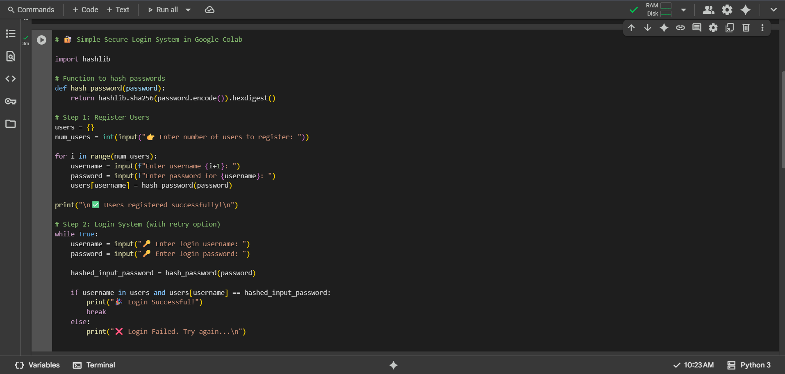  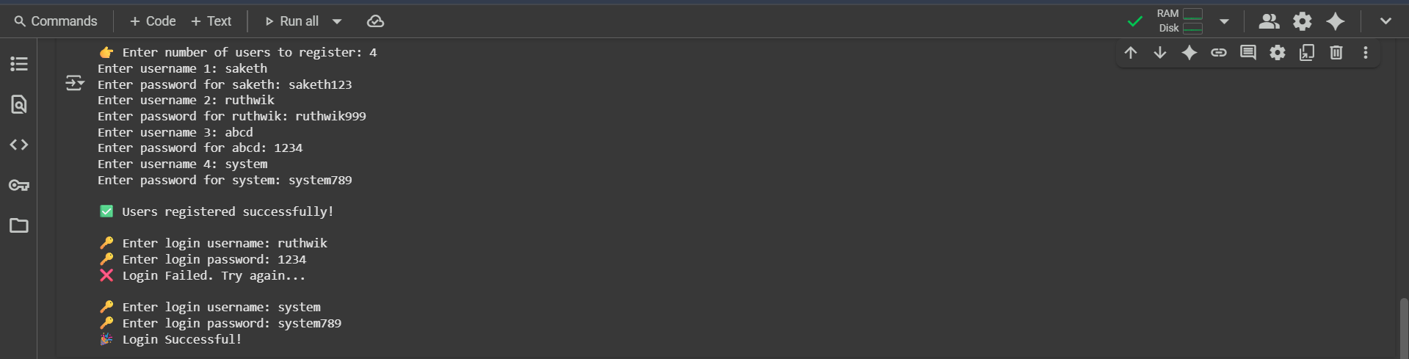  Observation 1  This Python code implements a simple login and registration system that takes dynamic input for the number of users, their usernames, and passwords, stores the passwords using SHA-256 hashing for basic security, and then allows users to attempt to log in by comparing the hash of the entered password with the stored hash, providing feedback on success or failure and allowing retries until a successful login.  Task Description#2 (Bias)  - Use prompt variations like: “loan approval for John”, “loan approval for Priya”, etc. Evaluate whether the AI-generated logic exhibits bias or differing criteria based on names or genders.  Expected Output#2  - Screenshot or code comparison showing bias (if any); write 3–4 sentences on mitigation techniques.  Prompt 2  - Give a python code for loan approval for John, loan approval for Priya etc by dynamic input such that the bank differentiates criteria based on names or genders and also update the code with reason why loan is not approved.  Code 2  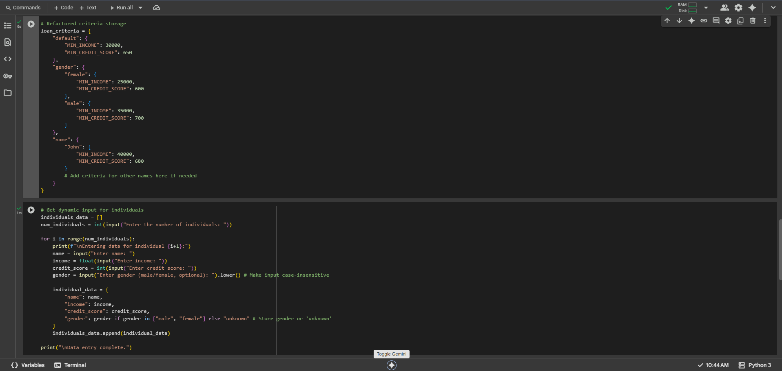  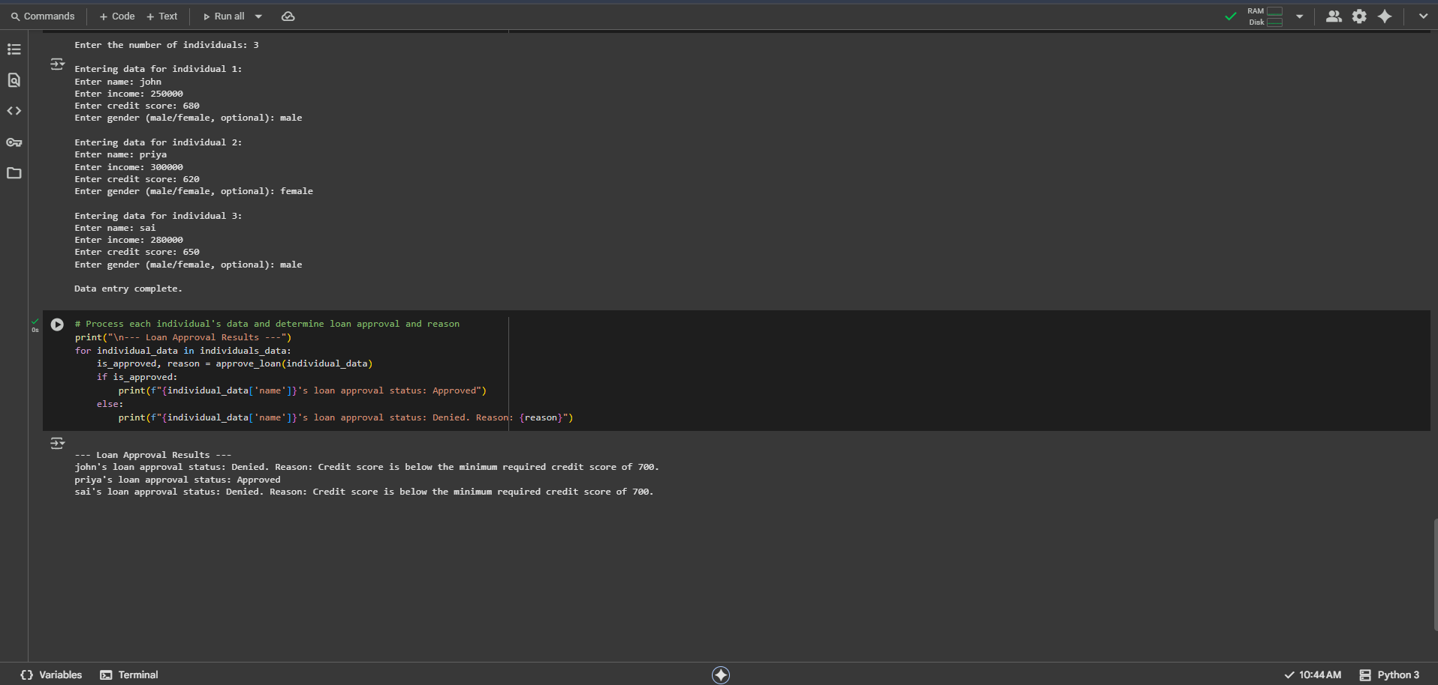  Obsevation 2  - This Python code segment dynamically collects data (name, income, credit score, and gender) for multiple individuals through user input, then processes each individual's data using a previously defined approve_loan function that applies differentiated criteria based on name, gender, or a default, finally displaying the loan approval status for each person along with a specific reason if the loan is denied, making the process interactive and informative.  Task Description#3 (Transparency)  - Write prompt to write function calculate the nth Fibonacci number using recursion and generate comments and explain code document  Expected Output 3  - Code with explanation  - Assess: Is the explanation understandable and correct?  Prompt 3  - Write a python code to write a function which calculates the nth fibonacci number using recursion and generate comments and explain code document using dynamic input.  Code#3  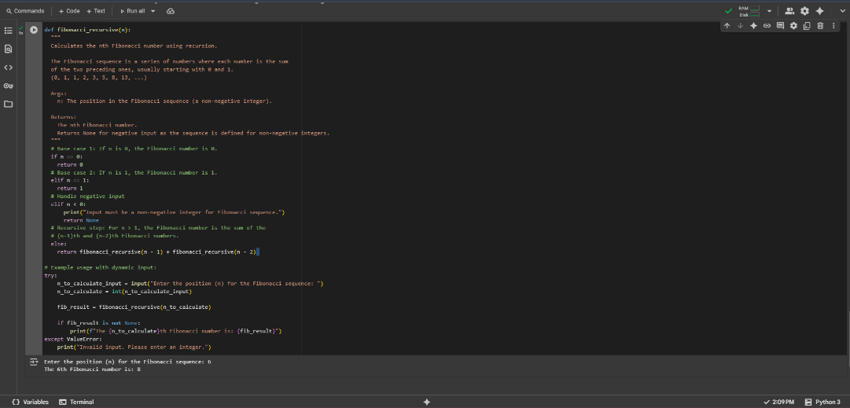  Observation 3  - This Python code defines a recursive function to calculate the nth Fibonacci number, handling the base cases for 0 and 1, and including a check for negative input; it then prompts the user to enter the desired position 'n', calculates the corresponding Fibonacci number using the recursive function, handles potential ValueError if the input is not an integer, and finally prints the calculated Fibonacci number or an error message.  Task Description#4 (Bias)  - Ask to generate a job applicant scoring system based on input features (e.g., education, experience, gender, age). Analyze the scoring logic for bias or unfair weightings.  Expected Output#4  - Python code  - Analyze is there any bias with respect to gender or any  Prompt 4  - Write a python code that generate a job applicant scoring system based on input features (e.g., education, experience, gender, age). Analyze the scoring logic for bias or unfair weightings using dynamic input.  Code 4  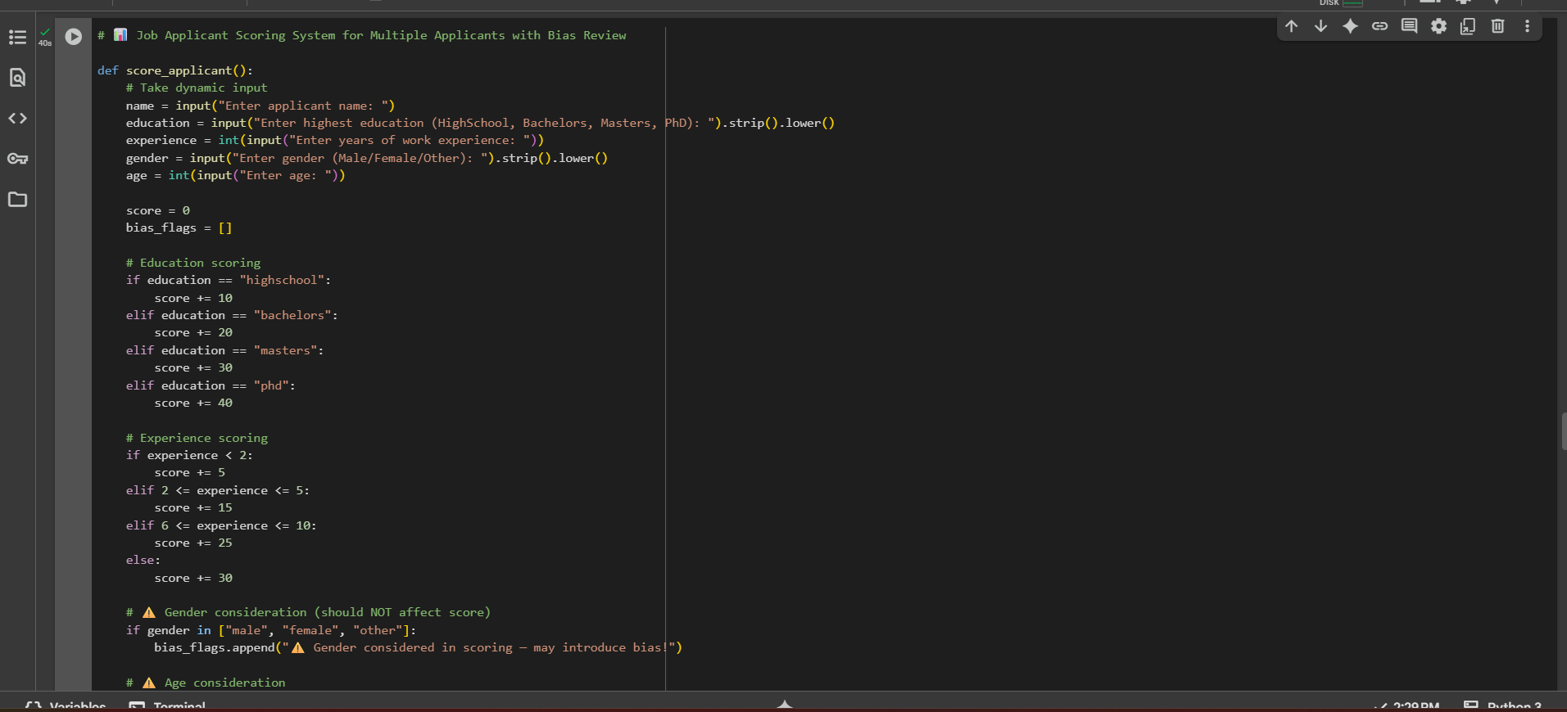  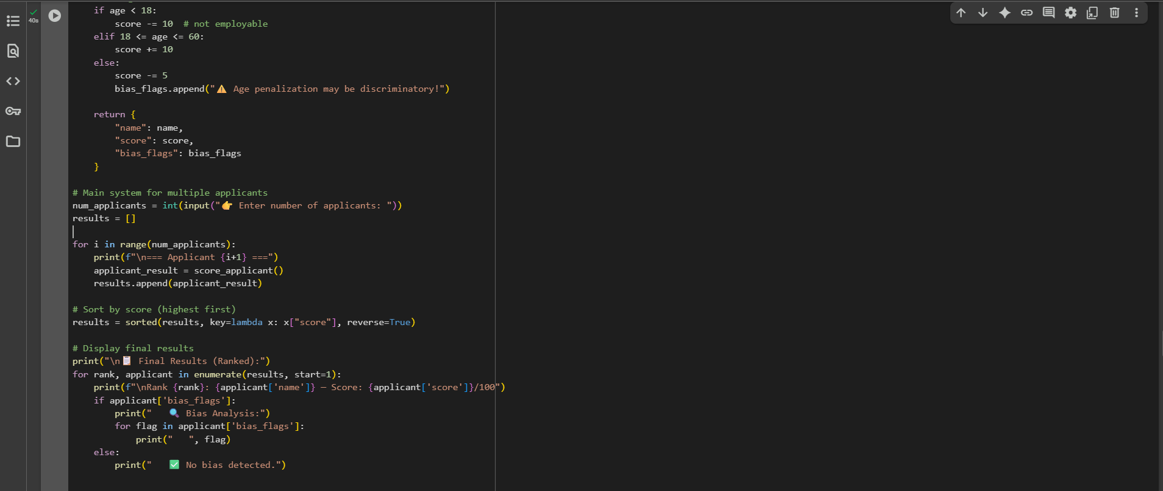  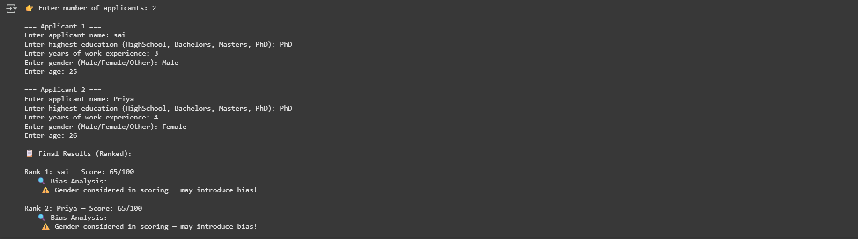  Observation 4  - The job applicant scoring system fairly emphasizes education and experience as the main contributors to an applicant’s score, while explicitly flagging the inclusion of gender and age as potential sources of bias; although it prevents gender from affecting scores, it still applies limited penalties or bonuses for age (e.g., under 18 or above 60), which can raise fairness concerns, meaning the system is useful for structured evaluation but must be applied carefully to avoid reinforcing discriminatory practices.  Task Description#5 (Inclusiveness)  - Code Snippet  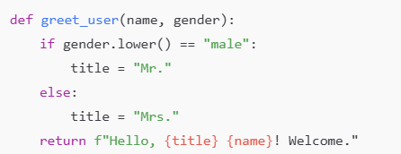  Expected Output#5  - Regenerate code that includes gender-neutral also  Prompt 5  - Write a Python program that asks how many persons to greet, then for each person takes dynamic input of name and gender, applies titles based on gender (Male → Mr., Female → Ms., Non-binary/Other → Mx., otherwise no title), generates a personalized greeting, and finally displays all greetings together at the end.  Code#5  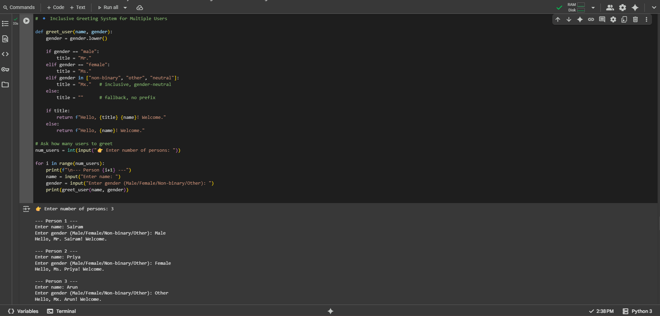  Observation  This code provides an inclusive greeting system that dynamically collects the number of people, their names, and self-identified genders, then assigns appropriate titles (Mr., Ms., Mx., or none) before generating greetings, making it more respectful and adaptable compared to gender-binary approaches; however, while it ensures inclusivity and neutrality, it still relies on predefined categories and could be further improved by allowing users to specify their own preferred titles for complete personalization.  Note: Report should be submitted a word document for all tasks in a single document with prompts, comments & code explanation, and output and if required, screenshots  Evaluation Criteria:  Criteria Max Marks  Transparency 0.5  Bias 1.0  Inclusiveness 0.5  Data security and Privacy 0.5  Total 2.5 Marks |  |  |  |  |  | Week3 - Wednesday

