SCHOOLOFCOMPUTER SCIENCE AND ARTIFICIAL INTELLIGENCE |  |  |  |  | DEPARTMENTOFCOMPUTER SCIENCE ENGINEERING
ProgramName:B. Tech |  |  |  | AssignmentType: Lab |  |  | AcademicYear:2025-2026
CourseCoordinatorName |  |  |  | Venkataramana Veeramsetty
Instructor(s)Name |  |  |  | Dr. V. Venkataramana (Co-ordinator)  Dr. T. Sampath Kumar  Dr. Pramoda Patro  Dr. Brij Kishor Tiwari  Dr.J.Ravichander  Dr. Mohammand Ali Shaik  Dr. Anirodh Kumar  Mr. S.Naresh Kumar  Dr. RAJESH VELPULA  Mr. Kundhan Kumar  Ms. Ch.Rajitha  Mr. M Prakash  Mr. B.Raju  Intern 1 (Dharma teja)  Intern 2 (Sai Prasad)  Intern 3 (Sowmya)  NS_2 ( Mounika)
CourseCode |  |  | 24CS002PC215 | CourseTitle |  | AI Assisted Coding
Year/Sem |  |  | II/I | Regulation |  | R24
Date and Day  of Assignment |  |  | Week6 - Monday | Time(s)
Duration |  |  | 2 Hours | Applicableto  Batches
AssignmentNumber:12.1(Presentassignmentnumber)/24(Totalnumberofassignments)
 | Q.No. | Question |  |  |  |  |  | ExpectedTime  to complete
 | 1 | Lab 12: Algorithms with AI Assistance – Sorting, Searching, and Optimizing Algorithms  Lab Objectives:  - Apply AI-assisted programming to implement and optimize sorting and searching algorithms.  - Compare different algorithms in terms of efficiency and use cases.  - Understand how AI tools can suggest optimized code and complexity improvements.  Task Description #1 (Sorting – Merge Sort Implementation)  - Task: Use AI to generate a Python program that implements the Merge Sort algorithm.  - Instructions:  - Prompt AI to create a function merge_sort(arr) that sorts a list in ascending order.  - Ask AI to include time complexity and space complexity in the function docstring.  - Verify the generated code with test cases.  - Expected Output:  - A functional Python script implementing Merge Sort with proper documentation.  Prompt:  Write a python code that implements the merge sort algorithm.  Code:  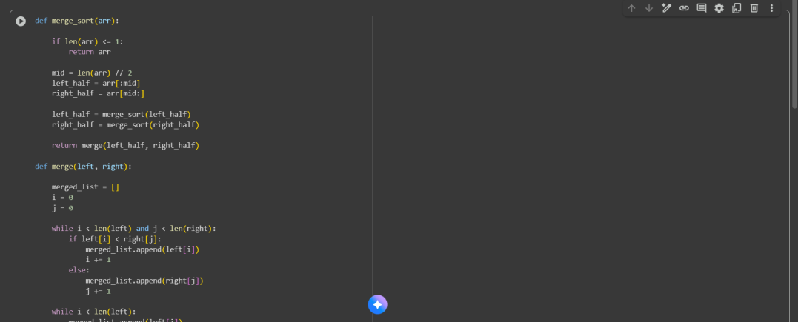  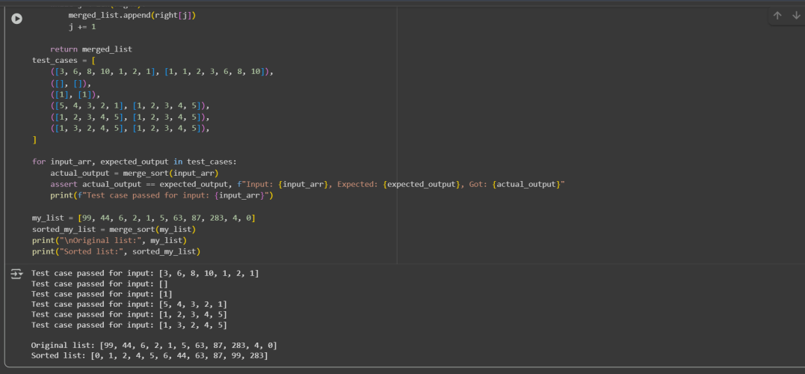  Observation:  The Merge Sort algorithm works on the principle of divide and conquer by recursively splitting the list into smaller sub lists until each contains a single element. These sub lists are then merged back together in sorted order, producing a fully ordered list. It guarantees a time complexity of O(n log n) for best, average, and worst cases, making it highly efficient for large datasets. However, its space complexity of O(n) requires additional memory, which can be a limitation compared to in-place sorting algorithms.  Task Description #2 (Searching – Binary Search with AI Optimization)  - Task: Use AI to create a binary search function that finds a target element in a sorted list.  - Instructions:  - Prompt AI to create a function binary_search(arr, target) returning the index of the target or -1 if not found.  - Include docstrings explaining best, average, and worst-case complexities.  - Test with various inputs.  - Expected Output:  - Python code implementing binary search with AI-generated comments and docstrings.  Prompt:  Write a python code a binary search function that finds a target element in a sorted list.  Code:  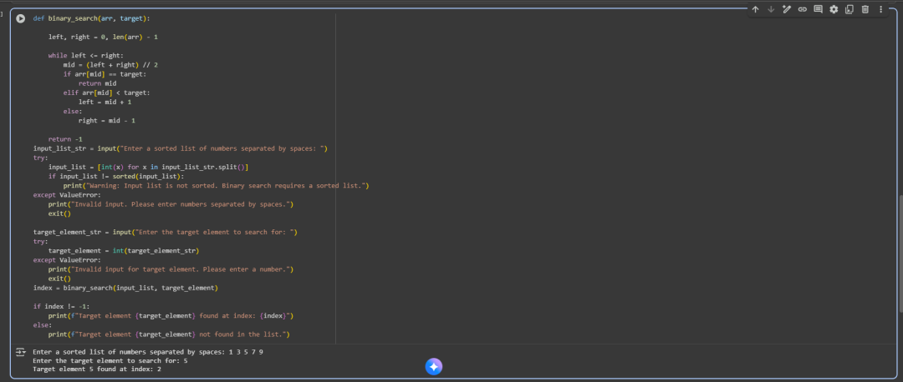  Observation:  The Binary code algorithm efficiently finds a target element in a sorted list by repeatedly dividing the search range in half. It significantly reduces the number of comparisons compared to linear search, achieving a logarithmic time complexity of O(log n). This makes it ideal for large datasets, though it requires the input list to be sorted beforehand.  Task Description #3 (Real-Time Application – Inventory Management System)  - Scenario: A retail store’s inventory system contains thousands of products, each with attributes like product ID, name, price, and stock quantity. Store staff need to:  - Quickly search for a product by ID or name.  - Sort products by price or quantity for stock analysis.  - Task:  - Use AI to suggest the most efficient search and sort algorithms for this use case.  - Implement the recommended algorithms in Python.  - Justify the choice based on dataset size, update frequency, and performance requirements.  - Expected Output:  - A table mapping operation → recommended algorithm → justification.  - Working Python functions for searching and sorting the inventory.  Prompt:  Write a python code retail store inventory system contains thousand of products, each with attributes like product id, name price, and stock quantity. Store staff need to.  Code:  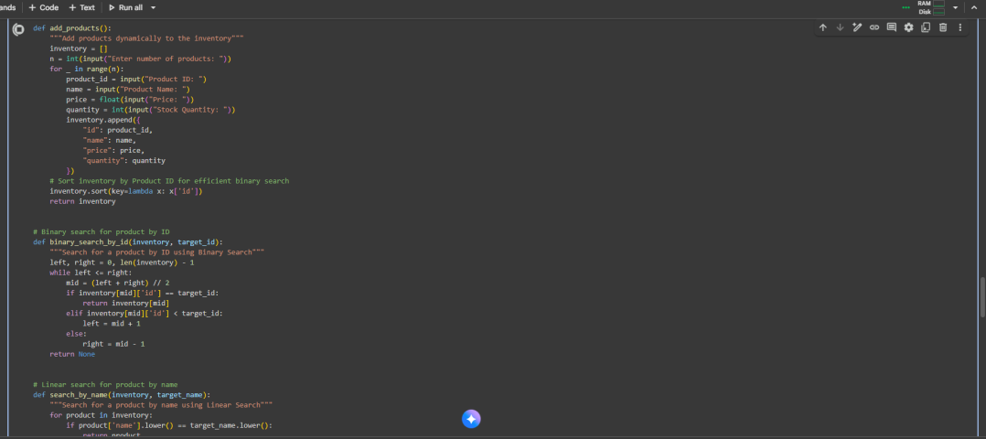  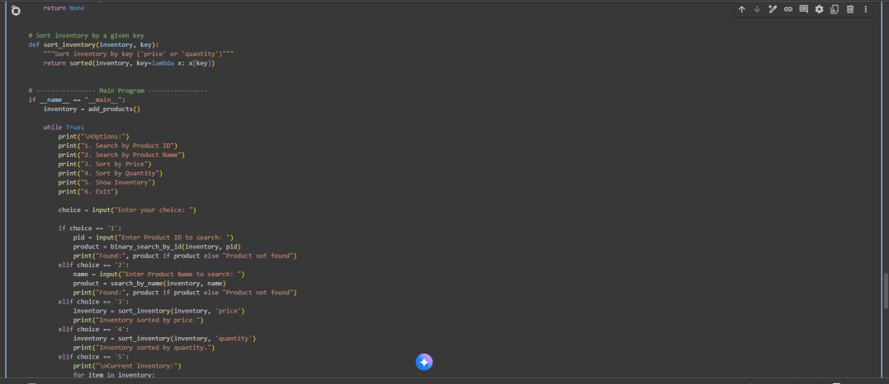  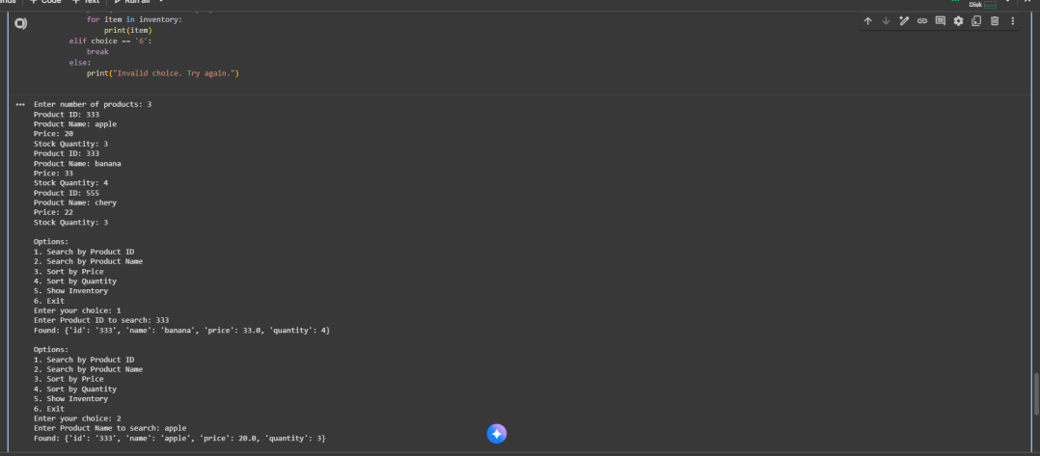  Observation:  The inventory system efficiently manages products by combining binary search for IDs and linear search for names, allowing quick lookups even in large datasets. Sorting by price or quantity helps staff analyze stock levels and make informed decisions. Dynamic input and a menu-driven interface make the system flexible and easy to use in real-time scenarios.  ✅ Deliverables (For All Tasks)  - AI-generated prompts for code and test case generation.  - At least 3 assert test cases for each task.  - AI-generated initial code and execution screenshots.  - Analysis of whether code passes all tests.  - Improved final version with inline comments and explanation.  - Compiled report (Word/PDF) with prompts, test cases, assertions, code, and output. |  |  |  |  |  | Week6 - Monday

