Name: Akshaya Neerati
Enrollment No: 2403A510B8
SCHOOLOFCOMPUTER SCIENCE AND ARTIFICIAL INTELLIGENCE |  |  |  |  | DEPARTMENTOFCOMPUTER SCIENCE ENGINEERING
ProgramName:B. Tech |  |  |  | AssignmentType: Lab |  |  | AcademicYear:2025-2026
CourseCoordinatorName |  |  |  | Venkataramana Veeramsetty
Instructor(s)Name |  |  |  | Dr. V. Venkataramana (Co-ordinator)  Dr. T. Sampath Kumar  Dr. Pramoda Patro  Dr. Brij Kishor Tiwari  Dr.J.Ravichander  Dr. Mohammand Ali Shaik  Dr. Anirodh Kumar  Mr. S.Naresh Kumar  Dr. RAJESH VELPULA  Mr. Kundhan Kumar  Ms. Ch.Rajitha  Mr. M Prakash  Mr. B.Raju  Intern 1 (Dharma teja)  Intern 2 (Sai Prasad)  Intern 3 (Sowmya)  NS_2 ( Mounika)
CourseCode |  |  | 24CS002PC215 | CourseTitle |  | AI Assisted Coding
Year/Sem |  |  | II/I | Regulation |  | R24
DateandDay  of Assignment |  |  | Week8 - WednesDay | Time(s)
Duration |  |  | 2 Hours | Applicableto  Batches
AssignmentNumber:16.3(Presentassignmentnumber)/24(Totalnumberofassignments)
 | Q.No. | Question |  |  |  |  |  | ExpectedTime  to complete
 | 1 | Lab 16 – Database Design and Queries: Schema Design and SQL Generation  Lab Objectives  - To practice basic SQL query generation with AI assistance.  - To analyze AI-suggested queries for correctness and efficiency.  - To understand how AI can help in documenting and improving database logic.  Learning Outcomes  After completing this lab, students will be able to:  - Use AI tools to design a simple ER diagram / schema for a given scenario.  - Generate CREATE TABLE statements using AI.  - Write and refine basic SQL queries (SELECT, INSERT, UPDATE, DELETE).  - Validate correctness and efficiency of AI-generated SQL.  - Compare AI-generated vs manually written queries.  Task Description #1 – Schema Generation  Task: Ask AI to design a schema for a Library Management System (Tables: Books, Members, Loans).  SQL Code  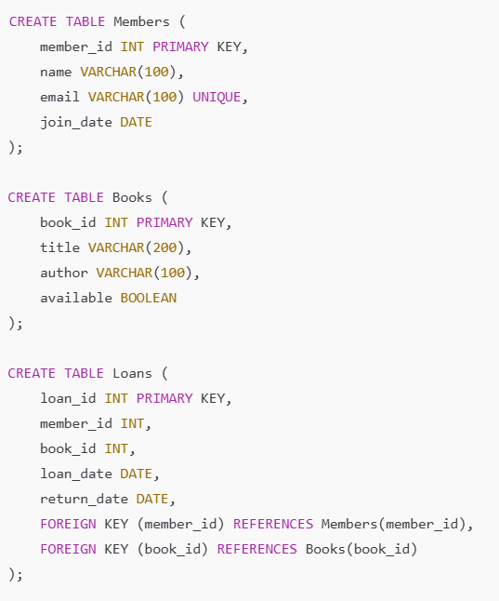  Prompt: Create SQL tables for a library: Members, Books, and Loans. Members have name, email, join date. Books have title, author, and available status. Loans link members and books with loan and return dates, using foreign keys.  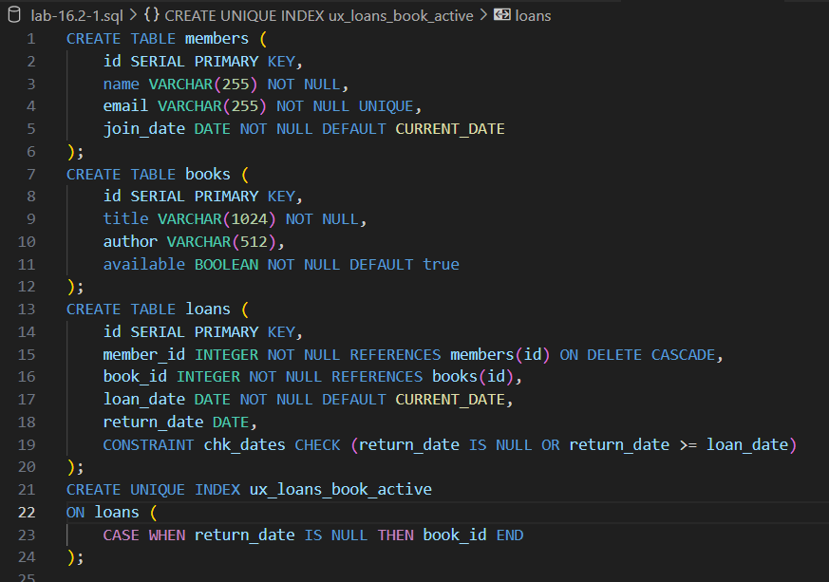  Task Description #2 – Error Insert Data  Task: Ask AI to generate INSERT INTO queries for the schema above (3 sample records per table).  Prompt: Write SQL INSERT INTO statements for the tables members, books, and loans for a library system. Provide 3 sample records for each table, using realistic values.  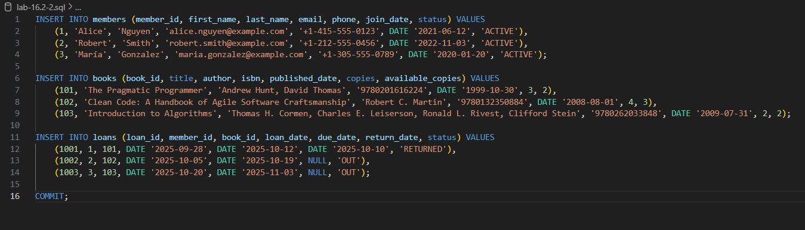  Task Description #3 – Basic Queries  Task: Use AI to generate a query to list all books borrowed by a specific member.  Prompt: Write an SQL query that lists all books borrowed by a specific member, showing the book titles and borrowing dates. Use the members, books, and loans tables.  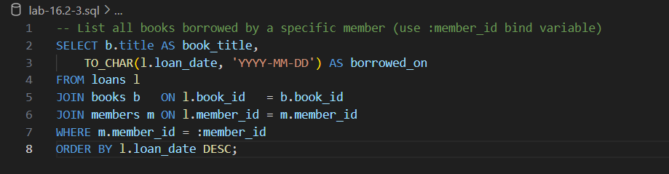  Task Description #4 – Update and Delete Queries  Task: Generate queries with AI for:  - Updating a book’s availability to FALSE when borrowed.  - Deleting a member record safely.  Prompt: Write SQL queries to: 1) update a book’s availability to FALSE when it is borrowed, and 2) safely delete a member record, ensuring referential integrity with the loans table.  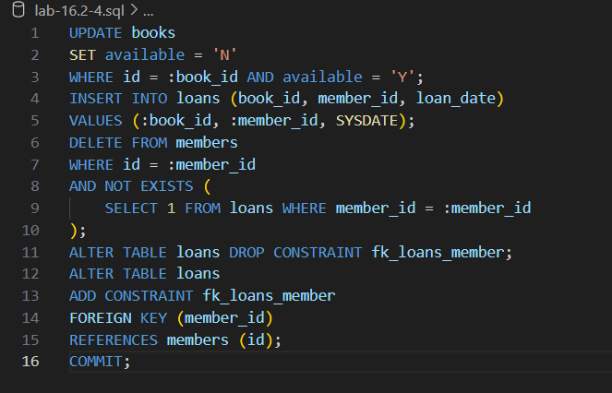 |  |  |  |  |  | Week5 - Monday

