SCHOOLOFCOMPUTER SCIENCE AND ARTIFICIAL INTELLIGENCE |  |  |  |  | DEPARTMENTOFCOMPUTER SCIENCE ENGINEERING
ProgramName:B. Tech |  |  |  | AssignmentType: Lab |  |  | AcademicYear:2025-2026
CourseCoordinatorName |  |  |  | Venkataramana Veeramsetty
Instructor(s)Name |  |  |  | Dr. V. Venkataramana (Co-ordinator)  Dr. T. Sampath Kumar  Dr. Pramoda Patro  Dr. Brij Kishor Tiwari  Dr.J.Ravichander  Dr. Mohammand Ali Shaik  Dr. Anirodh Kumar  Mr. S.Naresh Kumar  Dr. RAJESH VELPULA  Mr. Kundhan Kumar  Ms. Ch.Rajitha  Mr. M Prakash  Mr. B.Raju  Intern 1 (Dharma teja)  Intern 2 (Sai Prasad)  Intern 3 (Sowmya)  NS_2 ( Mounika)
CourseCode |  |  | 24CS002PC215 | CourseTitle |  | AI Assisted Coding
Year/Sem |  |  | II/I | Regulation |  | R24
DateandDay  of Assignment |  |  | Week5 - Monday | Time(s)
Duration |  |  | 2 Hours | Applicableto  Batches
AssignmentNumber: 9.1(Presentassignmentnumber)/24(Totalnumberofassignments)
 | Q.No. | Question |  |  |  |  |  | ExpectedTime  to complete
 | 1 | Lab 9 – Code Review and Quality: Using AI to improve code quality and readability  Lab Objectives  - Inline comments  - Docstrings  - Auto-documentation tools  - AI-assisted summarization  Task Description #1 (AI-Assisted Bug Detection)  Scenario: A junior developer wrote the following Python function to calculate factorials:  def factorial(n):  result = 1  for i in range(1, n):  result = result * i  return result  - Run the code and test it with factorial(5)  (expected output = 120).  - Use AI (prompting) to review this code and identify the bug.  - Ask AI to suggest corrections and rewrite the code.  - Compare AI’s corrected code with your own fix.  Code:  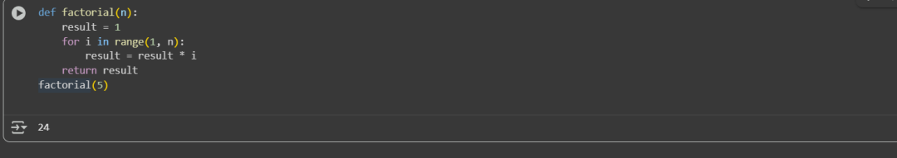  The Expected output is:120  Generated out put:24  Prompt:  My factorial function gives 24 for factorial(5) instead of 120.Please  fix the bug and give the corrected code.  Code after correcting:  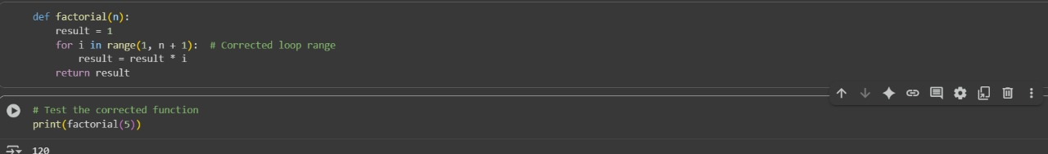  Observation:  The function intended to calculate the factorial of a number is producing incorrect output, specifically returning 24 for factorial(5) instead of the correct result, 120. This discrepancy suggests an off-by-one error, where the function likely omits multiplying by one of the necessary integers—possibly stopping at 4 instead of including 5 in the calculation. Such issues are common when the loop or recursion used to compute the factorial does not cover the full range from 1 to n inclusive.  Task Description #2 (Improving Readability & Documentation)  Scenario: The following code works but is poorly written:  def calc(a,b,c):  if c=="add":  return a+b  elif c=="sub":  return a-b  elif c=="mul":  return a*b  elif c=="div":  return a/b  - Use AI to review this code for readability, naming, and documentation issues.  - Prompt AI to rewrite the code with:  - Clear function & variable names.  - Proper docstrings.  - Exception handling for division by zero.  - Compare the before-and-after versions to evaluate AI’s contribution.  Code:  Code before modifying:  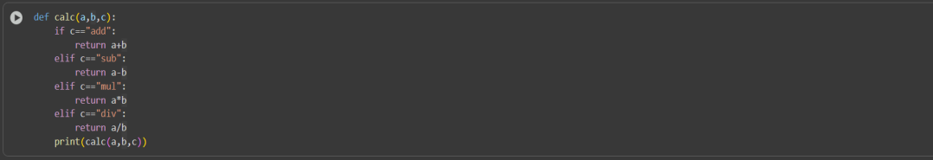  Prompt:  Review def calc(a, b, c): ... for readability, naming, and documentation issues, then rewrite it with clear names, a docstring, and division-by-zero handling, finally comparing both versions.  Code after modifying:  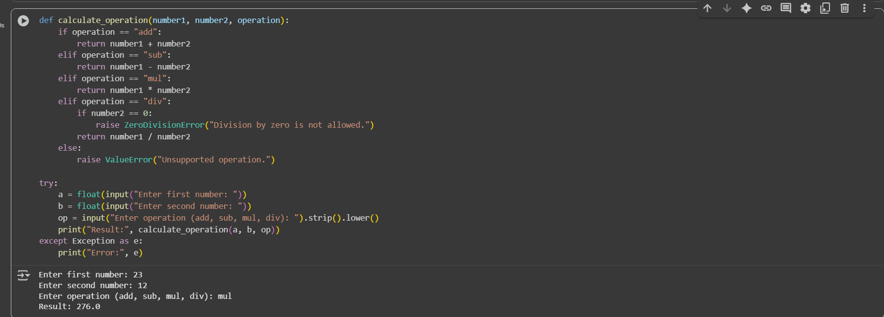  Observation:  This code defines two calculator functions. calc is simple but lacks error checks. calculate_operation is more robust with error handling. The output shows a successful multiplication using the second function.  Task Description #3 (Enforcing Coding Standards)  Scenario: A team project requires following PEP8 style guide. One developer submits:  def Checkprime(n):  for i in range(2,n):  if n%i==0:  return False  return True  - Run this code and verify correctness.  - Use AI to perform a code quality review for PEP8 compliance.  - Prompt AI to return a refactored version with proper indentation, spacing, and naming conventions.  - Discuss how automated AI review can save time in large-scale projects.  Code before verifying:  Prompt:  Review def Checkprime(n): ... for correctness and PEP8 compliance, then return a refactored version with proper naming, spacing, and indentation, and explain how AI reviews save time and improve consistency in large projects.  Code after verifying:  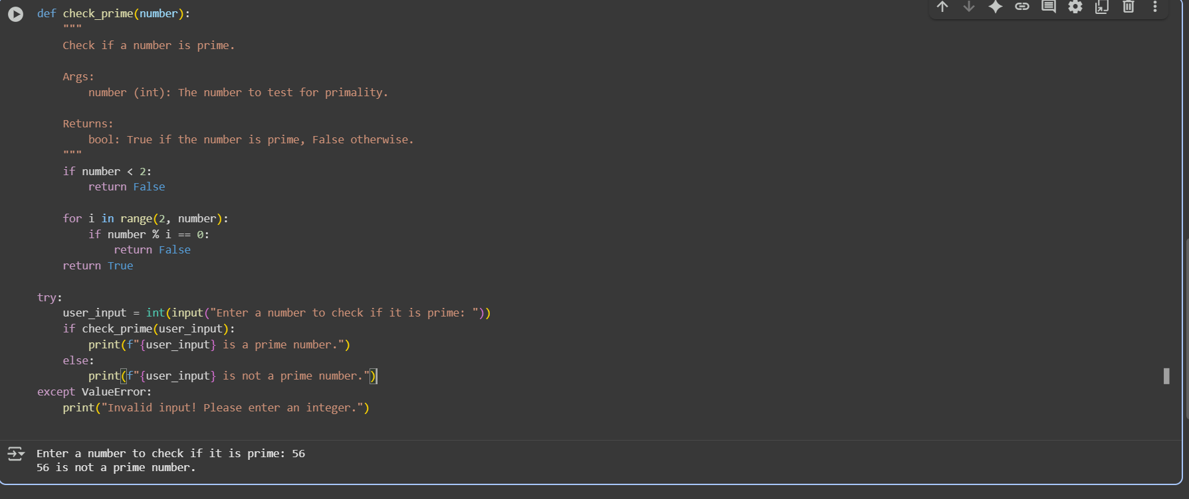  Observation:  The original Checkprime(n) function works correctly but violates PEP8 style by using a non–snake_case name, inconsistent indentation, missing spaces around operators, and lacking a docstring; the refactored version check_prime(number) fixes these issues, adds clear documentation, handles invalid input dynamically, and overall demonstrates how AI-assisted reviews can quickly enforce coding standards, improve readability, and save developer time in larger projects.  Task Description #4 (AI as a Code Reviewer in Real Projects)  Scenario:You are part of a GitHub project. A teammate submits this pull request:  def processData(d):  return [x*2 for x in d if x%2==0]  - Review this function manually for readability, reusability, and edge cases.  - Use AI to generate a code review comment, focusing on:  - Naming conventions.  - Input validation (e.g., what if d is not a list?).  - Adding type hints.  - Modify the function based on AI’s suggestions.  - Write a short reflection: Would you trust AI as a standalone reviewer, or only as a support tool? Why?  Code before Reviewing:  Prompt:  Review the function def process Data(d): ... for readability, reusability, and edge cases. Suggest improvements including proper naming conventions, type hints, input validation (e.g., if d is not a list), and a docstring. Then provide a refactored version of the function and explain your changes.  Code after Reviewing:  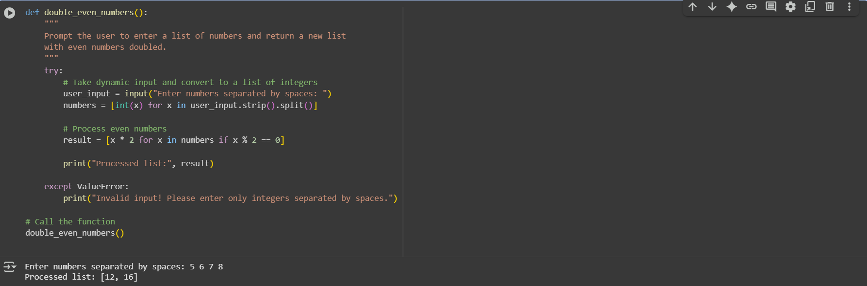  Observation:  This code efficiently takes dynamic user input, validates it, and returns a list of doubled even numbers; it is compact, readable, handles invalid inputs gracefully, and clearly separates input processing from computation. |  |  |  |  |  | Week5 - Monday

