

|  |  |
| --- | --- |
| **Web technologies | Front-End** | |
| Student(s’) name(s): | Aktan Nurzhan Erbol Ashim |
| Teacher name: | Dariya Bissengaliyeva |
| Project name: | Interpөl |
| Project type: | Group |

***INTRODUCTION***

Our group chose the idea of Interpol as the theme for our project. Our goal is to help people to be on their guard against bad people, and so that if they meet them on the street or somewhere in a public place, let us know.

***MAIN PART* (Practical)**

For such a site, you need to know how to create it, and for this, an application called atom will help us, in order to download it, you need to go to the site https://atom.io and click the download button. How to boot we need to create a folder "your name".html, and in order for your site to be detailed and beautiful, you must also create "your folder name".css, and then you can get to work.  
*CSS describes how HTML elements should be displayed.*

to create html code already, you need to write html in the atom itself, as in the picture

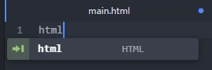

then you already have a ready-made robot site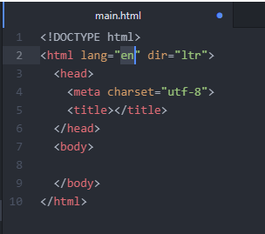

to create an icon for your site, you need to write the following code



in order for css to work and connect to html, you need to write this code



In the css file, we added some characteristics such as bisque background color, display grid, align items center, justify items center, width: 100%; height: 80px; color: rgb(110, 160, 210) and etc.

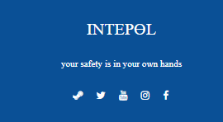

we have also created a link to contact us

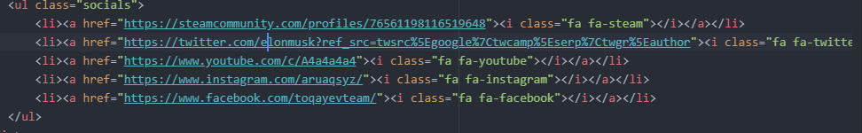

In total, we have created 12 classes: header, body, .interpol_logo, .interpol_menu, . question, . banner-area, .form, . footer, . socials, table, th, td.

In the header class, we made a holiday that discount announcement caught the attention of a real customer. In the .css file, we used Georgia, serif, as the font for the inscription.

Summing up, we can briefly list what we have done

in **HTML**: h1-h6, br, hr, p, a, img, ul, ol, div, tables, forms, html entities, em, strong, input, favicon, etc.

in **CSS**: tags, classes, background-colors, paddings, borders, flex-box, width, height, font-size, text-align, etc.

We use **Bootstrap** to adjust it to the mobile version of the site. We used different scripts and bootstrap tags. For example, we added a **Navbar** to support site's header.

How it works

Here’s what you need to know before getting started with the navbar:

* Navbars require a wrapping .navbar with .navbar-expand{-sm|-md|-lg|-xl} for responsive collapsing and [color scheme](https://getbootstrap.com/docs/4.0/components/navbar/#color-schemes) classes.
* Navbars and their contents are fluid by default. Use [optional containers](https://getbootstrap.com/docs/4.0/components/navbar/#containers) to limit their horizontal width.
* Use our [spacing](https://getbootstrap.com/docs/4.0/utilities/spacing/) and [flex](https://getbootstrap.com/docs/4.0/utilities/flex/) utility classes for controlling spacing and alignment within navbars.
* Navbars are responsive by default, but you can easily modify them to change that. Responsive behavior depends on our Collapse JavaScript plugin.
* Navbars are hidden by default when printing. Force them to be printed by adding .d-print to the .navbar. See the [display](https://getbootstrap.com/docs/4.0/utilities/display/) utility class.
* Ensure accessibility by using a <nav> element or, if using a more generic element such as a <div>, add a role="navigation" to every navbar to explicitly identify it as a landmark region for users of assistive technologies.

There's an example of our primary code:

<nav class="navbar navbar-expand-lg navbar-dark bg-dark">

<div class="container-xxl">

<a class="navbar-brand" href="#">

<img src="file:///C:/Users/Admin/Downloads/MC.svg" alt="" width="30" height="30" class="d-inline-block align-text-top">

MaxCoffee

</a>

<button class="navbar-toggler" type="button" data-bs-toggle="collapse" data-bs-target="#navbarSupportedContent" aria-controls="navbarSupportedContent" aria-expanded="false" aria-label="Toggle navigation">

<span class="navbar-toggler-icon"></span>

</button>

<div class="collapse navbar-collapse" id="navbarSupportedContent">

<ul class="navbar-nav me-auto mb-2 mb-lg-0">

<li class="nav-item">

<a class="nav-link active" aria-current="page" href="#">Home</a>

</li>

<li class="nav-item">

<a class="nav-link" href="#">About us</a>

</li>

<li class="nav-item dropdown">

<a class="nav-link dropdown-toggle" href="#" id="navbarDropdown" role="button" data-bs-toggle="dropdown" aria-expanded="false">

</a>

<ul class="dropdown-menu" aria-labelledby="navbarDropdown">

<li><a class="dropdown-item" href="#">Address</a></li>

<li><a class="dropdown-item" href="#">Franchise</a></li>

<li><hr class="dropdown-divider"></li>

<li><a class="dropdown-item" href="#"></a></li>

</ul>

</li>

<li class="nav-item">

<a class="nav-link disabled">Blog</a>

</li>

</ul>

<form class="d-flex">

<input class="form-control me-2" type="search" placeholder="Type of Coffee" aria-label="Search">

<button class="btn btn-outline-success" type="submit">Search</button>

</form>

</div>

</div>

<br>

</nav>

</nav>

How did we add bootstrap? Using two tags <link> and <script> we added them to the code of the main page, and thus added a bootstrap.

It is worth noting that we added <**button**> tag with btn. classes. However, you can also use these classes on <a> or <input> elements (though some browsers may apply a slightly different rendering). When using button classes on <a> elements that are used to trigger in-page functionality (like collapsing content), rather than linking to new pages or sections within the current page, these links should be given a role="button" to appropriately convey their purpose to assistive technologies such as screen readers.

we have also created a **carousel** on our website

Carousel - A slideshow component for cycling through elements—images or slides of text—like a carousel.The carousel is a slideshow for cycling through a series of content, built with CSS 3D transforms and a bit of JavaScript. It works with a series of images, text, or custom markup. It also includes support for previous/next controls and indicators.

Moreover, we learned how to do a **wireframe**. Wireframing is a way to design a website service at the structural level.

In brief, we learned new Bootstrap commands, such a button, navbar and carousel, made new design with css and html commands and, finally, we got new upgraded site "Pharmacy helper" not only on computers, but also on phones.

**PROGRESS**

|  |  |
| --- | --- |
| 17.11.2020 | Bootstrap, Adobe Photoshop СС |