**Task 1:**

time = 0:23;

time_even = time(1, 1:2:23);

time_odd = time(1, 2:2:24);

temp = [9.2, 9.6, 9.0, 7.7, 6.8, 6.0, 5.9, 4.3, 7.2, 8.9, 9.2, 10.2, 10.9, 10.6, 10.6, 10.7, 10.3, 8.6, 8.2, 8.0, 8.8, 7.1, 7.5, 7.5];

temp_even =temp(1, 1:2:23);

temp_odd =temp(1, 2:2:24);

P = polyfit(time_even,temp_even,1);

temp_int_odd = polyval(P, time_odd);

MSE = sum((temp_int_odd - temp_odd).^2)/length(temp_odd);

plot(time, temp, 'b', time_even, temp_even, 'r', time_odd, temp_int_odd, 'r');

line(time, P(1)*time + P(2), 'Color', 'green');

ylabel('Temperature (C)');

xlabel('Time');

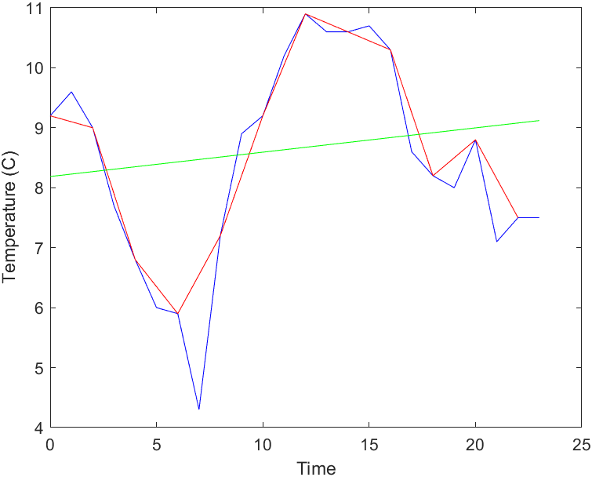

The interpolated values are nowhere near the actual ones. Therefore, a degree one (straight line) model is not appropriate for this data.

**Task 2:**

time = 0:23;

time_even = time(1, 1:2:23);

time_odd = time(1, 2:2:24);

temp = [9.2, 9.6, 9.0, 7.7, 6.8, 6.0, 5.9, 4.3, 7.2, 8.9, 9.2, 10.2, 10.9, 10.6, 10.6, 10.7, 10.3, 8.6, 8.2, 8.0, 8.8, 7.1, 7.5, 7.5];

temp_even =temp(1, 1:2:23);

temp_odd =temp(1, 2:2:24);

for ii = 1:9

P = polyfit(time_even,temp_even,ii);

temp_int_odd = polyval(P, time_odd);

MSE(ii) = sum((temp_int_odd - temp_odd).^2)/length(temp_odd);

end

plot(1:9, MSE);

xlabel('degree');

ylabel('MSE');

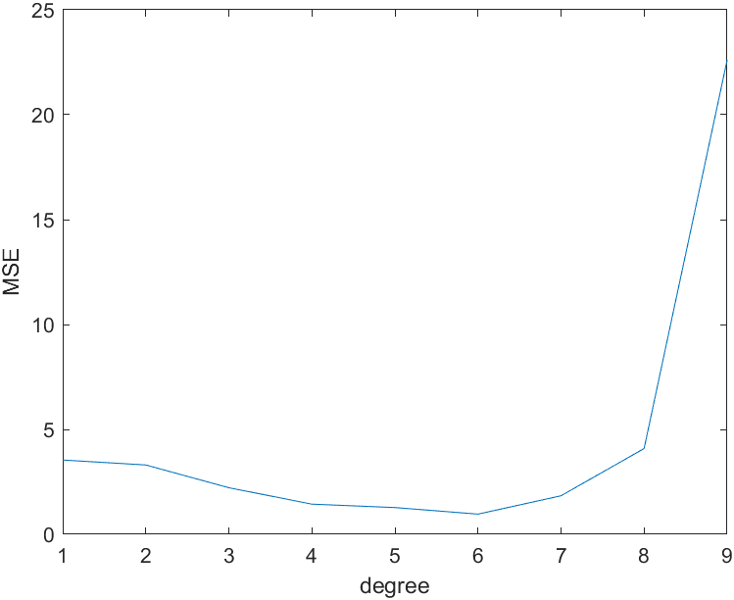

According to the graph, the best interpolation would be by a degree 6 polynomial.   
MSE = 0.9627 (for degree 6).