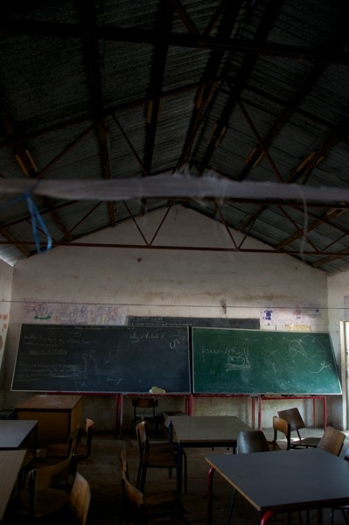
The view from inside a perforated block window classroom at midday.

