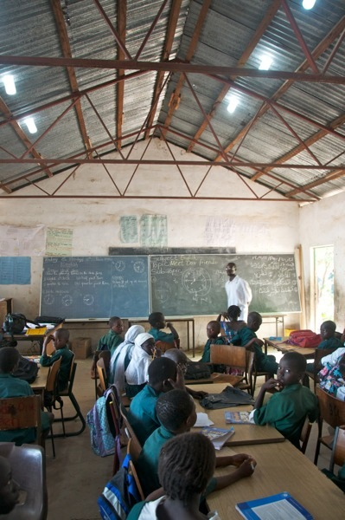
A classroom in the same building as the prior picture with solar bottle bulbs installed.

