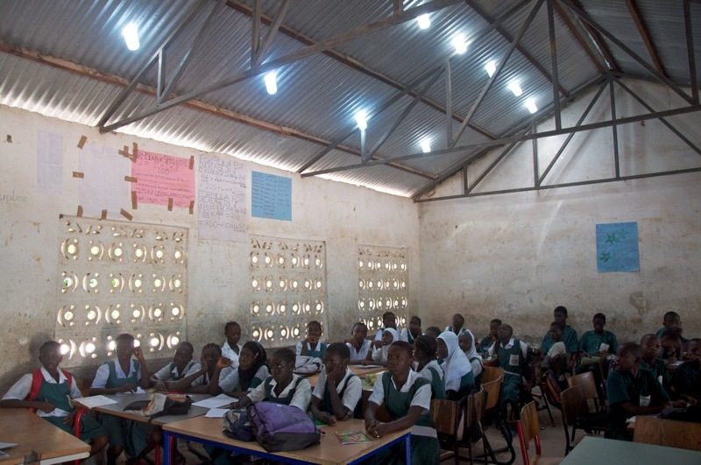
Another classroom at Kembujeh Lower Basic School after installation of ten Solar Bottle Bulbs.

