**Software Engineering**

**Final Report**

**Birds of Prey**

Team 6 Members:

Sebastian Farias - Team Leader and Technical Writer

Maaz Ansari - Configuration Manager

Anibal Ruiz - API - Liaison

Jean Claude Charles Boute - Webmaster

**Table of Contents**

1. Game Overview
2. User Guide

2.1 Installation & Gameplay (Youtube link)

2.2 System Requirements

2.3 Installation

1. Game Screenshots

3.1 Main Menu

3.2 Load Level Menu

3.3 How To Play

3.4 Credits and Story

3.5 Red Bird

3.6 Thief/Enemy

3.7 Crate (Tower Structure)

3.8 Ground

3.9 Forest Background

3.10 Level 1

3.11 Level 2

3.12 Level 3

3.13 Level 4

3.14 Level 5

3.15 Game Over Menu

1. Glossary & References
2. Our Experience
3. Team Member Contributions
4. **Game Overview**

Our team’s objective was to recreate the mobile game “Angry Birds” that is playable on IOS and Android devices. The main objective is to make it playable on desktop and laptop devices. Our design goal was to also incorporate a different art style for the birds, enemies, tower structures, environments, and create our own level layouts. Our version of the game is called “Birds of Prey”.

This game is a simple 2-D single player game in which any person of any age can play. The user interface will be simple to navigate as it will all have clear button layouts, and the instructions and controls of the game will be simple as well. It will be playable on all desktop and laptop devices by downloading the program and executing the files through unity. The story and setting of our game is that thieves have invaded the forest habitat of the birds, and it is up to the birds to destroy all of the thieves and their tower structures in order to take back the land that is rightfully theirs. To complete the game, the player controls the playable birds and must launch them and destroy the thieves and their tower structures for each level. Our game will be fast, easy to navigate, and fun to play. The player can play the game as many times as they want and can navigate through the entire game simply with a keyboard, and a mouse or a laptop trackpad.

1. **User Guide**

**2.1 Installation & Gameplay (Youtube link)**

[**https://youtu.be/AgLsL82lZ0E**](https://youtu.be/AgLsL82lZ0E)

**2.2 System Requirements**

* For this game to run on the Windows operating system, the following are the minimum requirements: Windows 7 SP1+, 8, 10, 64-bit versions only.
* For this game to run on macOS, the following are the minimum requirements: Mac OS X 10.12+.
* GPU requirements to run this game:

Graphics card with DX10 (shader model 4.0) capabilities.

**2.3 Installation**

Step 1: Download the folder with the executables for the game.

Step 2: Download unity hub using the following link:

<https://unity3d.com/get-unity/download>

Step 3: Load the unity hub and create a unity account and update to the latest version of unity (Editor Version 2020.3.30f1 is enough to run the game). Once loaded, choose the “Projects” tab on the left hand side.

Step 4: On the upper right hand corner of the unity hub, click the arrow next to the “Open” button and select “Add project from disk”; then find the folder with the executables of the game and select “Add project”.

Step 5: Once it is added to the project list, select and load the file. Once the game loads, click the play arrow on the top center of the screen and the game will run starting from the main menu.

1. **Game Screenshots**

**3.1 Main Menu**

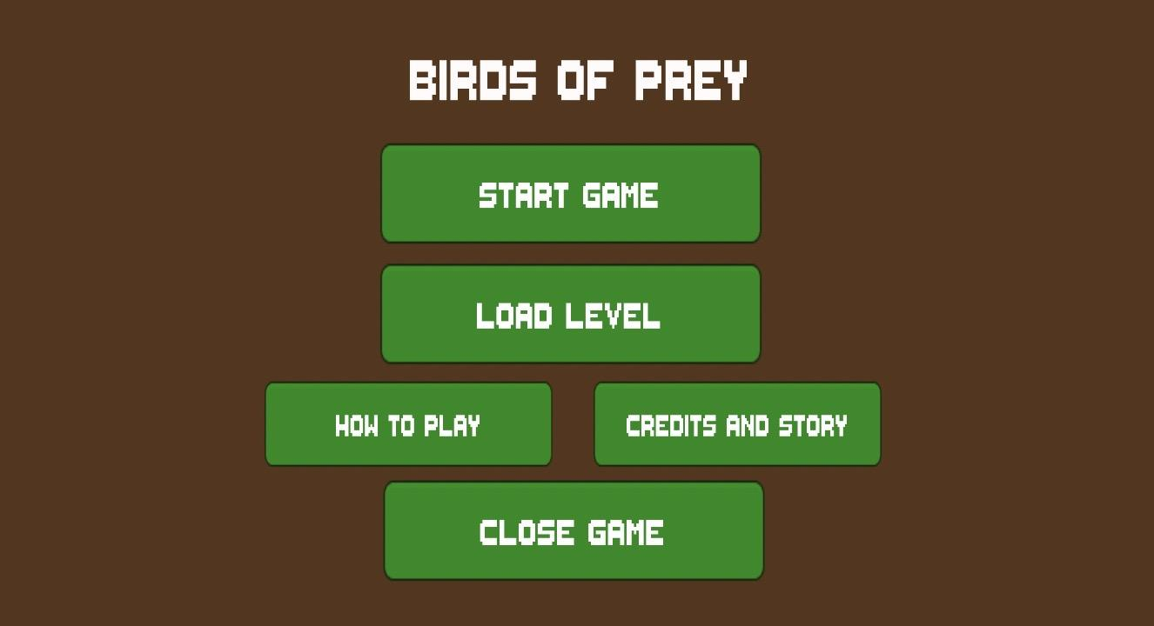

This is the main menu of the game and will appear when the game is launched. It is composed of “Start Game”, “Load Level”, “How To Play”, “Credits And Story”, and “Close Game” buttons. All of these buttons lead to different things. The buttons are green and pop out on the screen. The text is white so they appear more clear with the green boxes.

**3.2 Load Level Menu**

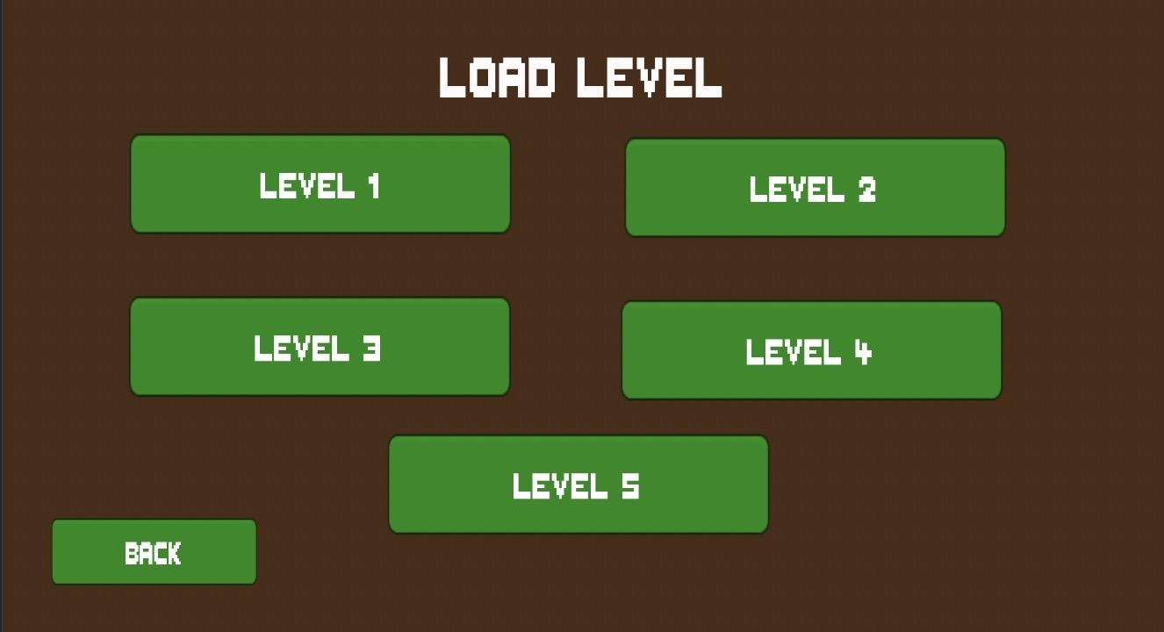

There are five levels in the “Birds of Prey” game. In this load level screen, you have the option to choose any of the five levels to play and complete. There is also a back button to exit the level. There are five different levels in this game and you can access whatever one you want to from the “Load Level” screen. You can always choose a different level if you do not feel like completing the current level or if you are stuck.

**3.3 How To Play**

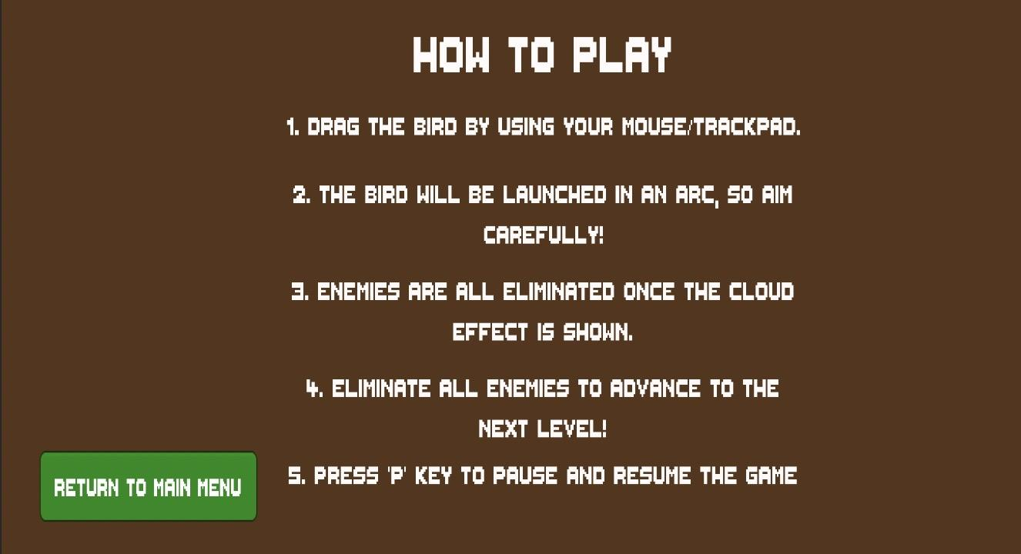

The How to Play screen displays instructions on how to operate the “Birds of Prey'' game. It tells you exactly how to operate the characters and how to progress through the game. The instructions are pretty simple and are step by step. They are written in very clear terms so it does not confuse the player.

**3.4 Credits and Story**

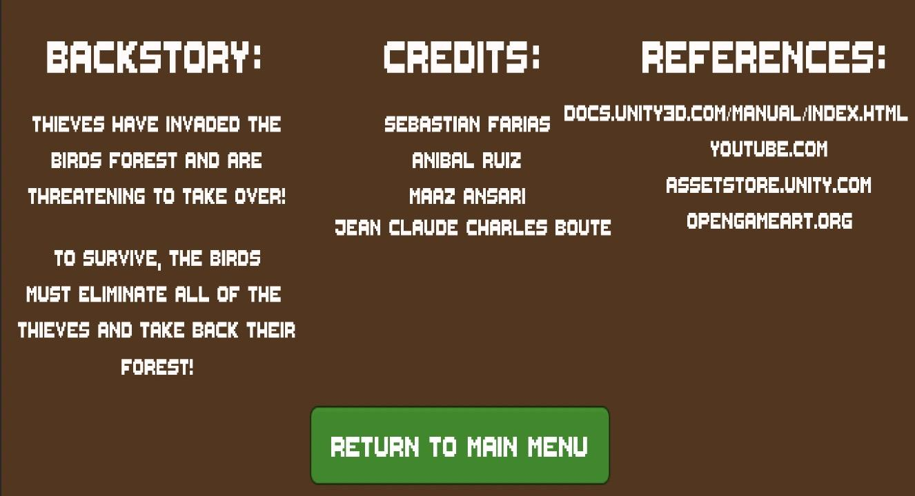

The Credits and Story screen gives information on who created the came and a short backstory about the game. There are references included as well. The references are all of the sources that we used to create the game. The credits include our four team members.

**3.5 Red Bird**



This is the playable character that the user will be using throughout the whole game. The user will launch this bird towards the enemies to eliminate them and to clear the level.

**3.6 Thief/Enemy**

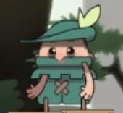

This is the enemy/thief of the game. These are the characters that you are supposed to defeat. This character is non-playable; this means that you cannot complete the levels utilizing this character, but the red bird must eliminate all of the thieves on the level in order to advance.

**3.7 Crate (Tower Structure)**

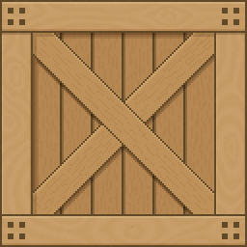

These crates are stacked on top of each other in order to create the enemy tower structures. There are multiple crates throughout the five levels. These towers are what will be guarding the thieves and what the user will be knocking down in the game.

**3.8 Ground**

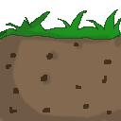

The ground is used on every level to give structural ground support for all of the game objects.

**3.9 Forest Background**

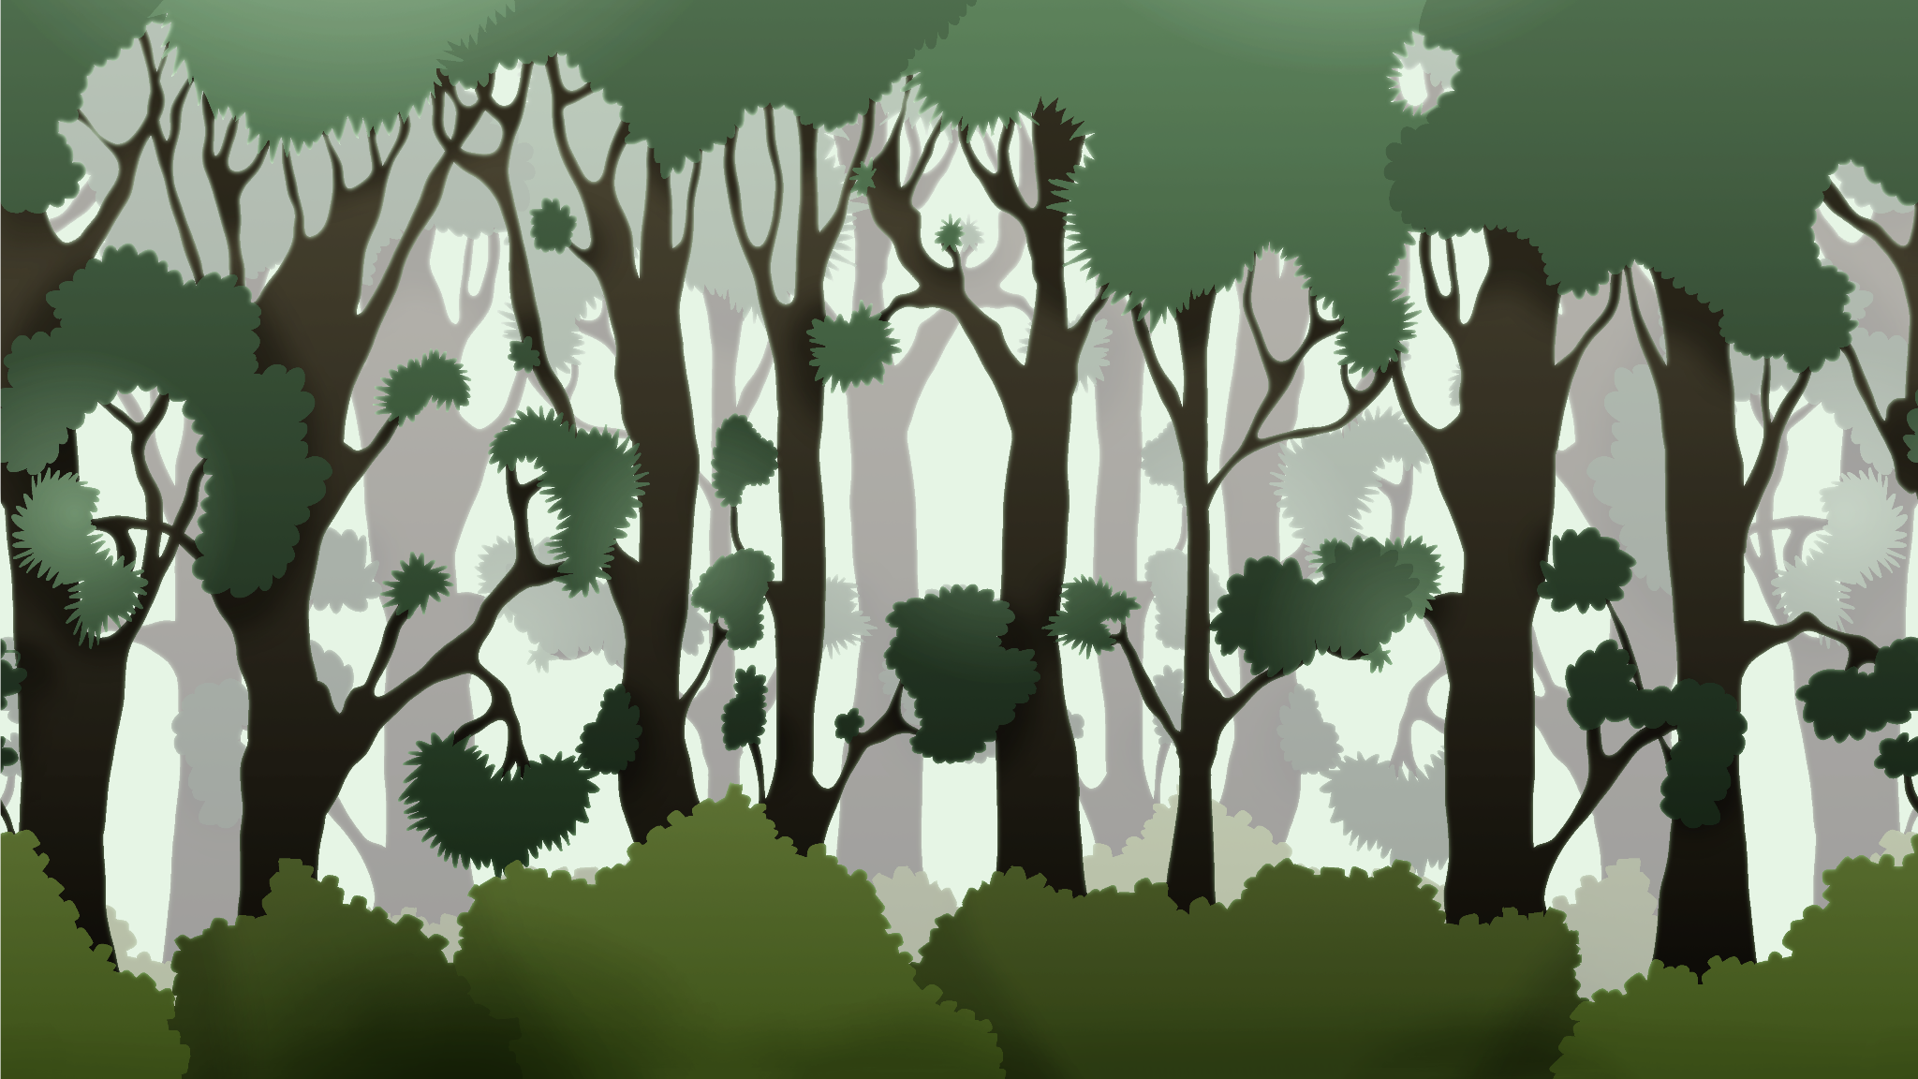

This is the background art of the game. The forest represents the bird’s habitat according to the backstory that we have created. This gives the game a lot more depth and perspective.

**3.10 Level 1**

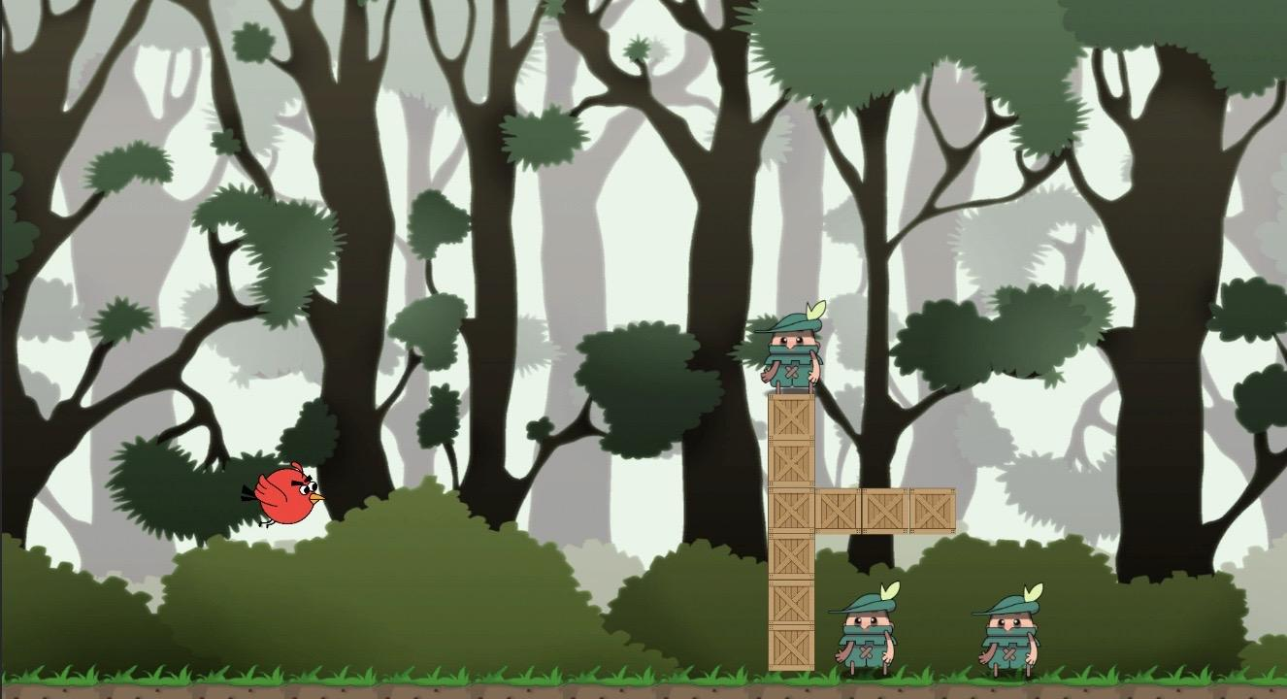

This is what the game looks like for level 1. There is the playable character shown on the left side of the screen. On the right side of the screen are multiple crates and the thieves located around the crates. The background is composed of trees and bushes. In total, there are three thieves the user must defeat in order to progress and move on to the next level.

**3.11 Level 2**

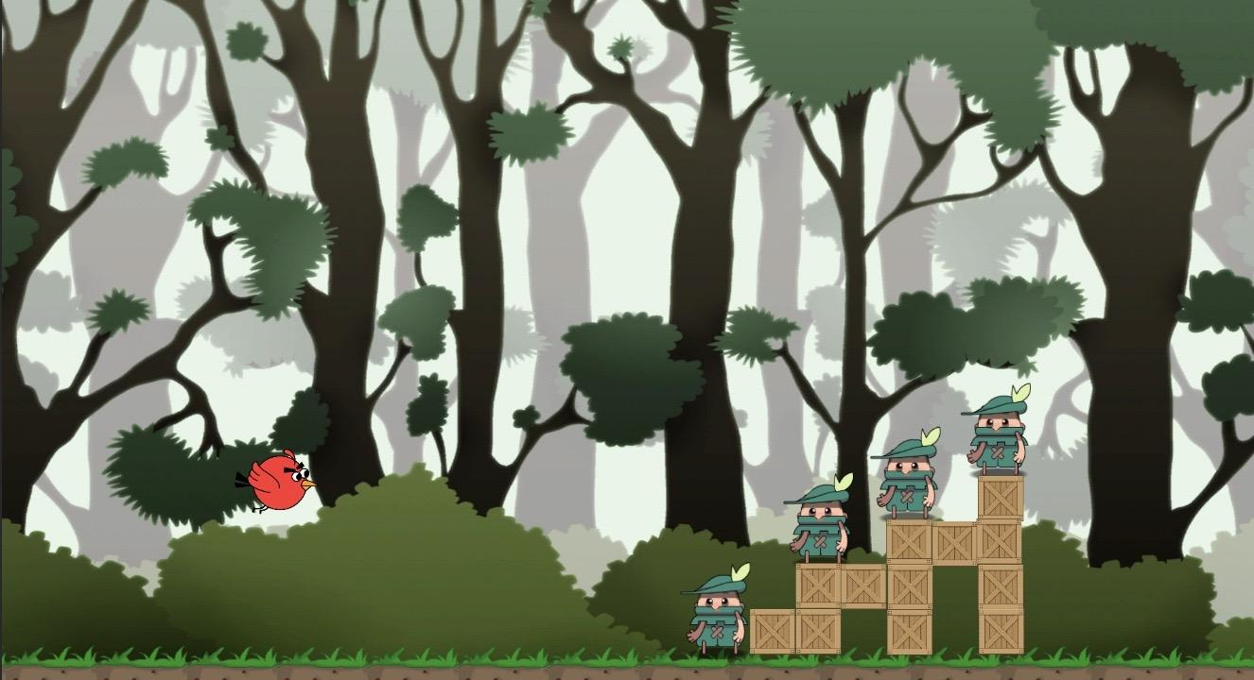

This is what the game looks like for level 2. There is the playable character shown on the left side of the screen. On the right side of the screen are multiple crates and the thieves located around the crates. The background is composed of trees and bushes. In total, there are four thieves the user must defeat in order to progress and move on to the next level.

**3.12 Level 3**

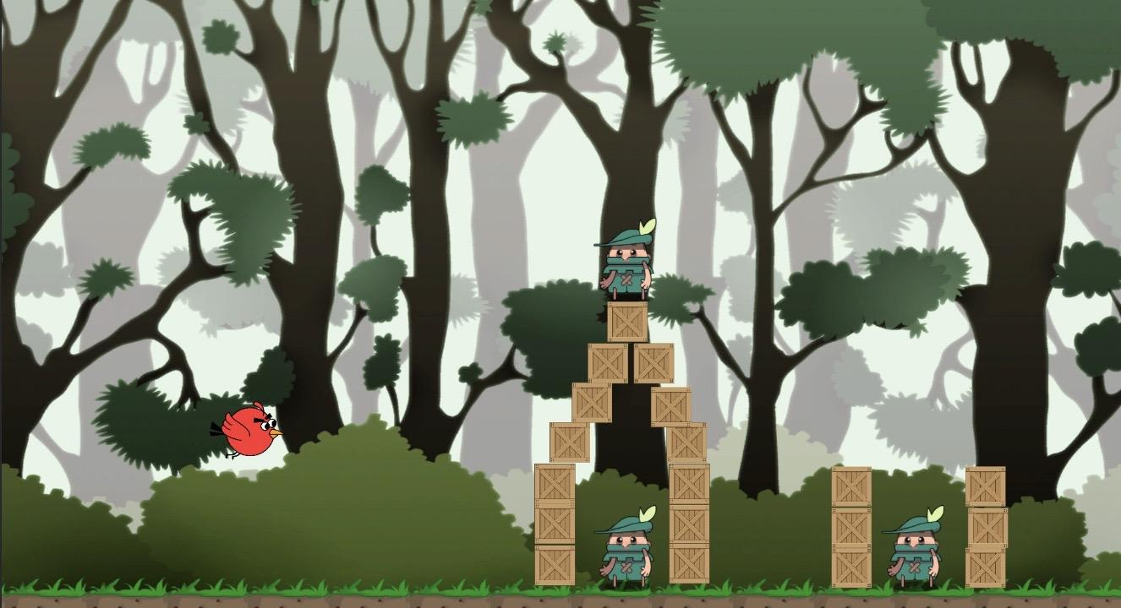

This is what the game looks like for level 3. There is the playable character shown on the left side of the screen. On the right side of the screen are multiple crates and the thieves located around the crates. The background is composed of trees and bushes. In total, there are three thieves the user must defeat in order to progress and move on to the next level.

**3.13 Level 4**

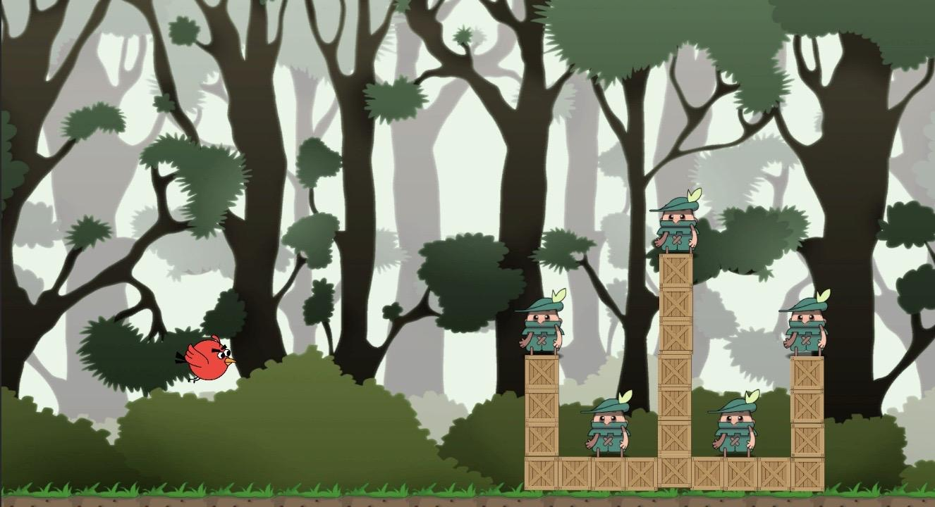

This is what the game looks like for level 4. There is the playable character shown on the left side of the screen. On the right side of the screen are multiple crates and the thieves located around the crates. The background is composed of trees and bushes. In total, there are five thieves the user must defeat in order to progress and move on to the next level.

**3.14 Level 5**

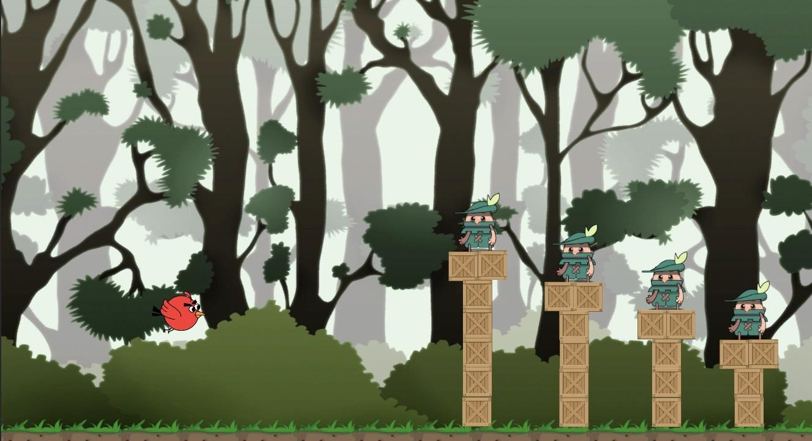

This is the fifth and final level. There is the playable character shown on the left side of the screen. On the right side of the screen are multiple crates and the thieves located around the crates. The background is composed of trees and bushes. In total, there are four thieves the user must defeat in order to complete the game.

**3.15 Game Over Menu**

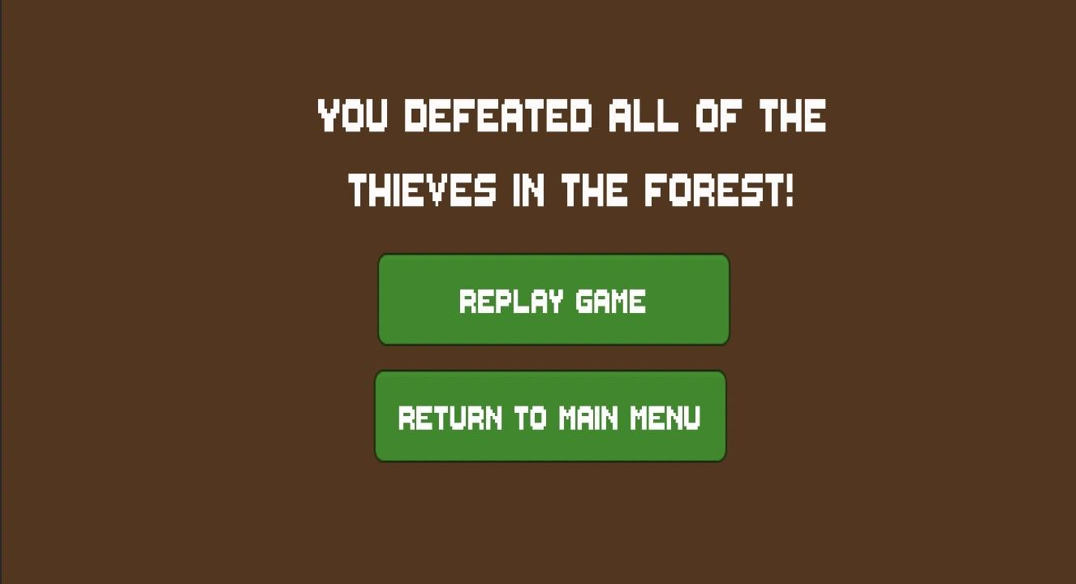

After all of the thieves are defeated in all five levels, the user has completed the game and this is the screen that pops up. Replay game will restart the game from level 1, and return to main menu will divert the user back to the main menu.

1. **Glossary & References**

* Coding Manual & Tutorials:

<https://docs.unity3d.com/Manual/index.html>

https://unity3d.com/get-unity/download

<https://www.youtube.com>

* Game Art:

<https://opengameart.org>

<https://assetstore.unity.com>

1. **Our Experience**

Our experience analyzing, designing, and implementing our project was a challenging, but insightful experience. In order for us to prioritize our time to meet the deadlines we held team meetings after class and always stayed in contact with each other at all times documenting our progress on the documents, as well as the writing of the source code. For each of the documents everyone was assigned similar tasks: two people were tasked with creating the graphs and modeling the project, and the two others were tasked to focus on the non-functional and functional requirements, as well as the high-level architecture design. We have learned that communication and trust is of the utmost importance when working on a team project; nothing can get done without a solid understanding of our tasks as well as trusting that your teammate will do their part. If one or two people lag behind or get stuck, it will affect the progression of the entire team, so it is just as important to recognize that your teammates are also counting on you whether you are the team leader or not because everyone is a piece of the puzzle. At the beginning, our team was struggling with ideas on the project and on top of that no one had extensive experience on the software lifecycle, so upon completing the implementation of our software project we proved to ourselves that as long as we use our resources and work as a team we can get the job done and do it well.

1. **Team Contributions**

Sebastian Farias:

My main contribution to the Final Report was to work on section 2 of this document. I recorded myself downloading unity, running the source code on my laptop, showing all of the features of our game, and then uploaded the video on my YouTube channel. Then, I explained the requirements that a system will need in order to download unity and run our game, and then I provided written steps that one must take in order to download unity and run the game. Section 5 was also a description of the creative process that our team underwent throughout the development of our software system.

Maaz Ansari:

My principal contributions to the Final Report involved me working on the screenshots of the game. I provided in depth explanations to what the screenshots mean. These screenshots are a quick overview of what the game looks like and the many aspects of it. The explanations give a better understanding of what the different aspects of the game are. Some of the explanations range from describing the main playable character all the way to the backgrounds of the levels.

Anibal Ruiz:

My contributions are the introduction of how our team’s objective is to recreate

the mobile game “Angry Birds” that is playable on IOS and Android devices. The main

objective is to make it playable on desktop and laptop devices. Also I wrote the game

overview, a little of the story behind the game. The story and setting of our game is that

thieves have invaded the forest habitat of the birds and it is up to the birds to destroy all

of the thieves and their tower structures in order to take back the land that is rightfully

theirs.

Jean Claude Charles Boute:

My main contributions to the project was that I went into detail with the introduction of the game with another team member in this group, which is part of the beginning which focuses on how the game is laid out and how to play the game also to be able to give a bit of background about the game and what it is about. We gave a bit of details of how the game works and what to expect while a player is playing our game, the game will be played on the computer unlike the mobile version. Which some might find more enjoyable to be able to use the mouse and keyboard.