Assignment 1

Aruzhan Boranbay

15N – 20P

1. <https://data.world/hdx/2b2a77fe-3fb9-4910-811f-f636ecd96e7e/workspace/query?filename=climate-change-indicators-for-kazakhstan-1.csv&newQueryType=SQL&selectedTable=climate_change_indicators_for_kazakhstan_1&tempId=1615622030412>

**SELECT * FROM climate_change_indicators_for_kazakhstan_1**

**LIMIT 120;**

1. .csv

­­­­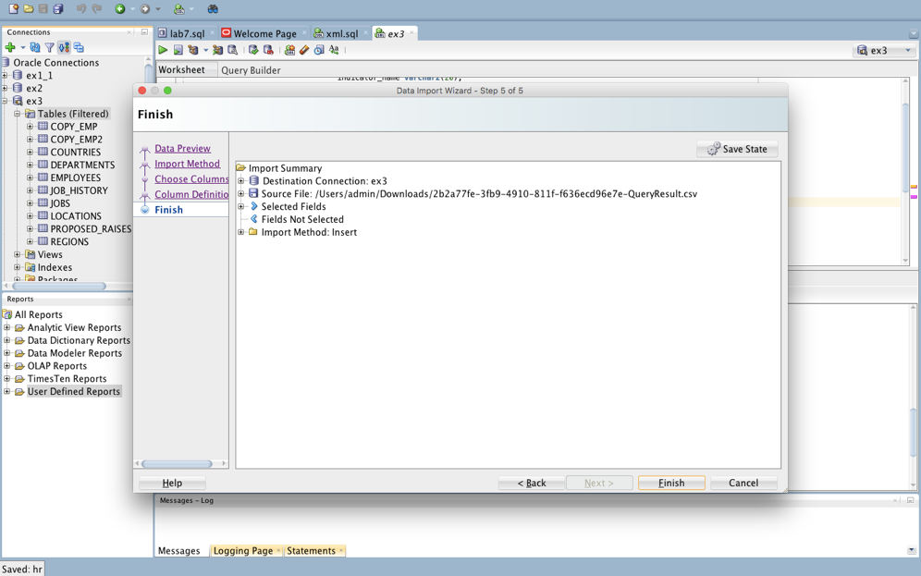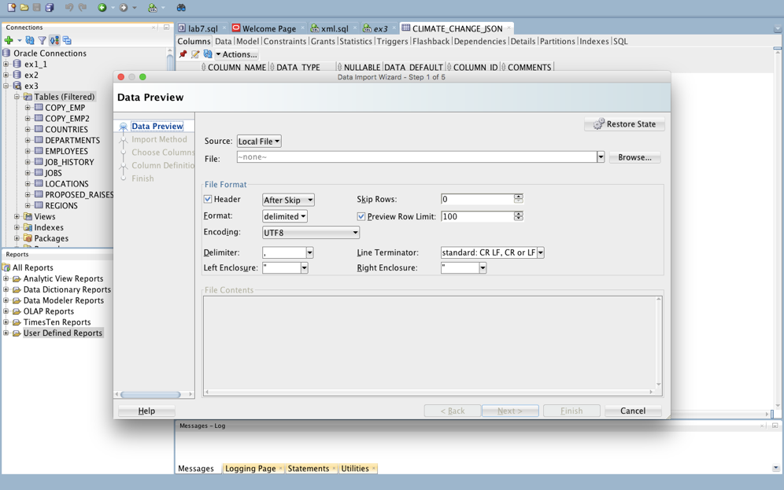

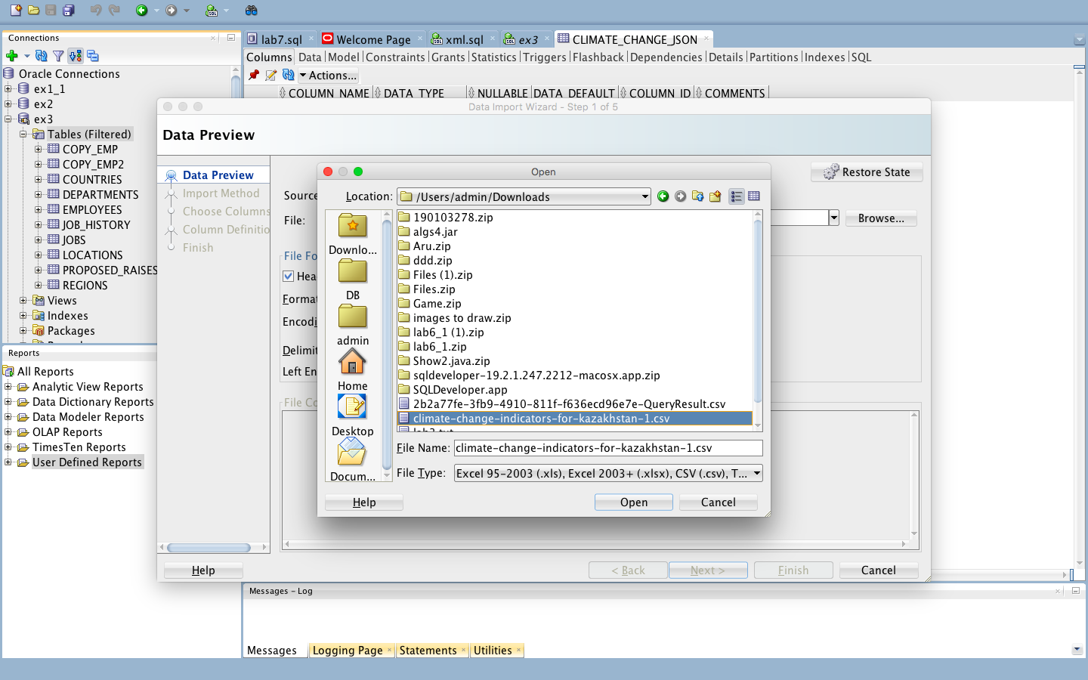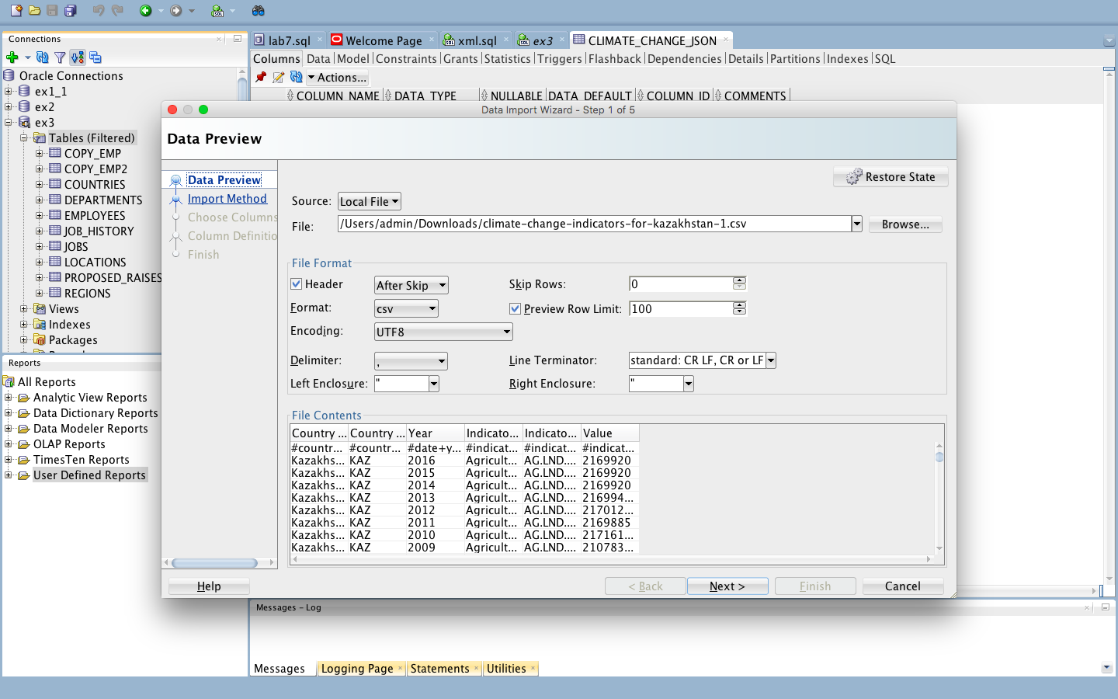

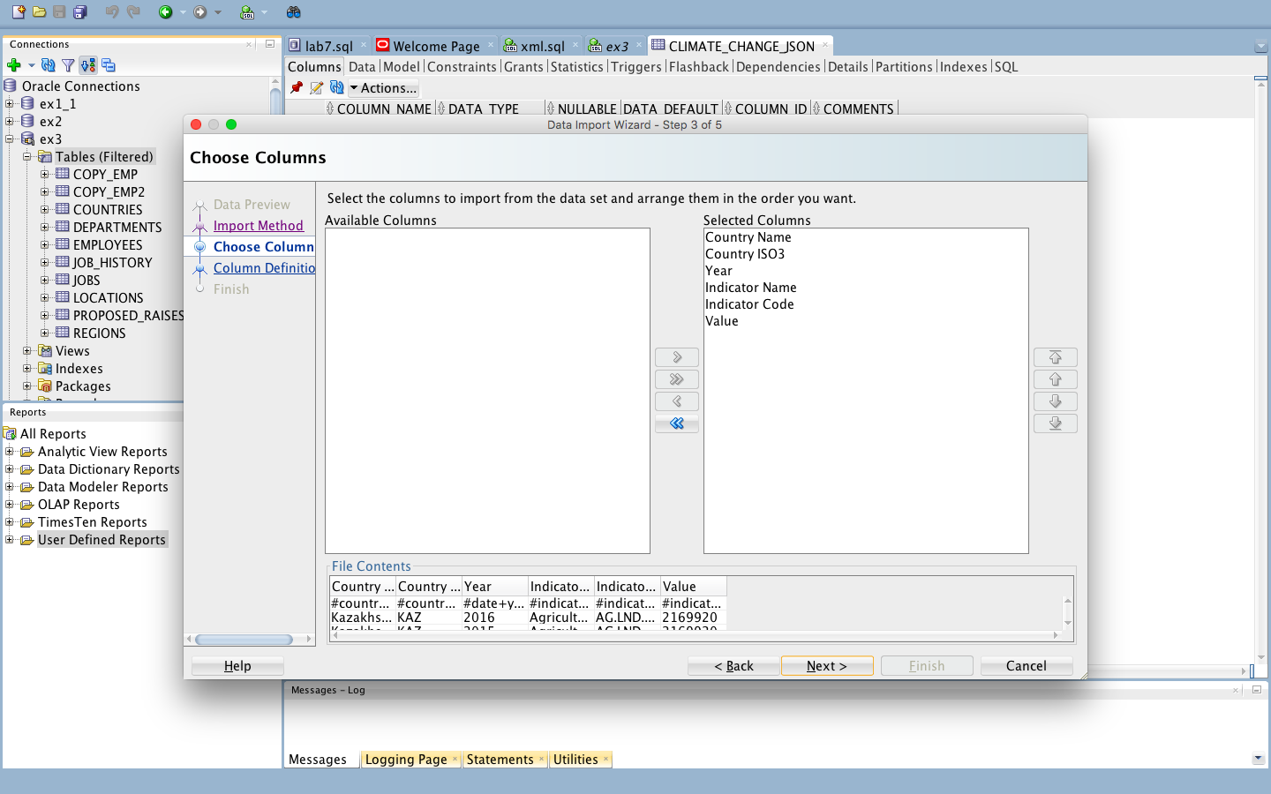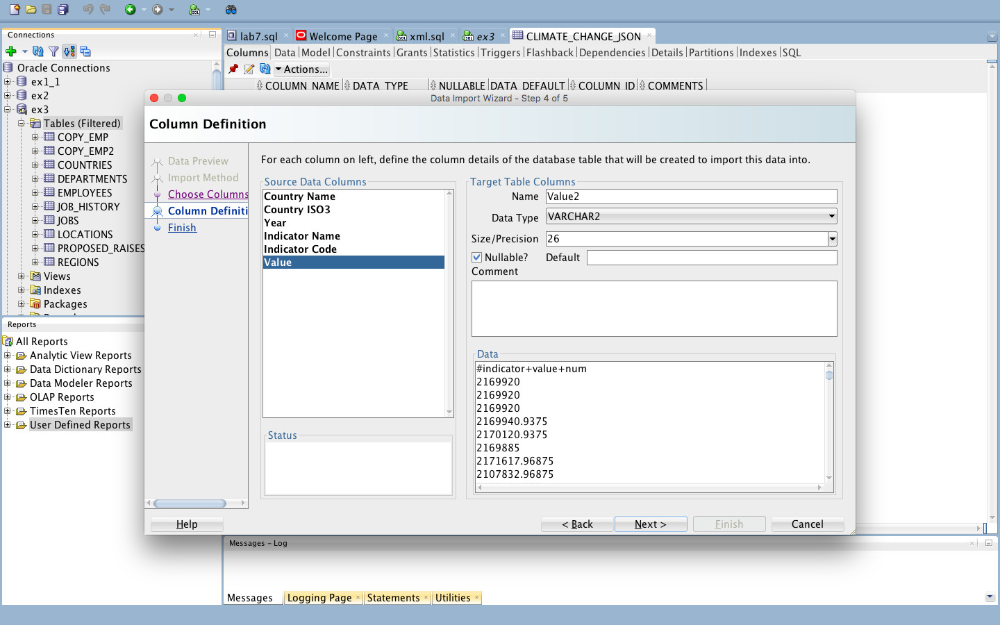

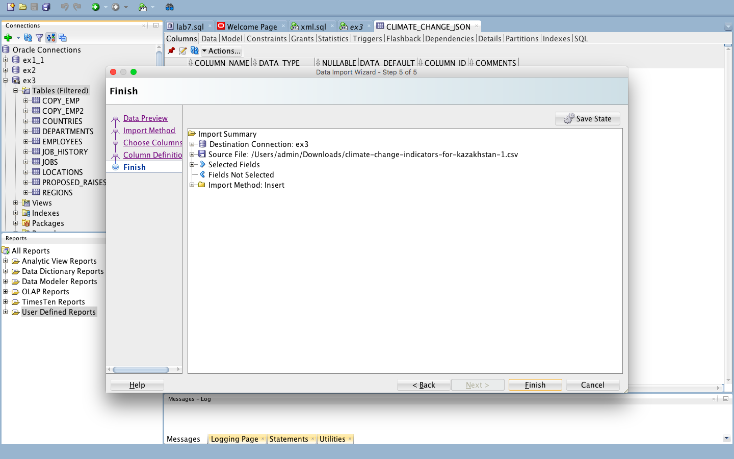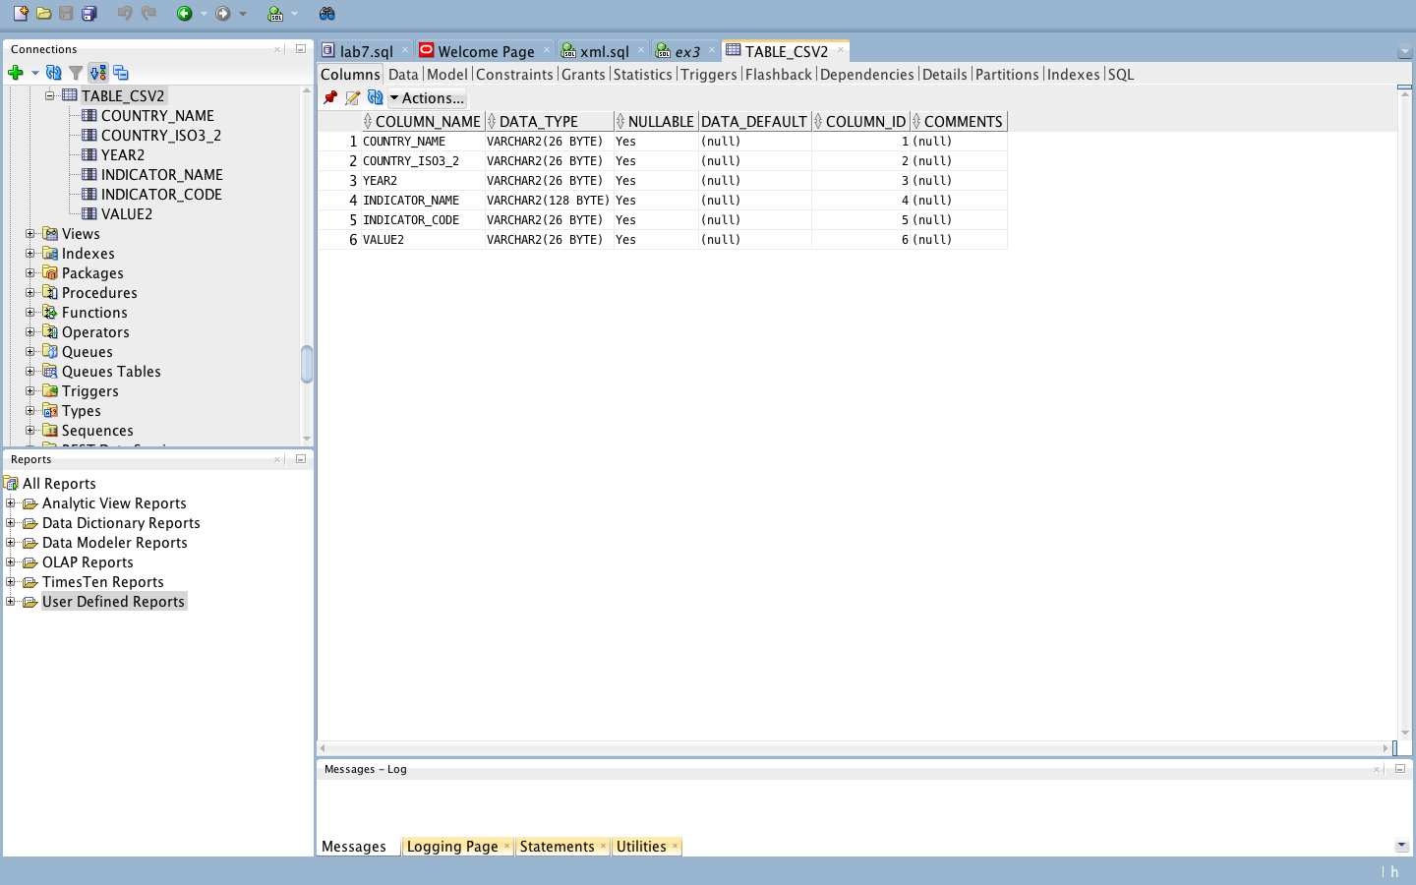

.json

DECLARE @JSON VARCHAR(max)

SELECT @JSON = BulkColumn

FROM OPENROWSET (BULK '/Users/admin/Downloads/2b2a77fe-3fb9-4910-811f-f636ecd96e7e-QueryResult.json',SINGLE_BLOB)

import

SELECT * INTO table_csv2

FROM OPENJSON(@JSON)

WITH

(

[COUNTRY_NAME] varchar(20),

[COUNTRY_ISO3] varchar(20),

[YEAR] number,

[INDICATOR_NAME] varchar(128),

[INDICATOR_CODE] varchar(26),

[VALUE] varchar(26)

);

SELECT * FROM table_csv2;

3)

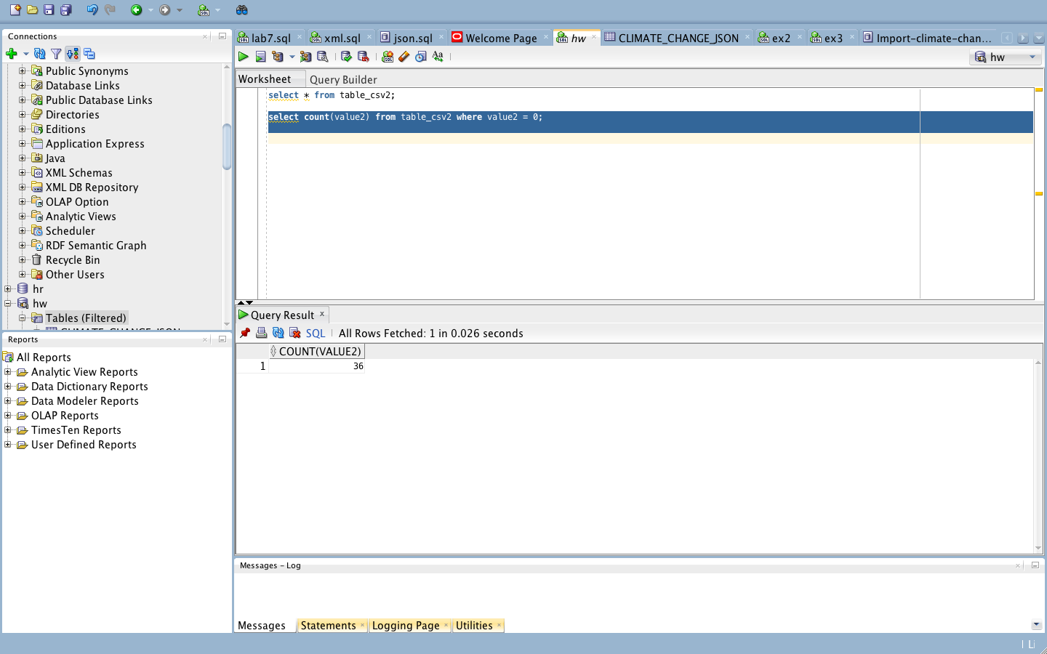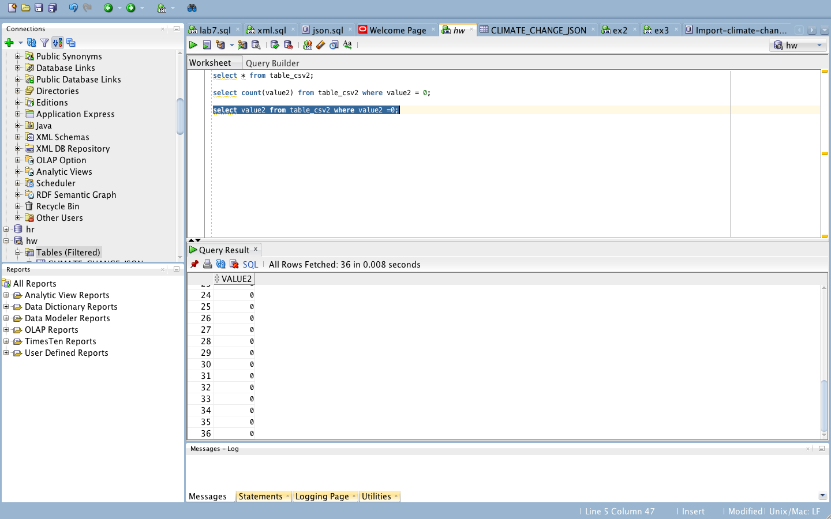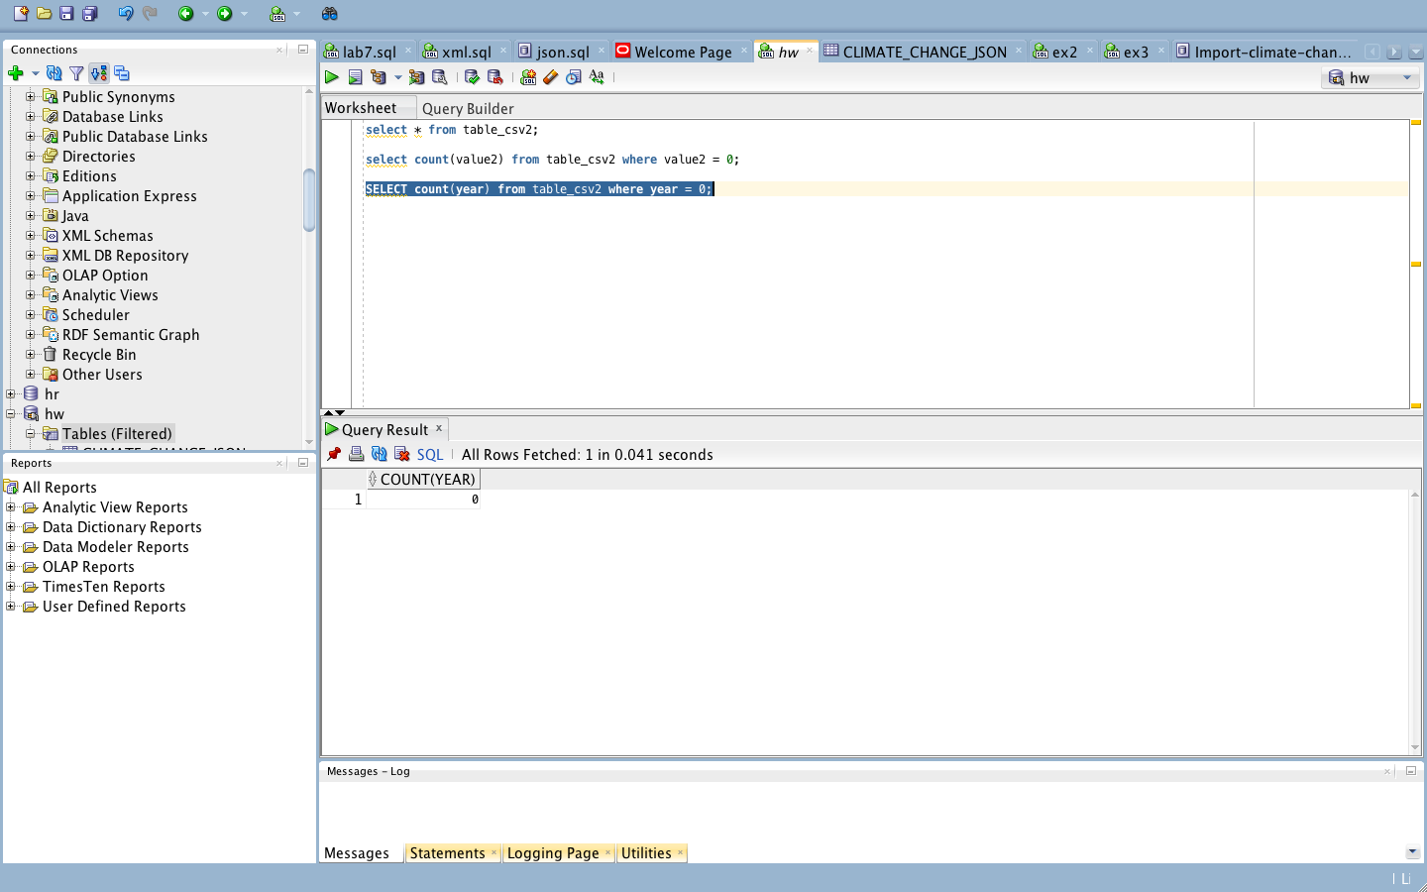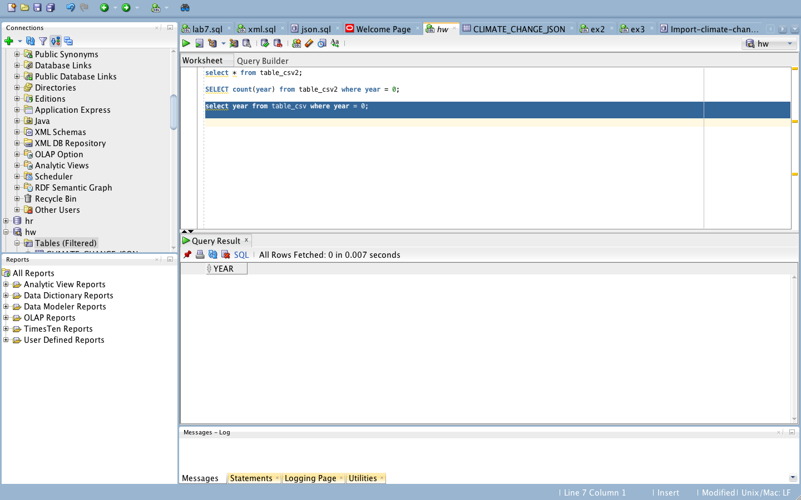

4)

1.

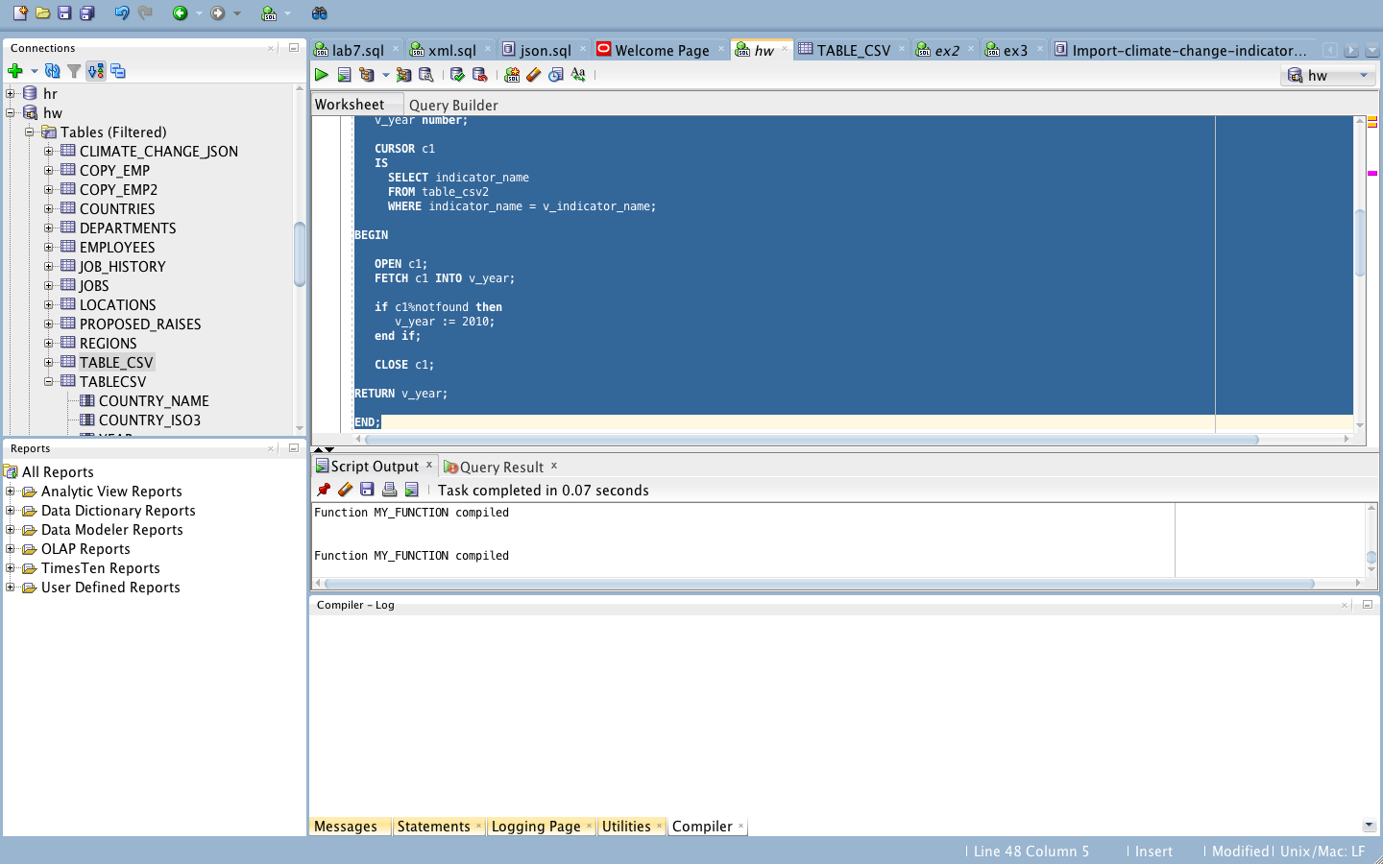

CREATE OR REPLACE Function my_function

( v_indicator_name IN varchar2 )

RETURN number

Is

v_year number;

CURSOR c1

IS

SELECT indicator_name

FROM table_csv2

WHERE indicator_name = v_indicator_name;

BEGIN

OPEN c1;

FETCH c1 INTO v_year;

if c1%notfound then

v_year := 2010;

end if;

CLOSE c1;

RETURN v_year;

END;

2.

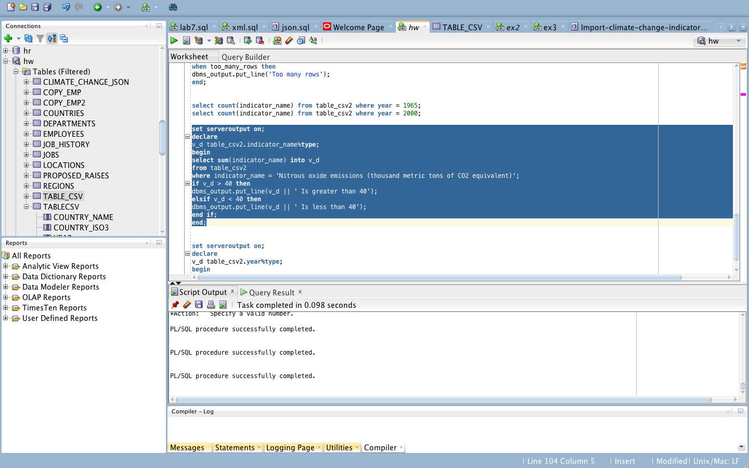

set serveroutput on;

declare

v_d table_csv2.indicator_name%type;

begin

select sum(indicator_name) into v_d

from table_csv2

where indicator_name = 'Nitrous oxide emissions (thousand metric tons of CO2 equivalent)';

if v_d > 40 then

dbms_output.put_line(v_d || ' Is greater than 40');

elsif v_d < 40 then

dbms_output.put_line(v_d || ' Is less than 40');

end if;

end;

3.

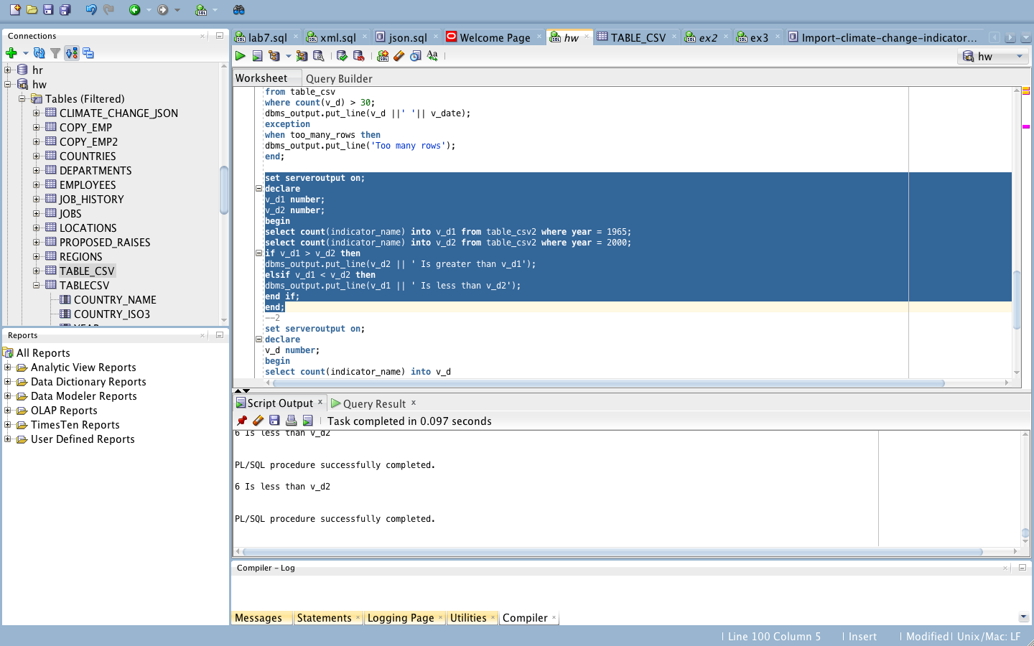

set serveroutput on;

declare

v_d1 number;

v_d2 number;

begin

select count(indicator_name) into v_d1 from table_csv2 where year = 1965;

select count(indicator_name) into v_d2 from table_csv2 where year = 2000;

if v_d1 > v_d2 then

dbms_output.put_line(v_d2 || ' Is greater than v_d1');

elsif v_d1 < v_d2 then

dbms_output.put_line(v_d1 || ' Is less than v_d2');

end if;

end;

5) Comparison criteria Oracle. MSSQL MySql

**Supports core sql** Yes yes yes

**Supports usage of procedures yes Yes Yes**

**Supports loopin** yes Yes Yes

**Can create variables yes Yes Yes**

**Can create packages** Yes Yes No

**Can create triggers yes Yes Yes**

**Use T/SQL No Yes Yes**

**Use DML yes Yes Yes**

**Use Pl/Sql Yes No Yes**