

Product Dissection for blinkit By Chandan Aruk

## Company Overview:

Blinkit is a leading Indian quick commerce (Q-commerce) company, founded in 2013 by Albinder Dhindsa and Saurabh Kumar. Initially known as Grofers, the company rebranded to Blinkit in 2021 to emphasize its commitment to ultra-fast delivery services. Headquartered in Gurugram, Haryana, Blinkit specializes in delivering groceries, household essentials, and daily items within 10-15 minutes through its mobile app and website.

The company operates on a hyperlocal supply chain model, utilizing dark stores—small, strategically located warehouses—to ensure swift order fulfillment. This model allows Blinkit to cater efficiently to the growing demand for instant deliveries in urban areas. Its revenue model is diversified, earning through commissions on product sales, delivery fees for smaller orders, and advertising partnerships with brands looking to promote their products on the platform.

In 2022, Blinkit was acquired by Zomato for approximately $568 million, a move that strengthened its market position and expanded its operational capabilities. Blinkit faces stiff competition from other Q-commerce giants such as Zepto, Swiggy Instamart, BigBasket Now, and Dunzo. Despite this, the company continues to grow rapidly, focusing on technological advancements like AI-driven demand forecasting to optimize inventory management and improve delivery efficiency.

Blinkit’s success lies in its ability to adapt to changing consumer behaviors, providing convenience, speed, and reliability in the fast-paced world of quick commerce.

## Product Dissection and Real-World Problems Solved by Blinkit:

Blinkit effectively tackles a range of real-world challenges through its innovative platform design, focusing on speed, efficiency, and customer satisfaction.

* **Ultra-Fast Delivery:** Blinkit revolutionizes the traditional grocery shopping experience by addressing the time constraints faced by urban consumers. Through optimized supply chain logistics, intelligent route planning, and dynamic rider management, the platform ensures groceries are delivered within 10 minutes, eliminating the need for time-consuming store visits.
* **Real-Time Inventory Management:** Unlike traditional retail models prone to stock discrepancies, Blinkit maintains accurate inventory levels by synchronizing data across multiple warehouses and the mobile app. This real-time tracking system minimizes the risk of out-of-stock situations, ensuring product availability for customers at all times.
* **Smart Cart and Personalized Recommendations:** Leveraging AI and machine learning algorithms, Blinkit enhances user convenience by offering smart cart features and personalized product suggestions. These recommendations are tailored based on users’ purchase history, browsing behavior, and preferences, creating a more intuitive and efficient shopping experience.
* **Seamless Payment Integration:** To address common transaction-related issues, Blinkit supports a wide range of secure payment options, including UPI, credit/debit cards, and digital wallets. The platform also features instant refund mechanisms, reducing payment friction and enhancing user trust.
* **Efficient Delivery Partner Management:** Blinkit’s robust delivery management system automates rider assignments based on real-time data, including location tracking, workload distribution, and traffic conditions. This ensures optimal delivery efficiency, reducing delays and improving service reliability.
* **Customer Loyalty Programs:** To foster long-term customer relationships, Blinkit implements loyalty programs that include rewards, referral incentives, and targeted promotional campaigns. These strategies help increase customer retention and encourage repeat purchases.

Collectively, these features significantly improve the overall user experience by solving critical issues such as delayed deliveries, stock unavailability, payment inefficiencies, and the lack of personalized shopping. The database schema will be designed to reflect these functionalities through dedicated modules for user management, orders, payments, inventory control, logistics optimization, and promotional activities.

## Case Study on Real-World Problems and Blinkit’s Approach to Solving Them:

Blinkit has revolutionized the quick commerce space by addressing everyday challenges through innovative solutions. This case study highlights specific user pain points and showcases how Blinkit’s core features effectively solve them. Additionally, it outlines how these solutions influence the platform’s database schema design.

### 1. Emergency Grocery Needs

**Problem:**  
Customers often need urgent groceries, such as missing ingredients during cooking or last-minute party essentials. Traditional delivery services with longer timelines cannot fulfill such immediate requirements.

**Blinkit’s Solution:**  
Blinkit’s 10-minute delivery model, powered by a network of dark stores and real-time rider assignment, ensures ultra-fast service. The platform uses dynamic algorithms to optimize routes and assign the nearest available rider for quick deliveries.

**Schema Impact:**

* **Order Management:** Real-time tracking with timestamps for order placement and delivery.
* **Rider Assignment:** Tables for rider availability, live locations, and optimized routes.
* **Warehouse Inventory:** Real-time updates to ensure accurate stock information.

### 2. Stock Unavailability

**Problem:**  
Inconsistent inventory management often results in out-of-stock items being displayed as available, leading to cancelled orders and customer dissatisfaction.

**Blinkit’s Solution:**  
Blinkit’s real-time inventory management system syncs stock levels across warehouses and the app interface. Predictive analytics also help in proactive stock replenishment.

**Schema Impact:**

* **Inventory Tables:** Real-time stock updates with SKU tracking.
* **Product Catalog:** Manages product details and availability status.
* **Order Validation:** Ensures stock availability before order confirmation.

### 3. Payment Processing Issues

**Problem:**  
Failed transactions, delayed refunds, and limited payment options are common pain points in e-commerce, affecting customer trust.

**Blinkit’s Solution:**  
Blinkit integrates multiple secure payment gateways, including UPI, cards, and wallets, with real-time transaction monitoring and automated refund processes for failed payments.

**Schema Impact:**

* **Payment Tables:** Track transactions, statuses, and payment methods.
* **Refund Management:** Automates refund initiation and tracking.
* **Transaction Logs:** For monitoring payment issues and audit purposes.

### 4. Lack of Personalized User Experience

**Problem:**  
Traditional shopping platforms offer limited personalization, requiring users to manually search for frequently purchased items.

**Blinkit’s Solution:**  
Blinkit employs AI-driven algorithms to offer personalized recommendations based on purchase history and browsing patterns, enhancing convenience and engagement.

**Schema Impact:**

* **User Activity Tracking:** Captures purchase history and behavior data.
* **Recommendation Engine:** Generates personalized suggestions.
* **Customer Segmentation:** For targeted marketing and promotions.

### 5. Delivery Delays Due to Inefficient Rider Management

**Problem:**  
Manual rider assignments and poor route optimization often cause delivery delays, especially during peak hours.

**Blinkit’s Solution:**  
Blinkit uses automated systems to assign orders based on rider proximity, workload, and real-time traffic conditions, ensuring timely deliveries.

**Schema Impact:**

* **Rider Performance:** Tracks efficiency, delivery times, and feedback.
* **Dynamic Routing:** Optimizes delivery routes with live traffic data.
* **Delivery Logs:** For performance analysis and continuous improvement.

**Key Takeaways for Schema Design:**

Blinkit’s ability to address these real-world problems is supported by a robust database schema comprising:

* **User Management:** Storing user profiles and activity data.
* **Order & Inventory Management:** Ensuring real-time tracking and stock updates.
* **Payment Processing:** Handling secure transactions and refunds.
* **Personalization:** Powering AI-driven recommendations.
* **Logistics & Rider Management:** Optimizing deliveries and tracking performance.

This schema design ensures operational efficiency, scalability, and an enhanced user experience, aligning with Blinkit’s core business objectives.

## Top Features of Blinkit:

1. **10-Minute Delivery Promise-**

* **Description:** Blinkit’s core value proposition is its ability to deliver groceries and daily essentials within 10 minutes of order placement.
* **Impact:** Enhances customer satisfaction through quick service, setting it apart from traditional e-commerce platforms.

**2. Real-Time Inventory Management-**

* **Description:** The app shows live stock availability, ensuring that customers only order items that are currently in stock.
* **Impact:** Reduces order cancellations due to stockouts and improves supply chain efficiency.

**3. Seamless User Experience-**

* **Description:** The app features an intuitive interface with easy navigation, quick search, and personalized recommendations based on purchase history.
* **Impact:** Increases user engagement and retention through a smooth, hassle-free shopping experience.

**4. Wide Product Range-**

* **Description:** Blinkit offers a vast selection of groceries, personal care products, household items, and more, catering to diverse customer needs.
* **Impact:** Encourages customers to rely on Blinkit as a one-stop shop for daily essentials.

**5. Efficient Order Tracking-**

* **Description:** Real-time order tracking allows customers to monitor the status of their deliveries from preparation to doorstep arrival.
* **Impact:** Builds trust and transparency, reducing customer anxiety around delivery timelines.

**6. Multiple Payment Options-**

* **Description:** Supports various payment methods, including UPI, credit/debit cards, net banking, and wallets.
* **Impact:** Offers flexibility, catering to different customer preferences for secure transactions.

**7. Hyperlocal Warehousing Model-**

* **Description:** Utilizes dark stores strategically located in high-demand areas to fulfill orders quickly.
* **Impact:** Reduces delivery time and operational costs while maintaining product freshness.

**8. Personalized Recommendations and Offers-**

* **Description:** AI-driven algorithms suggest products based on browsing and purchase history, along with personalized discounts.
* **Impact:** Enhances the shopping experience and drives higher conversion rates.

**9. Scheduled Deliveries-**

* **Description:** Allows users to schedule deliveries at their convenience, in addition to instant delivery options.
* **Impact:** Provides flexibility for customers who prefer to plan their orders in advance.

**10. Robust Customer Support-**

* **Description:** 24/7 customer support through chat and call to address queries, complaints, and issues promptly.
* **Impact:** Ensures quick resolution of problems, improving customer satisfaction and loyalty.

## Schema Description:

The schema design for Blinkit is structured to support its fast delivery model, focusing on real-time order processing, inventory management, and efficient logistics. The schema reflects the relationships between key entities involved in the Blinkit ecosystem, such as users, products, orders, payments, and deliveries.

**Key Entities and Attributes:**

**1. Users Entity**

The **Users** entity stores customer information required for placing orders, receiving deliveries, and communication.

* **Attributes:**
  + user_id (Primary Key): Unique identifier for each user.
  + name: Full name of the user.
  + email: Email address for communication.
  + phone: Contact number of the user.
  + address: Default delivery address of the user.
  + registration_date: Date when the user signed up on the platform.

**2. Products Entity**

The **Products** entity contains details of all items available for purchase.

* **Attributes:**
  + product_id (Primary Key): Unique identifier for each product.
  + name: Name of the product.
  + category: Category to which the product belongs.
  + price: Cost of the product per unit.
  + description: Brief details about the product.

**3. Inventory Entity**

The **Inventory** entity helps track product availability across warehouses.

* **Attributes:**
  + inventory_id (Primary Key): Unique identifier for inventory records.
  + product_id (Foreign Key): Links to the **Products** table.
  + stock_quantity: Number of units available.
  + warehouse_location: Storage location of the product.

**4. Orders Entity**

The **Orders** entity logs every purchase made by a user and its status.

* **Attributes:**
  + order_id (Primary Key): Unique identifier for each order.
  + user_id (Foreign Key): Links to the **Users** table.
  + order_date: Timestamp when the order was placed.
  + status: Current status of the order (e.g., Processing, Delivered, Cancelled).

**5. Order Items Entity**

The **Order Items** entity connects products with specific orders, as each order may contain multiple products.

* **Attributes:**
  + order_item_id (Primary Key): Unique identifier for each order item.
  + order_id (Foreign Key): Links to the **Orders** table.
  + product_id (Foreign Key): Links to the **Products** table.
  + quantity: Number of units ordered.
  + price: Price per unit at the time of purchase.

**6. Payments Entity**

The **Payments** entity records transaction details for orders.

* **Attributes:**
  + payment_id (Primary Key): Unique identifier for each payment.
  + order_id (Foreign Key): Links to the **Orders** table.
  + payment_method: Mode of payment (e.g., UPI, Card, Wallet, COD).
  + payment_status: Status of payment (e.g., Successful, Pending, Failed).
  + transaction_date: Timestamp of payment processing.

**7. Riders Entity**

The **Riders** entity holds information about delivery personnel.

* **Attributes:**
  + rider_id (Primary Key): Unique identifier for each rider.
  + name: Full name of the rider.
  + phone: Contact number of the rider.
  + assigned_area: Geographic location where the rider operates.

**8. Deliveries Entity**

The **Deliveries** entity tracks the delivery status of each order.

* **Attributes:**
  + delivery_id (Primary Key): Unique identifier for each delivery.
  + order_id (Foreign Key): Links to the **Orders** table.
  + rider_id (Foreign Key): Links to the **Riders** table.
  + delivery_status: Status of the delivery (e.g., Out for Delivery, Delivered).
  + delivery_time: Timestamp when the order was delivered.

**Relationships:**

* **Users ↔ Orders:** One-to-Many (A user can place multiple orders).
* **Orders ↔ Order_Items:** One-to-Many (An order can contain multiple items).
* **Products ↔ Order_Items:** One-to-Many (A product can appear in multiple order items).
* **Orders ↔ Payments:** One-to-One (Each order has one payment transaction).
* **Orders ↔ Deliveries:** One-to-One (Each order is associated with a delivery).
* **Riders ↔ Deliveries:** One-to-Many (A rider can handle multiple deliveries).
* **Products ↔ Inventory:** One-to-Many (A product can be stocked in multiple warehouses).

## ER Diagram:

Let's construct an ER diagram that vividly portrays the relationships and attributes of the entities within the Blinkit schema. This ER diagram will serve as a visual representation, shedding light on the pivotal components of Blinkit 's data model. By employing this diagram, you'll gain a clearer grasp of the intricate interactions and connections that define the platform's dynamics.

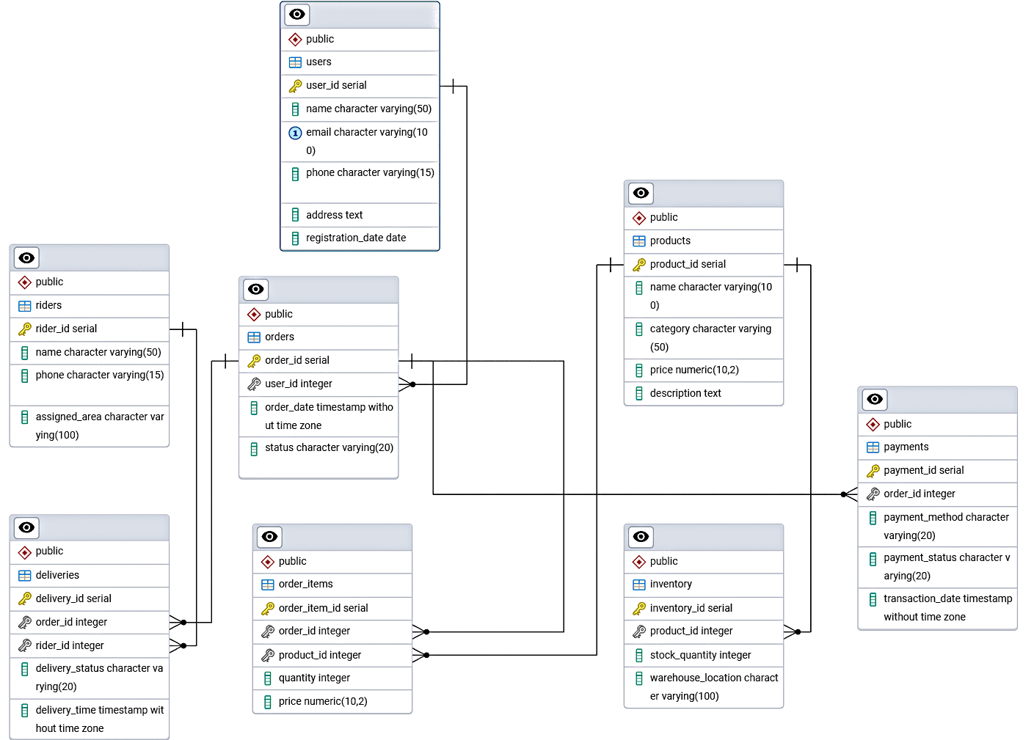

Now, let's discuss how the database design effectively addresses real-world challenges faced by Blinkit.

**1. Efficient Order Processing:**  
 The relational structure connects the Users, Orders, and Order_Items tables seamlessly. When a customer places an order, the system quickly retrieves user information, verifies product availability, and processes the order—all in real-time. This ensures a smooth and fast ordering experience, which is critical for Blinkit's promise of quick deliveries.

**2. Real-Time Inventory Management:**  
 The Inventory table is directly linked to the Products table, allowing Blinkit to track stock levels across different warehouses. This design helps prevent stockouts or overselling by updating product quantities automatically after each purchase, ensuring accurate inventory visibility for both customers and the company.

**3. Optimized Delivery Tracking:**  
 The Deliveries table, linked with both Orders and Riders, helps assign delivery tasks efficiently based on rider availability and location. By tracking the delivery_status and delivery_time, Blinkit can monitor real-time delivery progress, optimize routes, and maintain its promise of delivering within 10 minutes.

**4. Secure and Streamlined Payments:**  
 The Payments table is connected to the Orders table, capturing details like payment methods, statuses, and transaction timestamps. This structure ensures secure payment processing, easy reconciliation of transactions, and quick resolution of payment-related issues, enhancing customer trust.

**5. Data Integrity and Scalability:**  
 Finally, the use of primary and foreign keys enforces data integrity, ensuring relationships between tables remain consistent. The schema is also designed to be scalable, allowing Blinkit to handle increasing user data, product catalogs, and transactions as the business grows.

## 

## Conclusion

The Blinkit SQL project provided a comprehensive understanding of database schema design, data modeling, and real-world problem-solving through structured data management. By analyzing Blinkit’s core features, user interactions, and operational workflows, we designed a relational schema that supports efficient order processing, real-time inventory management, secure payment handling, and optimized delivery tracking.

The Entity-Relationship Diagram (ERD) effectively captured key entities such as **Users, Orders, Products, Inventory, Payments, Riders,** and **Deliveries**, illustrating their attributes and relationships. This schema not only ensures data integrity and consistency but also supports scalability to accommodate Blinkit’s rapid growth and evolving business needs.

Through this project, we gained valuable insights into how robust database design plays a crucial role in enhancing platform performance, improving user experiences, and solving real-world challenges in the fast delivery ecosystem.