2024 年ソフトウェア演習2B

第４ 回課題

**B243392　　ALCANDER IMAWAN　　2024年6月25日**

**Q1**

**プログラム**

main.cpp

1: #include <iostream>

2: #include <random> //to use std::mt19937

3: #include <cmath> //for std::pow and std::sqrt

4: #include <vector>

5: #include <cstdlib> //for std::atof and std::atoi

6: #include <fstream>

7: #include <iomanip>

8:

9: double calculateMean (const std::vector<double>& arr, int n){

10: double sum = 0.0;

11: for(int i= 0; i < n; i++){

12: sum += arr[i];

13: }

14: return sum / n;

15: }

16:

17: double calculateVariance(const std::vector<double>& arr, int n){

18: double sum = 0.0;

19: double mean = calculateMean(arr, n);

20:

21: for (int i= 0; i < n; i++){

22: sum += std::pow(arr[i] - mean, 2);

23: }

24: return sum / n;

25: }

26:

27: int main (int argc, char *argv[]){

28: double meanDifferenceSquared, varianceDifferenceSquared;

29: if(argc != 5){

30: std::cerr << "Usage: " << argv[0] << " <seed> <number of data> <mean> <variance>" << std::endl;

31: return 1;

32: }

33:

34: //parse input

35: std::uint32_t seed = std::atoi(argv[1]);

36: int numData = std::atoi(argv[2]);

37: double mean = std::atof(argv[3]);

38: double variance = std::atof(argv[4]);

39:

40: double stdev = std::sqrt(variance);

41:

42: std::cout << "Calculating sample mean and sample variance" <<std::endl;

43:

44: std::vector<double> arr;

45: //

46: std::mt19937 mt(seed); //instantiate 32-bit Mersenne Twister with a seed from std::random_device to ensure different results every run

47:

48: //create a reusable random number generator that generates uniform numbers between -100 and 100

49: std::normal_distribution<double> randoms{mean, stdev};

50: //put random numbers in arr

51: for(int count = 0; count < numData; ++count){

52: arr.push_back(randoms(mt));

53: }

54:

55: std::ofstream outfile("plot_data.txt");

56: outfile << "N\tMeanDifferenceSquared\tVarianceDifferenceSquared\n";

57:

58: // Calculate squared differences

59: for(int i = 100; i <= numData; i += 100){

60: meanDifferenceSquared = std::pow(calculateMean(arr, i) - mean, 2);

61: varianceDifferenceSquared = std::pow(calculateVariance(arr, i) - variance, 2);

62:

63: outfile << i << "\t" << meanDifferenceSquared << "\t" << varianceDifferenceSquared << "\n";

64: }

65:

66: outfile.close();

67: std::cout << "Data saved to plot_data.txt" << std::endl;

68: return 0;

69: }

**解説**

**動作確認**

Data saved to plot_data.txt

Plot_data.txt

N MeanDifferenceSquared VarianceDifferenceSquared

100 0.0103786 0.0175694

200 0.00187758 0.00142483

300 0.000270825 0.000769888

400 0.000538777 0.000384614

500 0.000665555 0.00591506

600 2.42007e-05 0.00537752

700 0.000742843 0.00497827

800 0.00142535 0.00344825

900 0.000155548 0.0017347

1000 0.000196631 0.00137239

1100 0.000737603 0.00269971

1200 0.000489377 0.00133032

1300 0.000264515 0.00165191

1400 0.000158869 0.00315386

1500 0.000349483 0.001978

1600 0.000794502 0.00131933

1700 0.000516864 0.00160336

1800 0.000912338 0.0017477

1900 0.000584689 0.00189066

2000 0.000660701 0.00194345

2100 0.000174878 0.00202137

2200 0.00026961 0.00112756

2300 0.000251723 0.000875984

2400 0.000418808 0.000487835

2500 0.000123877 0.000855268

2600 0.000158729 0.000673903

2700 0.00016915 0.000378366

2800 0.000103726 0.000206894

2900 0.000153929 0.000202593

3000 0.000123642 6.92101e-05

3100 0.000127404 8.05281e-05

3200 0.000154629 5.74922e-05

3300 1.1365e-05 0.000180523

3400 1.61586e-05 8.29125e-05

3500 2.83436e-05 2.35843e-05

3600 6.05951e-05 4.10438e-05

3700 1.6171e-05 4.78518e-06

3800 9.06973e-07 2.08673e-05

3900 4.54796e-06 1.99806e-05

4000 3.49748e-05 8.03822e-06

4100 6.9424e-05 1.92141e-06

4200 0.000117525 3.57647e-05

4300 6.30825e-05 0.000110551

4400 2.96631e-05 0.000141169

4500 6.78097e-05 0.000162772

4600 6.52549e-05 0.000273645

4700 0.000112284 8.87016e-05

4800 0.000100868 2.72363e-05

4900 8.54177e-05 2.98613e-06

5000 6.66216e-05 6.9164e-06

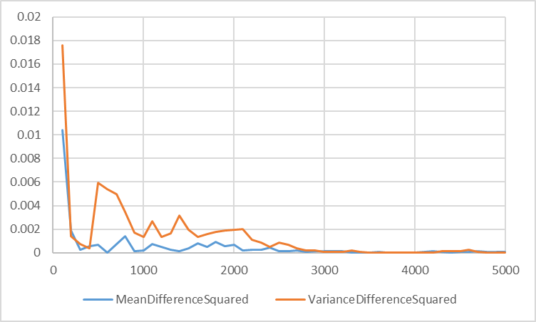

**Q2**

**プログラム**

**解説**

**動作確認**

**Q3**

**プログラム**

あ

**解説**

**動作確認**

**Q４**

**プログラム**

あ

**解説**

**動作確認**

**自己チェック項目**

4 静的リンクライブラリを作成できる.

4 静的リンクライブラリのリンク方法を理解した.

4 動的リンクライブラリを作成できる.

3 動的リンクライブラリのリンク方法を理解した.

4 それぞれのライブラリをリンクしたプログラムの実行時の振る舞いを理解した.