7.1 Electronic Data Interchange

Electronic Data Interchange (EDI) is the electronic exchange of business documents in a standard, computer-processable, uni-versally accepted format between trading partners. EDI is quite different from sending electronic mail messages or sharing files through a network, or a bulletin board. In EDI, the computer applications of both the sender and the receiver, referred to as Trading Partners (TPs) have to agree upon the format of the business document which is sent as a data file over an elec-tronic messaging service. Figure 7.1 illustrates the traditional methods of business documents handling versus sending these documents over EDI.

Since data is exchanged in standard pre-defined formats, it becomes possible to exchange business documents, irrespective of the computerised business application at either end of com-munication. For example, the Supplier's Accounts Receivable application for raising an Invoice for payment could still be implemented on a file system using COBOL while the customer's Accounts Payable may be based on an RDBMS such as ORACLE.

Figure 7.2 illustrates how EDI messages can be used to totally automate the procurement process between two trading partners.

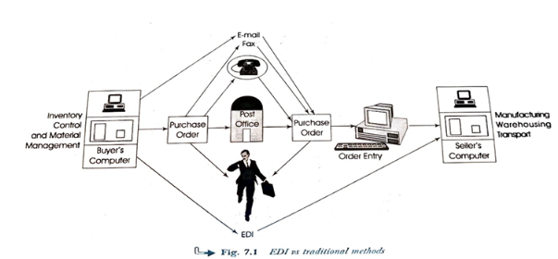

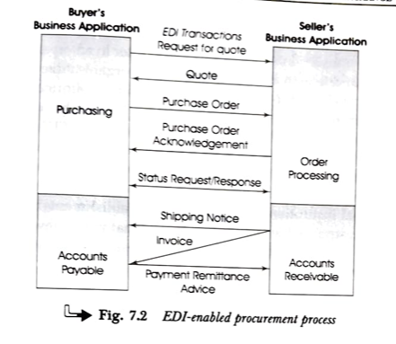

Once data are entered into the buyer's computer system and transmitted electronically, the same data get entered into the seller's computer, without the need for re-keying or re-entry. This is normally referred to as application-to-application EDI. EDI can be fully integrated with application programs. This allows data to flow electronically between trading partners without the need for re-keying, and between internal applications of each of the trading partners.

The repeated keying of identical information in the traditional paper-based business communication creates a number of problems that can be significantly reduced through the usage of

EDI. These problems include:

• Increased time

• Low accuracy

• High labour charges

• Increased uncertainty

EDI consists of standardised electronic message formats for common business documents such as Request for Quotation,

Purchase Order, Purchase Order Change, Bill of Lading, electronic transaction sets enable the computer in an organisation to communicate with a computer in another organisation withe actually producing paper documents. It thus eliminates the human effort required to read, sort, and physically transpon such documents. The documents for which standard EDI formath are either in existence or under development, constitute about 85 percent of the official communications associated with commercial transactions among business, government, and educational institutions, and non-profit establishments in most of the industrialised world. It is estimated that in the developing countries also, the preponderance of these documents is in similar proportion.

In order to take full advantage of EDI's benefits, a company must computerise its basic business applications. Trading partners are individual organisations that agree to exchange EDI transactions. EDI cannot be undertaken unilaterally but requires the co-operation and active participation of trading partners. Trading partners normally consist of an organisation's principal suppliers and wholesale customers. Since large retail stores transact business with a large number of suppliers, they were among the early supporters of EDI. In the manufacturing sector, EDI has enabled the concept of Just-In-Time (JIT) inventory to be implemented. JIT reduces inventory and operating capital requirements.

7.2 Costs and Benefits

Where EDI has been implemented, computers electronically exchange business documents with each other, ideally without human intervention. This reduces operating costs, administrative errors, and delivery delays. The benefits accruing from EDI implementations can be classified into direct benefits and long-term strategic benefits

7.2.1 Direct Benefits of EDI

• Since the transfer of information from computer to computer is automatic, there is no need to re-key information. Data is only entered at the source.

• The cost of processing EDI documents is much smaller than that of processing paper documents.

• Customer service is improved. The quick transfer of business documents and marked decrease in errors allow orders to be met faster.

• Information is managed more effectively.

7.2.2 Strategic Benefits

• Customer relations are improved through better quality and speed of service.

• Competitive edge is maintained and enhanced.

• Reduction in product costs can be achieved.

• Business relations with trading partners get improved.

• More accurate sales forecasting and business planning is possible due to availability of information at the right place at the right time.

• There is improved job satisfaction among data entry operators, clerks, etc. when they are re-deployed in more creative activities.

Most organisations with mature EDI programs find that they order more frequently, more orders of smaller quantities. This is consistent with the principles of JIT manufacturing and Quick response (QR) retailing, and requires greater flexibility in the supply chain. Reliance on fax technology limits flexibility and makes it necessary to carry out time-intensive error-prone re-keying of data. If only one order is received per week, then there are up to five working days to process that order. However, if orders are received daily or even hourly via EDI, the processing time is dramatically reduced. This is where EDI is clearly superior.

Even if a trading partner is planning to send only purchase or Eers electronically at this time and perhaps infrequently, at that, there still may not be a choice about implementing EDI Most organisations, even the largest and most prestigious ones, find that implementing EDI involves a phased approach consequently, some functions may not be in place from the start It is quite common for a large organisation to convert order processing from paper-based to EDI first and bring in other processes later.

Implementing purchase orders on EDI is typically the first step. It is easy to cost-justify and involves the fewest interruptions to the overall environment. Other transactions such as invoices, delivery notices and functional acknowledgments are usually implemented soon thereafter.

7.3 Components of EDI Systems

The three main components required to be able to send or receive EDI messages are:

• EDI standards

• EDI software

• Communication networks

7.3.1 EDI Standards

While using EDI, it becomes possible for a business application on the computer of one organisation to communicate directly with the business application on the computer of another organisation. This exchange of information should be independent of hardware, software or the nature of implementation at either of these two organisations.

In order to achieve this, it is required to extract data from the business application and to transform it into a standard format which is widely, if not universally, acceptable. This standard

data, when recieved at the destination, is interpreted and automatically delivered to the recipient application in an acceptable form.

The exchange of business documents in a commonly agreed structured format necessitated the development of EDI standards. EDI standards are basically data standards in that they lay down the syntax and semantics of the data being exchanged. In the US, the transportation industry was one of the first to develop EDI standards. Certain large segments of the retail industry also saw the advantages of EDI and proceeded to develop unique standards. They developed their own standards because the earlier standards of the transportation industry were not adequate to accommodate some of the retailers' requirements. The Uniform Communication Standard (UCS) was devised by the grocery segment and adopted by them and several other retail sectors. Meanwhile, in Europe, other sets of standards were developing. These were Trade Data Interchange (TDI) for warehousing, Organisation for Data Exchange by Tele Transmission in Europe (ODETTE) for the automobile industry, and Data Interchange for Shipping (DISH).

Independent efforts resulted in standards for participants in specific industries in the US. It soon became evident, however, that all businesses could benefit from the use of EDI. Some groups promoted the idea of an industry-wide EDI standard. This led to the formation of the Accredited Standards Committee (ASC) X12. The X12 Committee of the American National Standards Institute (ANSI) has, therefore, developed standards for use by all US businesses. These are commonly known as ANSI X12 Standards. Today, EDI standards are firm but not static because the development of EDI is a continuing effort. Specific industry groups are continuing to evolve new transaction sets that may be candidates for standardisation.

UN/EDIFACT (EDI for Administration, Commerce and Transport) standard was announced in 1987 by the United Nations. The EDIFACT Standard has since been promoted by

data, when recieved at the destination, is interpreted and automatically delivered to the recipient application in an acceptable form.

The exchange of business documents in a commonly agreed structured format necessitated the development of EDI standards. EDI standards are basically data standards in that they lay down the syntax and semantics of the data being exchanged. In the US, the transportation industry was one of the first to develop EDI standards. Certain large segments of the retail industry also saw the advantages of EDI and proceeded to develop unique standards. They developed their own standards because the earlier standards of the transportation industry were not adequate to accommodate some of the retailers' requirements. The Uniform Communication Standard (UCS) was devised by the grocery segment and adopted by them and several other retail sectors. Meanwhile, in Europe, other sets of standards were developing. These were Trade Data Interchange (TDI) for warehousing, Organisation for Data Exchange by Tele Transmission in Europe (ODETTE) for the automobile industry, and Data Interchange for Shipping (DISH).

Independent efforts resulted in standards for participants in specific industries in the US. It soon became evident, however, that all businesses could benefit from the use of EDI. Some groups promoted the idea of an industry-wide EDI standard. This led to the formation of the Accredited Standards Committee (ASC) X12. The X12 Committee of the American National Standards Institute (ANSI) has, therefore, developed standards for use by all US businesses. These are commonly known as ANSI X12 Standards. Today, EDI standards are firm but not static because the development of EDI is a continuing effort. Specific industry groups are continuing to evolve new transaction sets that may be candidates for standardisation.

UN/EDIFACT (EDI for Administration, Commerce and Transport) standard was announced in 1987 by the United Nations. The EDIFACT Standard has since been promoted by

replacing paper documents. EDIFACT activity is undertaken by two international organisations. The ISO is responsible for developing syntax rules and the data dictionary. The United Nations Economic Commission is the other agency concerned with the use, promotion and standardisation of EDIFACT messages.

The basic unit of communication among EDI trading partners defined by EDIFACT is an interchange. An interchange consists of functional groups of messages. Each functional group may contain many messages of the same type. Every message consists of a collection of segments with each segment comprising data elements, both composite and otherwise. Special delimiters are specified in the service segment to be used as separators for segments, component data elements and (composite) data elements. UN/EDIFACT is the subject matter of a separate chapter.

Transmission of EDI messages in standard formats over data networks is enabled using separate standards defined by ITU and other international organisations.