**Week 2 – Quiz**

**1. What is the number '1, 283, 004' in words?**

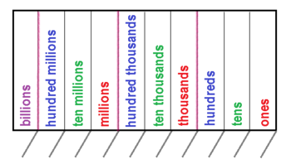

**1, 2 8 3, 0 0 4**

**One million, two hundred and eighty-three thousand and four**

**2. What is '1,000,000,000' called?**



**1, 0 0 0, 0 0 0, 0 0 0**

**One Billion**

**3. Round 378 to the nearest 'tens'.**



**3 7 8**

**8 is 5 or more, add 1 to the 7 to make 8, pad to the right with zeros**

**380**

**4. Harry is planning a holiday for 4 people for 7 days.**

**Here are the costs for the holiday for each person:**

**Travel                              £150**

**Hotel                                £50 for EACH day**

**Spending money         £250**

**Work out the total cost of the holiday for 4 people for 7 days.**

**One Person = Travel + 7 days Hotel + Spending Money = £150 + 7x £50 + £250**

**= £150 + £350 + £250 = £750**

**4 People = 4 X £750 = £3,000**

**5. Paula expects to get 15 Christmas card. She receives 41. How many more did she get than expected?**

**41 – 15 = 26 cards more**

**6. Write 180 minutes in hours.**

**1 hour = 60 minutes**

$\frac{180}{60}$**= 3 hours**

**7. An egg box holds 6 eggs. If there are 165 eggs, how many boxes will be full and how many eggs will be remaining?**

$\frac{165}{6}$**= 27 Remainder 3 = 27 boxes and 3 eggs remaining**

**8. What is 67+138-67?**

**67 + 138 – 67 = 205 – 67 = 138**

**9. What does the  '=' sign mean?**

**Equals**

**10. What does 'C' button do on a calculator?**

**Clear**