**ARULKUMAR.** **A**

**Mobile:** **8754300277** **Email** **:** [**a.arulkumar@gmail.com**](mailto:a.arulkumar@gmail.com)

**Career** **Objective:**

In the quest of senior level assignments over innovative software projects that will reveal my R&D skills, through which I could put forth my valuable Technical & Managerial contribution to IT industry

About Me: A Core technical Person 90% & 10% Managerial

**IT** **Experience:** 24+ years into Software Development

10+ years as Technical Architect guiding large volume of development team across the globe both on-site & offshore.

**Last Served** **Company:** Tech Mahindra Ltd – **Last Played** **Role:** Java Technical Architect

-- **Current** **Clients:** Nissan Inc, US

**Duration:** 23rd Nov 2023 to 13th Jan 2025

**Last Worked Technical Stack**: Java / J2EE (jdk 21), AWS – SQS, Kafka, S3, ECS, EC2, Cloud watch Alarm, Step Function, State

Machine, Lambda, Angular, ReactJS, Oracle, Postgres, Mongo DB, Veracode, Sonar Qube, GitHub,

Bitbucket, Jenkins (DevOps), Maven, Gradle, Swagger – Open API, Docker etc.,

**Last Project Detail:**

**Project Name:** DMS – Dealer Management System

**Fron End** – Angular 17 along with HTML#, CSS, Bootstrap

**Back End DB:** Oracle

**ORM:** Hibernate

**Swagger** Open API

**Lombok** – for avoiding boiler plate codes

Source Control: **GitHub**

DevOps: **Jenkins** – along with Docker script for CI / CD

Maven, SonarQube & Veracode has been used in DevOps pipe-line for building, scanning (Standards) & Veracode Security

**OWASP ESAPI Framework** has been used in both UI & Microservices Code to fix the Security Vulnerabilities.

**AppDynamics** is been used as APM tool to get the transactions; dynamic call traces & to know the health of JVM along with

Thread -heap dumps

**Splunk** is used for Log analytics & preparing Dashboards with Error pie charts through which we can easily identify the % of java error & ORA error & Memory Errors etc.,

**Middleware Services:** Java Spring boot Microservices with all below patterns involved

**Bounded Context Pattern** – Table per microservice

**Saaga Pattern with Message Streaming using AWS MSK (Kafka)** for reducing https calls & making it as

Asynchronous for service-to-service calls with event driven approach – Choreography architecture.

**Transaction outbox Pattern:** Which is used for few use cases from business to handle dual write with

**T**able & Kafka along with deduplication

**Event Source Mapping Pattern** is implemented between Kafka topics & Lambdas which is connected through Cloud Watch alarm & log there by it enables and disables the Event source Trigger based on it’s error limit during message consumptions & pushes. Here I have implemented Step-Functions / State Machine script to do retry & error handling mechanism of AWS cloud.

**Programmatic retry** is also writteninside microservices & Lambdas**.**

**NB:** Initially we have tried with **AWS SQS** (Simple Queuing Service) because it has built in FIFO feature for topics. Later we have decided to go with AWS MSK (Kafka) due to Cost & Other reasons from Client side. I have done 2 POCs on this regard for both SQS & Kafka and showcased to client along with detailed technical & cost information such as Configuration, Machine type, Replication Factor & number of topics etc.,

**Find below the Kafka Use cases & Technical details used in my POCs.**

**Use case 1:**

Broker Instance Type: kafka.m5.xlarge

Broker per Availability Zone: 2

**Configuration:**

6 m5.large machine

# of Topic 1

Replication Factor 1

# of Partition 6

Testing with 500K records

**Result**

1. Max record rate: ±90K rec/sec (90 MB / sec)
2. Avg latency: 302 ms
3. Max latency: 600 ms

**Overall throughput would process 100K rec/sec**

**Use Case 2:**

1. Cluster size: 15 brokers
2. Machine type: kafka.m5.12xlarge
3. Partitions per topic: 15
4. Replication factor: 1
5. Max record rate: ±310K rec/sec (310 MB /sec)
6. Avg latency: 103 ms

**Overall throughput would process 500K rec/sec**

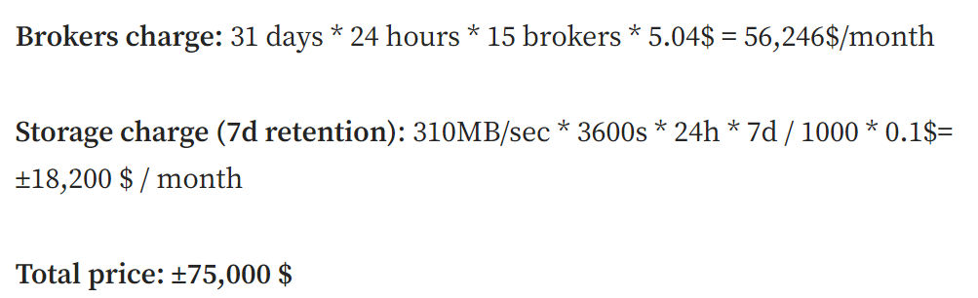

**Use Case 3: P.T.O**

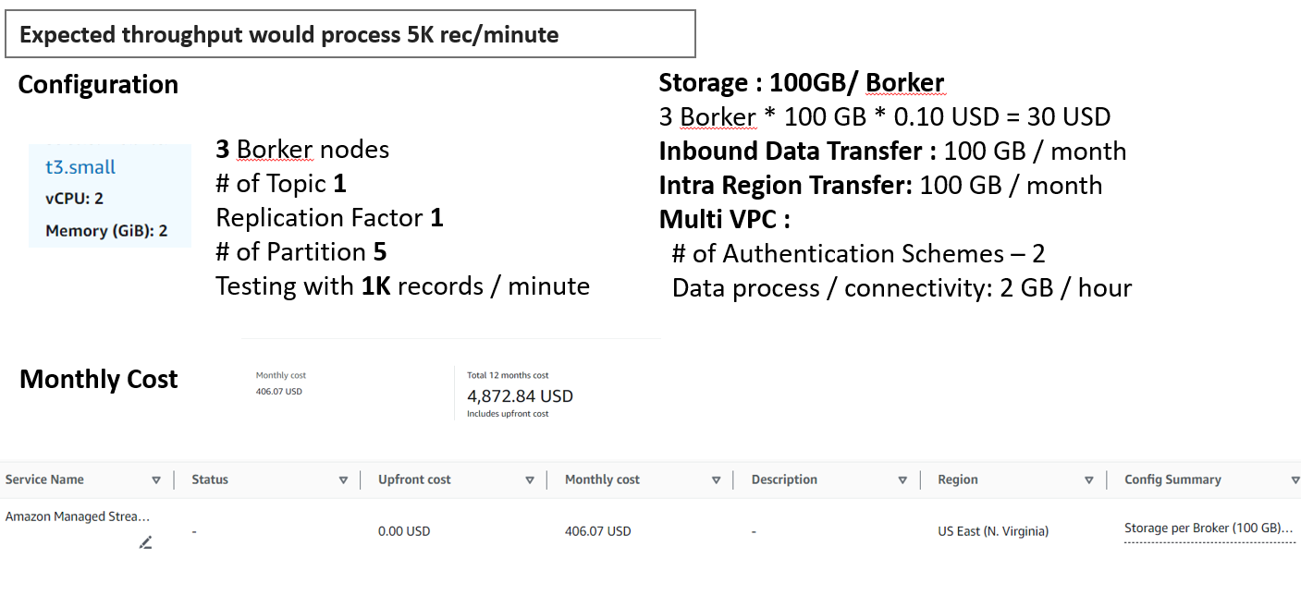

**AWS SQS with Cloud Features used**

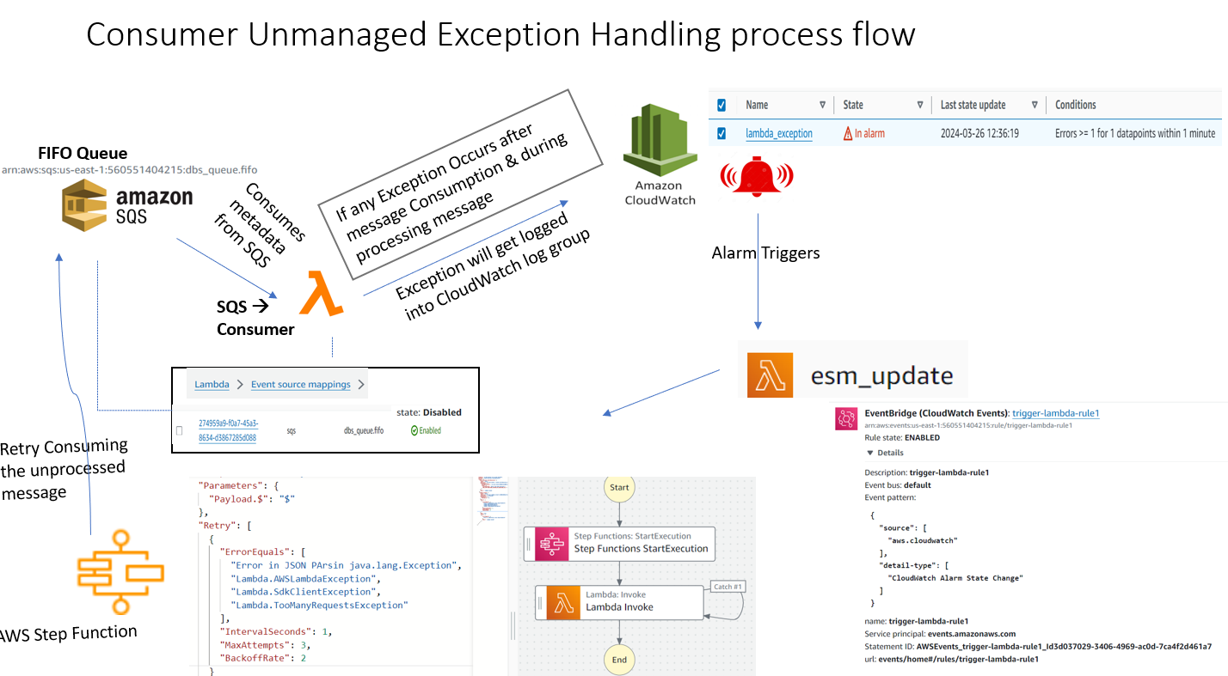

**AWS MSK with Cloud Features used**

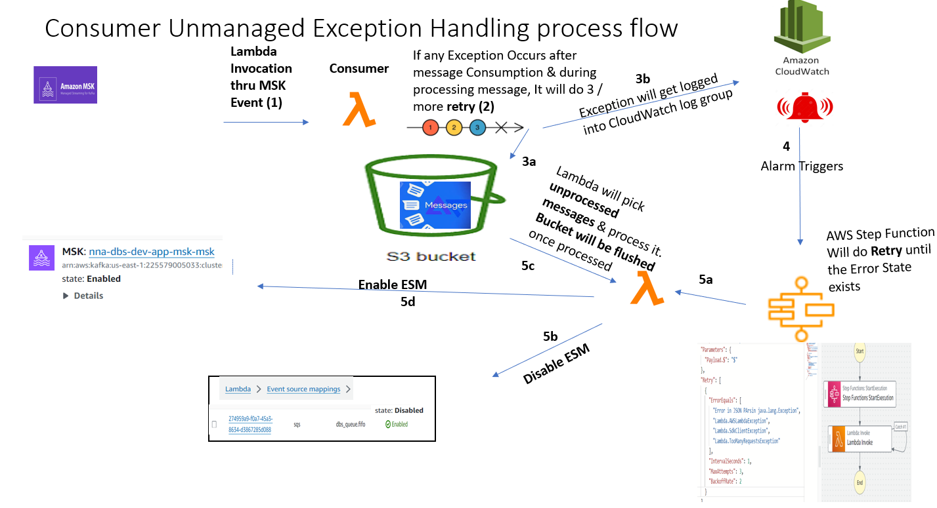

**Custom Retry code used in Project:**

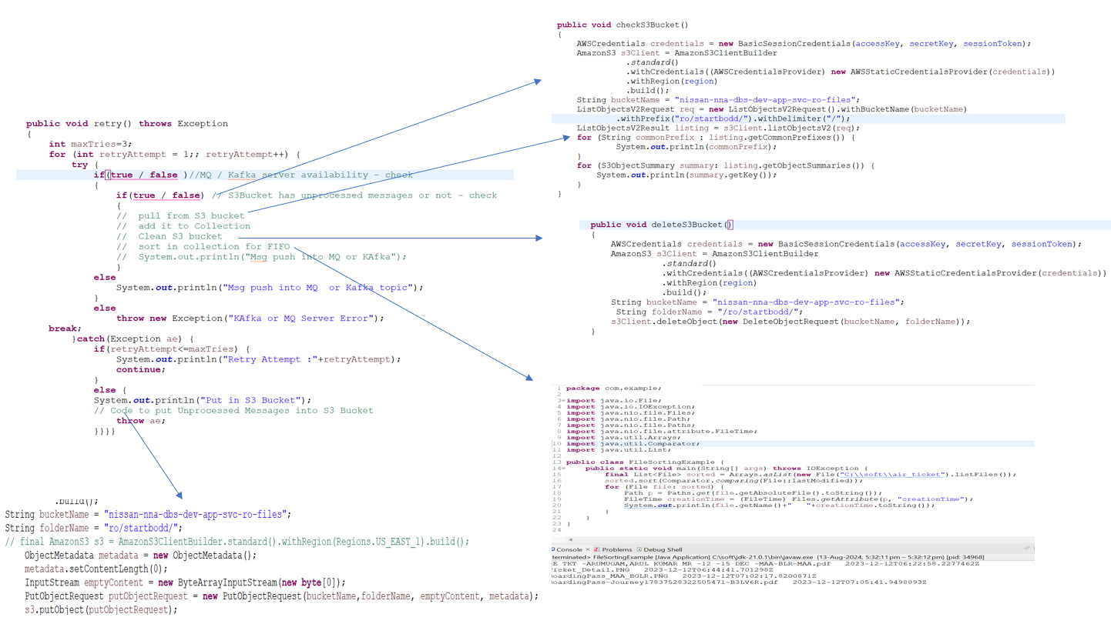

# Activities Involved: Designing & Solution Architecting across various technologies & POCs, Training & guiding the Technical Team

Done a complete study on various API gateways & prepared a technical review-analytical doc. Client Handling

Requirement gathering & analysis. Architecting the technical stack Coding on services side

Database designing & modeling. RDBMS to NoSQL data migration

# Technology Stack Hands-on:

Frameworks: Jersey, Hibernate, Spring Boot (for micro services Development) Security Framework: OWASP ESAPI (SSL Implementation)

Automation: Selenium Webdriver, Katalon Studio APM Tools: Appdynamics, XRebel

Security Tools : Veracode, OWASP ZAP DevOps : Jenkin,

Source Control Tools: Github, Github Desktop, Maven & Gradle.

Security : PKI / SSL / SHA 256 / AES using JCE with extended security policy files. Java Profiling : Java VisualVM, Eclipse MAT, X Rebel

Code Analysis Tool : SonarQube 6.0 with sonar-scanner-2.6.1

Testing Tools : nGrinder & JMeter for load / performance Testing, Selenium Web Frameworks : Angular 1.x, HTML5, BootStrap & CSS3

Log Analytics Tool : Splunk

# Performance Optimization:

Recently resolved a performance issue on concurrent http post calls consuming 45 minutes; fixed it to consume just 43 seconds using Java1.8 Executor Multithreading implementation.

# Services:

Spring-Boot Micro Services with embedded tomcat. Jersey Framework - For REST-Full Web-services

Hibernate with Ehcache & hibernate c3p configuration for connection pooling & query retry Created Authentication framework for the below

Sign up / login

OTP validation / Resend OTP

Automated welcome email & SMS configuration Password AES encryption/decryption

Token based services invocation.

DB – MySQL

Installation & Basic configuration

Configured the max_allowed_packet size & max_connection configuration in My SQL

# UI/UX:

Angular1.x, JQuery, CSS3, HTML5, JavaScript, Bootstrap Native Android – Just lead the team of android

**Data** **Migration** – From MySQL to Mongo DB using **Pelica** **Migrator**

Mongo DB installation & configuration.

Apache & Tomcat 8.0 Virtual host configuration with httpd & mod_jk. Cross origin filter configuration in tomcat 8.0.

Services migration to NodeJS with Mongo DB.

NodeJS integration with Mongo DB using mongo dB, monk & mongoose modules NodeJS modules – Jad & expressJS

Image base64 conversion for file uploads Image compression strategy

**Previously** **Serviced** **Company:** First Gulf Bank - Abu Dhabi

# Role Played: Software Development Manager Activities Involved:

**Release** **Activity:**

Identifying the open items for development Prioritizing open items

Scope reduction based on iteration priority.

# Teams Managed

Requirement & Scope, Development, CM team, PMO team, SMEs, Business Analyst, Risk Mitigation & Action Items

# Vendor Management:

SLA Management, Project Budget & Cost Reduction, Delivery Deviation & Risk

**Project** **Budget** **Type:** Fixed Bid

# Project Stages Involved:

SOW stage, BRD & FSD discussions & preparation of artifacts Setting up the Development & Delivery process

Risk Mitigation through identifying the open items & gaps among development teams & BA Offshore Team set up such as Development, BA, Testing, Architects team etc.

Quality Team: Quality Gate (QG) Team & System Testing (ST) Team

# Technical Knowledge & Skills Summary:

**Frameworks** **&** **web** **services:**

Spring3.0 Hibernate3.0

RESTful Web Services.

SOA, Jersey & Metro, Apache CXF implementation Apache Hadoop File System

# Java Technical Proficiency:

Java Basics: Core Java, Design Patterns, OOAD, Java Applets, Files and Streams Advanced Java: JFC, JDBC, Networking, RMI, Java Beans

J2EE Technologies: Servlets, JSP, Tag Extension

# Java & Webservices Technologies:

SOAP, WSDL, UDDI, XML

JAXP, JAXB, JAX-RPC, JAX-WS, SAX

**Databases:** Oracle 11g, IBM DB2, Postgresql 9.0, MySql, SQL Server 2012, MongoDB, Couch DB

# Middleware Technologies:

**Server** **Technology:** Apache Tomcat 7.0, JBOSS, Oracle Weblogic10g, IBM MQ Server6.0 , JMS, Mule ESB

**IDE:** Eclipse, Spring Tool Suite, WSAD 5.1, RAD 6.0, JDeveloper

**Designing** **Tools:** MS Visio, Rational Rose

# Project Tools Known:

Building Tool: ANT, Maven3.0

Versioning Tool: SVN, VSS 6.0, Perforce 4.0 Planning Tools: Microsoft Project Professional 2003

**Configuration** **Management**: SVN, VSS 6.0, Perforce 4.0

**JIRA:** Agile Project management & Defect tracking tool

**SONAR**: Code Quality Management tool to perform PMD, Check style, Find Bug etc.,

**Jmeter:** Load & Performance testing tool used in this project

**SOAP** **UI**: Service testing for Service & Integration Layers

**Rally** – Defect Tracking

**Bugzilla** – Defect Tracking (But used it before 2006)

**Microsoft** **Project** **Professional** – Effort Estimation & Resource allocation, setting up the Milestones for Release

# Previous Projects Worked:

1. Project Name: Loyalty App, Sales Force Automation (mobile app with REST full services)
2. Project Name: First Connect, Corporate Transaction Banking Platform
3. Project Name: Vendor Credentialing System (SAAS Modeled Application)
4. Project Name: Badging System (SAAS Modeled Application)
5. Project Name: Flexre – Java/J2EE & Oracle Fusion Stack technologies
6. Project Name: Swift Connect – Java/J2EE / J2ME
7. Project Name: Profit and Loss-Java/J2EE
8. Project Name: Seven Socrates (2.0)-J2ME/J2EE
9. Project Name: Accounting Professional Partners- Java/J2EE

# Previous Employment History:

* 1. Organization: Mphasis Ltd – Chennai Client: AIG Inc.

Designation: Technical Architect.. Duration: From Dec 2017 to Till Date

* 1. Organization: Object Frontier Solutions Ltd – Chennai Client: FedEx.

Designation: Engineering Officer Duration: From Jul 2016 to Dec 2017

* 1. Organization: Truetech Solutions Pvt Ltd – Chennai Client: Ultratech Cements & Myshare India. Designation: Technical Project Manager.

Duration: From Sep 2015 to May 2016.

* 1. Organization: First Gulf Bank, Abudhabi – U.A.E

(This was a contract job. I was under the payroll of **Finesseme** – A Dubai based consultancy) Vendor: HCL Technologies Ltd, Chennai – India

Designation: Software Consultant / Project Coordinator Duration: From June 2012 to Jul 2013.

* 1. Organization: SM Infosolutions Pvt, Ltd., Madurai.

Designation: Chief Delivery Officer Duration: From Sep 2009 to Oct 2011.

* 1. Organization: Oracle Financial Services Software LTD, Chennai Designation: Consultant

Duration: From Dec 2007 to Jan 2009

* 1. Organization: Cambridge Solutions Ltd, Chennai Designation: Member Technical Staff (Equivalent to Architect) Duration: From Nov 2006 to Nov 2007
  2. Organization: Caterpillar Inc, Bangalore Designation: IT Analyst (Equivalent to Architect) Duration: From Dec 2005 to Oct 2006
  3. Organization: Aftek Infosys Ltd, Pune.

Designation: Senior Software Engineer Duration: From Sep 2005 to Dec 2005

* 1. Organization: Envisage IT Solutions Pvt Ltd, Bangalore, India.

Designation: Senior Developer Duration: From April 2003 to Sep 2005

* 1. Organization: SSI Educations Ltd, Madurai, India.

Designation: Technical Head Duration: From Mar 2001 to Mar 2003

|  |  |  |  |
| --- | --- | --- | --- |
| **Academic** **Details:**  **Std** **/** **Degree** | **School** **/** **University** | **Year** **of** **Passing** | **%** |
| X Std | M.M.hr.Sec.School, Madurai | 1995 | 72 |
| XII Std | U.C.Hr.Sec.School, Madurai | 1997 | 66 |
| B.Sc Chemistry | Madurai Kamaraj University, Madurai | 2000 | 80 |

# Projects History:

**Project** **#1**

Project Name : **First** **Connect,** **Corporate** **Transaction** **Banking** **Platform** **Vendor** **:** **HCL** **Technologies** **-** **Chennai**

Duration : 06/2012 to 07/2013 Location : Chennai.

Role : Offshore Delivery & Project Manager

Environment : Temenos T24, Cent O.S, JBoss, Spring Source Tool Suite2.8.1, Hibernate3.0, SOAP based web services.

**Project** **Description** : This is a SAAS modeled Corporate Transaction Banking Platform.

**NB:** Description not provided since NDA.

# Project #2:

**Project** **Name** **:** **Vendor** **Credentialing** **System**

Client : Vendormate Inc, Atlanta – GA. Duration : 09/2009 to 10/2011 Location : Madurai.

Role : Delivery Head & Project Manager

Environment : Windows XP, Java/J2EE, Postgresql 9.1, Apache Tomcat 6.0, Eclipse 3.4.2, Hibernate3.0, REST API for service calls.

**Project** **Description** : This is a SAAS modeled, Vendor Credentialing application, designed for the benefit of Customers to ensure their Vendor credentials & to provide a ranking system.

The application is been developed for the below mentioned reasons.

1. Customer Safety towards standards & norms.
2. Ensure Vendor’s norm compliance. c) Ensure Vendors Financial Stability.
3. Prevent dealing with unknown Vendors.
4. Controlled access to Customer & Vendor users.

For example, if the Vendor is healthcare guy, this app ensures his compliance towards health norms such as HIPPA / PSQIA...etc

# My Role over it:

1. Architecting & Providing Tech solutions to choose technology
2. Business process modeling & Implementation
3. Defining Process & Tech strategies.
4. Requirement Gathering & Client co-ordination (Offshore team handling)
5. Effort Estimation Delivery Plan & Billing/Profit calculation for each delivery/release.
6. Modularizing application as per the Delivery plan
7. High Level Designing (Domain / Data Modeling)

**Badging** **System:** - Sub Module inside Customer Dashboard module itself

**Rating** **Engine** **&** **Cron** **Jobs:** **-** Module which do all business calculation (Background Process).

**Technical** **aspects:** Application is developed using the following technical stuff Java/J2EE spring application with Hibernate 3.0 as ORM tool.

# Spring modules used:

Spring Web, MVC framework, Core container & Application modules Spring module validation are used for annotated validation in value objects ORM mapping integration module for integrating hibernate

# Hibernate stuff

Subclass strategies are implemented such as table per subclass, table per hierarchy & table per concrete class etc. First & Second level caching method are used for both session level & application level caching

Named queries are used upon Value Objects in using hibernate templates Hibernate annotations are also used apart from spring module validations **UI** **-** Yahoo User Interface is used for UI - An AJAX framework

# REST API

Restful web services are implemented for services instead of WSDL and SOAP stuff. Since no special tools required developing restful web services and less xml mark-up.

# Roles & Responsibilities:

Involved in Project Planning, Domain modeling & Data modeling using MS Project Professional & MS Visio respectively

Involved in Service side coding and integration with UI. PMO activities.

Involved in Project co-ordination & closure activities. Coordinating QA & Development Process.

Designed Agile QA Process implementation. Requirement Analysis and designing

Effort Estimation and Planning

Database / Object modeling design strategies activity. Design Technical Strategy and Planning

Customer Interaction process

# Project #3:

**Project** **Name** **:** **Badging** **System** Client : Vendormate Inc, Atlanta – GA. Duration : 01/2010 to 10/2011 Location : Madurai.

Role : Project Manager.

Environment : Windows XP, Java/J2EE, Postgresql 8.3, Apache Tomcat 6.0, Eclipse 3.4.2, Hibernate3.0, REST API for service calls.

**Project** **Description** : This is a SAAS modeled, visitor badging system for all visitors entering into hospitals. Visitors may be of a representative from healthcare vendor or a consulting doctor or a general patient visitor. It is a part of Healthcare credentialing domain. Credentialing the vendor details in compliance with various health norms. These credentials are going to be useful for both vendors and their customers (Hospitals). This badging system is a part of this core application called vision Core.

# My Role over it:

1. Architecting & Providing Tech solutions to choose technology
2. Business process modeling & Implementation
3. Defining Process & Tech strategies.
4. Requirement Gathering & Client co-ordination (Offshore team handling)
5. Effort Estimation Delivery Plan & Billing/Profit calculation for each delivery/release.
6. Modularizing application as per the Delivery plan
7. High Level Designing (Domain / Data Modeling)

# Project #4:

**Project** **Name:** **Flexre**

Client : Oracle Corporation Duration : 12/07 to 01/2009 Location : Chennai

Role : Project Lead / Associate Manager

Environment : Windows XP, Java/J2EE, Oracle 10g DB, Weblogic10g, Oracle Internet Directory Server (LDAP), JDeveloper 10g. Oracle BPEL Workflow Engine. IBM MQ Series 6.0, Oracle SOA Suite.

**Project** **Description** : It is about Reinsurance Business Process Automation. It is a product for Reinsurance process firms and also planned for few of the insurance firms too. Reinsurance is nothing but insuring the insurance policies. It includes four different modules such as Outward Treaty, Outward Facultative, Inward Treaty and Inward Facultative. These modules are been done using Oracle Fusion Middleware Technologies which includes Oracle SOA suite.

Reinsurance business process flow, been automated by Oracle Business Process Execution Language (shortly called BPEL).

# Project #5:

**Project** **Name** **:** **SWIFT** **Connect** Client : **Commercial** **Bank** **of** **Dubai** Duration : 11/06 to 11/07

Location : Chennai

Role : Senior Developer and into Implementation and Integration

Environment : Windows XP, Java/J2EE/J2ME, Oracle 9i, SQL Server 2000, Web methods Adapters (JDBC, Email, XML)

**Project** **Description** : SWIFT Connect (SWIFT-Society for Worldwide Interbanking Financial Telecommunication) is mainly implemented in most of the banks for inter bank financial telecommunications like fund transfer. As per their requirement we have done the application as distributed and multithreaded application using web services. It includes Forex conversions as built in features, while transferring funds across the different currency’s accounts. During the transfer of funds the Banks need to communicate thru various message types between them. This application includes mobile banking also. Technology wise Spring MVC & Hibernate for ORM has been used during the development.

# Project #6:

**Project** **Name** **:** **Profit** **and** **Loss** **Client** : **Caterpillar** **Inc,** **Morton** **Duration** : 12/05 to 10/06 **Location** : Bangalore

**Role** : IT Analyst

**Environment** : Windows XP, Java/J2EE, IBM DB2, Web methods Adapters (JDBC, LDAP, XML), WSAD5.1/RAD6.0 Caterpillar’s TUF API plug-in

**Project** **Description** : Profit and Loss is a web based Java application developed for Warehouse and supply Chain Management. In which entire warehouse operations like calculating the wages of contract employees who are working in warehouse based on the number of picking / packing and claims made by them. Using which customer can monitor the entire logistics/supply chain management process. In this Caterpillar’s API plug-in called TUF (The Universal Framework) is used for Database/LDAP operations. Entire application development has been done using struts framework.

***Project*** ***#7:***

# Project Name : Seven Socrates

Client : **Seven** **Inc,** **Redwood** **City,** **California.**

Duration : 09/05 to 12/05 Location : Pune

Role : Senior Software Engineer

Environment : Windows XP, Java (JDK1.5) and J2ME toolkit (WTK2.2). Then Carrier 400/700 Servers.

**Project** **Description** : Seven Socrates is an email client application developed using Java/J2ME technologies. This is mainly used for accessing our mailbox in mobile device. So that new mail notification and mail checking options will be available in mobile phones itself. In this application we used Java/J2ME code in the client side and J2EE server application in the

**Device** **Certification**: Device Certification done for **Nokia** **6/7/9** **series,** **Sanyo,** **Motorola** **devices** and **Nextel** devices (GSM / Symbian Devices not of CDMA)**.** **Project** **#8:**

# Project Name : Accounting Professional Partners (APP)

Client : **Accusys** **Inc,** **U.S** Duration : 02/04 to 09/05 Location : Bangalore

Role : Senior Software Engineer

Environment : Windows XP, Java (JDK1.4.2) , Weblogic8.1 and Eclipse 3.1

**Project** **Description** : Accounting Professional Partner is a client server architecture java application. It has been developed using j2ee for web module and Java swings for Client module. The client module includes image processing also. It has been developed for automation of auditing outsources process. It has been implemented with cross platform supporting feature. This application can operate across multiple reputed platforms like windows/Linux Solaris etc. This project is developed mainly for the U.S auditing offices outsource their process to the data entry operators sitting in India. This application helps them to maintain and manage the entire outsource process.

I solemnly declare that the above furnished details are correct to the best of my Knowledge and Belief.

**Place:** Madurai Arulkumar.A