Introducing “NewsFlow AI” – An Executive News Approval Engine Built with n8n
I recently built an AI-powered automated newsletter workflow designed specifically for leadership teams who approve news communications.
The goal?
Eliminate manual content filtering, formatting, structuring, and repetitive editorial work — while still keeping final approval in human hands.
Now, a Head of Communications can receive, review, approve, and publish global news updates in minutes instead of hours.🛠 Tools Used
🔹 n8n – Workflow orchestration
🔹 OpenAI (GPT-4.1-mini) – Structured editorial generation
🔹 SERP API – Real-time global news retrieval
🔹 Slack Trigger + Approval Node – Human-in-the-loop validation
🔹 Gmail Node – Automated distribution
🔹 JavaScript + Regex Parsing – Structured content rendering
🔹 Dynamic HTML Templating – Gmail-safe formatting
Email Proof and Format:
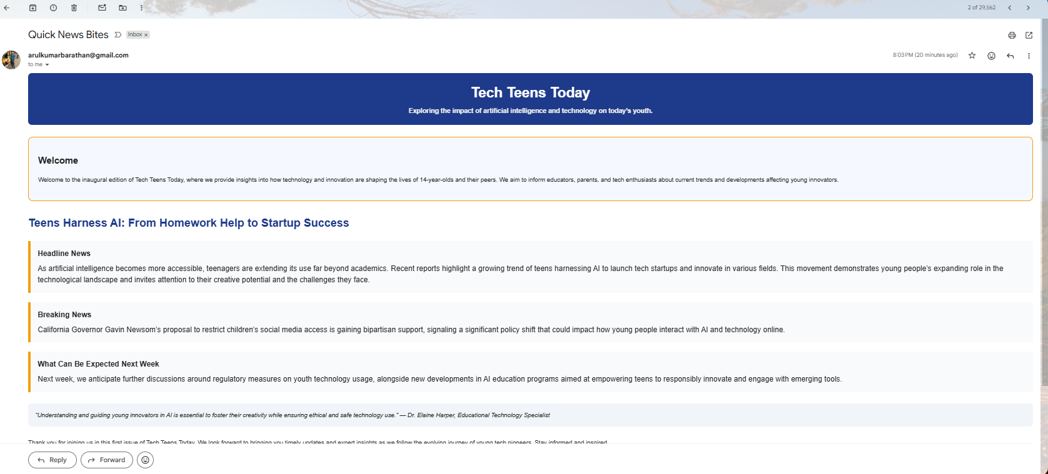
N8N Workflow Screenshot:
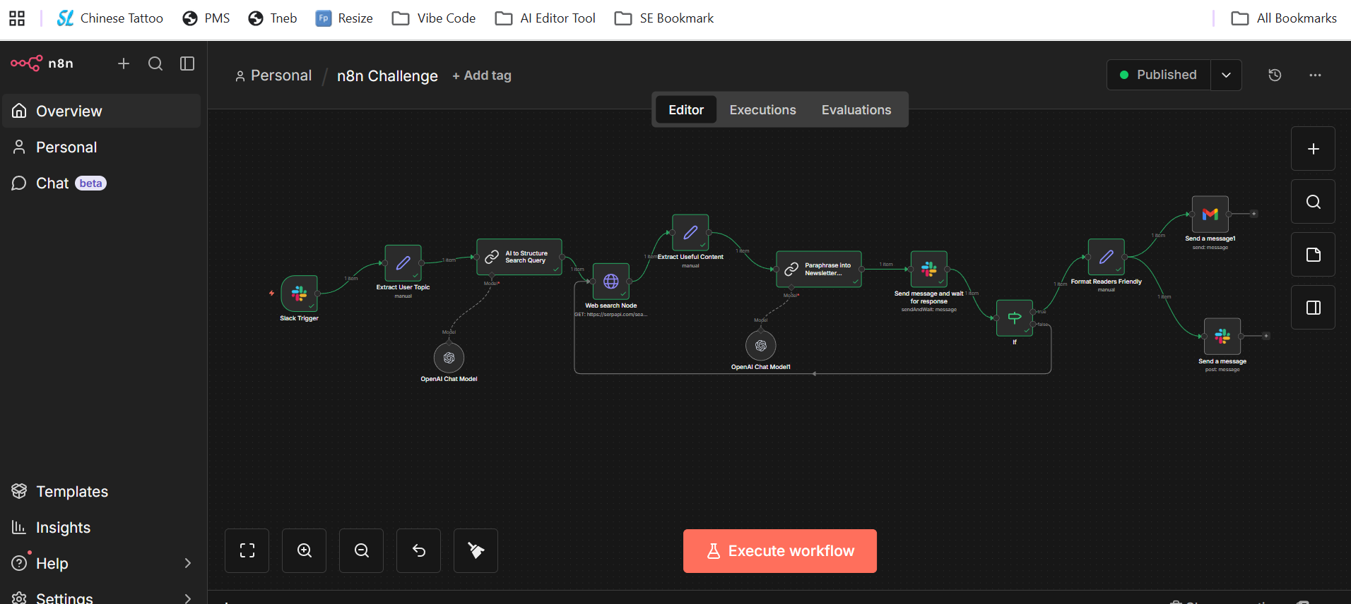
JSON File link: https://github.com/arulkb12/n8n.git
3 Successful Execution Proof:
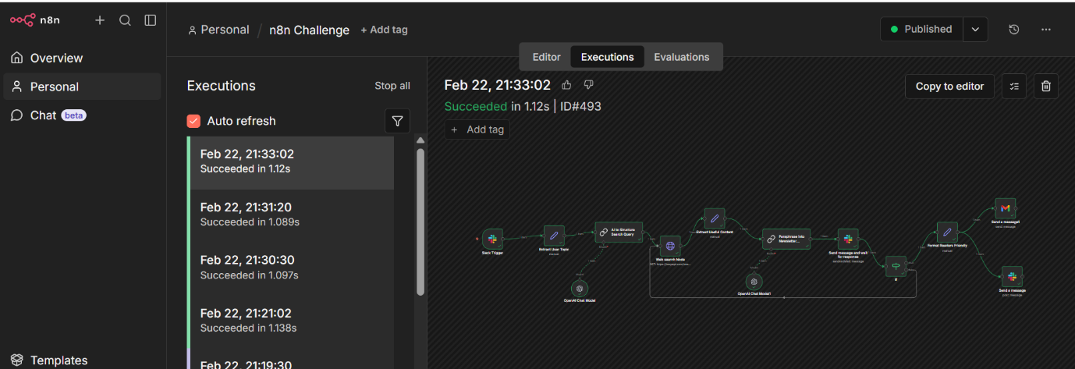

Slack message Proof:
