MODEL/EOS REACT NATIVE PRATICAL

1.HOME SCREEN WITH OPTION SIGN UP & SIGN IN
1.1 SIGN IN
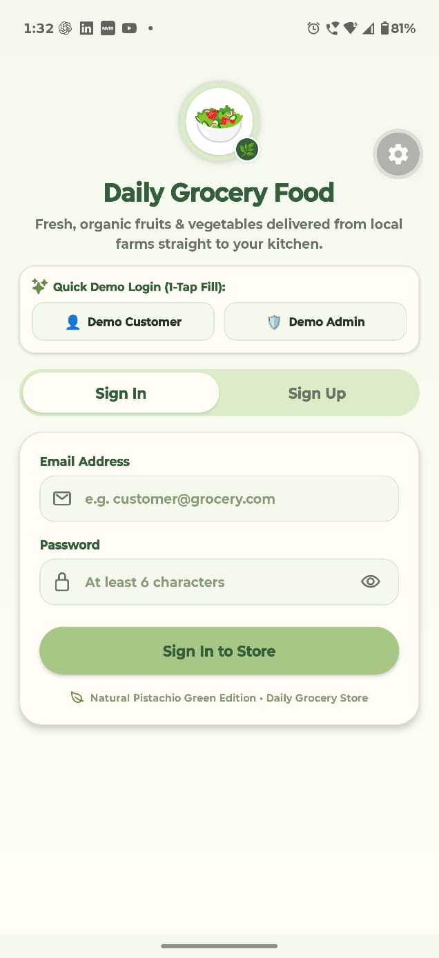
FIG1.1 SIGN IN

1.2 SIGN UP

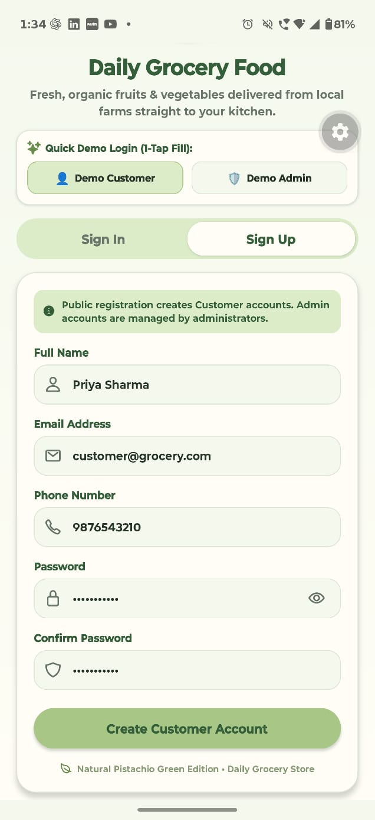
FIG 1.2 SIGN UP

1.3 CUSTOMER LOGIN /HOMEPAGE

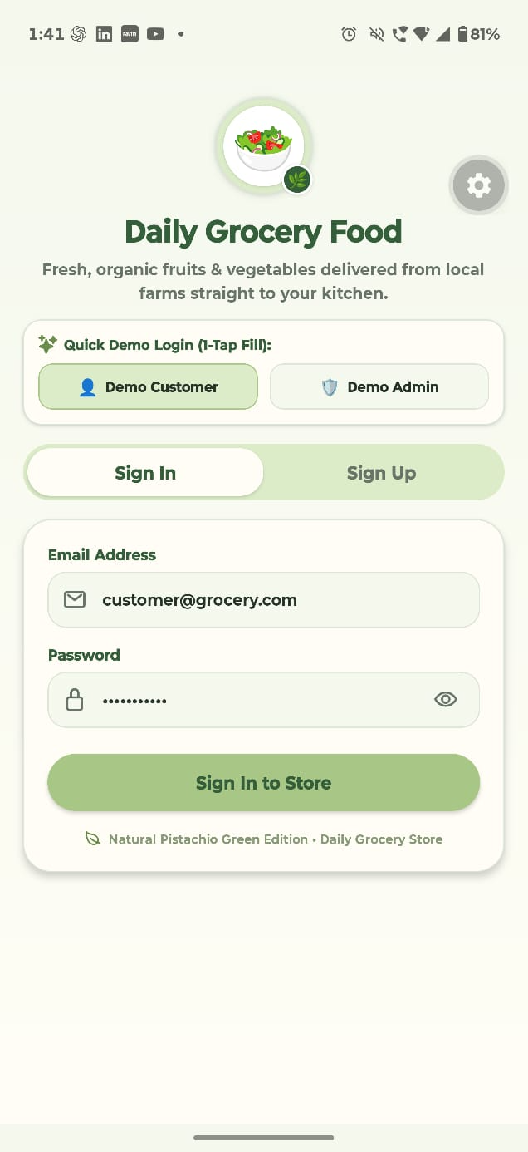
FIG 1.3.1 CUSTOMER LOG IN PAGE

1.3.2 CUSTOMER HOME PAGE

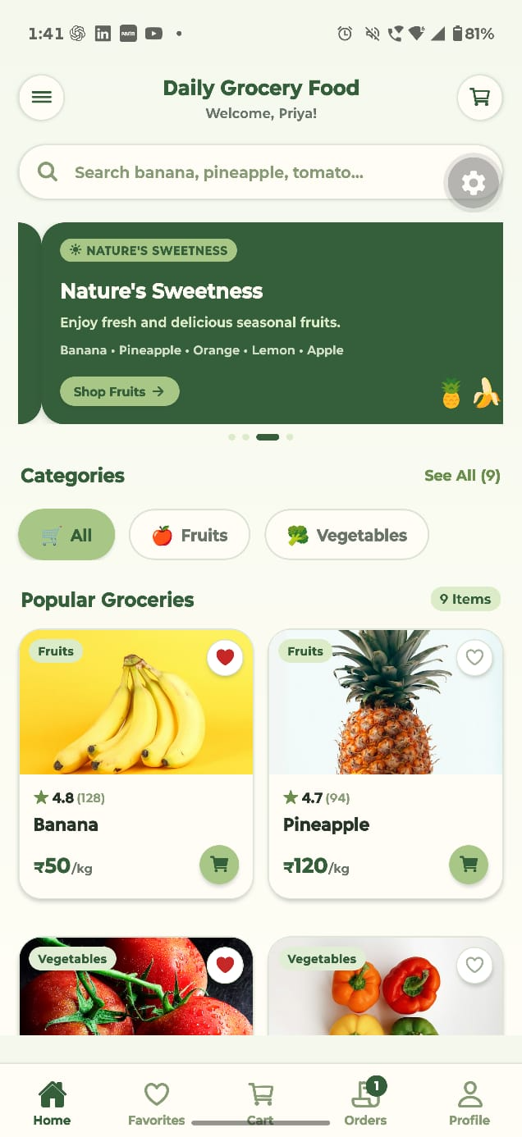
FIG 1.3.2 CUSTOMER HOME PAGE

1.4 ADMIN LOGIN/HOME PAGE
# LOGIN PAGE

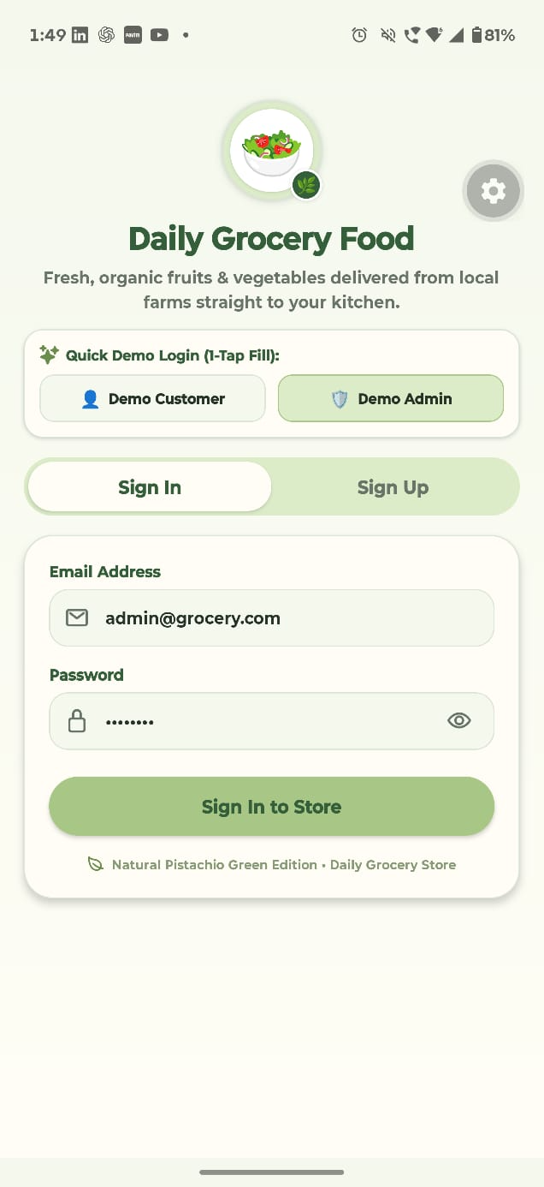
FIG 1.4.1 ADMIN LOGIN PAGE

# HOME PAGE

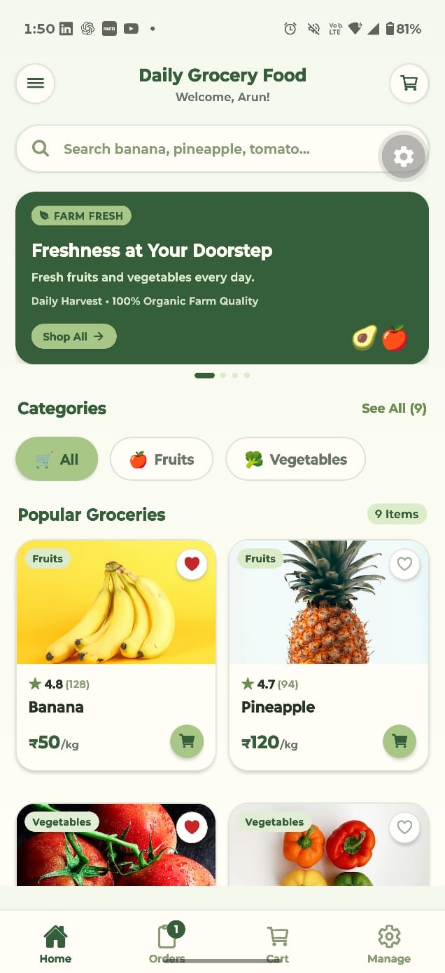
FIG 1.4.2 ADMIN HOME PAGE

2. DAILY GROCERY FOOD PRODUCT LIST SCREEN

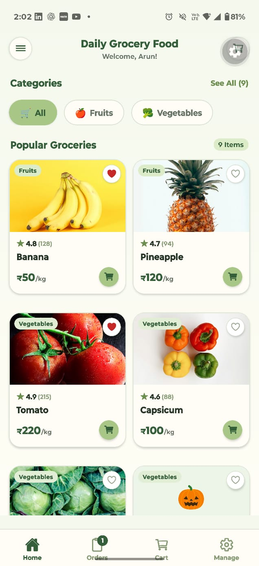
FIG. 2.1 ALL PRODUCTS

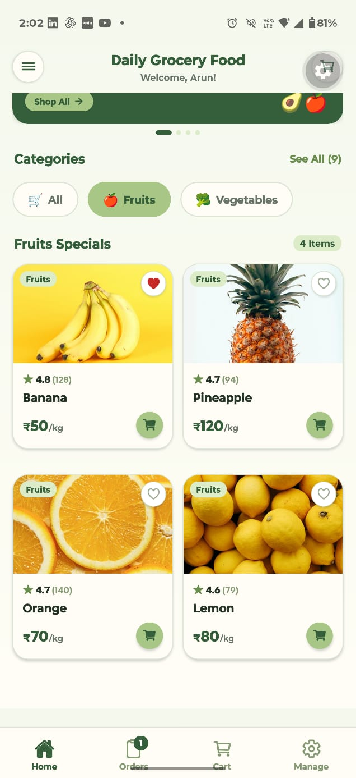
2.2 FRIUTS LIST
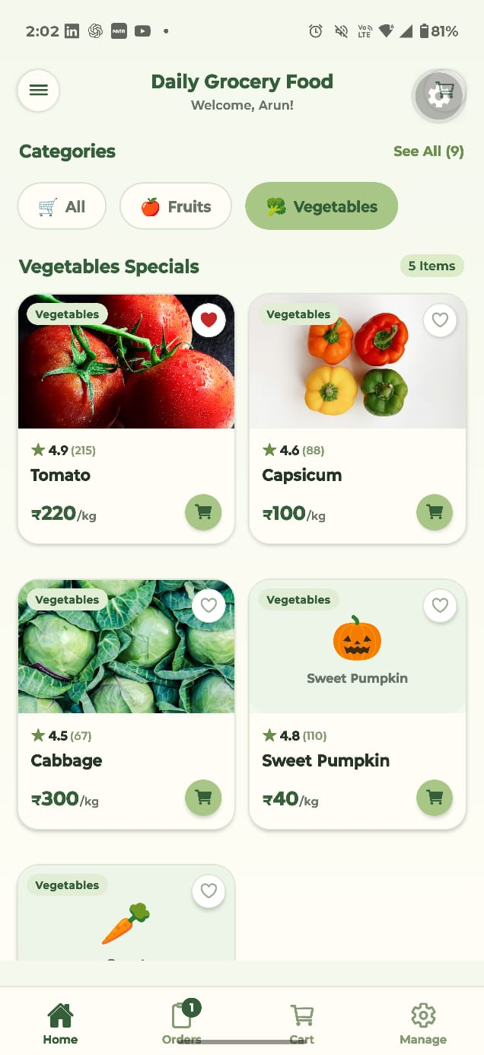
2.3.VEGETABLE PRODUCT LIST

3.PROFILE AND EDIT SCREEN
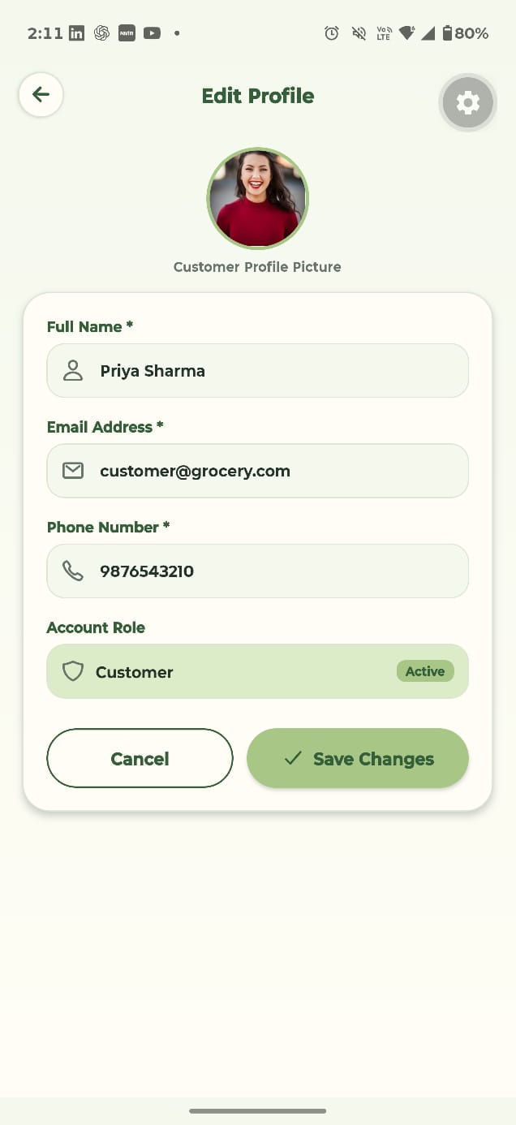
FIG 3. PROFILE AND EDIT SCREEN

4. ADD FAVORITE SCREEN
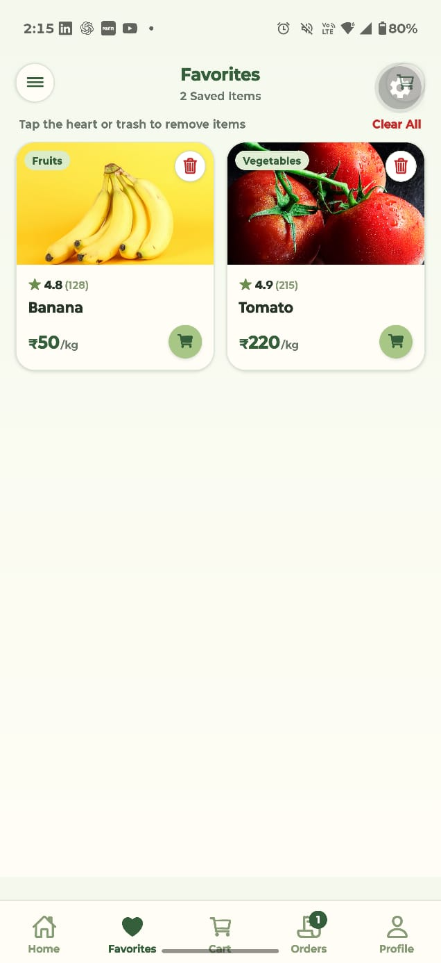
FIG 4 ADD FAVORITE SCREEN

5. PRODUCT DETAILS
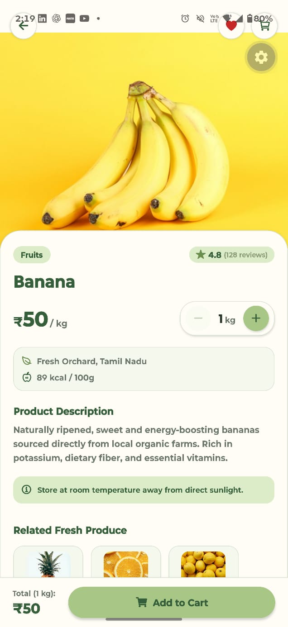
FIG 5. PRODUCT DETAILS

6.MY CART
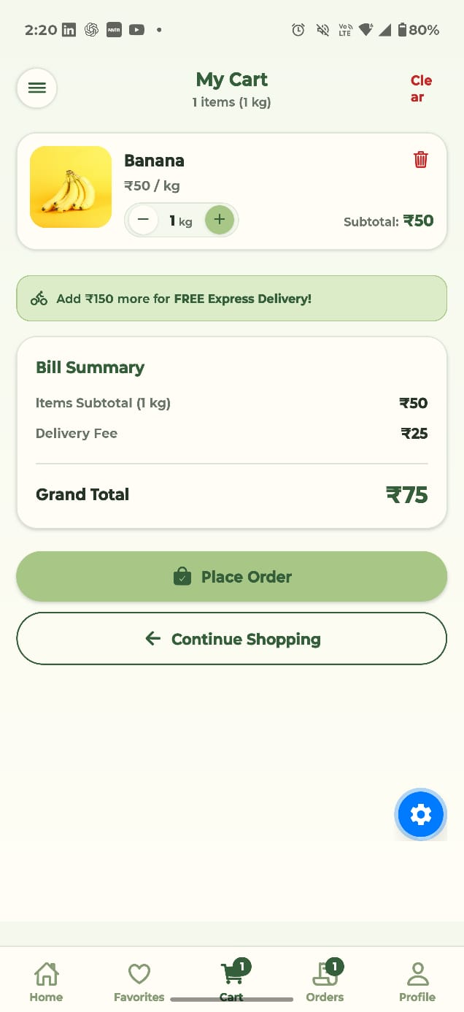
FIG 6. MY CART

7. REACT NATIVE (STACK ,TAB , DRAWER)
# STACK
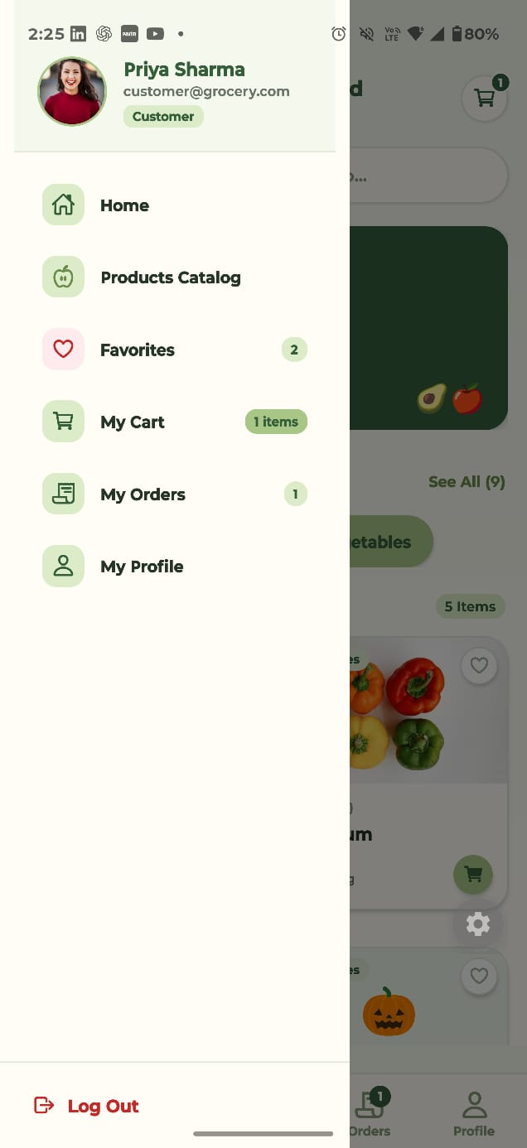
#TAB
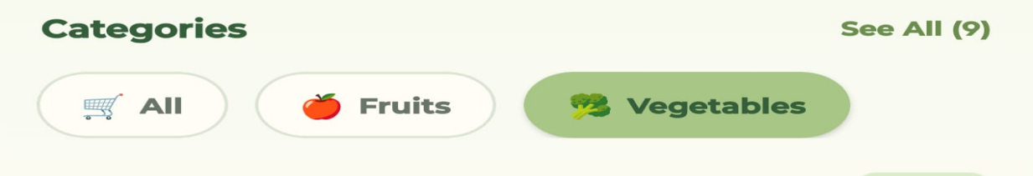
#DRAWER


8 FUNCTIONAL REQUIREMENST
MODLES/SCR/CONTEXT/ AUTH CONTEXT.JS
SAMPLE CODE
mport React, { createContext, useContext, useState } from 'react';

const AuthContext = createContext();

// Sample pre-configured demo accounts for grading and testing
export const DEMO_ACCOUNTS = {
customer: {
id: 'cust-1',
fullName: 'Priya Sharma',
email: 'customer@grocery.com',
phone: '9876543210',
password: 'customer123',
role: 'Customer',
avatar: 'https://images.unsplash.com/photo-1494790108377-be9c29b29330?auto=format&fit=crop&w=300&q=80',
},
admin: {
id: 'admin-1',
fullName: 'Arun Kumar',
email: 'admin@grocery.com',
phone: '9876512345',
password: 'admin123',
role: 'Admin',
avatar: 'https://images.unsplash.com/photo-1472099645785-5658abf4ff4e?auto=format&fit=crop&w=300&q=80',
},
};

export const AuthProvider = ({ children }) => {
// App initialization state for splash screen
const [isInitializing, setIsInitializing] = useState(true);

// Authenticated active session user
const [user, setUser] = useState(null);

// Post-login splash transition state ('Customer' | 'Admin' | null)
const [splashRole, setSplashRole] = useState(null);

// Registered accounts database (initialized with demo accounts)
const [accounts, setAccounts] = useState([
DEMO_ACCOUNTS.customer,
DEMO_ACCOUNTS.admin,
]);

// Validation helpers
const validateEmail = (email) => {
const re = /^[^\s@]+@[^\s@]+\.[^\s@]+$/;
return re.test(String(email).toLowerCase());
};

