ARUL kumaran G
251901018
COMPUTER NETWORKS
Ex. No:13 | NETWORK FORENSICS USING PCAPXRAY TOOL
DATE: | NETWORK FORENSICS USING PCAPXRAY TOOL

PcapXray is a network forensics tool. Its main purpose is to take a captured network traffic file (.pcap or .pcapng) and help you understand what happened on the network
AIM:
To analyze a PCAP file using PcapXray and visualize network activity for basic network forensic investigation.
ALGORITHM: For Installing PCAP and Analyzing:
- Install PcapXray dependencies using: sudo pip3 install -r requirements.txt
- Launch the tool with: sudo python3 PcapXray.py
- Open the web interface and upload the given PCAP file.
- Click Analyze to process the packet data.
- View the generated network topology and communication graph.
- Examine hosts, protocols, and suspicious connections.
- Save the generated report and diagrams for documentation.
Working entirely in Chrome without installing:
https://wiki.wireshark.org/SampleCaptures
What to do
- Open the link above.
- Find ipv4frags.pcap.
- Download it to your Downloads folder.
- Open your online PCAP analyzer.
- Click Upload.
- Select:
ipv4frags.pcap
7.Click Analyze.
Working entirely in Chrome without installing:
Yes. Let me show you exactly what to click and what to look for in A-Packets. You can do this entirely in Chrome.
Step 1 — Open A-Packets
Open the official upload page:
A-Packets PCAP Upload
You should see “Choose a PCAP” / “Click or Drop to Select.” A-Packets currently accepts .pcap, .pcapng, and .cap files, with a 25 MB free limit.

Step 2 — Get a sample PCAP
For your first experiment, use a sample PCAP, not your personal network traffic.
You can download ipv4frags.pcap from the Wireshark sample captures collection:
Wireshark Sample Captures
Save the file in your Downloads folder.
Step 3 — Upload the file
On A-Packets:
Click/Drop to Select
Then:
Downloads → ipv4frags.pcap → Open
You should see the filename appear on the page.
Then click:
Upload PCAP and Analyze
A-Packets says the analysis normally takes only a short time, depending on the capture.
Step 4 — Examine the results
After processing, you'll get a results page.
Summary:
This gives you an overview of the PCAP, such as:
- Number of packets
- Capture duration
- Traffic information
- Hosts involved
The A-Packets documentation describes a summary and traffic analysis view
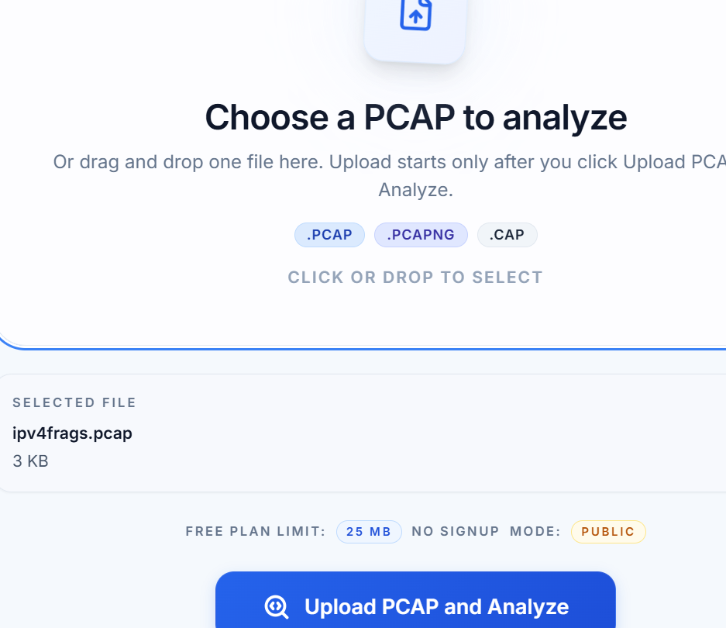

After Uploading PCAP View Report:
SAMPLE OUTPUTS:
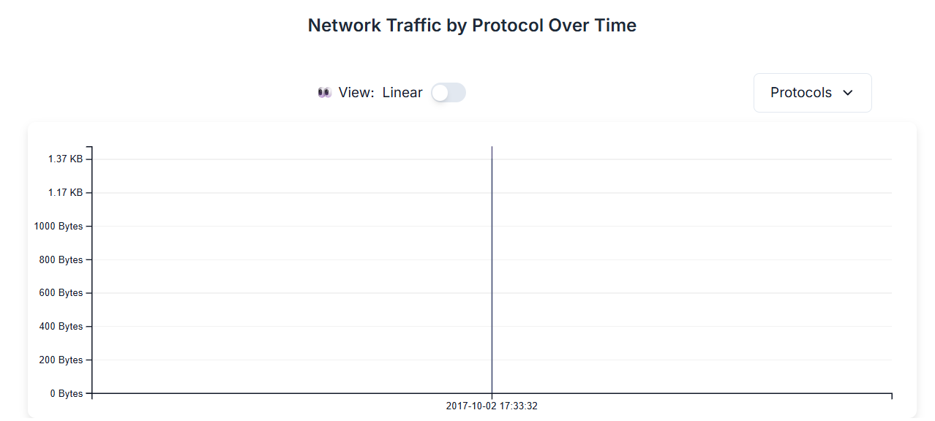
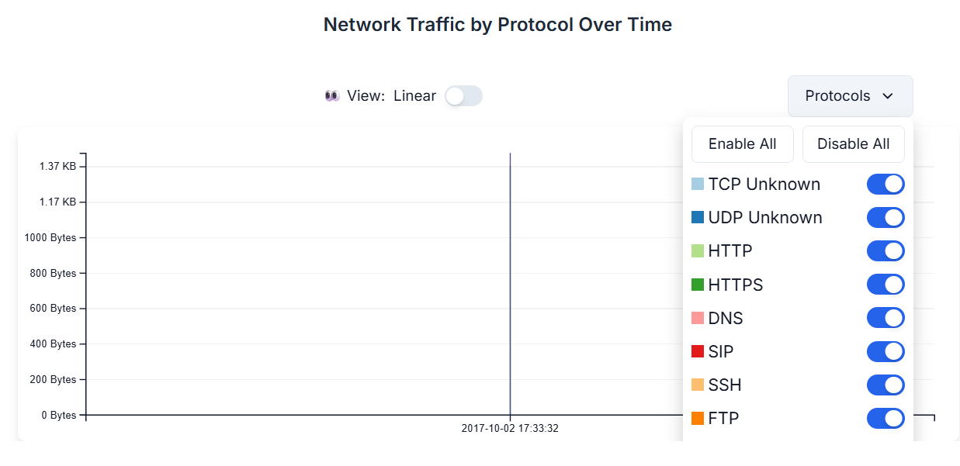
OUTPUT:

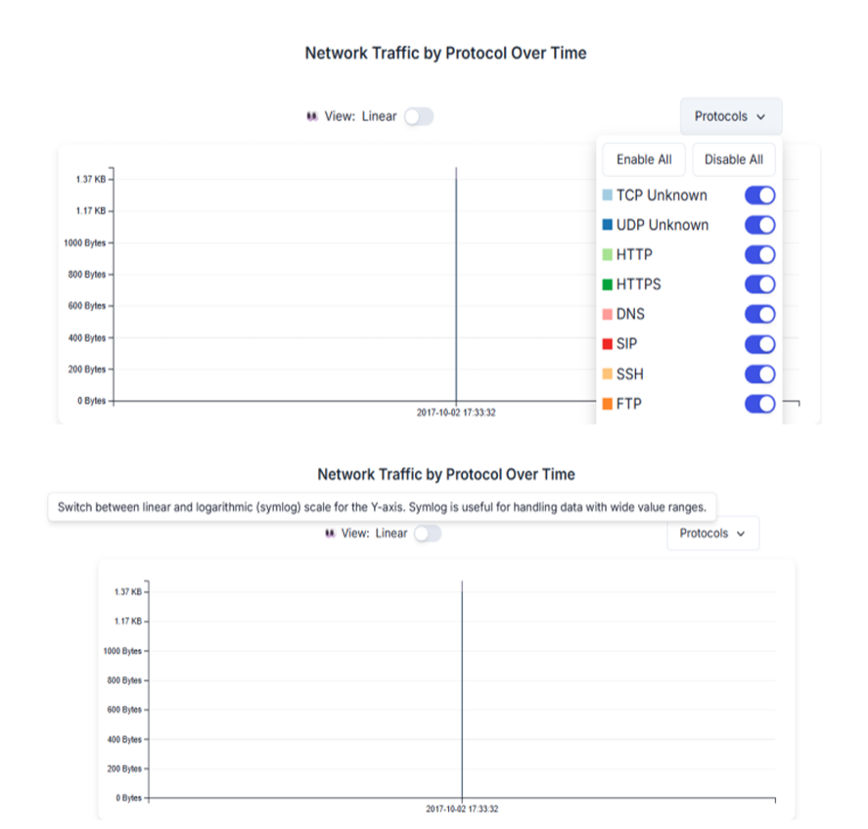

RESULT:
The PCAP file was successfully analyzed using PcapXray, and the network activities, communicating hosts, and protocols were identified and visualized.

