Object Spy
- Install Java version ”jdk1.7.0_45” and “apache-tomcat-7.0.37”
- SSL Certification:
Next, locate your Tomcat’s server configuration file and modify it by adding a connector element to support for SSL or https connection.
apache-tomcat-7.0.37\conf\server.xml,
Note: change the port accordingly in the same server.xml
<Connector port="8443" protocol="HTTP/1.1" SSLEnabled="true"
maxThreads="150" scheme="https" secure="true"
clientAuth="false" sslProtocol="TLS"
keystoreFile="D:\infotreesol.jks"
keystorePass="infotree"
ciphers="TLS_ECDHE_RSA_WITH_AES_128_CBC_SHA256,TLS_ECDHE_RSA_WITH_AES_128_CBC_SHA,
TLS_ECDHE_RSA_WITH_AES_256_CBC_SHA384,TLS_ECDHE_RSA_WITH_AES_256_CBC_SHA,TLS_ECDHE_RSA_WITH_RC4_128_SHA,
TLS_RSA_WITH_AES_128_CBC_SHA256,TLS_RSA_WITH_AES_128_CBC_SHA,TLS_RSA_WITH_AES_256_CBC_SHA256,
TLS_RSA_WITH_AES_256_CBC_SHA,SSL_RSA_WITH_RC4_128_SHA" />
- Saved it and restart Tomcat, access to https://localhost.clictest.com:8443/. If it displays tomcat home page then SSl certificate is configured successfully. Ex:

- Place ObjectSpyWeb.war into C: \apache-tomcat-7.0.37\webapps\

- Place below .jar files in C:\apache-tomcat-7.0.37\webapps\ROOT
  - ObjectSpy.jar(d)
  - mysql-connector-java-5.1.24-bin.jar(d)
  - selenium-server-standalone-2.44.0.jar(d)
  - jersey-client-1.9.1.jar
  - jersey-core-1.9.1.jar
  - jersey-server-1.9.1.jar"/>
- Signing jar files using .jks file :
Sign the jar file with newly created keystore “testkeys” to jar files one by one, Here give absolute path for jar file. Open command line and type:
C:\Program Files\Java\jdk1.7.0_45\bin>jarsigner.exe -keystore D:\clictestjarsigncert.jks C:\apache-tomcat-7.0.37\webapps\ROOT \ObjectSpy.jar clic
Enter Passphrase for keystore:
Note: Do jar singing for all above jar files. (During jar signing it ll ask for password *, Anjali will share the password)
- Start and Stop the tomcat will extract ObjectSpyWeb.war and create ObjectSpyWeb folder C:\apache-tomcat-7.0.37\webapps\ObjectSpyWeb

- Go to C: \apache-tomcat-7.0.37\webapps\ObjectSpyWeb\objectspy1.6.jsp and change the IP address or hostname according to respective environments.
(same things also we have to do for objectspy1.7.jsp , object1.8.jsp )

<%@ page language="java" contentType="application/x-java-jnlp-file" pageEncoding="ISO-8859-1"%>

<?xml version="1.0" encoding="utf-8"?>
<jnlp spec="1.0+" codebase="http://demoapp3.clictest.com:8080/" href="ObjectSpyWeb/objectspy.jsp?userid=<%=request.getParameter("userid")%>&projid=<%=request.getParameter("projid")%>&browser=<%=request.getParameter("browser")%>&url=<%=request.getParameter("url")%>&chvr=<%=request.getParameter("chvr")%>">
<information>
<title>ObjectSpy</title>
<vendor>Info Tree</vendor>
<homepage href="http://demoapp3.clictest.com:8080/" />
<description>ObjectSpy</description>
</information>
<security>
<all-permissions/>
</security>
<resources>
<j2se version="1.6+" java-vm-args="-Xmx1024m -Xms256m -Xss8m" />
<jar href="ObjectSpy.jar" />
<jar href="mysql-connector-java-5.1.24-bin.jar"/>
<jar href="selenium-server-standalone-2.44.0.jar"/>
<jar href="jersey-client-1.9.1.jar"/>
<jar href="jersey-core-1.9.1.jar"/>
<jar href="jersey-server-1.9.1.jar"/>
</resources>
<application-desc main-class="com.infotree.webdriver.SeleniumWebDriver" >
<argument><%=request.getParameter("userid")%></argument>
<argument><%=request.getParameter("projid")%></argument>
<argument><%=request.getParameter("browser")%></argument>
<argument><%=request.getParameter("url")%></argument>
<argument><%=request.getParameter("chvr")%></argument>
</application-desc>
</jnlp>

- Edit the file C:\apache-tomcat-7.0.37\webapps\ObjectSpyWeb\user-extensions.js
Search with parameter 8443 you will find one url there change ipaddress or hostname after save and close. Here also change true in place of false.
- Go to D:\objectspy\apache-tomcat-7.0.37\webapps\ObjectSpyWeb\WEB-INF\classes directory and edit config.properties and log4j.properties as shown below screenshots.
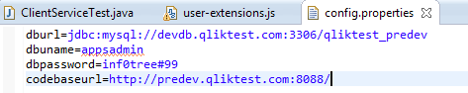
In codebaseurl we have to provide the server url like http://demoapp3.clictest.com:8080/

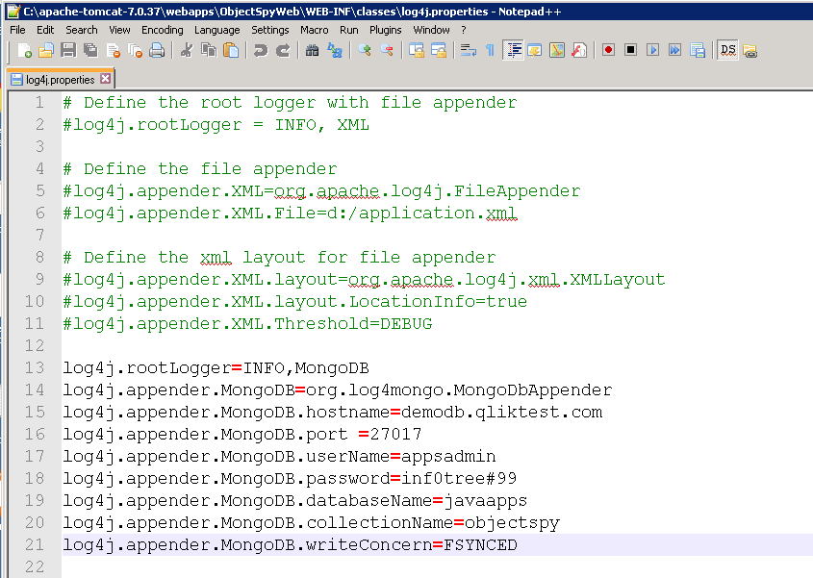
- Convert the objectspy.jar to zip and change the config.properites accordingly. After the changes have occurred, again we need to perform the jar signing. (only developers jars)
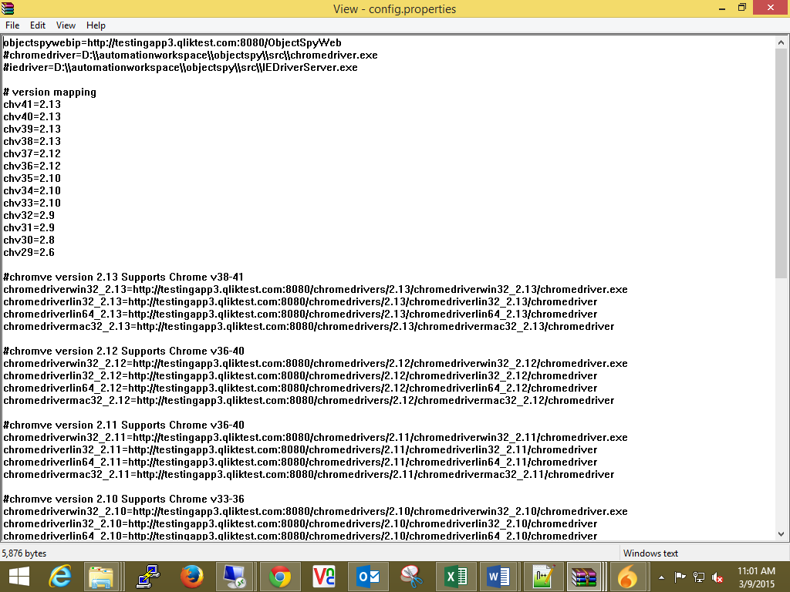

21. And make sure in the ROOT folder of tomcat should contain the below chrome folders
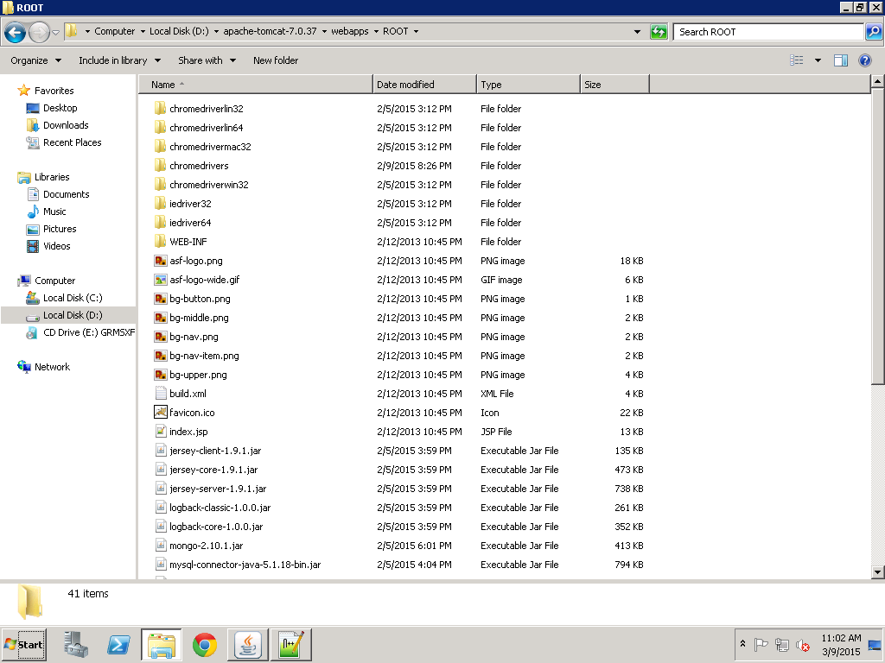

22. Start the tomcat server from C:\objectspy\apache-tomcat-7.0.37\bin\startup.bat
23. Verify it by opening the browser and type url = http://ipaddresss:8080/ObjectSpyWeb /objectspy.jsp?configid=&userid=&projid=

Deployment Document for LogServiceRestful:
It is a web application so directly deploy this war file to tomcat server
Directly copy and paste logServiceRestful.war file inside C:\apache-tomcat-7.0.37\webapps
Folder. Then start and stop the tomcat server, it will create logServiceRestful folder.
Now to go this path C:\apache-tomcat-7.0.37\webapps\logServiceRestful\WEB-INF\classes
- And open config.properties and do changes accordingly to your database.
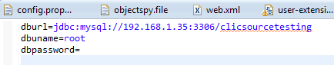
- log4j_objectspy.properties
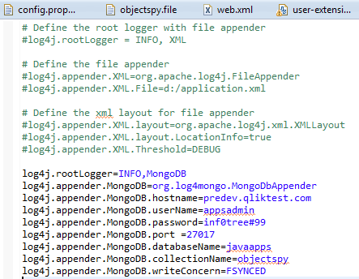
This file is related to log. All logging activities we are maintaining in MongoDB, here we have to provide MongoDB details.(ObjectSpy logs we are keeping in objectspy collection)
hostname: where the MongoDB service is running
userName and password: If MongoDB is running with Authentication then we have to pass the username and password.
databaseName : All collections related to log , we are maintaining in javaapps database in MongoDB.
collectionName : Here we have to give the collection name to store all log information. For objectspy log we are maintaining objectspy collection.

