1. **.Write a blog on Difference between HTTP1.1 vs HTTP2**

* HTTP/2 is a further development of the HTTP/1.1 internet protocol. While the basic concept has remained the same, HTTP/2 reduces the time it takes to load websites as well as the protocol overhead. It offers webmasters the ability to prioritize requests and enables “server push”.
* HTTP/1.1 loads resources one after the other, so if one resource cannot be loaded, it blocks all the other resources behind it.
* HTTP/2 is able to use a single TCP connection to send multiple streams of data at once so that no one resource blocks any other resource.
* HTTP/2 solves several problems that the creators of HTTP/1.1 did not anticipate.

* In particular, HTTP/2 is much faster and more efficient than HTTP/1.1. One of the ways in which HTTP/2 is faster is in how it prioritizes content during the loading process.
* HTTP/2 Protocol. Binary protocols – Binary protocols consume less bandwidth, are more efficiently parsed and are less error-prone than the textual protocols used by HTTP/1.1.
* HTTP2 can better handle elements such as whitespace, capitalization and line endings.

1. Write a blog about objects and its internal representation in Javascript

**2.Write a blog about objects and its internal representation in Javascript**

* “A JavaScript object is a collection of named values having state and behavior (properties and method)”.

**1)Objects:**

* The following code assigns a **simple value** (Mercedes) to a **variable** named car:
* var car = "Mercedes";
* Objects are variables too. But objects can contain many values.
* The following code assigns **many values** (Mercedes, C-class, White and soo on) to a **variable** named Car:
* var car = {Make: “Mercedes”, Model: “C-Class”, Color: “White”, Fuel: Diesel, Weight: “850kg”, Mileage: “8Kmpl”, Rating: 4.5};
* The values are written as **name:value** pairs (name and value separated by a colon).
* Syntax:
* var <object-name> = {key1: value1, key2: value2,... keyN: valueN};
* So, conclusion and definition for JS objects is “JavaScript objects are containers for named values”.

**2)Object Properties**

* The name:values pairs (in JavaScript objects) are called **properties**.
* var car = {Make: “Mercedes”, Model: “C-Class”, Color: “White”, Fuel: Diesel, Weight: “850kg”,Mileage: “8Kmpl”, Rating: 4.5};
* From the above snippet, let’s have a look what falls under property and property value:
* The object properties can be different primitive values, other objects and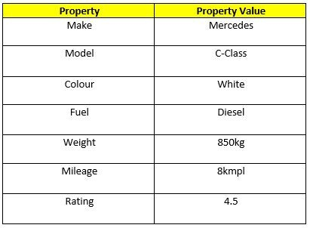 functions.
* Properties can usually be changed, added, and deleted, but some are read only.
* **The syntax for adding a property to an object is :**
* ObjectName.ObjectProperty = propertyValue;
* **The syntax for deleting a property from an object is:**
* delete ObjectName.ObjectProperty;
* **The syntax to access a property from an object is:**
* objectName.property        // Car.Make

//or

* objectName["property”]    // Car["Make"]

//or

* objectName[expression]   // x = "Make"; Car[x]
* So, Conclusion and simple definition for Java Script properties is “Properties are the values associated with a JavaScript object”.

**3)Object Methods**

* An object method is an object property containing a function definition.

i.e.,Let’s assume to start the car there will be a mechanical functionality.

function(){return ignition.on}

and so similar is to stop/brake/headlights on & off, etc.