HoloKai GLiNER Fine Tuning Report
Run 3 Sweep B
Batch size and learning rate experiments | 23 completed runs
Model: knowledgator/gliner-pii-base-v1.0 | Results through the second extension round

1 Summary
Sweep B evaluates batch sizes 2, 8 and 16 around the batch-4 anchor established in Sweep A. The nine initial configurations were followed by eight first-round and six second-round extensions. Batch 4 was not retrained.
- Best observed validation result. Batch 16 with learning rate 1.2e-4 and an 8-epoch schedule selects epoch 6: F1 90.68%, precision 88.12%, recall 93.38%, 57 false positives and 30 false negatives. Its V4 F1 is 87.92%.
- Progress across experiments. Validation F1 is 79.06% in Run 1, 76.79% in Run 2, 88.77% in Sweep A A5 and 90.68% in Sweep B B22. B22 gains 13.89 points over Run 2 and 1.91 over A5; its false positives fall to 57 from 208 and 87 respectively. Section 4 compares the configurations and tradeoffs.
- Longer schedules have mixed effects. Batch 2 benefits from longer schedules at 2e-5 and 3e-5. Batch 8 at 9e-5 falls from 88.22 to 87.21 validation F1 when the total schedule changes from 5 to 8 epochs. Epoch selection remains necessary.
- Selection and completion status. Keep validation as the selection criterion and V4 for reporting. Two batch-2 epoch extensions remain pending; the current leading configuration is provisional until the planned checks and seed repeats are complete.

2 Setup
Item | Protocol
Initial grid | Batch 2: {1.5e-5, 2e-5, 3e-5}, 5 epochs; batch 8: {3e-5, 4e-5, 6e-5}, 5 epochs; batch 16: {4e-5, 6e-5, 8e-5}, 8 epochs.
Fixed settings | Run 1 configuration; seed 42, warmup 0.1, weight decay 0.01, linear decay, threshold 0.4 and flat_ner=false.
Data protocol | Training: 1,509 units. Validation: 171 units / 453 entities. V4: 648 units / 1,320 entities. These dataset sizes follow the Run 1 and Sweep A protocol.
Metric and selection | Exact span and label match, micro-averaged over 11 labels. Select the highest validation F1; checkpoint ties use provider F1, then precision. V4 is reporting-only.
Batch execution | All 23 rows report accumulation 1 and effective batch equal to batch_size. No completed row records the batch-16 fallback to micro batch 8 with accumulation 2.
Extensions | Boundary learning rates are multiplied or divided by 1.5; last-epoch winners receive 3 more total epochs. Each longer schedule restarts from the base model.

3 Results

3 1 Complete overview
The 23 completed configurations are ranked by their best validation checkpoint below. The exact precision, recall, error counts and V4 results follow in the data table. All F1 values are percentages; differences are percentage points.
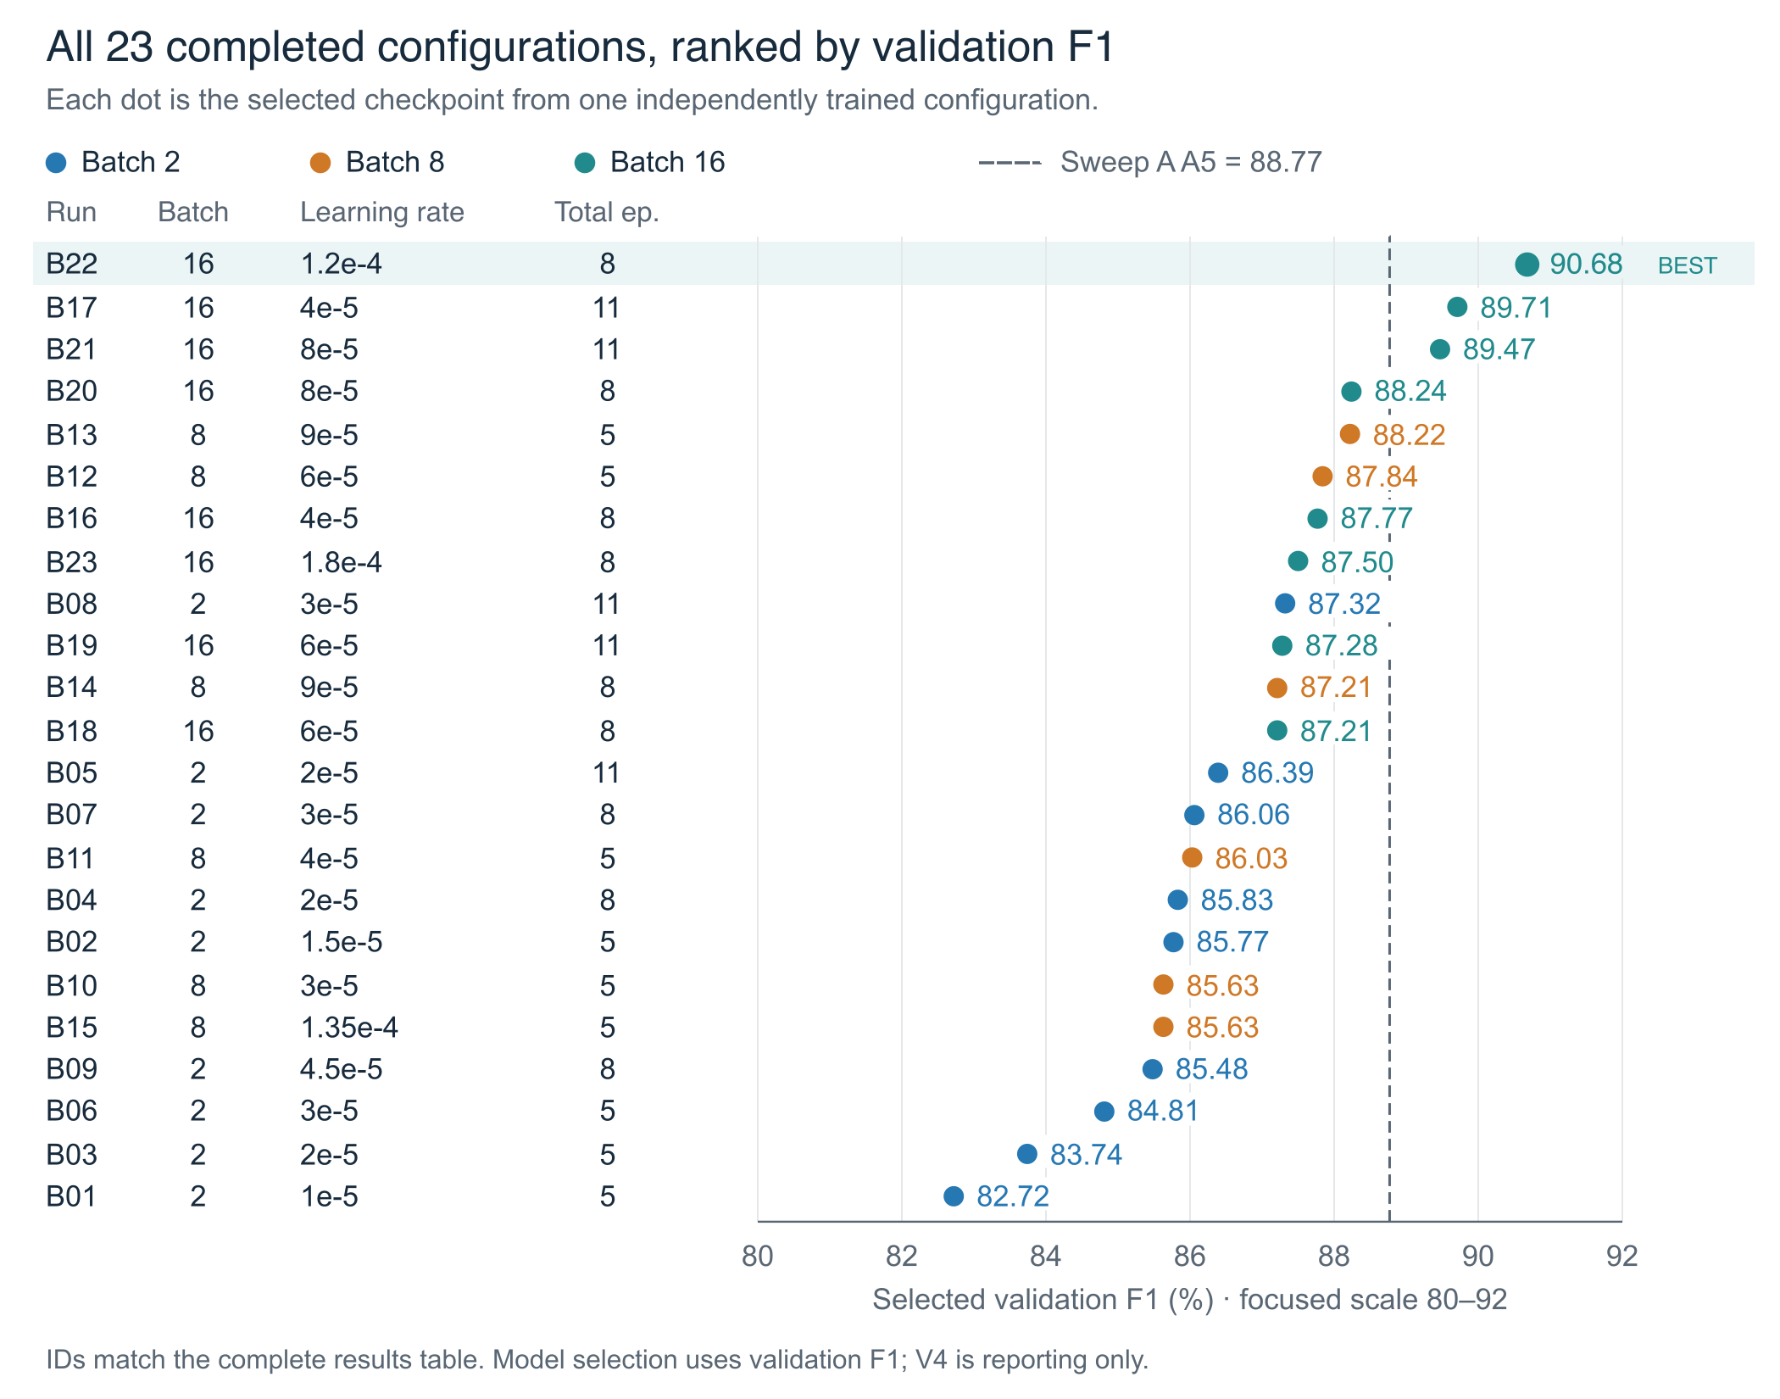
Figure 1. All 23 validation-selected results, ranked by F1. The dashed reference is Sweep A A5 at 88.77%. Colors identify batch size; the focused F1 scale is 80-92%.
B22 leads at 90.68%. It uses batch 16, learning rate 1.2e-4 and an 8-epoch schedule, selecting epoch 6. Three completed Sweep B configurations exceed the A5 validation reference; all three use batch 16.
The best observed results within batches 2, 8 and 16 are 87.32%, 88.22% and 90.68%. Their learning rates, schedules and numbers of trials differ, so these maxima identify candidate configurations rather than an isolated batch-size effect.

3 1 Complete overview data table
P, R and F1 are percentages; differences are percentage points unless stated otherwise. FP and FN are validation entity counts. Total is the full training schedule; Pick is the selected epoch. IDs are assigned here by batch, learning rate and total epochs, not execution order. Blue rows are the validation winners within each batch.
ID | Batch | LR | Total | Pick | Val F1 | P | R | FP | FN | V4 F1
B01 | 2 | 1e-5 | 5 | 4 | 82.72 | 73.83 | 94.04 | 151 | 27 | 82.57
B02 | 2 | 1.5e-5 | 5 | 4 | 85.77 | 79.00 | 93.82 | 113 | 28 | 84.42
B03 | 2 | 2e-5 | 5 | 5 | 83.74 | 75.62 | 93.82 | 137 | 28 | 84.60
B04 | 2 | 2e-5 | 8 | 8 | 85.83 | 79.25 | 93.60 | 111 | 29 | 86.48
B05 | 2 | 2e-5 | 11 | 11 | 86.39 | 80.53 | 93.16 | 102 | 31 | 86.98
B06 | 2 | 3e-5 | 5 | 5 | 84.81 | 77.08 | 94.26 | 127 | 26 | 85.19
B07 | 2 | 3e-5 | 8 | 8 | 86.06 | 79.81 | 93.38 | 107 | 30 | 87.60
B08 | 2 | 3e-5 | 11 | 10 | 87.32 | 81.33 | 94.26 | 98 | 26 | 87.64
B09 | 2 | 4.5e-5 | 8 | 8 | 85.48 | 79.14 | 92.94 | 111 | 32 | 86.09
B10 | 8 | 3e-5 | 5 | 4 | 85.63 | 77.70 | 95.36 | 124 | 21 | 85.35
B11 | 8 | 4e-5 | 5 | 3 | 86.03 | 79.44 | 93.82 | 110 | 28 | 84.81
B12 | 8 | 6e-5 | 5 | 4 | 87.84 | 83.63 | 92.49 | 82 | 34 | 87.98
B13 | 8 | 9e-5 | 5 | 5 | 88.22 | 82.91 | 94.26 | 88 | 26 | 86.93
B14 | 8 | 9e-5 | 8 | 7 | 87.21 | 83.03 | 91.83 | 85 | 37 | 88.59
B15 | 8 | 0.000135 | 5 | 3 | 85.63 | 79.07 | 93.38 | 112 | 30 | 84.09
B16 | 16 | 4e-5 | 8 | 8 | 87.77 | 82.12 | 94.26 | 93 | 26 | 87.81
B17 | 16 | 4e-5 | 11 | 7 | 89.71 | 86.33 | 93.38 | 67 | 30 | 88.42
B18 | 16 | 6e-5 | 8 | 8 | 87.21 | 81.30 | 94.04 | 98 | 27 | 87.88
B19 | 16 | 6e-5 | 11 | 10 | 87.28 | 82.10 | 93.16 | 92 | 31 | 87.75
B20 | 16 | 8e-5 | 8 | 8 | 88.24 | 83.46 | 93.60 | 84 | 29 | 88.24
B21 | 16 | 8e-5 | 11 | 9 | 89.47 | 84.78 | 94.70 | 77 | 24 | 87.77
B22 | 16 | 0.00012 | 8 | 6 | 90.68 | 88.12 | 93.38 | 57 | 30 | 87.92
B23 | 16 | 0.00018 | 8 | 7 | 87.50 | 84.11 | 91.17 | 78 | 40 | 88.25

Highlighted rows are the validation winners within batches 2, 8 and 16. B22 leads validation at 90.68%; B14 has the highest V4 result at 88.59%, but V4 is reserved for reporting and does not determine the chosen model.
Every selected F1 equals the maximum recorded epoch F1 for that configuration. Appendices A and B contain all 172 measured epoch values, grouped by the actual training schedule.

3 2 Learning rate and batch size
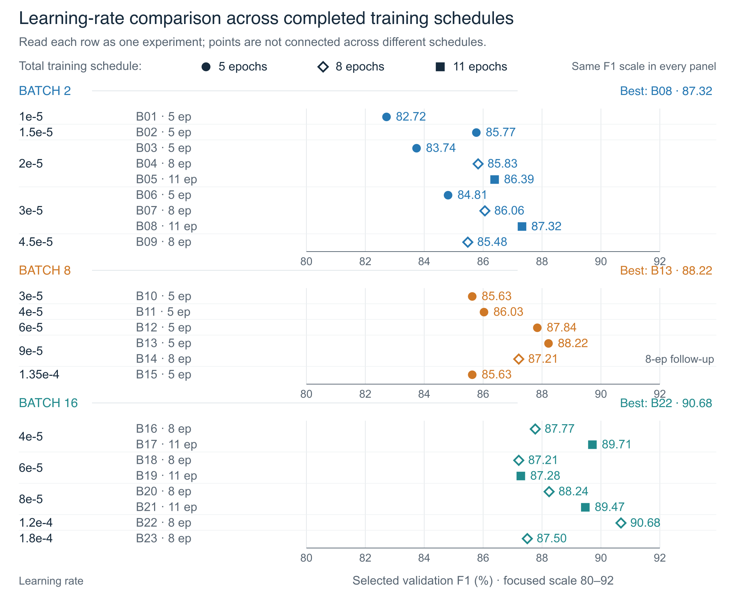
Figure 2. All tested learning rates and schedules, grouped by batch. Each point is one completed configuration, with its total epochs shown explicitly. The batch-8 8-epoch result is a single follow-up at 9e-5, not a missing series.
Batch 2: At 5 epochs, 1.5e-5 is strongest at 85.77%. Longer schedules shift the leading rate to 3e-5: 86.06% at 8 epochs and 87.32% at 11. Two further duration checks remain pending.
Batch 8: Within the 5-epoch runs, F1 rises to 88.22% at 9e-5 and falls to 85.63% at 1.35e-4. The separate 8-epoch follow-up at 9e-5 scores 87.21%, so extending that schedule does not improve its selected validation score.
Batch 16: Within the 8-epoch runs, extending the rate from 8e-5 to 1.2e-4 raises F1 from 88.24% to 90.68%; increasing again to 1.8e-4 lowers it to 87.50%. B22 lies inside the tested rate range and selects epoch 6 before its schedule ends.

3 3 Epoch selection and longer schedules
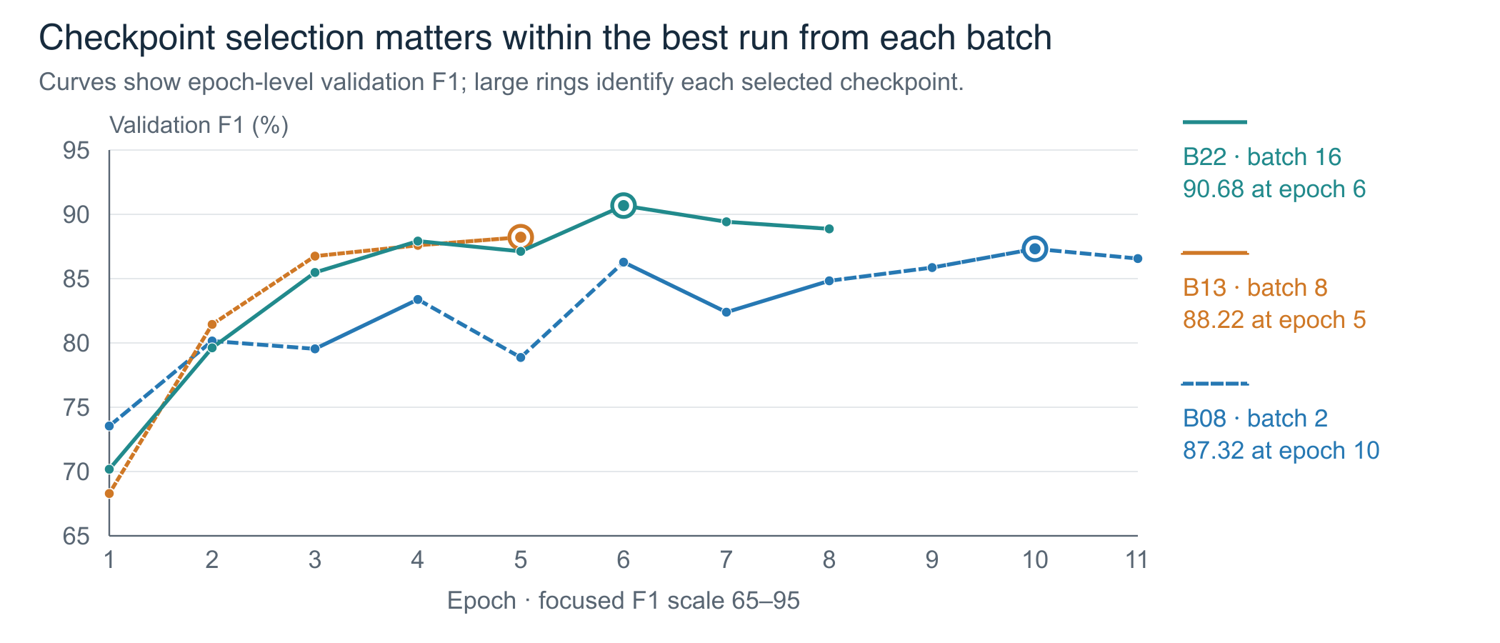
Figure 3. Validation F1 by epoch for the winning configuration within each batch. Highlighted points mark selection. Different total schedules make this a trajectory comparison, not a controlled batch-size comparison.
B22 peaks at epoch 6 (90.68%) and finishes at 88.87%, a 1.81-point loss if the final model is used. Across the 23 runs, 13 select an earlier epoch and 10 select their final epoch.
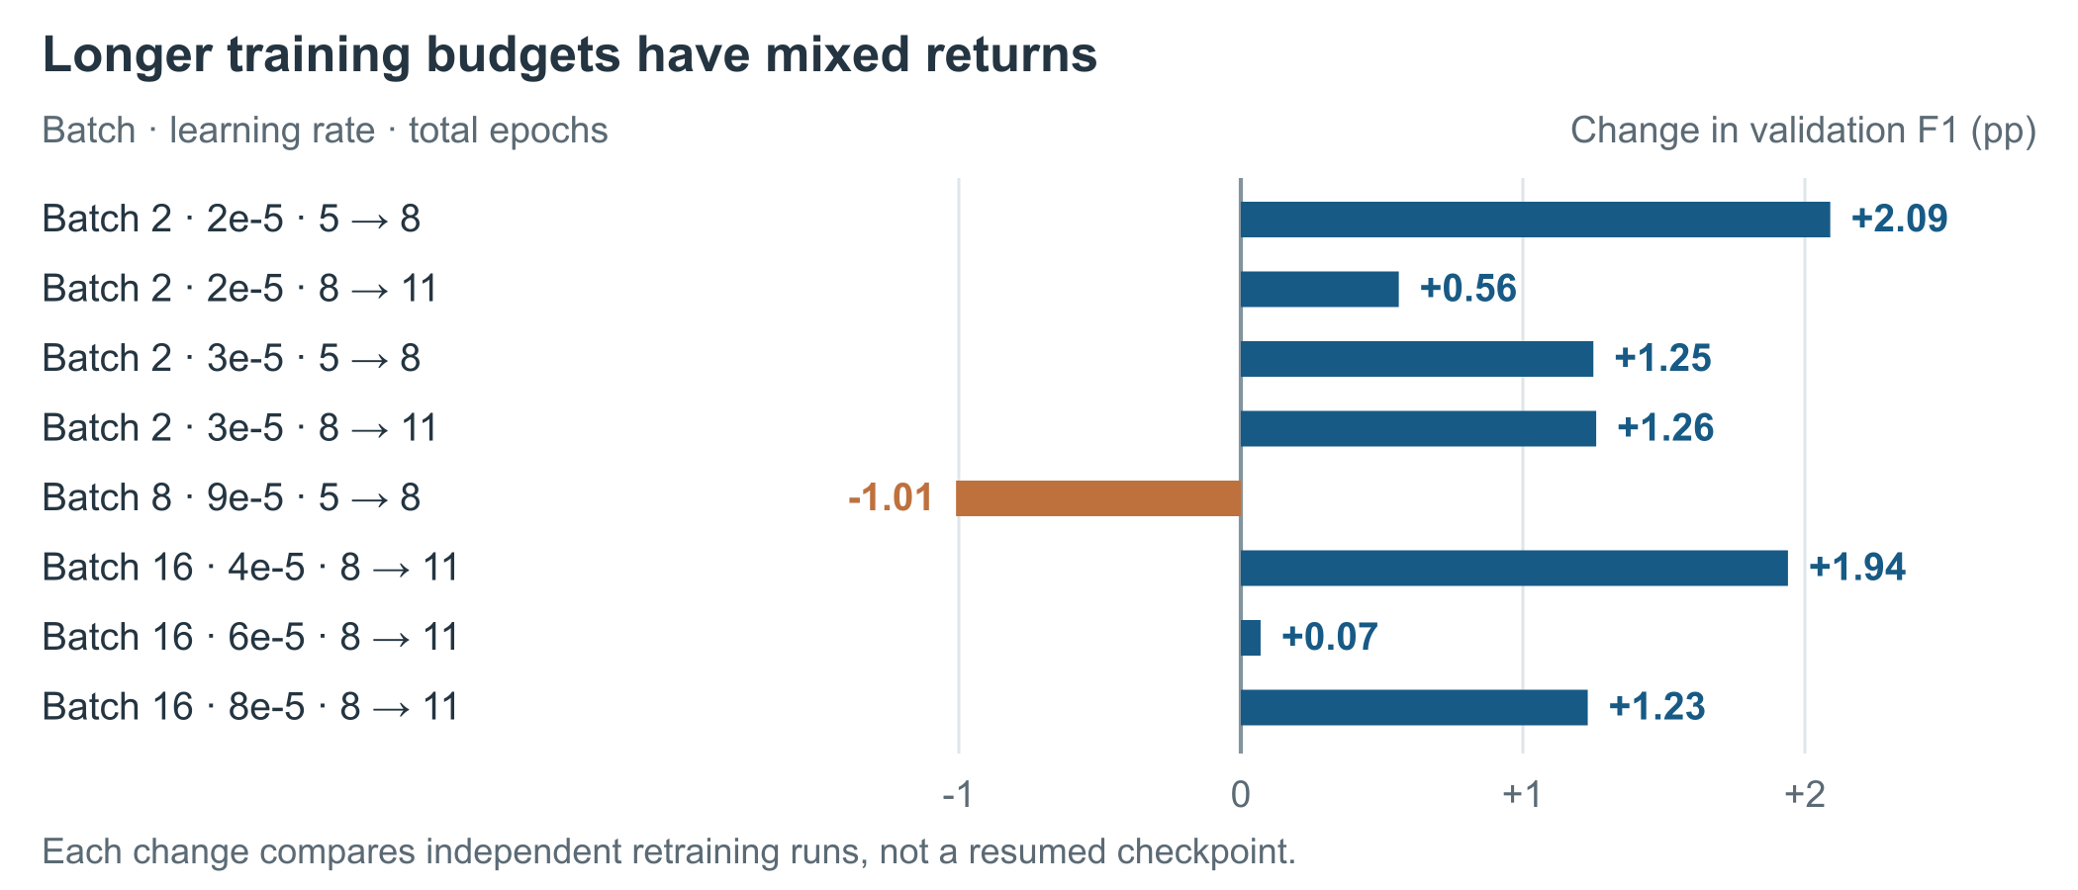
Figure 4. Change in the best validation F1 after increasing the total training schedule. Each transition compares separate retraining runs with the same batch and learning rate. Exact before and after scores are in Appendix D.
Longer schedules help seven of the eight completed transitions, but batch 8 at 9e-5 loses 1.01 points. Changing total epochs changes the warmup and decay schedule. Reproducing B22 requires an 8-epoch schedule with epoch-6 selection, not a new 6-epoch run.

4 Comparison with Run 2 and Sweep A
Run 2 tested a lower learning rate; Sweep A searched rates at batch 4; Sweep B searches batches 2, 8 and 16 with rate and schedule extensions. All comparisons below use the reported exact-match evaluation at threshold 0.4 with flat_ner=false.
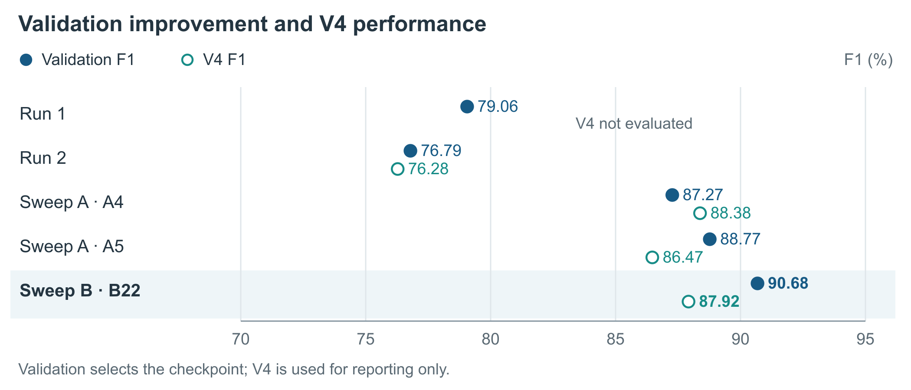
Figure 5. Validation and independent V4 F1 across the earlier experiments and B22. Run 1 has no V4 result in the supplied reports. Validation guides selection; V4 remains reporting-only.

4 1 Overall results
Experiment | Val F1 | Precision | Recall | FP | FN | V4 F1
Run 1 | 79.06 | 68.79 | 92.94 | 191 | 32 | Not run
Run 2 | 76.79 | 66.45 | 90.95 | 208 | 41 | 76.28
Sweep A A4 | 87.27 | 81.57 | 93.82 | 96 | 28 | 88.38
Sweep A A5 | 88.77 | 83.20 | 95.14 | 87 | 22 | 86.47
Sweep B B22 | 90.68 | 88.12 | 93.38 | 57 | 30 | 87.92

4 2 Change from each earlier reference to B22
B22 compared with | Val F1 pp | Precision pp | Recall pp | FP change | FN change | V4 F1 pp
Run 1 | +11.62 | +19.33 | +0.44 | -134 | -2 | Not tested
Run 2 | +13.89 | +21.67 | +2.43 | -151 | -11 | +11.64
Sweep A A4 | +3.41 | +6.55 | -0.44 | -39 | +2 | -0.46
Sweep A A5 | +1.91 | +4.92 | -1.76 | -30 | +8 | +1.45

B22 improves both precision and recall versus Run 2. Versus A5, it trades 30 fewer false positives for 8 more missed entities. A5 is the Sweep A validation winner; A4 is retained as part of the recommended anchor range and has the highest V4 score within Sweep A. Configuration details are in Appendix D.

4 3 How Sweep B extends the earlier findings
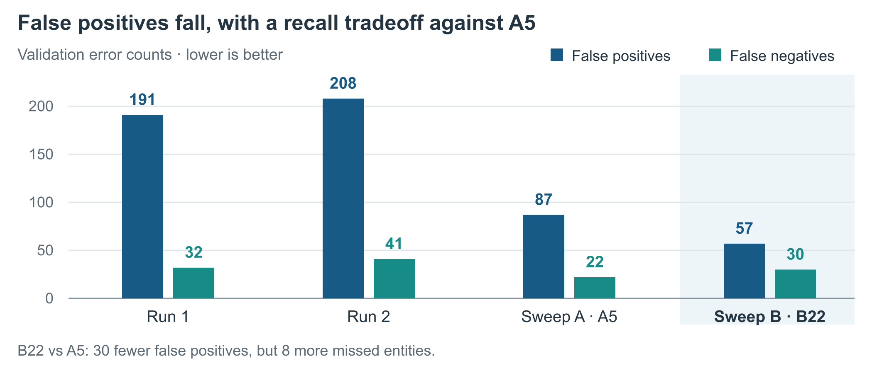
Figure 6. Validation errors across Run 1, Run 2, the Sweep A validation winner and the Sweep B validation winner. All use the reported 453-entity validation protocol.
Run 2 did not support lowering the learning rate to reduce over-tagging. Moving from 1e-5 to 5e-6 at batch 4 and 3 epochs lowered F1 by 2.27 points and increased false positives by 17. Sweep A then found stronger results with higher rates and a 5-epoch schedule. Sweep B extends the search and reaches 57 false positives at B22; this supports exploring the joint configuration, without proving a single cause for the improvement.

Comparisons with the same learning rate and total epochs
These pairs all use 5 total epochs and the same learning rate within each row. They help separate the headline winner comparison from the results at shared settings. Changing batch size still changes the number of optimizer updates.
LR | Sweep A batch 4 F1 | Sweep B batch and ID | Sweep B F1 | Change pp
1e-5 | 82.78 A2 | Batch 2 B01 | 82.72 | -0.06
2e-5 | 85.80 A3 | Batch 2 B03 | 83.74 | -2.06
3e-5 | 87.27 A4 | Batch 2 B06 | 84.81 | -2.46
3e-5 | 87.27 A4 | Batch 8 B10 | 85.63 | -1.64
4e-5 | 88.77 A5 | Batch 8 B11 | 86.03 | -2.74

None of these shared settings beats batch 4. B22 succeeds with a different combination: batch 16, a higher rate of 1.2e-4 and an 8-epoch schedule. The practical result is a stronger candidate configuration, not evidence that a larger batch is always better.

4 4 V4 gains are smaller than the validation gains
B22 scores 87.92% on V4: +11.64 points versus Run 2, +1.45 versus A5, but -0.46 versus A4. The larger validation gain therefore does not establish a clear V4 advantage over every strong Sweep A model. Run 1 was not evaluated on V4 in the supplied reports.
B14 has the highest V4 F1 in Sweep B (88.59%; validation F1 87.21%). This is a reporting-only observation. B22 remains the validation-selected candidate; choosing B14 because of V4 would change the selection protocol.

4 5 Post processing and label level evidence
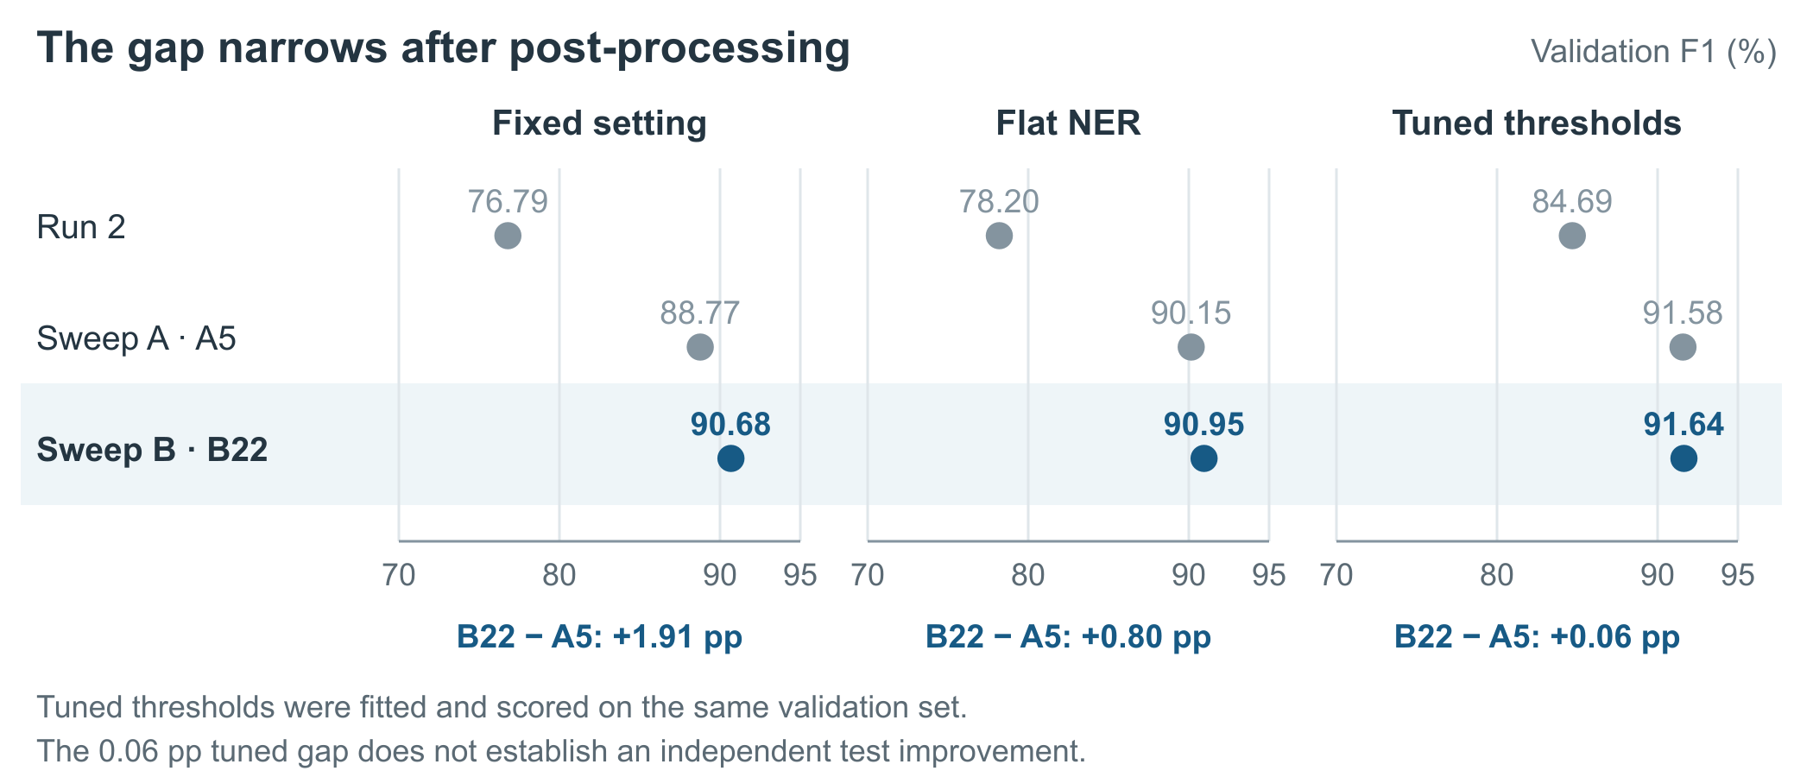
Figure 7. Validation F1 at the fixed setting, with overlapping predictions suppressed, and after per-label threshold tuning. B22 minus A5 is 1.91 points at the fixed setting, 0.80 with flat NER and 0.06 with tuned thresholds; these are separate evaluation settings. Tuning and scoring use the same validation set.
At the fixed setting, B22 improves over A5 by 1.91 points. After threshold tuning the scores are 91.64% and 91.58%, a 0.06-point gap. This does not establish a meaningful performance difference or an independent test gain. Full post-processing scores for all 23 runs are in Appendix C; historical values are in Appendix D.
The earlier reports identify LAB_RESULT false positives and PROCEDURE performance on V4 as weaknesses. Run 2 records LAB_RESULT validation F1 47.14 with 63 false positives; Sweep A reports F1 of roughly 72-75 at its strongest rates. Sweep B has no label-level results in the aggregate export, so its overall gain cannot establish that those particular weaknesses are resolved.

5 Limitations and next steps
- Confirm B22 across seeds. Repeat batch 16, learning rate 1.2e-4 and 8 total epochs, selecting each run by the same per-epoch validation rule, alongside A5. Current results use seed 42 with repeated validation-guided choices; uncertainty across seeds is not measured.
- Account for different training budgets. Batch, learning rate and schedule change together. Dataset sizes and settings follow the inherited protocol; Sweep B has no recorded hashes, hardware or timings in the CSV. Run 2 used CPU, whereas Run 1 and Sweep A used T4 GPUs.
- Complete the two remaining duration checks. Their results are absent from the 23-run export and may change the batch-2 ranking.
Pending configuration | Reason
Batch 2 / 2e-5 / 14 epochs | B05 selects epoch 11 of 11.
Batch 2 / 4.5e-5 / 11 epochs | B09 selects epoch 8 of 8.

Preserve the selected weights outside temporary Colab storage and review label-level errors before choosing a final model. Keep V4 for reporting throughout.

Appendix A Five and eight epoch schedules
Every displayed epoch was actually run. Experiments are grouped by their total training schedule, so there are no placeholders for unrun epochs. All F1 values are percentages at threshold 0.4 with flat_ner=false. Bold values mark the selected epoch. IDs match Section 3 1.

5 epoch schedules with 9 completed experiments
ID | Batch | LR | Ep 1 | Ep 2 | Ep 3 | Ep 4 | Ep 5
B01 | 2 | 1e-5 | 75.80 | 79.22 | 82.05 | 82.72 | 82.10
B02 | 2 | 1.5e-5 | 75.19 | 78.38 | 80.78 | 85.77 | 84.23
B03 | 2 | 2e-5 | 70.84 | 76.55 | 80.89 | 82.68 | 83.74
B06 | 2 | 3e-5 | 70.53 | 78.69 | 84.39 | 81.02 | 84.81
B10 | 8 | 3e-5 | 79.23 | 78.12 | 83.19 | 85.63 | 85.54
B11 | 8 | 4e-5 | 74.04 | 79.62 | 86.03 | 84.92 | 84.85
B12 | 8 | 6e-5 | 72.61 | 84.02 | 85.77 | 87.84 | 86.99
B13 | 8 | 9e-5 | 68.29 | 81.44 | 86.75 | 87.59 | 88.22
B15 | 8 | 0.000135 | 68.86 | 79.83 | 85.63 | 77.12 | 85.30

8 epoch schedules with 9 completed experiments
ID | Batch | LR | Ep 1 | Ep 2 | Ep 3 | Ep 4 | Ep 5 | Ep 6 | Ep 7 | Ep 8
B04 | 2 | 2e-5 | 74.66 | 79.26 | 77.01 | 81.78 | 83.44 | 84.97 | 85.42 | 85.83
B07 | 2 | 3e-5 | 55.37 | 75.16 | 73.50 | 83.05 | 73.09 | 82.65 | 86.03 | 86.06
B09 | 2 | 4.5e-5 | 18.20 | 76.95 | 74.15 | 84.14 | 81.62 | 84.82 | 85.45 | 85.48
B14 | 8 | 9e-5 | 67.11 | 77.93 | 82.51 | 86.54 | 82.34 | 86.45 | 87.21 | 87.20
B16 | 16 | 4e-5 | 79.62 | 82.19 | 85.54 | 84.71 | 83.05 | 85.60 | 87.14 | 87.77
B18 | 16 | 6e-5 | 78.26 | 81.21 | 83.86 | 85.43 | 87.05 | 85.77 | 85.80 | 87.21
B20 | 16 | 8e-5 | 77.31 | 81.88 | 82.55 | 85.37 | 85.48 | 87.03 | 87.46 | 88.24
B22 | 16 | 0.00012 | 70.18 | 79.62 | 85.48 | 87.92 | 87.12 | 90.68 | 89.42 | 88.87
B23 | 16 | 0.00018 | 68.92 | 79.84 | 86.26 | 78.62 | 84.76 | 85.59 | 87.50 | 87.21

B09 starts at 18.20% F1 in epoch 1 and reaches 85.48% at epoch 8. The early value is retained exactly as exported; the aggregate table does not identify its cause.

Coverage of epoch measurements
The export uses a shared set of epoch 1-11 columns for all runs. Its 81 empty cells all lie after the configured training duration: 54 cells for the nine 5-epoch runs and 27 cells for the nine 8-epoch runs. There are no missing F1 values within a completed schedule. This grouping removes those structural empty cells without discarding results.

Appendix B Eleven epoch schedules
Five experiments ran for 11 epochs. The two tables below continue the same trajectories; both contain the same five IDs. All recorded epochs are shown, and bold values mark selection.

Epochs 1 to 6
ID | Batch | LR | Ep 1 | Ep 2 | Ep 3 | Ep 4 | Ep 5 | Ep 6
B05 | 2 | 2e-5 | 66.13 | 78.42 | 82.05 | 84.10 | 84.01 | 85.10
B08 | 2 | 3e-5 | 73.54 | 80.15 | 79.54 | 83.38 | 78.87 | 86.28
B17 | 16 | 4e-5 | 76.41 | 77.67 | 83.77 | 86.09 | 87.31 | 85.83
B19 | 16 | 6e-5 | 80.76 | 83.25 | 82.75 | 85.14 | 83.49 | 84.67
B21 | 16 | 8e-5 | 76.09 | 79.44 | 83.93 | 87.07 | 85.19 | 81.99

Epochs 7 to 11
ID | Batch | LR | Ep 7 | Ep 8 | Ep 9 | Ep 10 | Ep 11
B05 | 2 | 2e-5 | 85.48 | 83.18 | 85.40 | 85.92 | 86.39
B08 | 2 | 3e-5 | 82.39 | 84.83 | 85.86 | 87.32 | 86.56
B17 | 16 | 4e-5 | 89.71 | 89.00 | 88.25 | 88.16 | 88.98
B19 | 16 | 6e-5 | 86.92 | 87.07 | 86.03 | 87.28 | 86.99
B21 | 16 | 8e-5 | 88.87 | 87.72 | 89.47 | 88.20 | 89.33

How to identify each experiment
A folder name encodes the batch, learning rate and total schedule: finetune_run3_b{batch}_lr{learning_rate}_ep{total_epochs}. For example, B22 is finetune_run3_b16_lr0.00012_ep8. The notation 0.00012 means 1.2e-4; 0.000135 means 1.35e-4.
The total epoch count identifies a complete retraining schedule. An 11-epoch experiment restarts from the base model with its own learning-rate schedule; it is not a continuation of the corresponding 8-epoch trajectory. Report IDs B01-B23 are sorted by batch, learning rate and total epochs, not execution order.

Completeness of the results
The 23 schedules contain 172 measured epoch F1 values: 45 from 5-epoch runs, 72 from 8-epoch runs and 55 from 11-epoch runs. Every one appears in Appendix A or B. All 23 selected-model precision, recall, F1, false-positive, false-negative and V4 F1 values are present in Section 3 1.
Per-epoch precision, recall and error counts are not fields in the supplied Sweep B CSV. Sweep A reported them from more detailed evaluation files. They cannot be reconstructed from F1 alone, so this appendix reports the available per-epoch F1 without inventing additional metrics.

Appendix C Final models and post processing
All 23 completed configurations are included. Selected is the best validation checkpoint at the fixed setting; Final is the last model in the schedule. Flat and Tuned refer to the selected model evaluated with flat_ner=true and with per-label tuned thresholds. All values are validation F1 percentages.
ID | Selected | Final | Flat NER | Tuned thresholds
B01 | 82.72 | 82.10 | 83.75 | 88.42
B02 | 85.77 | 84.23 | 86.48 | 90.04
B03 | 83.74 | 83.74 | 84.68 | 88.49
B04 | 85.83 | 85.83 | 86.36 | 89.08
B05 | 86.39 | 86.39 | 86.31 | 88.28
B06 | 84.81 | 84.81 | 85.54 | 89.27
B07 | 86.06 | 86.06 | 87.05 | 89.39
B08 | 87.32 | 86.56 | 87.71 | 90.08
B09 | 85.48 | 85.48 | 86.07 | 88.24
B10 | 85.63 | 85.54 | 87.79 | 90.38
B11 | 86.03 | 84.85 | 87.29 | 89.49
B12 | 87.84 | 86.99 | 88.51 | 90.22
B13 | 88.22 | 88.22 | 89.05 | 91.09
B14 | 87.21 | 87.20 | 87.35 | 88.56
B15 | 85.63 | 85.30 | 87.45 | 89.17
B16 | 87.77 | 87.77 | 88.52 | 90.38
B17 | 89.71 | 88.98 | 90.54 | 91.60
B18 | 87.21 | 87.21 | 87.87 | 90.29
B19 | 87.28 | 86.99 | 87.76 | 89.22
B20 | 88.24 | 88.24 | 88.72 | 89.99
B21 | 89.47 | 89.33 | 90.56 | 91.08
B22 | 90.68 | 88.87 | 90.95 | 91.64
B23 | 87.50 | 87.21 | 87.70 | 88.91

Sources and checks
Sweep B: sweep_B_table-2.csv, 23 unique configurations. All selected F1 values equal the maximum recorded epoch F1 and their named checkpoint value. Final F1 equals the last epoch F1. Validation precision, recall and F1 reconcile with FP/FN and 453 gold entities to the reported rounding precision.
Historical sources: HoloKai_GLiNER_Fine-tuning_Report_for_Run_2.docx, Sections 2-5; HoloKai_GLiNER_Fine-tuning_Report_Sweep_A.docx, Sections 2-3 and the appendix. Run 1 V4 and flat NER are explicitly marked not run in those sources. Historical comparisons use their reported figures, without inferring later results.
Execution and coverage: Holokai_Finetune_Run_3_Sweep_B.ipynb and the log after the second extension round: 9 initial runs, 8 first extensions and 6 second extensions. The two further pending runs have no result rows. Appendices A to C group results by training schedule and retain every recorded epoch and post-processing value.

Appendix D Supporting comparison data

Training schedule comparisons
All gains below are differences in selected validation F1, in percentage points. Each row compares separate retraining schedules rather than continued training from the shorter run.
Batch | LR | Total epochs | Selected F1 change | Gain pp
2 | 2e-5 | 5 to 8 | 83.74 to 85.83 | +2.09
2 | 2e-5 | 8 to 11 | 85.83 to 86.39 | +0.56
2 | 3e-5 | 5 to 8 | 84.81 to 86.06 | +1.25
2 | 3e-5 | 8 to 11 | 86.06 to 87.32 | +1.26
8 | 9e-5 | 5 to 8 | 88.22 to 87.21 | -1.01
16 | 4e-5 | 8 to 11 | 87.77 to 89.71 | +1.94
16 | 6e-5 | 8 to 11 | 87.21 to 87.28 | +0.07
16 | 8e-5 | 8 to 11 | 88.24 to 89.47 | +1.23

Historical configurations
Experiment | Batch | Learning rate | Total epochs | Selected checkpoint
Run 1 | 4 | 1e-5 | 3 | Epoch 3 / final
Run 2 | 4 | 5e-6 | 3 | Epoch 3 / final
Sweep A A4 | 4 | 3e-5 | 5 | Epoch 4
Sweep A A5 | 4 | 4e-5 | 5 | Epoch 4
Sweep B B22 | 16 | 1.2e-4 | 8 | Epoch 6

Post processing comparisons
Selected model | Fixed F1 | Flat NER F1 | Tuned thresholds F1
Run 1 | 79.06 | Not run | 86.43
Run 2 | 76.79 | 78.20 | 84.69
Sweep A A5 | 88.77 | 90.15 | 91.58
Sweep B B08 batch 2 | 87.32 | 87.71 | 90.08
Sweep B B13 batch 8 | 88.22 | 89.05 | 91.09
Sweep B B22 batch 16 | 90.68 | 90.95 | 91.64

Historical metrics come from the Run 2 and Sweep A reports. Sweep B chart values and tables come from the same 23-row results export; no interpolation fills untested configurations and no unrun epoch is assigned a value.

