HoloKai GLiNER Fine-tuning Report: Sweep A (Learning Rate × Epochs)
Model: knowledgator/gliner-pii-base-v1.0 · Owner: person A · Date: October 6, 2026 · Hardware: Google Colab T4 GPU

1. Summary
Sweep A trained six models that differ only in learning rate (5e-6 to 5e-5). Each model was trained for 5 epochs and evaluated after every epoch.
- The learning rate used in Run 1 (1e-5) was too low. Validation F1 rises steadily with the learning rate up to 3e-5 and then levels off. The three highest rates (3e-5, 4e-5, 5e-5) all reach 87–89 F1, against 79.06 for Run 1.
- A higher learning rate fixes most of Run 1's false-positive problem. Validation false positives fall from 191 (Run 1) to 84–96. Precision rises from 68.8 to 81.6–83.5, while recall stays at 94–95.
- Five epochs beat three, and epoch 4 is usually best. Five of the six runs peak at epoch 4 and lose 0.4–3.9 points at epoch 5, so each epoch must be evaluated and the best one selected.
- The gains carry over to the independent V4 test set. At 3e-5, V4 F1 is 88.38, compared with 53.33 for the base model and 76.28 for Run 2.
- Two labels remain weak. LAB_RESULT has low precision on validation (about 60–65), and PROCEDURE has the lowest F1 on V4 (66–76). These two labels are the targets for the data-augmentation phase.
- Recommendation: use a learning rate of 3e-5 to 4e-5, train for 5 epochs, and keep per-epoch model selection. Use this as the new anchor for the batch-size sweep (B) and the end-of-week combination search.

2. Setup
Item | Value
Base config | Run 1 (finetune_run_1.json); only learning_rate and epochs changed
Learning rates | 5e-6 (A1), 1e-5 (A2), 2e-5 (A3), 3e-5 (A4), 4e-5 (A5), 5e-5 (A6)
Epochs | 5 (Run 1 and Run 2 used 3)
Fixed settings | batch size 4, seed 42, warmup 0.1, linear decay to 0, weight decay 0.01, max grad norm 1.0
Training data | 1,509 units (sha256 identical to Run 1)
Validation data | 171 units, 453 entities
Test data | V4, 648 units, 1,320 entities (120 per label), used for reporting only
Labels | 11 labels, recommended GLiNER names
Metric | Exact span + exact label, micro-averaged, threshold 0.4, flat_ner=false
Model selection | Highest validation F1, then PROVIDER F1, then precision
Notebook | Holokai_Finetune_Sweep_A.ipynb; results in Drive Holokai_Project/finetune_A/

All six runs fit comfortably in free Colab T4 sessions (run times were not logged precisely). Model weights were deleted after evaluation to save Drive space; only metrics, predictions and logs were kept.
Note on the learning-rate schedule. The learning rate rises during the first 10% of steps and then decays linearly to 0 at the last step. In a 5-epoch run, epoch 3 ends with 44% of the peak learning rate still remaining, whereas a 3-epoch run ends at 0. An intermediate epoch of a 5-epoch run is therefore not equivalent to a shorter run, and epoch 3 here should not be compared directly with Run 1.

3. Results

3.1 Overview
Run | LR | Ep 1 | Ep 2 | Ep 3 | Ep 4 | Ep 5 | Selected | Val F1 | Precision | Recall | FP / FN | flat_ner F1 | Per-label thr. F1 | V4 F1
A1 | 5e-6 | 72.78 | 73.60 | 77.15 | 78.81 | 78.42 | ep 4 | 78.81 | 69.66 | 90.73 | 179 / 42 | 79.92 | 85.68 | 78.61
A2 | 1e-5 | 78.10 | 77.26 | 79.36 | 82.78 | 81.60 | ep 4 | 82.78 | 74.34 | 93.38 | 146 / 30 | 84.22 | 88.36 | 82.68
A3 | 2e-5 | 75.16 | 80.75 | 85.80 | 85.69 | 85.03 | ep 3 | 85.80 | 78.89 | 94.04 | 114 / 27 | 86.60 | 88.82 | 83.87
A4 | 3e-5 | 72.78 | 82.63 | 81.18 | 87.27 | 86.11 | ep 4 | 87.27 | 81.57 | 93.82 | 96 / 28 | 88.56 | 90.77 | 88.38
A5 | 4e-5 | 66.77 | 79.58 | 81.60 | 88.77 | 84.84 | ep 4 | 88.77 | 83.20 | 95.14 | 87 / 22 | 90.15 | 91.58 | 86.47
A6 | 5e-5 | 66.19 | 80.87 | 85.07 | 88.47 | 88.05 | ep 4 | 88.47 | 83.53 | 94.04 | 84 / 27 | 88.51 | 91.15 | 87.63

Reference points:
 | Val F1 | Precision | Recall | FP / FN | V4 F1
Base model (no fine-tuning) | 47.79 | 40.94 | 57.40 | 375 / 193 | 53.33
Run 1 (1e-5, 3 epochs) | 79.06 | 68.79 | 92.94 | 191 / 32 | not run
Run 2 (5e-6, 3 epochs) | 76.79 | 66.45 | 90.95 | 208 / 41 | 76.28

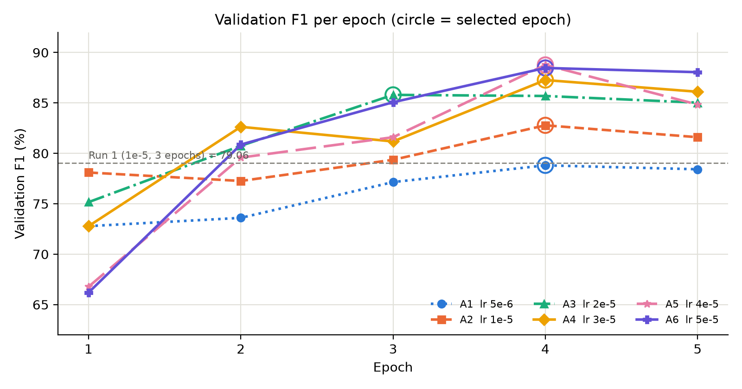
Figure 1. Validation F1 after each epoch for the six learning rates. Circles mark the selected epoch.

3.2 Effect of the learning rate
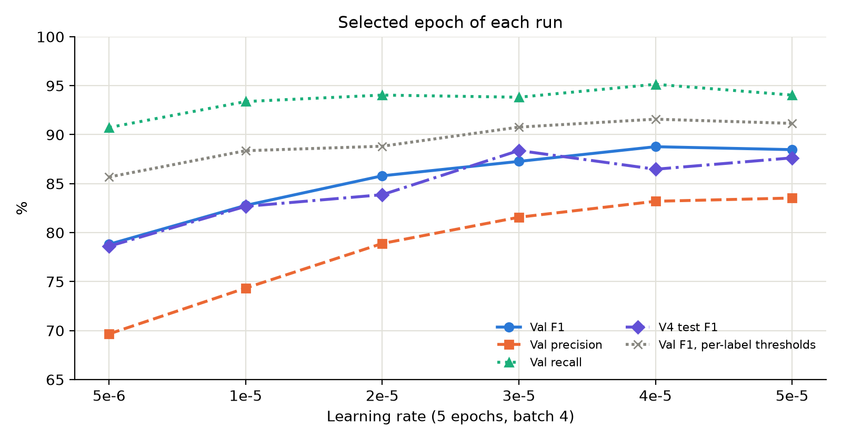
Figure 2. Metrics of the selected epoch as a function of the learning rate.
- F1 increases with the learning rate and then plateaus. Validation F1 goes 78.8 → 82.8 → 85.8 → 87.3 → 88.8 → 88.5.
  - From 5e-6 to 3e-5, each step adds 1.5–4 points.
  - The three highest rates are within 1.5 points of each other, which is within the run-to-run noise observed in this sweep (see Section 3.6).
- Precision drives the improvement. Precision climbs from 69.7 to 83.5, while recall only moves from 90.7 to 94–95. A higher learning rate mainly teaches the model what not to tag.
- V4 agrees with validation. V4 F1 rises from 78.6 to 88.4 (3e-5), then stays at 86.5–87.6. The best rate is 3e-5 on V4 but 4e-5 on validation. This disagreement is another sign that the top three rates cannot be separated with one seed.

3.3 Effect of the number of epochs
- More training helps at every learning rate. With an identical setup except for 5 epochs instead of 3:
  - 1e-5 improves from 79.06 (Run 1) to 82.78 (A2), +3.7.
  - 5e-6 improves from 76.79 (Run 2) to 78.81 (A1), +2.0.
- Epoch 4 is the sweet spot of a 5-epoch schedule.
  - Five of the six runs select epoch 4, and A3 peaks at epoch 3, with epoch 4 only 0.1 lower.
  - Epoch 5 is always lower: −0.4 (A1), −1.2 (A2), −0.7 (A3), −1.2 (A4), −3.9 (A5) and −0.4 (A6).
- High learning rates start slowly but finish highest. At 4e-5 and 5e-5, epoch 1 is the worst of all runs (66–67 F1, up to 375 false positives), but these runs overtake the others by epoch 3–4.
- Curves are not smooth. Several runs drop between consecutive epochs (A2 epoch 1→2, A4 epoch 2→3, A5 epoch 4→5). This is why the best epoch must be selected by evaluation rather than assumed.

3.4 False positives
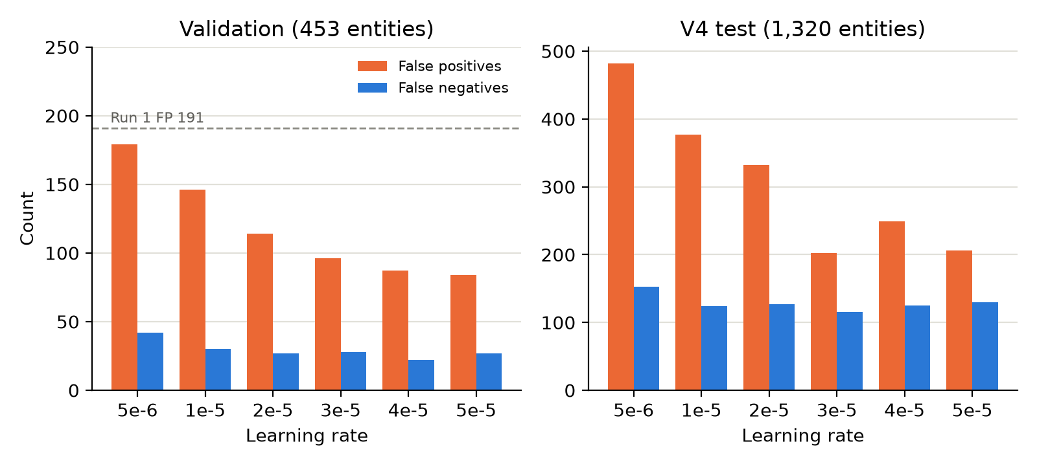
Figure 3. False positives and false negatives of the selected epoch on validation and V4.
Run 1's main problem was over-tagging: 191 false positives against 32 false negatives on validation. Run 2 tested whether a lower learning rate would make the model more cautious, and it did not.
Sweep A shows the opposite.
- Validation: false positives fall from 179 (5e-6) to 96 (3e-5) and 84 (5e-5), about half of Run 1. False negatives fall too, from 42 to 22–28.
- V4: false positives fall from 482 (5e-6) to 202 (3e-5), −58%. False negatives stay at 115–153.
The over-tagging was a symptom of under-training, not of training too aggressively.

3.5 Per-label results
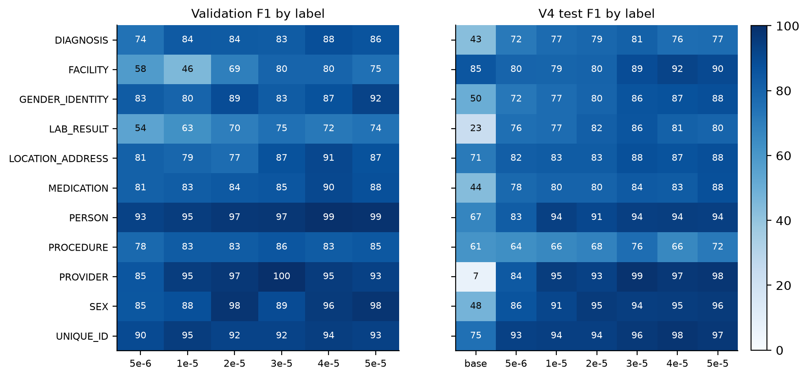
Figure 4. F1 by label on validation (selected epoch) and on V4. The V4 panel includes the base model.
Label | Val support | Val F1 range (A1–A6) | V4 base | V4 at 3e-5 (A4) | V4 at 4e-5 (A5) | V4 at 5e-5 (A6)
PROVIDER | 30 | 85.2–100.0 | 6.8 | 98.8 | 96.7 | 97.6
UNIQUE_ID | 45 | 89.6–94.6 | 75.1 | 96.4 | 98.0 | 96.8
SEX | 21 | 85.1–97.7 | 47.6 | 94.4 | 94.7 | 95.5
PERSON | 72 | 92.9–99.3 | 67.1 | 94.0 | 94.3 | 93.8
FACILITY | 9 | 45.7–80.0 | 85.3 | 88.8 | 91.9 | 90.0
GENDER_IDENTITY | 24 | 80.0–92.3 | 50.2 | 86.2 | 86.9 | 88.1
LOCATION_ADDRESS | 22 | 76.9–90.9 | 71.2 | 87.6 | 86.7 | 87.9
MEDICATION | 59 | 81.2–90.3 | 43.6 | 83.7 | 83.0 | 87.8
LAB_RESULT | 44 | 54.4–75.0 | 23.3 | 85.6 | 81.2 | 80.0
DIAGNOSIS | 67 | 74.5–88.1 | 42.9 | 81.0 | 76.4 | 76.9
PROCEDURE | 60 | 77.9–85.5 | 61.2 | 76.3 | 66.2 | 71.6

- Largest gains over the base model.
  - PROVIDER rises from 6.8 to 97–99 on V4. The base model almost never recognised clinicians under the recommended label name.
  - LAB_RESULT (+57 to +62), SEX (+47), MEDICATION (+40 to +44) and GENDER_IDENTITY (+36 to +38) also improve strongly.
- FACILITY no longer drops. In Run 2 (5e-6), facility fell below the base model on V4 (85.3 → 81.9). Here it stays at 79–80 for the three lowest rates but rises to 89–92 from 3e-5 upwards. The earlier drop was a consequence of the low learning rate.
  - Validation facility scores are unreliable because there are only 9 facility entities in validation.
- LAB_RESULT is the weakest label on validation.
  - F1 is 72–75 even at the best rates, and precision stays around 60–65.
  - It is the largest source of validation false positives in every run: 21–47 of the run's false positives.
- PROCEDURE is the weakest label on V4.
  - V4 F1 is 64–76, compared with 83–86 on validation.
  - It produces the most V4 false positives (34–84).
  - The gap between validation and V4 suggests that the procedure spans in the training data differ from the V4 annotation guideline, for example in how much surrounding text a procedure span includes. This needs an error review before adding data.
- DIAGNOSIS stops improving on V4 beyond 3e-5 (76–81).

3.6 Post-processing and noise
- Per-label thresholds (tuned on validation) add +6.9 F1 at 5e-6 but only +2.7 to +3.5 F1 at 3e-5 to 5e-5.
  - Better-trained models are already better calibrated at the default threshold of 0.4.
  - These thresholds are fitted on validation and are therefore optimistic.
- `flat_ner=true` (no overlapping predictions) adds about +0.8 to +1.4 F1 in five runs, and nothing at 5e-5.
- Noise.
  - Single-epoch swings of 1–4 points occur within the same run.
  - Validation and V4 rank the top three learning rates differently.
  - Until person D measures seed-to-seed variation, differences below about 2 points should be treated as ties.

4. What we learned from Sweep A
- We found the useful learning-rate range: 3e-5 to 5e-5. Run 1's 1e-5 was 3 to 5 times too low. At equal epochs, moving from 1e-5 to 3e-5–5e-5 adds about 4.5–6 F1 on validation and 4–6 on V4. Relative to Run 1 (also fewer epochs), the gain is about 8–10 F1 on validation.
- The false-positive problem was under-training. The intuitive fix tested in Run 2, a lower learning rate, made things worse. A higher learning rate halves false positives without hurting recall.
- Five epochs with per-epoch selection is the right protocol. The best model is almost always at epoch 4, and the last epoch is often worse. Per-epoch evaluation should stay in every future run.
- Fine-tuning generalises. The best models score 86–88 on the independent V4 test set, 33–35 points above the base model. This confirms that the improvement is not an artefact of the validation set.
- We now know which labels need more data. LAB_RESULT needs higher precision, and PROCEDURE needs better generalisation. This turns the next phase, data augmentation, from a guess into a targeted task.
- We have a reusable, low-cost pipeline.
  - One Colab notebook trains, evaluates every epoch, selects, tests on V4 and writes a summary table.
  - Each learning rate runs on a free T4 without manual steps.
  - Results are stored in a fixed folder structure without filling Drive with weights.
  - Teammates can reuse it by changing a few values.
- We learned how noisy single runs are. Single runs move by 1–4 points from epoch to epoch. Seed repeats (person D) are needed before ranking close configurations.

5. Limitations
- One seed (42) per learning rate. The ranking of 3e-5, 4e-5 and 5e-5 is not statistically reliable.
- Validation scores are optimistic.
  - The best of five epochs is selected on validation and then reported on validation.
  - The per-label thresholds are also fitted on validation.
  - V4 is the unbiased check, and it was not used for any selection.
- The validation set is small (453 entities). FACILITY has only 9 validation entities, so its validation F1 can swing by more than 20 points from a few errors.
- No model weights were kept. Producing a final model requires one retraining run with keep_best_weights=True.
- Epoch 4 of a 5-epoch run is not the same as a 4-epoch run. A dedicated 4-epoch run was not tested.

6. Recommendations and next steps
- New anchor for the team: learning rate 3e-5 to 4e-5, 5 epochs, batch size 4, per-epoch selection.
- Batch-size sweep (B): rescale from the new anchor (3e-5 at batch 4), not from 1e-5.
  - Linear scaling would give 6e-5 for batch 8 and 1.2e-4 for batch 16. That is above the range tested here, so the square-root rule (about 4e-5 and 6e-5) is the safer starting point.
- End-of-week combination search: learning rate {3e-5, 4e-5} × batch size {4, 8} × at least 2 seeds, 5 epochs each. This replaces the original {1e-5, 2e-5}.
- Seeds (D): run the anchor config (3e-5) with seeds 7 and 123 to measure the noise floor.
- Data augmentation (next phase): focus on LAB_RESULT false positives and PROCEDURE boundaries. First review the PROCEDURE errors on V4 to check for an annotation-guideline mismatch.
- Final model: retrain the chosen config with keep_best_weights=True, then report V4 once with both flat_ner settings.

Appendix: per-epoch precision / recall / false positives (validation)
Run | Ep 1 P / R / FP | Ep 2 P / R / FP | Ep 3 P / R / FP | Ep 4 P / R / FP | Ep 5 P / R / FP
A1 5e-6 | 63.6 / 85.0 / 220 | 63.1 / 88.3 / 234 | 65.8 / 93.2 / 219 | 69.7 / 90.7 / 179 | 68.4 / 91.8 / 192
A2 1e-5 | 73.4 / 83.4 / 137 | 67.3 / 90.7 / 200 | 69.5 / 92.5 / 184 | 74.3 / 93.4 / 146 | 71.8 / 94.5 / 168
A3 2e-5 | 64.3 / 90.5 / 228 | 72.7 / 90.7 / 154 | 78.9 / 94.0 / 114 | 77.9 / 95.1 / 122 | 77.2 / 94.7 / 127
A4 3e-5 | 60.6 / 91.2 / 269 | 75.4 / 91.4 / 135 | 73.3 / 91.0 / 150 | 81.6 / 93.8 / 96 | 78.7 / 95.1 / 117
A5 4e-5 | 52.5 / 91.6 / 375 | 70.1 / 92.1 / 178 | 73.0 / 92.5 / 155 | 83.2 / 95.1 / 87 | 77.0 / 94.5 / 128
A6 5e-5 | 55.4 / 82.1 / 299 | 73.1 / 90.5 / 151 | 79.2 / 91.8 / 109 | 83.5 / 94.0 / 84 | 81.9 / 95.1 / 95

Source files: Drive Holokai_Project/finetune_A/ (sweep_A_table.csv, outputs/<run>/run_summary.json, model_eval/, extra/).

