HoloKai GLiNER Fine Tuning Report_for_Run_1
Recommended labels as the formal experimental schema
Run finetune_run_1 • Source notebook Holokai_Finetune_Mapped_Data_Only.ipynb
The supplied run summary reports that fine tuning increases validation F1 from 47.79% to 79.06% at threshold 0.4. Per-label threshold calibration raises validation F1 to 86.43%. The notebook defines a consistent mapped-label workflow for this comparison.
Evidence status: the attached notebook has 33 cells, no saved outputs, and no executed code-cell counts. Workflow, mapping and parameter assertions are verified from its code. Sample counts, reported scores and the epoch-3 selection below come from the accompanying user-provided results; they cannot be independently verified from this attachment. Missing measurements are explicitly identified.

1 Objective and research question
The experiment fine tunes knowledgator/gliner-pii-base-v1.0 for the project’s entity extraction task under one formal schema. It asks how well the pretrained model performs with recommended label names, how much fine tuning improves it, and which labels improve most or remain difficult.

2 Data
Dataset | Formal file | Samples
Training | train_gliner_mapping.json | 1,509
Validation | val_gliner_mapping.json | 171

Reported validation entities: 453. The attachment does not contain the data files, split-generation procedure or printed counts. Train entity count and per-label supports are not available.
Mapping changes only the label name. Cell 8 asserts equal sample counts, identical tokenized_text, equal entity counts and unchanged token-span coordinates for every original/mapped pair. Both mapped files must contain exactly the 11 mapped labels. These checks are defined in code, but their PASS outputs are not saved.
Original non-mapped files are used only to generate and validate the mapped files. Baseline evaluation, smoke test, training, model selection, comparison and threshold tuning all use mapped data.

3 Experimental setup
Setting | Notebook specification
Base model | knowledgator/gliner-pii-base-v1.0
Evaluation | Exact token span and exact label; fixed threshold 0.4
Learning rate | 1e-5
Train and evaluation batch sizes | 4 and 8
Epochs and seed | 3 and 42

Baseline and saved-model evaluation use the same mapped validation file. Exact-span evaluation is specified by the notebook; the evaluator implementation is not attached. Split independence and other training settings cannot be audited here.

4 Recommended label mapping
The following mapping is copied from cell 8. Uppercase canonical labels are shown for project readability; the notebook uses the lowercase source strings listed below.
Canonical label | Source label | Formal GLiNER label name
PROVIDER | provider | name medical professional
FACILITY | facility | organization medical facility
PERSON | person | name
LOCATION_ADDRESS | location address | location address
DIAGNOSIS | diagnosis | condition
UNIQUE_ID | unique identifier | personal identifier number
SEX | sex | sex assigned at birth
GENDER_IDENTITY | gender identity | gender identity
PROCEDURE | procedure | medical procedure or test performed
MEDICATION | medication | medication, drug, or prescription
LAB_RESULT | lab result | lab result or test finding

Label wording matters because GLiNER uses label text as part of the query. This run holds the recommended wording fixed throughout the experiment. It does not include a measured comparison against alternative label names, so the improvement cannot be attributed to mapping alone.

5 Pretrained baseline
Cell 13 evaluates the pretrained base model on val_gliner_mapping.json at threshold 0.4. Cell 14 loads baseline/metrics.json and baseline/per_label_metrics.csv.
Precision | Recall | F1
40.94% | 57.40% | 47.79%

These are the formal mapped baseline scores supplied with the request. The previously used non-mapped baseline is outside the scope of this report.
11-label P/R/F1: unavailable in the attachment. The notebook includes code to display all per-label metrics but retains no output. The baseline/per_label_metrics.csv file is required to populate this result without inventing values.

6 Fine tuning training results
The formal run trains for three epochs. A separate pipeline smoke test uses the first 100 mapped training samples and first 30 mapped validation samples for one epoch; it is not the formal result.
Cell 22 reads training/training_history.json and prints step, epoch, validation precision, recall, F1 and PROVIDER recall. No history values or training losses are embedded. Epoch 1 and 2 performance, the step-level trajectory and whether a plateau occurred are therefore undetermined. A validation F1 trajectory cannot be drawn from this attachment.

7 Best fine tuned model
Reported selected model: epoch-3 at threshold 0.4. The notebook evaluates all saved epoch models and final_model on the mapped validation set. Selection ranks validation F1 first, then PROVIDER F1 and overall precision. The candidate scores and saved best_model.json are not attached, so this selection is reported rather than independently confirmed.
Precision | Recall | F1
68.79% | 92.94% | 79.06%

8 Pretrained and fine tuned comparison
This is the main controlled comparison: the same mapped labels, validation data, fixed threshold and exact-span evaluation are used on both sides.
Metric | Pretrained | Fine tuned | Change
Precision | 40.94% | 68.79% | +27.85 pp
Recall | 57.40% | 92.94% | +35.54 pp
F1 | 47.79% | 79.06% | +31.27 pp

Changes are percentage-point differences calculated from the supplied rounded scores. Recall improves more than precision, while both increase substantially. Fine tuning is associated with broader entity recovery and better precision on this validation set. Exact TP/FP/FN totals are not reconstructed from rounded percentages.
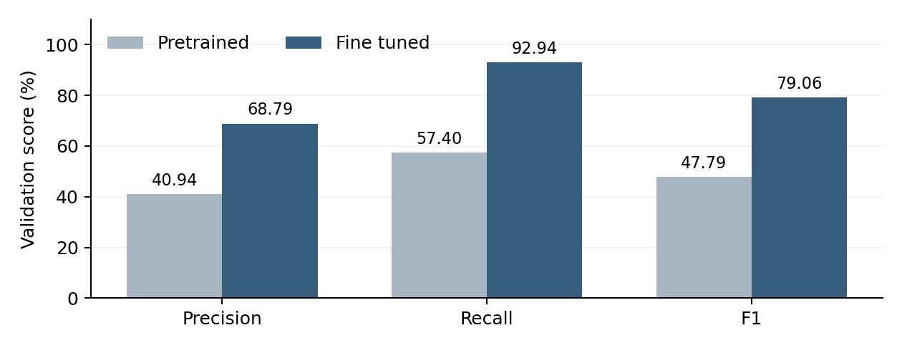
Figure 1. Fixed-threshold comparison using user-provided overall results; threshold 0.4 for both models.
11-label before and after F1 and largest improvements: unavailable. Cell 27 creates comparison/pretrained_vs_finetuned_per_label.csv, including P/R/F1 deltas, but no values are saved in the notebook. No label ranking or claim about the weakest label is supported by the attached evidence.

9 Per label threshold tuning
Cell 29 runs threshold tuning only for the selected best model on the same mapped validation set. Cell 30 reads best_thresholds.json, calibrated_metrics.json and calibrated_per_label_metrics.csv. The threshold grid, selected thresholds and per-label tuned scores are not present in the attachment.
Metric | Fixed threshold 0.4 | Per label calibrated | Change
Precision | 68.79% | 85.04% | +16.25 pp
Recall | 92.94% | 87.86% | −5.08 pp
F1 | 79.06% | 86.43% | +7.37 pp

This is validation-calibrated performance, not independent held-out test performance. Model selection and threshold calibration reuse validation data. The calibrated values should not be presented as unbiased test-set estimates.
The reported calibration improves precision while reducing recall, producing a higher overall F1. This supports a changed precision–recall balance at the aggregate level; per-label effects cannot be determined without the saved metrics.
Selected thresholds for all 11 labels: pending best_thresholds.json. No threshold is assumed from the fixed 0.4 comparison.

10 Error analysis
A complete qualitative analysis requires the relevant predictions.json, gold spans and evaluation metrics. None is included in the attachment, and the notebook contains no saved prediction examples. Consequently, labels with the most FP or FN, the most frequent confusion pairs and actual boundary-error examples cannot be identified reliably.
The fixed-threshold best model has lower precision than recall. This makes false-positive review a useful next analysis, but it does not establish which labels produce those errors. Calibration raises precision and lowers recall, consistent with a more selective prediction set.
Required analysis | Evidence needed
FP and FN by label | Best model per_label_metrics.csv and predictions.json
Confusion and boundary errors | Predicted and gold spans with labels in the same sample
Two or three concrete examples | Actual text or tokens, gold span, predicted span, label and score

For each real example, report the token span and surface text, predicted and gold label, confidence, selected threshold and error type. Classify exact-boundary mismatches separately from wrong-label overlaps and unmatched FP/FN. A boundary or label mismatch can contribute both an FP and an FN under exact matching.
Suggested review categories include PERSON and PROVIDER, FACILITY and LOCATION_ADDRESS, and SEX and GENDER_IDENTITY. These are review hypotheses, not observed findings from this run. No illustrative sentence is presented as a model prediction.

11 Key findings and conclusion
Recommended mapped labels are the formal schema for this experiment. The notebook consistently uses the mapped files across the baseline, training, saved-model comparison and threshold calibration; original files appear only in mapping generation and validation.
The supplied results show substantial improvement after fine tuning. At threshold 0.4, F1 rises by 31.27 percentage points, from 47.79% to 79.06%, with gains in both precision and recall. Epoch-3 is the reported best saved model.
Per-label calibration further improves the reported validation F1 to 86.43%, with a stronger precision–recall balance. This is a validation-calibrated result. The remaining weak labels and specific failure patterns still require per-label results and prediction-level review.

12 Next steps
- Inspect two or three real prediction examples that cover major confusion, boundary and missed-entity patterns. Use the analysis to determine which labels need additional or better annotated training examples.
- Export training_history.json and saved-model evaluation metrics. Plot epoch or step against validation F1 and assess whether the observed trajectory has plateaued.
- Freeze the selected checkpoint and per-label thresholds, then evaluate an independent held-out test set if available. Keep test data outside training, model selection and calibration.
- Compare additional hyperparameter runs under the same mapped schema and split. Record all settings and selection rules; avoid repeatedly using the test set to choose a run.

Evidence required to finalize detailed results
All paths below are relative to finetune/outputs/finetune_run_1. The notebook defines or references these outputs; their bytes and results are not attached.
Result to complete | Required run artifact
Data counts and run summary | run_summary.json and the mapped data files
Baseline 11-label P/R/F1 | baseline/metrics.json and per_label_metrics.csv
Epoch curve and plateau | training/training_history.json
Checkpoint selection | best_model.json and model_eval/*/metrics.json
Per-label improvement | comparison/pretrained_vs_finetuned_per_label.csv
Thresholds and tuned labels | threshold_tuning/best_thresholds.json and calibrated_per_label_metrics.csv
Prediction examples and error types | Relevant predictions.json with gold spans and labels

Source references: notebook cells 8–11 define mapping validation and formal config; 13–14 define baseline evaluation; 16–22 define smoke testing and full training; 24–27 define model selection and comparison; 29–32 define calibration and summary export. Overall numerical results and dataset counts in this report are supplied by the user, not saved notebook outputs.

