HoloKai GLiNER Weak-Label Error Analysis
Oct 19, 2026 · @MA JINGXUAN

Summary
The weak labels fail mainly because the training annotations define them inconsistently, not because the model confuses one label with another. Of 77 validation errors involving DIAGNOSIS, LAB_RESULT, PROCEDURE or MEDICATION, 41 (53%) are spurious predictions with no overlapping gold entity, and only 1 is a confusion between two weak labels.
- LAB_RESULT and PROCEDURE: the model tags vital signs, qualitative findings such as "normal" or "negative", physical examinations and assessment scales. The training set labels these in some records and not in others; "normal" is labeled 21 times and left unlabeled 36 times.
- MEDICATION: almost all errors are span boundaries, with dose and frequency included or not. Overlap F1 is 95.04 against exact F1 79.03.
- Numbered lists: the model joins adjacent list items into one span. Simulating flat_ner=true removes most of these and raises validation F1 from 87.33 to 87.97.
Recommendation: agree on five label-definition rules, relabel the training set against them, evaluate with flat_ner=true, and retrain the Final configuration with three seeds. Renaming labels is not needed.

Setup
The analysis uses the Final Run model and settings unchanged, and reproduces its validation result within 0.13 F1 points.
Item | Value
Model | week6/final_model/outputs/training/best_model (Final Run, checkpoint-760): learning rate 1.2e-4, batch 16, 8 epochs, weight decay 0.1, seed 42
Data analysed | Validation: 171 records, 453 entities. Training: 1,509 records, 3,947 entities
Not used | V4 held-out test set, kept untouched for final reporting
Labels | 11 recommended GLiNER label names; focus labels DIAGNOSIS ("condition"), LAB_RESULT ("lab result or test finding"), PROCEDURE ("medical procedure or test performed"), MEDICATION ("medication, drug, or prescription") as a control
Inference | Threshold 0.4, flat_ner=false, exact span and label match, micro-averaged. A second pass at threshold 0.1 scores missed entities
Run | Colab T4, run_error_analysis.ipynb, 19 October 2026
Sanity check on validation at threshold 0.4: TP 417, FP 85, FN 36, F1 87.33. The Final report gives TP 415, FP 81, FN 38, F1 87.46. The small gap comes from mapping character spans back to tokens.

Method
Each prediction is paired with the unmatched gold entity it overlaps most, and every error gets one type. A boundary error is one row here but costs one FP and one FN in exact-match scoring.
Error type | Definition
Boundary: too long, too short, shifted | Correct label, overlapping but unequal span
Label confusion | Identical span, wrong label
Boundary and label | Overlapping span, wrong label
Spurious FP | Prediction overlaps no unmatched gold entity
Missed, low score | Gold entity predicted only at a score between 0.1 and 0.4
Missed, unseen | Gold entity not predicted even at 0.1
Further analyses: a gold-by-predicted confusion matrix; exact versus overlap F1 per label, where overlap counts any same-label overlap as correct; the same error analysis on the training set; and model-free checks of training annotations (strings labeled in some records but not others, strings with more than one label, span length and composition).

Results overview
Spurious predictions are the largest error type for LAB_RESULT, PROCEDURE and DIAGNOSIS; MEDICATION is led by boundary errors.
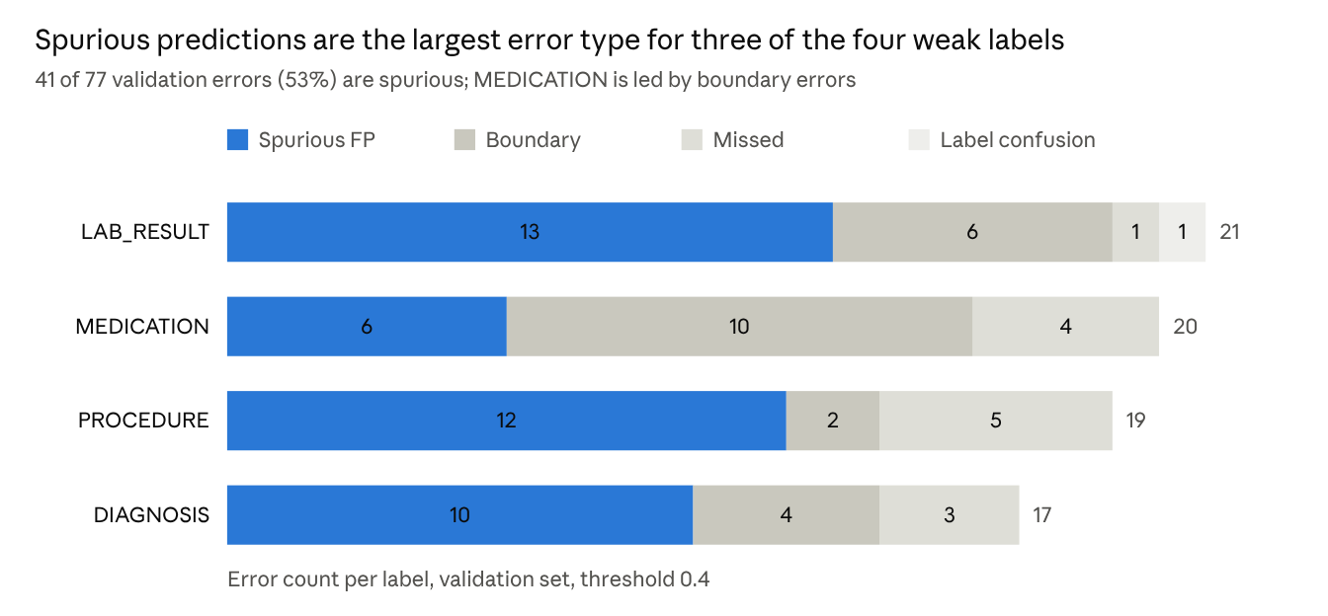
val_errors.csv · 77 validation errors involving the four focus labels
Exact versus overlap F1 on validation. Overlap counts any same-label overlap as correct, so the gap is the cost of boundary disagreements.
Label | Support | Exact F1 | Overlap F1 | Gap
LAB_RESULT | 44 | 75.73 | 84.60 | 8.87
MEDICATION | 59 | 79.03 | 95.04 | 16.00
PROCEDURE | 60 | 84.38 | 88.37 | 3.99
DIAGNOSIS | 67 | 85.11 | 91.55 | 6.44
All 11 labels | 453 | 87.33 | 92.62 | 5.29
The other seven labels range from 88.46 to 97.67 exact F1.

Finding 1: The weak labels are not confused with each other
Only 1 of 77 validation errors is a confusion between two weak labels: gold LAB_RESULT "concentrated, no infection", predicted DIAGNOSIS "infection". The training set shows 7 label confusions in 258 errors.
The earlier hypothesis was that the shared word "test" in "lab result or test finding" and "medical procedure or test performed" confuses the model. The data do not support it, so renaming labels is not a priority.

Finding 2: Most errors are spurious predictions caused by inconsistent definitions
Spurious false positives are 41 of 77 validation errors on the four labels and 242 of 258 on the training set. On its own training data the model reaches 99% recall yet still adds 132 LAB_RESULT and 68 PROCEDURE predictions with no gold entity. Over-prediction on training data usually points to incomplete or inconsistent gold labels rather than a model fault.
The spurious predictions fall into a few categories that the annotations treat inconsistently:
Label | Predicted without a gold entity | Training-set evidence (labeled / unlabeled occurrences)
LAB_RESULT | Vital signs: 98 %, 120 / 80 mmHg, 37.4 °C, heart and respiratory rates. Qualitative findings: normal, negative, unremarkable, within normal limits | normal 21 / 36; negative 23 / 12; unremarkable 9 / 8; within normal limits 6 / 9; reduced 1 / 32; clear 1 / 29
PROCEDURE | Examinations and assessments: neurologic examination, cardiovascular examination, Glasgow coma scale, neuro checks, genetic counseling | surgery 1 / 26; imaging 3 / 6
DIAGNOSIS | Symptoms and signs: hypoxia, seizure, dehydration, jaundice, hives | hives 2 / 9; cancer 3 / 6; infection 3 / 5
MEDICATION | Oxygen and supplements | oxygen 8 / 20; calcium 1 / 7
The check found 63 such strings for the four labels. Only 1 string carries two different labels: "right lower lobe infiltrate" (LAB_RESULT and DIAGNOSIS).
A few training false positives are non-clinical distractor text tagged as PROCEDURE, such as "oil change", "brake inspection" and a random ID. They are rare but show the label is over-generalised. Some spurious predictions are likely correct entities missing from the gold standard; val_errors.csv and train_errors.csv list each one with context for review.

Finding 3: Boundary errors dominate MEDICATION, and list items get merged
22 of 77 validation errors are boundary errors, 17 of them shorter than the gold span. MEDICATION has 10: gold spans include dose and frequency, such as "Metformin - 850 mg daily" and "Metoprolol - 150 mg twice daily", but the model often tags only the drug name.
LAB_RESULT gold spans sometimes join several findings with commas, such as "concentrated, otherwise negative" and "sinus tachycardia, no acute ST-T changes". The model splits these into separate spans.
The model also joins adjacent numbered-list items into one span: "COPD . 6 . Recent pneumonia", "Hypoxia . 8 . Seizure", "Metformin - 850 mg daily . 4 . Amlodipine". There are 6 such predictions on validation. With flat_ner=false these long spans are kept alongside the correct short ones.
Simulating flat_ner=true on the exported predictions, at the same threshold of 0.4:
Label | F1, flat_ner=false | F1, flat_ner=true (simulated) | False positives
All labels | 87.33 | 87.97 | 85 → 73
PROCEDURE | 84.38 | 86.40 | 14 → 11
DIAGNOSIS | 85.11 | 86.13 | 14 → 11
LAB_RESULT | 75.73 | 76.47 | 20 → 19
MEDICATION | 79.03 | 77.31 | 16 → 14
MEDICATION loses 3 true positives because some gold medication spans are nested, such as "aspirin / atorvastatin". The overall gain matches Sweep A and Sweep B, where flat_ner=true added 0.8 to 1.4 F1.

Finding 4: Missed entities are few, and thresholds are not the main lever
The four labels miss only 13 gold entities on validation. 9 are predicted at scores between 0.12 and 0.34, such as "urine ACR" (0.29), "HbA1c" (0.20) and "Extraction of tooth # 30" (0.32). 4 are not predicted at all: "AF with RVR", "tetanus toxoid", "Bedside swallow assessment" and "fluids".
Lowering thresholds would recover a few of these but add spurious predictions, which are already the larger problem. This matches the Final report, where validation-tuned thresholds added only 0.05 F1 on V4.

Recommendations
Fix the label definitions and the training annotations before any further tuning; hyperparameters are not the bottleneck.
- Agree on written rules for the open cases. Base them on the V4 annotation guideline, since V4 is the final benchmark, and record them in Labe_Definitions on Drive.
  - Are vital signs (SpO2, blood pressure, temperature, heart and respiratory rate) LAB_RESULT?
  - Are standalone qualitative findings (normal, negative, unremarkable) LAB_RESULT?
  - Are physical examinations, assessment scales and counseling PROCEDURE?
  - Are symptoms and signs (hypoxia, seizure, jaundice) DIAGNOSIS?
  - Does a MEDICATION span include dose, route and frequency, and is a comma-joined list of lab findings one span or several?
- Relabel the training set against these rules. Start from train_unlabeled_occurrences.csv (63 strings) and the 242 spurious predictions in train_errors.csv; each needs a yes or no decision.
- Evaluate with flat_ner=true from now on, and report V4 under both settings at the end.
- Retrain the Final configuration unchanged with three seeds, and compare validation means before and after relabeling. Report V4 once, for the final model only.
- Optional: check whether V4 PROCEDURE and DIAGNOSIS false positives follow the same categories, using one half of V4 and keeping the other half untouched.

Limitations
- Validation is small: 77 errors across the four labels, so the category shares are directional, not precise.
- Labeled and unlabeled counts are exact string matches. Some unlabeled occurrences are correct, for example "clear" used in another sense, and need human review.
- The flat_ner result is a simulation on exported predictions. It should be confirmed with a run using flat_ner=True.
- V4 was not examined, so the claim that V4 errors follow the same pattern is untested.
- The sanity check differs from the Final report by 0.13 F1 because of character-to-token span mapping.

Files
Outputs are on Drive in Holokai_Project/week7/weak_label_error_analysis/outputs/. The script error_analysis_weak_labels.py and the notebook run_error_analysis.ipynb sit one level up.
File | Content
summary.txt | All summary tables
val_errors.csv, train_errors.csv | One row per error with type, score and context; gold marked {{ }}, prediction marked [[ ]]
val_scores.csv, train_scores.csv | Per-label precision, recall, exact F1 and overlap F1
val_confusion.csv, train_confusion.csv | Gold label by predicted label; O means none
train_unlabeled_occurrences.csv | Strings labeled in some training records and unlabeled in others
train_multi_label_surfaces.csv | Strings carrying more than one label
span_stats.csv | Span length, share containing digits, most common first and last words per label
val_predictions.jsonl, train_predictions.jsonl | Gold spans and all predictions at threshold 0.1 with scores

