HoloKai Weak-Label Findings, Week of Oct 19
Oct 19, 2026 · @MA JINGXUAN

Scope
This week we analysed the errors of the Final Run model on its three weak labels, DIAGNOSIS, LAB_RESULT and PROCEDURE, with MEDICATION as a control. The model reproduces the Final report on validation: F1 87.33 (TP 417, FP 85, FN 36) against 87.46 reported.
Item | Value
Model | Final Run best model: learning rate 1.2e-4, batch 16, 8 epochs, weight decay 0.1, seed 42
Settings | Threshold 0.4, flat_ner=false, exact span and label match
Model errors analysed on | Validation (171 records, 453 entities) and training (1,509 records, 3,947 entities)
V4 test set (648 records, 1,320 entities) | Gold labels inspected for annotation conventions only; no model predictions on V4

Finding 1: Most errors are extra tags the model should not make
Spurious predictions, where the model tags text that has no gold entity, are 41 of 77 validation errors (53%). On training data the model reaches 99% recall yet still adds 242 spurious tags: 132 LAB_RESULT, 68 PROCEDURE and 31 DIAGNOSIS.
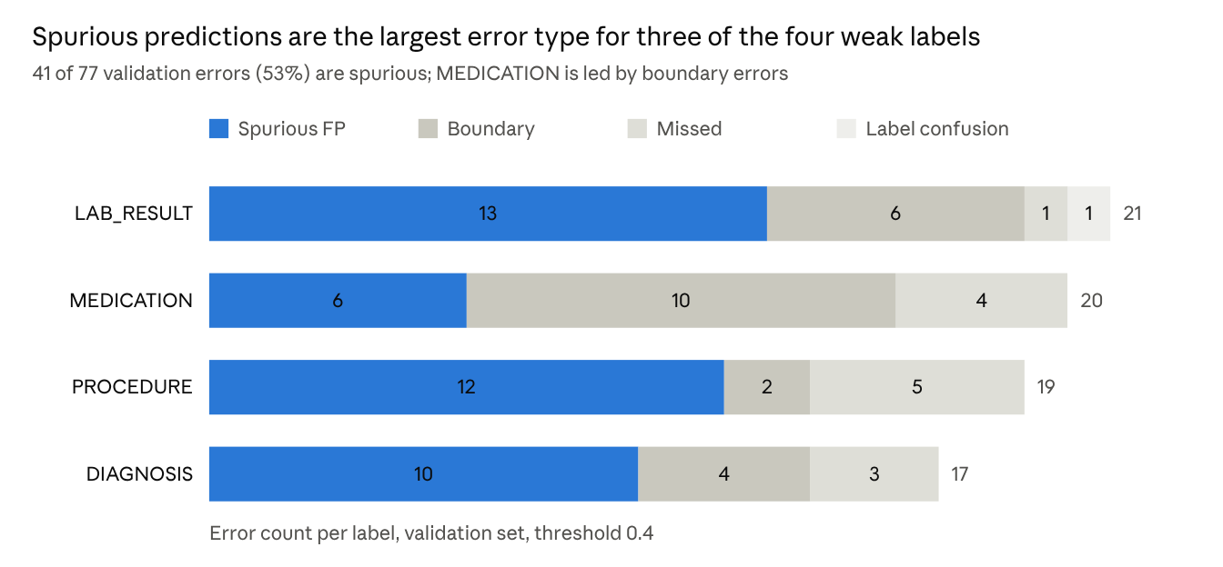
val_errors.csv · 77 validation errors involving the four labels
The extra tags fall into a few categories that gold labels leave out in training, validation and V4 alike:
Over-tagged category | Tagged as | Examples | Gold left unlabeled: Training / Validation / V4
Vital signs: blood pressure | LAB_RESULT | "120 / 80 mmHg" (4 times in training) | 95% / 100% / 100%
Vital signs: SpO2, heart rate, temperature | LAB_RESULT | "98 %" (6), "37 . 4 °C" | 100% / 100% / 100%
Physical exam or assessment | PROCEDURE | "neurologic examination" (3), "Glasgow coma scale" (3) | 87% / 83% / 88%
Counseling or education | PROCEDURE | "genetic counseling" (4) | 100% / 100% / 100%
Symptoms and signs | DIAGNOSIS | "hives" (9), "hypoxia", "seizure" | 97% / 88% / 97%
Physical exams are not fully consistent: 12% to 17% of exam mentions are labeled PROCEDURE, for example "pelvic examination" in V4. The model's tags on vital signs and exams are clinically reasonable, since the label names "lab result or test finding" and "medical procedure or test performed" cover them. They count as errors only because current annotations do not label them, so labeling them would mean re-annotating training, validation and V4 together.

Finding 2: The model tags "normal" and "negative" without checking context
The model added 37 qualitative words as LAB_RESULT that gold leaves unlabeled (9 validation, 28 training), and missed none that gold labels. Read in context, gold is correct in about 34 of the 37; only 3 are real test results that gold missed.
Context | Example | Errors | Gold correct under current rules?
Review of systems | "Review of systems is negative" | ~13 | Yes
Vital signs | "Vital signs within normal limits", "BP elevated" | ~9 | Yes
Physical exam | "Cardiovascular examination unremarkable" | ~8 | Yes
Hypothetical statement | "a negative result would not exclude" | 2 | Yes
Medication list | "Furosemide - none" | 2 | Yes
Result of a named test | "Doppler ultrasound negative for DVT" | 3 | No, gold missed these
A keyword count alone suggested inconsistency: these words are labeled LAB_RESULT in 43% of training matches, 33% of validation and 49% of V4. The context check shows the split mostly follows meaning, not annotator noise.

Finding 3: V4 tests different procedures than validation
PROCEDURE scores 86.4 F1 on validation but 72.5 on V4 because the two sets contain different kinds of procedures. Validation is dominated by lab tests the model handles well; V4 is dominated by surgeries with long names.
Share of PROCEDURE gold spans | Training | Validation | V4
Surgical (-ectomy, -otomy, repair, biopsy, surgery) | 13.8% | 18.3% | 28.3%
Lab test name (CBC, panel, culture, urinalysis) | 14.2% | 30.0% | 7.5%
Surgical mentions left unlabeled in the text | 28% | 21% | 8%
Typical V4 spans: "Microscopic assisted lumbar laminotomy with discectomy", "radical hysterectomy", "Scarf bunionectomy". Typical validation spans: "FBC", "CMP", "urinalysis", "urine ACR".

Finding 4: MEDICATION errors are about span length, not finding the drug
The model finds almost every medication but often cuts the dose and frequency. MEDICATION has an overlap F1 of 95.04 against an exact F1 of 79.03 on validation, the largest gap of any label; 10 of its 20 errors are boundary errors.
Gold span | Model span
Metformin - 850 mg daily | Metformin
Metoprolol - 150 mg twice daily | Metoprolol
Insulin therapy | Insulin
Training and V4 follow the same rule: attached dose, route and frequency are part of the span. V4 spans are longer and denser:
MEDICATION gold spans | Training | Validation | V4
Mean length (words) | 2.91 | 2.46 | 4.22
Contains a dose | 23.4% | 20.3% | 34.2%
Contains a frequency | 18.7% | 16.9% | 23.3%
V4 also uses abbreviations such as p.o., b.i.d., qod and q.a.m., for example "Glimepiride 2 mg, 1 p.o. b.i.d.".

Finding 5: Smaller findings
The weak labels are almost never confused with each other. Only 1 of 77 validation errors is a mix-up between two of them (gold LAB_RESULT "concentrated, no infection", predicted DIAGNOSIS "infection"); training shows 7 in 258.
The model joins numbered-list items into one span, for example "COPD . 6 . Recent pneumonia" and "Hypoxia . 8 . Seizure"; 6 such predictions on validation. Simulating flat_ner=true on the saved predictions removes them:
Label | F1, flat_ner=false | F1, flat_ner=true (simulated) | False positives
All labels | 87.33 | 87.97 | 85 → 73
PROCEDURE | 84.38 | 86.40 | 14 → 11
DIAGNOSIS | 85.11 | 86.13 | 14 → 11
LAB_RESULT | 75.73 | 76.47 | 20 → 19
MEDICATION | 79.03 | 77.31 | 16 → 14
Missed entities are few. The four labels miss 13 gold entities on validation; 9 of them score between 0.12 and 0.34, for example "urine ACR" (0.29) and "HbA1c" (0.20).
Validation annotates LAB_RESULT differently. 15.9% of validation LAB_RESULT spans join several findings with commas, for example "concentrated, otherwise negative", against 3.1% in training and 5.0% in V4.

Data notes and limits
- Validation is small: 77 errors across the four labels, so shares are directional.
- Categories such as vital signs, exams and surgical terms are matched by keywords, so counts are approximate.
- The flat_ner result is a simulation on saved predictions, not a new model run.
- Source files: week7/weak_label_error_analysis/outputs/ on Drive (summary.txt, val_errors.csv, train_errors.csv) and outputs/v4_audit/ (v4_audit_summary.txt, gold_span_samples.csv).

