OpenMed DiseaseDetect: Zero-Shot and Fine-Tuning Report
Nov 1, 2026 · @MA JINGXUAN

Summary
Fine-tuned on our 11 entities, OpenMed DiseaseDetect 184M ties our fine-tuned GLiNER on the V4 test set: 87.38 F1 against 88.25. It led clearly on validation (90.68 against 87.33), but that lead did not carry over to V4.
- Zero-shot, the model only detects diseases and does not beat our base GLiNER model even on DIAGNOSIS.
- Fine-tuned with a new 11-entity output head, it is better on PERSON, LAB_RESULT and DIAGNOSIS, and worse on MEDICATION and PROCEDURE.
- PROCEDURE stays the weakest entity in both architectures (67.4 and 72.5 F1 on V4), which points to the training data, not the model.
- We recommend keeping GLiNER as the main model; DiseaseDetect is a possible complement, pending Jerome's answer on whether its format can be deployed.

The model
OpenMed DiseaseDetect SuperClinical 184M is a token-classification model that tags diseases in biomedical text. Out of the box it covers only one of our 11 entities, DIAGNOSIS. Its encoder is the same size as the one in our GLiNER model, so the comparison below is mainly between architectures, not model sizes.
Item | DiseaseDetect SuperClinical 184M | Our GLiNER (gliner-pii-base-v1.0)
Architecture | Token classification, one BIO tag per word | Span classification against label names
Encoder size | DeBERTa-v2, 768 hidden, 12 layers | DeBERTa-v3-base, 768 hidden, 12 layers
Original labels | O, B-DISEASE, I-DISEASE | Any label name given at inference
Original training data | BC5CDR-Disease: 1,500 PubMed abstracts | PII-focused training by Knowledgator
Model file | 368 MB | about 660 MB
License | Apache-2.0; BC5CDR listed as Public Domain Mark 1.0; backbone pre-training data undocumented | Apache-2.0
Format for Jerome's system | Not GLiNER; ONNX export exists; loadability unconfirmed | GLiNER, supported

Zero-shot baseline
Before any training on our data, DiseaseDetect matches our base GLiNER model on DIAGNOSIS for validation and trails it on V4. Both models were run on the original corpus with exact span and label matching; GLiNER used our 11 label names at threshold 0.4.
Entity | gliner-pii-base, val | gliner-pii-base, V4 | DiseaseDetect, val | DiseaseDetect, V4
DIAGNOSIS | 37.9 | 43.9 | 37.5 | 32.3
Other 10 entities | 10.7 to 75.8 | 2.9 to 85.4 | Not covered | Not covered
All 11 entities | 49.4 | 55.3 | 16.5 | 10.2
DiseaseDetect's DIAGNOSIS precision is only 20 to 24%: it tags gender-identity phrases, words such as "discrimination" and "harassment", and negated symptoms as diseases.

Fine-tuning method
We followed the method used for the PharmaDetect-434M run: keep the pre-trained encoder, discard the disease-only output layer, and train a new 11-entity layer together with the whole model.
- Data conversion. Our GLiNER-format span annotations were converted to word-level BIO tags (O, B-ENTITY, I-ENTITY), with round-trip integrity checks. No record exceeded 512 tokens, so none was split.
- New output head. The original 3-tag layer (O, B-DISEASE, I-DISEASE) was replaced by a randomly initialised 23-tag layer: O plus B- and I- for each of the 11 entities.
- Full fine-tuning. All 184M parameters were trained on the original training set (1,509 records, 3,947 entities).
- Model selection. After each epoch, the model was scored on validation (171 records, 453 entities) with exact entity matching; each run kept its best epoch.
- One V4 evaluation. V4 (648 records, 1,320 entities) was scored once, for the run with the best validation F1, after all training ended.
Training ran on a Colab T4 GPU with fp16. The data is identical to the data used for our GLiNER model; file hashes match.

Learning-rate choice
We tested three learning rates, all higher than the PharmaDetect run's lowest settings, because both that run and our GLiNER sweeps improved as the learning rate rose.
Learning rate | Reason
3e-5 | Best setting of the PharmaDetect-434M run (89.0 validation F1); used as the anchor
5e-5 | PharmaDetect peaked at its highest tested rate, and our 184M model is half its size, so it can take a higher rate
8e-5 | Our GLiNER base models kept improving up to 8e-5 to 1.2e-4 at an effective batch of 16
Shared settings: 8 epochs (PharmaDetect's best came at its last of 5 epochs; our best GLiNER used 8), effective batch 16 (4 × 4 accumulation), weight decay 0.01, warmup 0.1, linear decay, gradient clipping 1.0, seed 42.
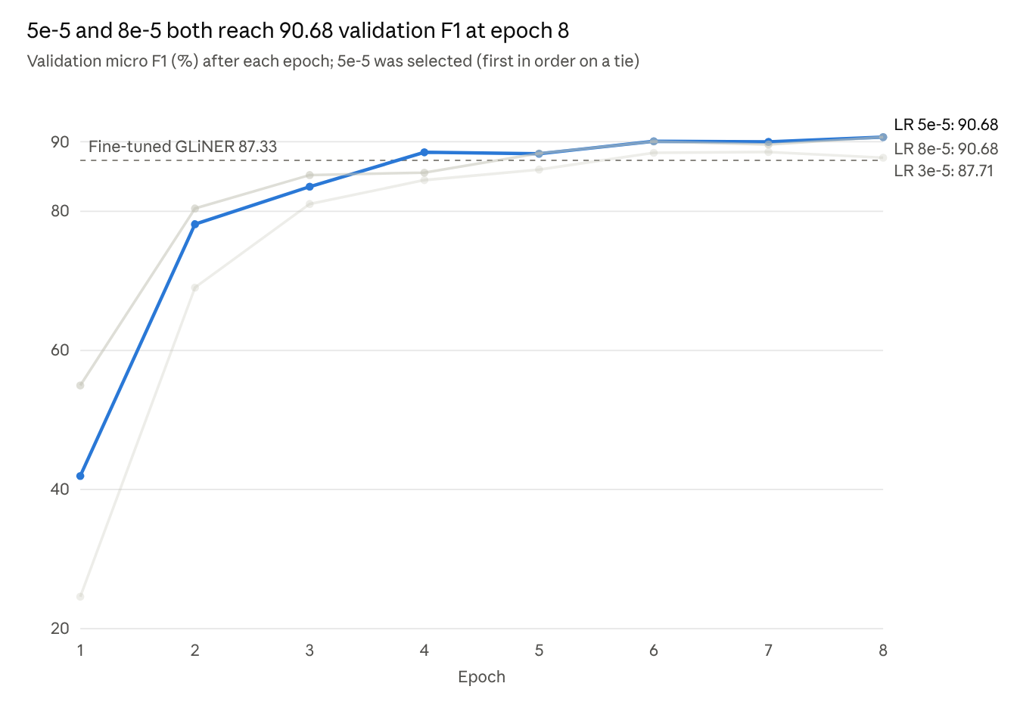
Colab training log, 3 runs × 8 epochs, seed 42
The higher rates learned faster and finished higher; 3e-5 peaked at epoch 7 and dropped at epoch 8.

Results against our fine-tuned GLiNER
The validation-selected run (learning rate 5e-5, epoch 8) leads GLiNER by 3.35 points on validation but trails it by 0.87 points on V4.
Model | Validation F1 | V4 F1
Fine-tuned GLiNER (gliner-pii-base) | 87.33 | 88.25
Fine-tuned DiseaseDetect 184M (LR 5e-5, epoch 8) | 90.68 | 87.38
Fine-tuned PharmaDetect 434M (teammate, LR 3e-5) | 89.01 | Not yet evaluated
Zero-shot DiseaseDetect 184M | 16.5 | 10.2
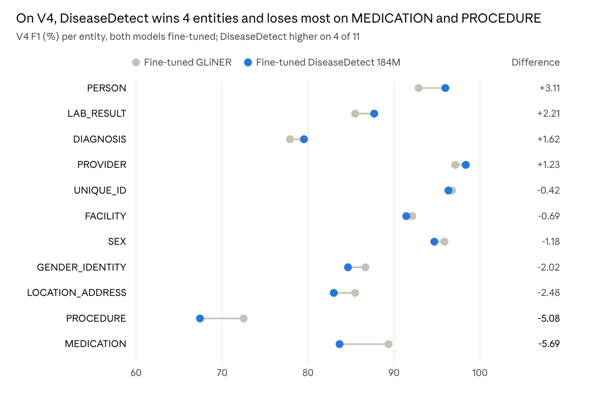
final_v4_results.json (DiseaseDetect) and Final Run report (GLiNER), threshold 0.4 for GLiNER
PROCEDURE is the weakest entity for both models: DiseaseDetect produces 51 false positives and 33 misses out of 120 gold procedures on V4.

Conclusions
- Fine-tuning works, but switching architecture does not beat GLiNER. DiseaseDetect rose from 10.2 to 87.38 F1 on V4, ending 0.87 points below our GLiNER, within the 1.5 to 2 point seed-to-seed noise seen in earlier sweeps.
- Validation is not a reliable guide to V4. A 3.35-point validation lead became a 0.87-point V4 deficit, as with the B22 GLiNER run earlier. Keeping V4 untouched until the end was necessary.
- The two models are complementary. DiseaseDetect is stronger on PERSON, LAB_RESULT and DIAGNOSIS; GLiNER is stronger on MEDICATION, PROCEDURE and LOCATION_ADDRESS. This fits Jerome's suggestion to compare coverage, not only F1.
- PROCEDURE is a data problem. It is the weakest V4 entity under both architectures. V4 procedures are mostly long surgical names, which our training data covers poorly, so more and better-labeled surgical examples are needed.
- GLiNER remains the main model. It matches DiseaseDetect on accuracy, supports new labels without retraining, and is already in a format Jerome's system can load.
Caveats: each learning rate was run with one seed (42); validation per-entity scores are saved in outputs/<group>/validation_results.json on Drive.

