NLP to SQL Translation for Weather Data Querying

NLP TO SQL QUERY CONVERTING

INPUT

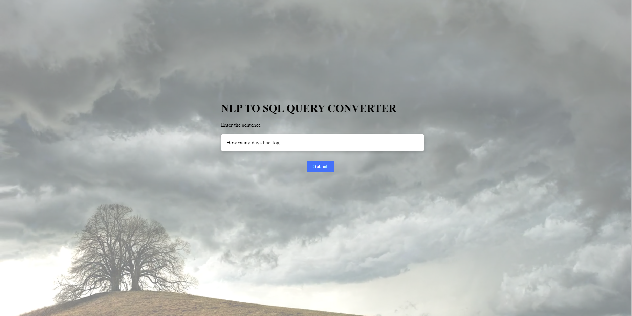

OUTPUT

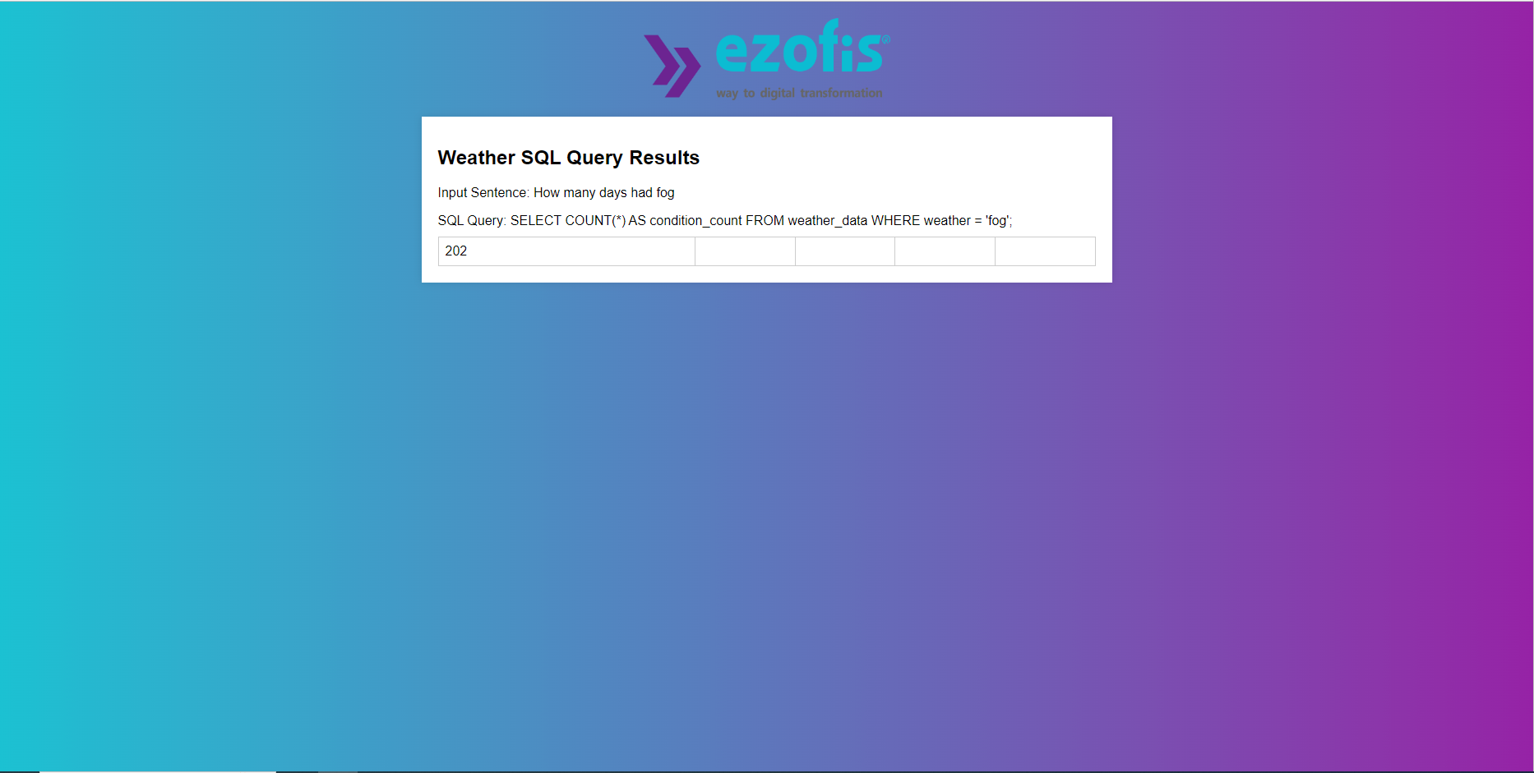

WEATHER_PREDECTION

INPUT

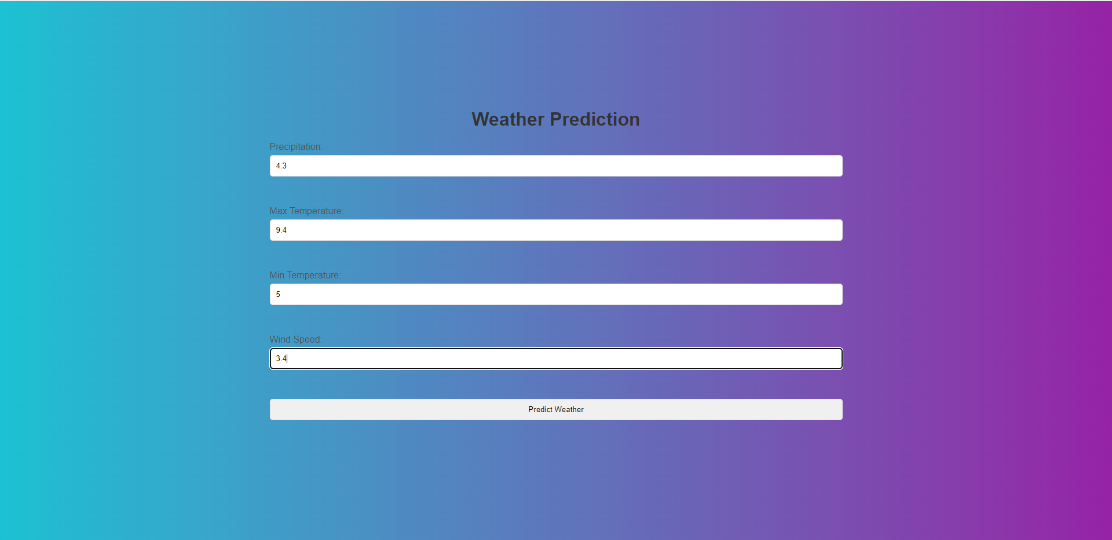

OUTPUT

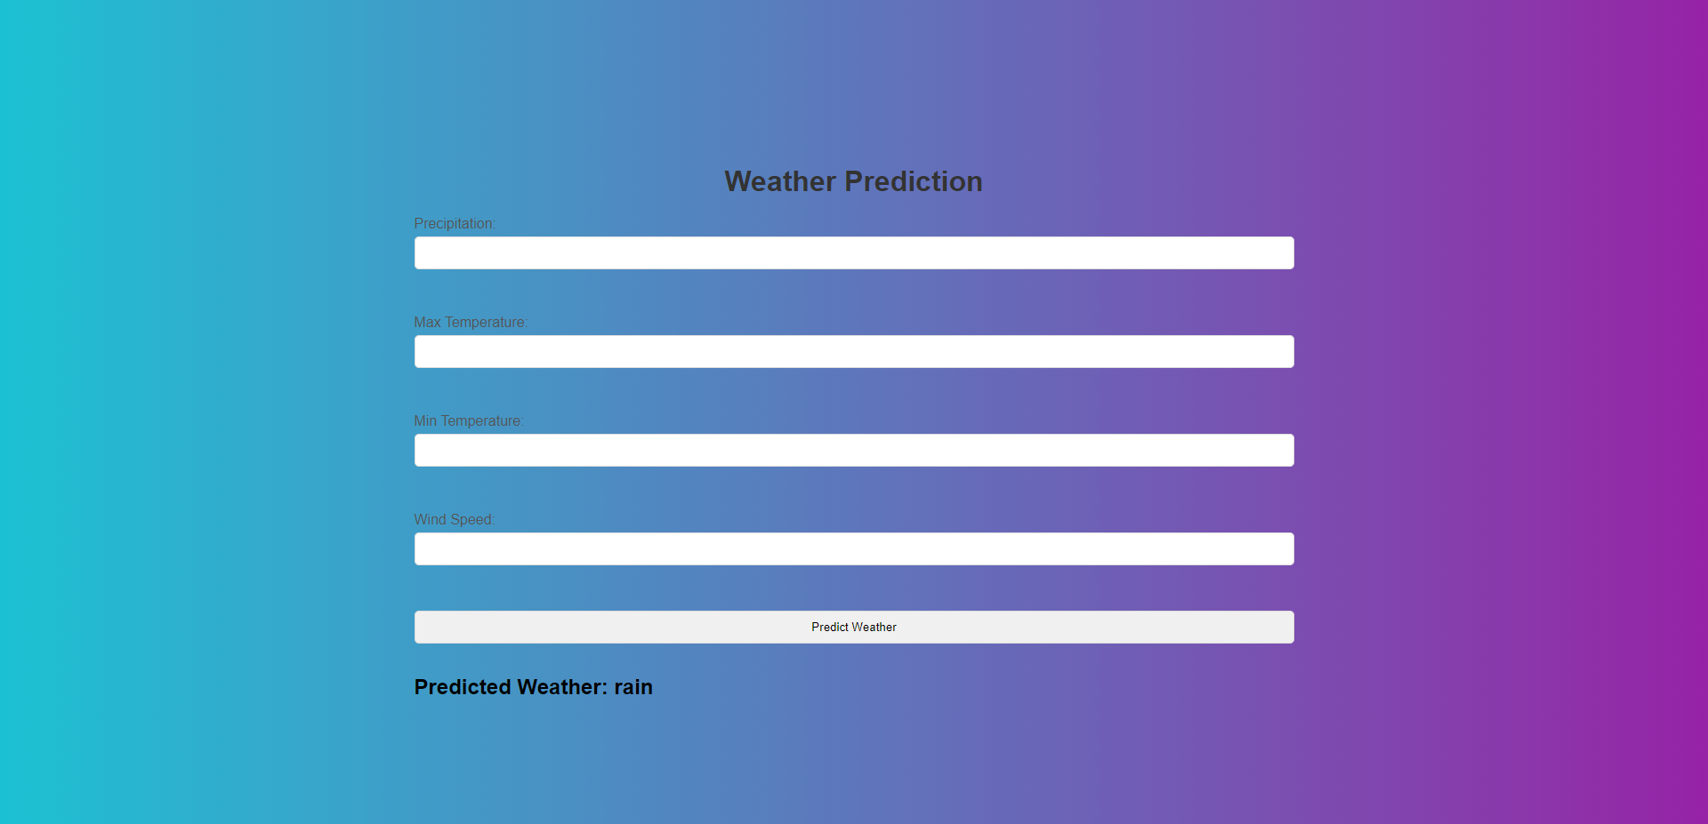

WEATHER_UPDATION

INPUT

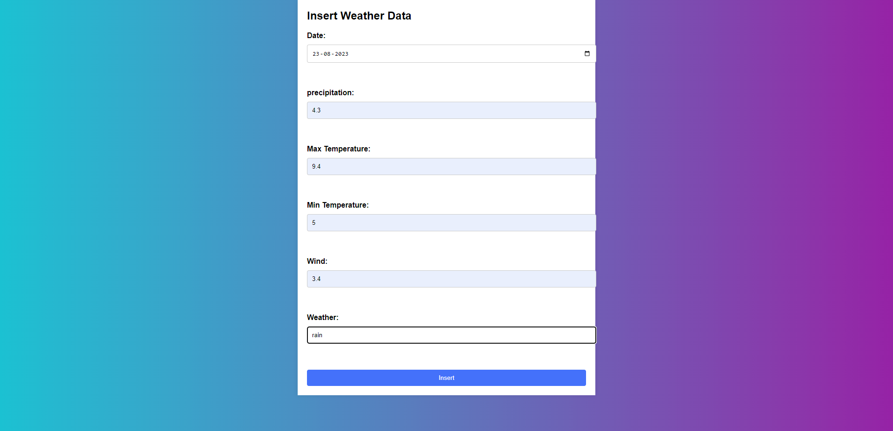

OUTPUT