Devops -Week-1 Assignment

- Run a command to check the Linux distribution name and version of the operating system installed on your machine

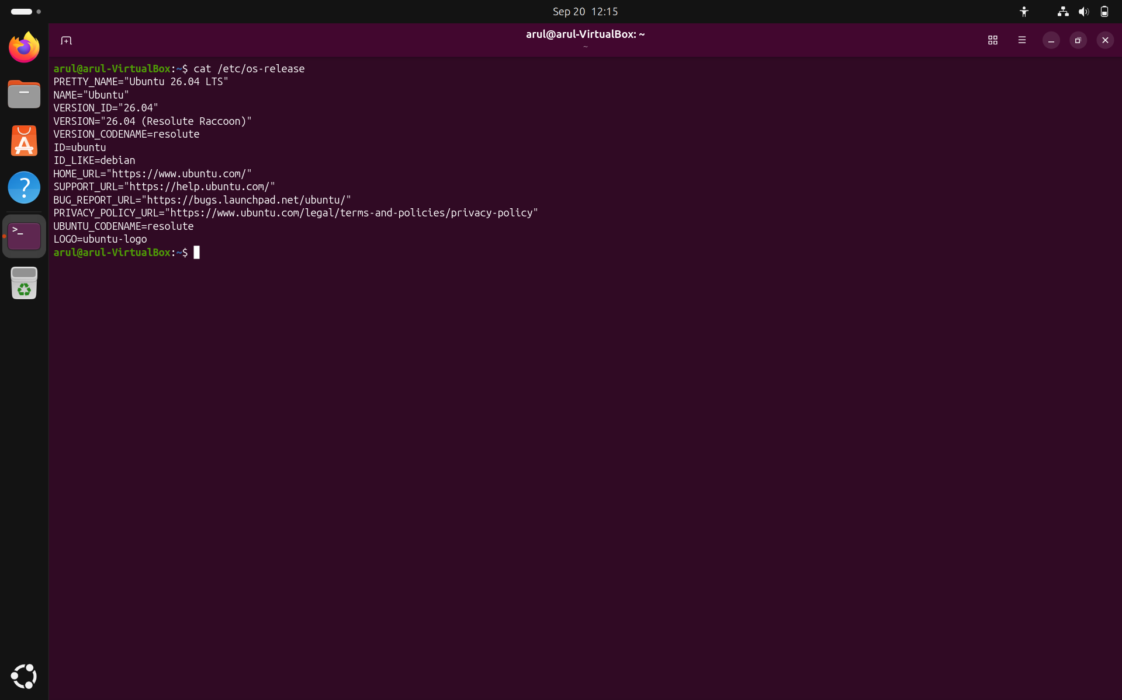

- Cat- view file content
- /etc- system configuaration files
- os- release - operating system

Files & Directories:
- Create directory /home/devops project
- Inside it, create 2 files: plan.txt and network_report.txt
- Copy plan.txt to /tmp and delete the original

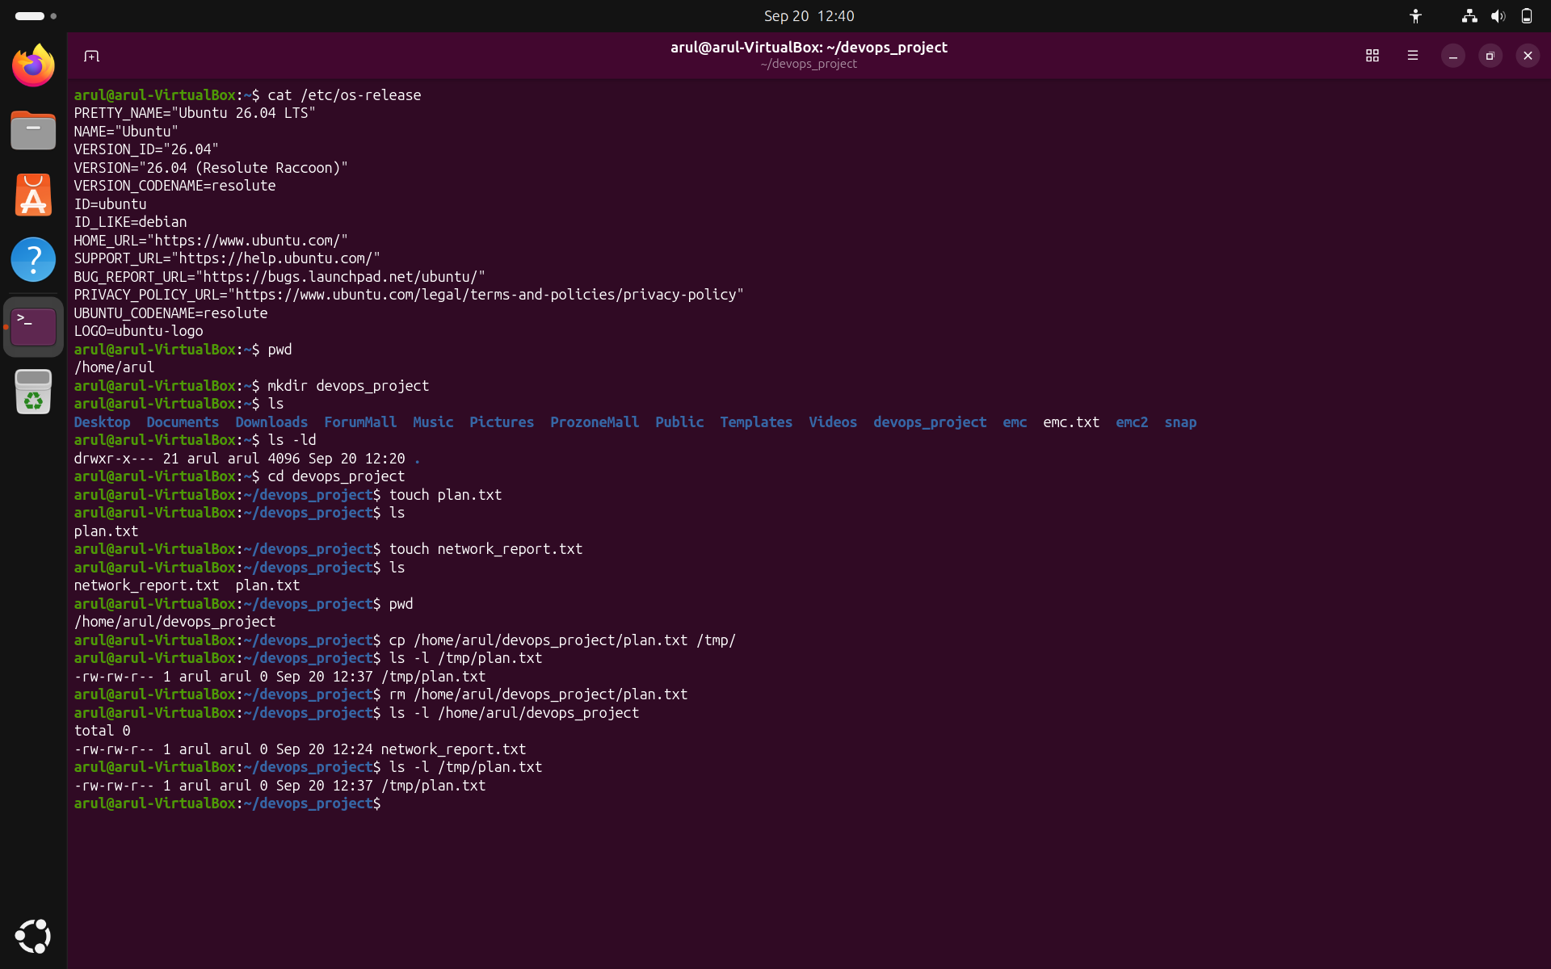

Users & Permissions:

- Create a user devstudent
- Create a group devops_team
- Add devstudent to devops_team
- Create a file secrets.txt, and:
- Change its owner to devstudent
- Set permissions so only owner can read/write

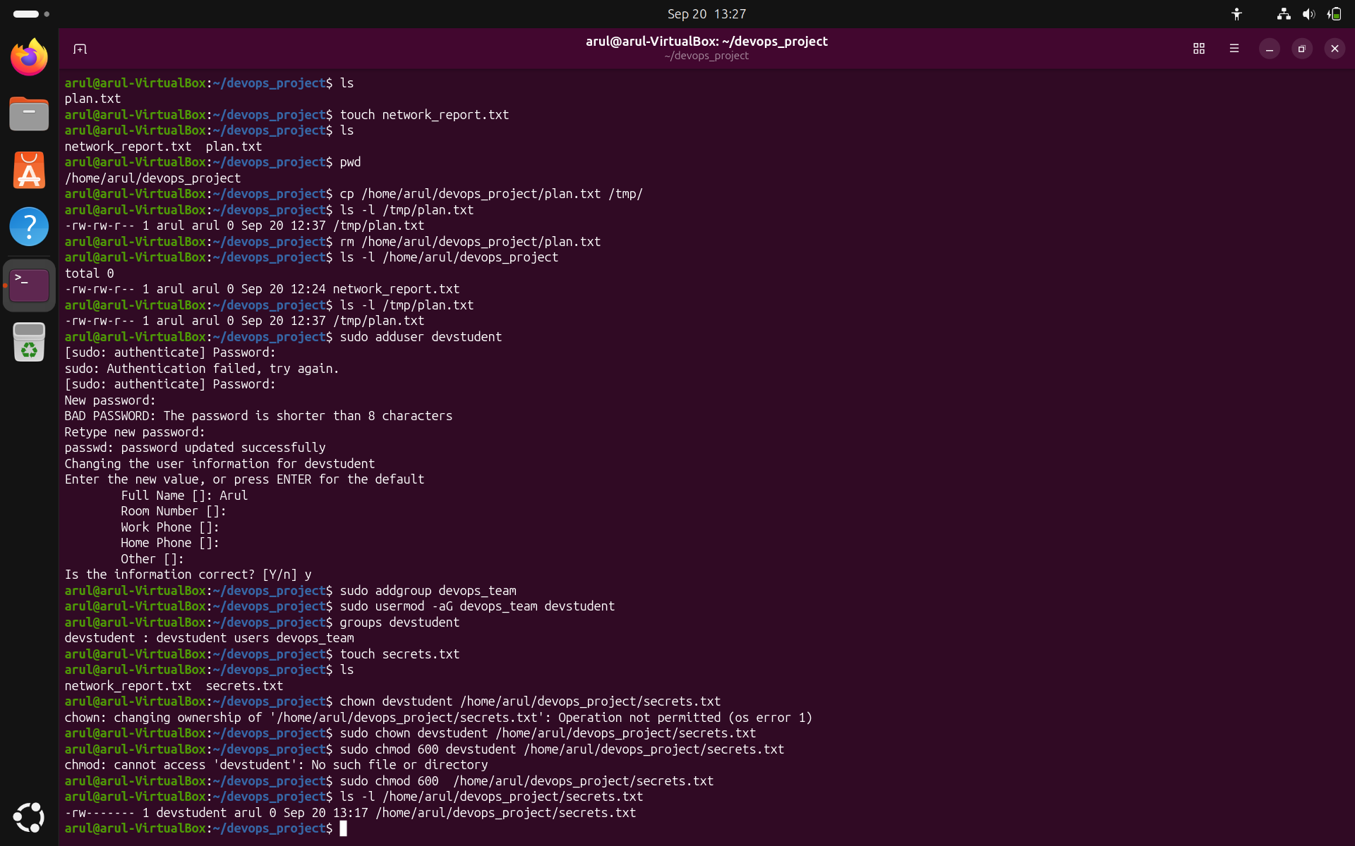

File Compression:

    - create dummy one using echo
    - Compress it using gzip and tar

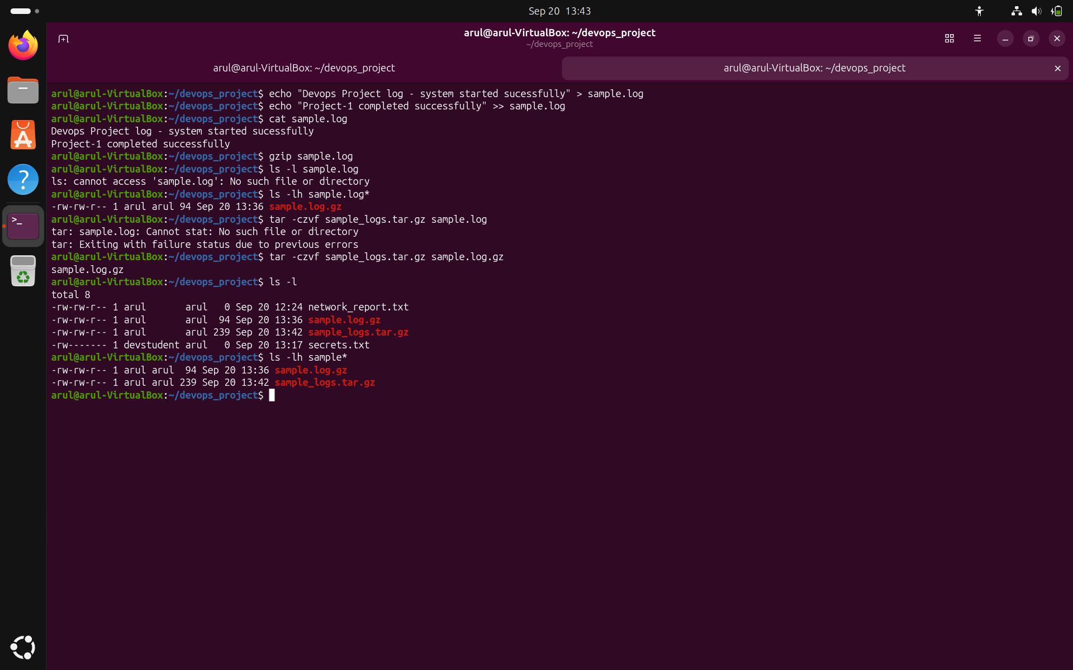

Package Management:
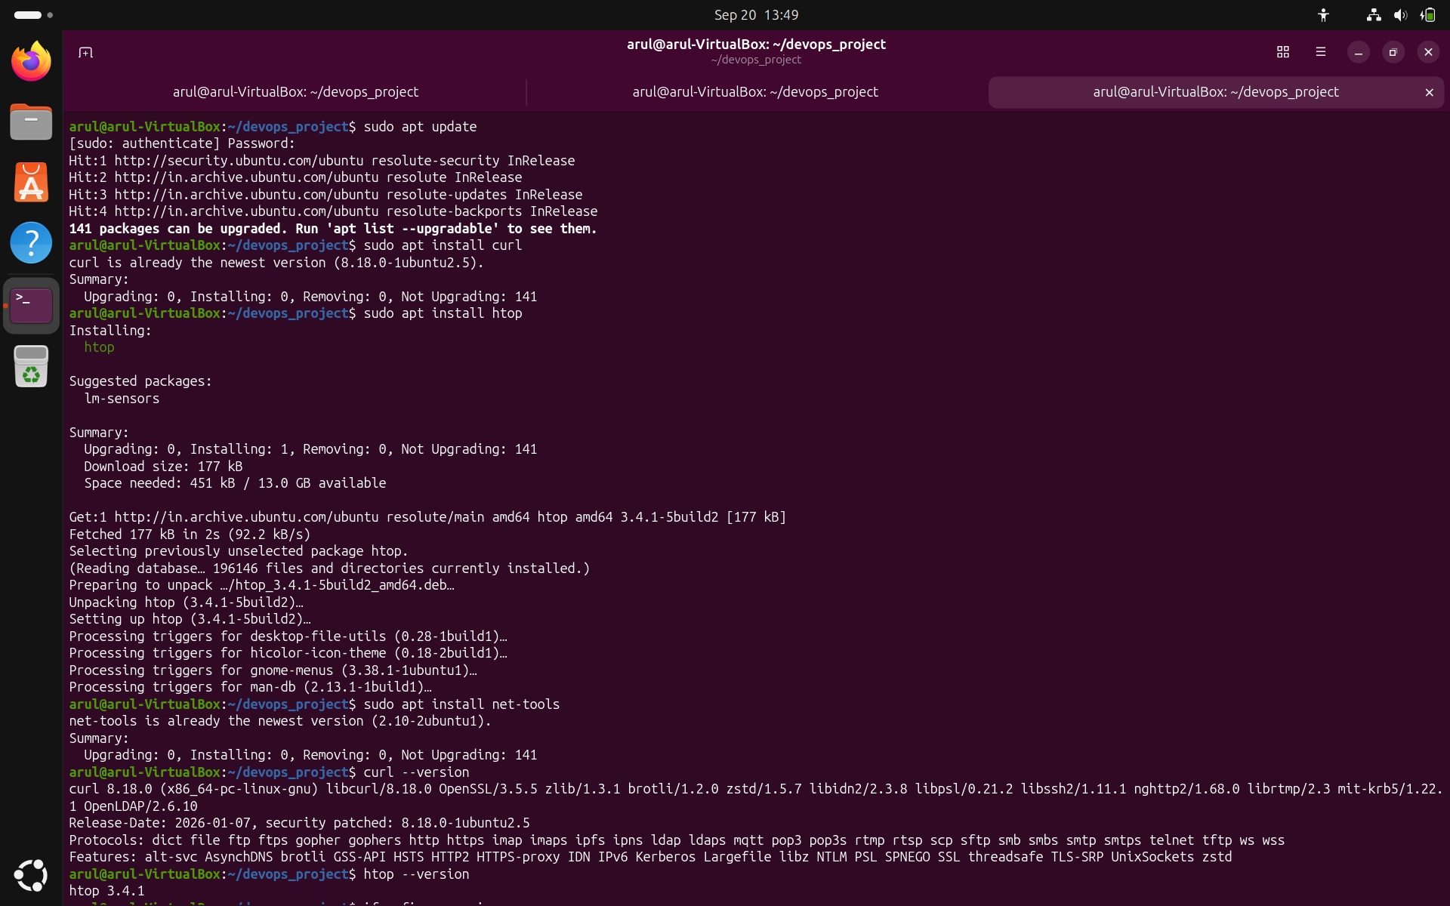
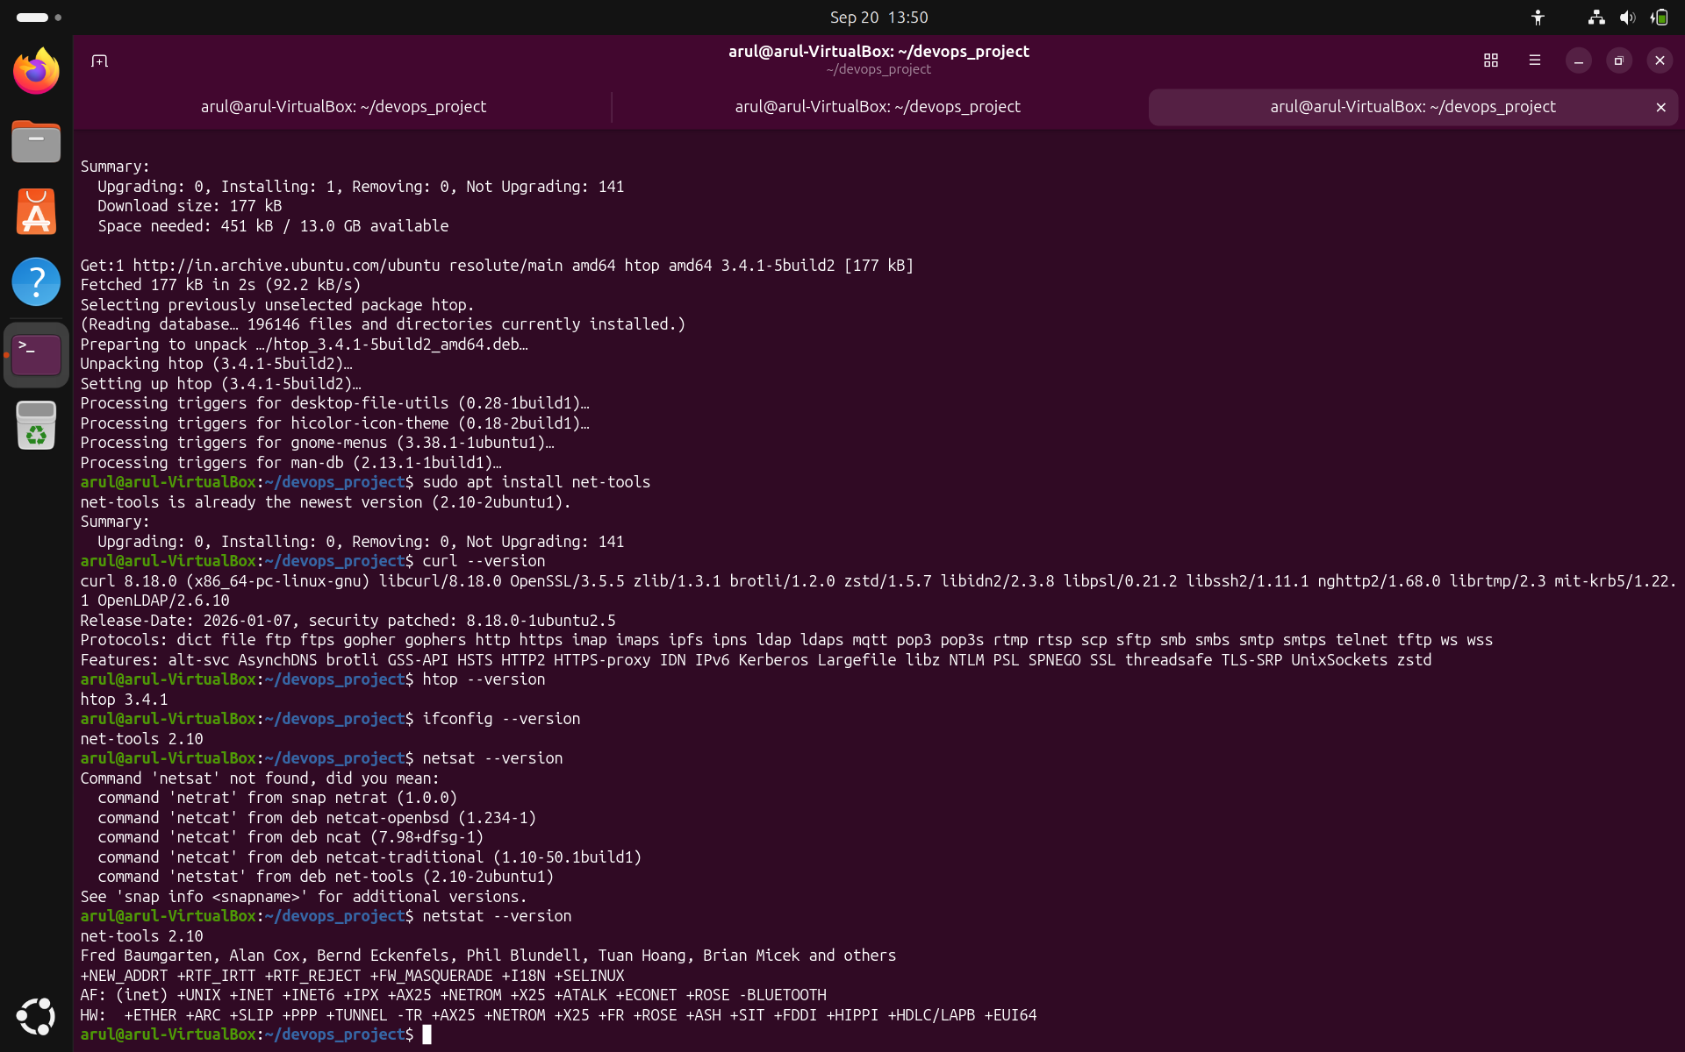
Networking Commands:

- ip -Show the system ip address
- Network interfaces
- IPv4 addresses
- IPv6 addresses
- MAC addresses
- Interface status
- lo is the loopback interface.
- enp0s3 or similar is usually your VirtualBox network interface.

- ping google.com -c 4

ping checks whether your machine can communicate with Google's server using ICMP.

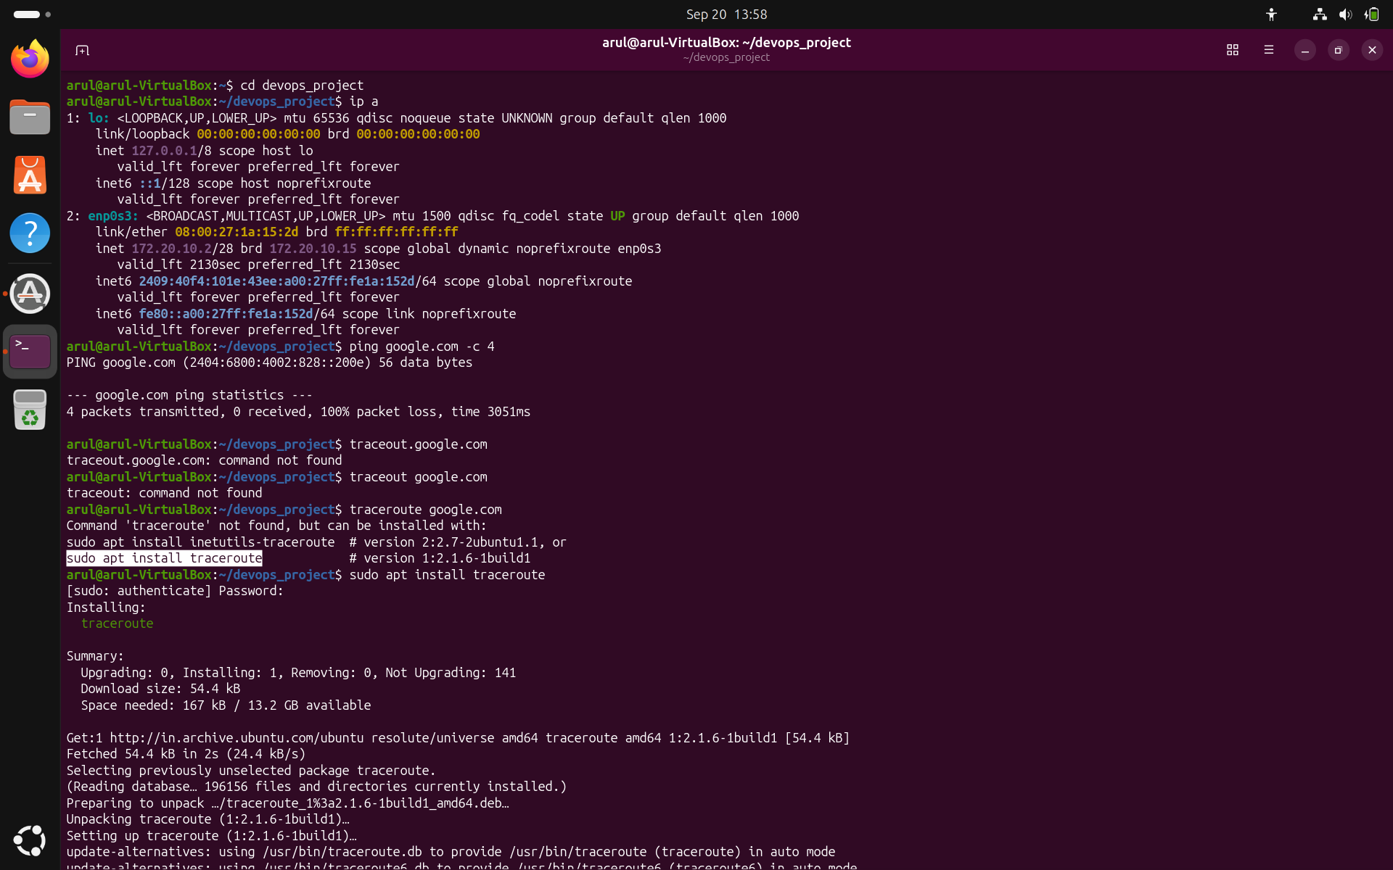

- traceroute google.com
traceroute shows the network hops between your computer and the destination.

- nslookup google.com
Used to query DNS to obtain name or ip address mapping

- netstat -tuln
- -t → TCP connections
- -u → UDP connections
- -l → Listening ports
- -n → Show numerical addresses/ports

