I am not able to start BookService via Docker, it through communication link error as it connects to DB

Instead I created instance for spring cloug config server

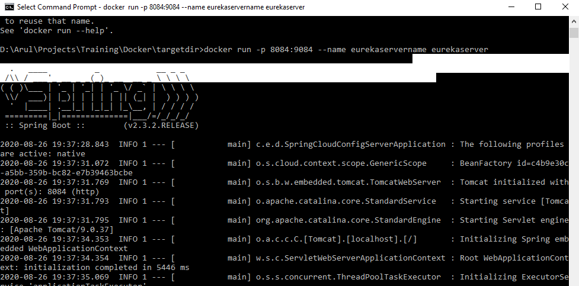

Started Docker second instance with 8085

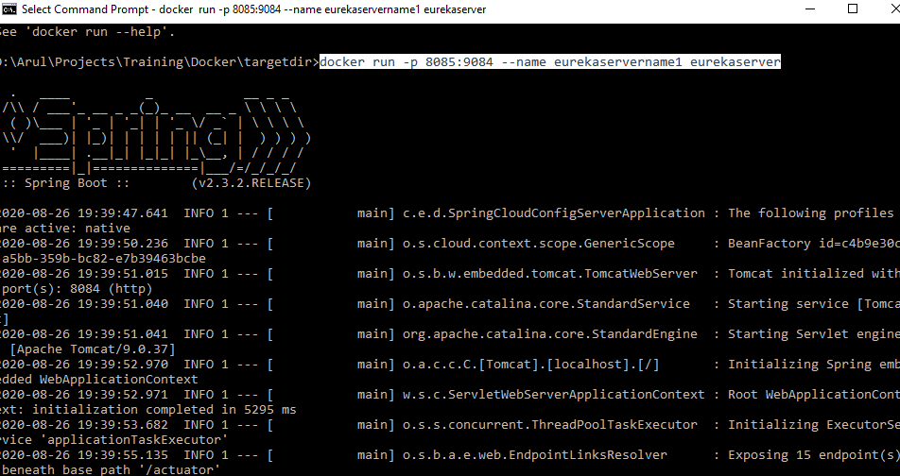

Started Docker third instance with 8086

