**CYBER RISK ANALYSIS OF COMBINED DATA ATTACKS AGAINST POWER SYSTEM STATE ESTIMATION**

**MODULES:**

* **User interface design**
* **Author login**
* **Book upload**

**MODULES DESCRIPTION:**

* **USER INTERFACE DESIGN:**

This is the first module of our project. The important role for the user is to move login window to user window. This module has created for the security purpose. In this login page we have to enter login user id and password. It will check username and password is match or not (valid user id and valid password). If we enter any invalid username or password we can’t enter into login window to user window it will shows error message. So we are preventing from unauthorized user entering into the login window to user window. It will provide a good security for our project. So server contain user id and password server also check the authentication of the user. It well improves the security and preventing from unauthorized user enters into the network. In our project we are using JSP for creating design. Here we validate the login user and server authentication.

* **AUTHOR LOGIN**

This is the second module of our project. The important role for the author is to move login window to user window. This module has created for the security purpose. In this login page we have to enter login user id and password. It will check username and password is match or not (valid user id and valid password). If we enter any invalid username or password we can’t enter into login window to user window it will shows error message. So we are preventing from unauthorized user entering into the login window to user window. It will provide a good security for our project. So server contain user id and password server also check the authentication of the user. It well improves the security and preventing from unauthorized user enters into the network. In our project we are using JSP for creating design. Here we validate the login user and server authentication.

**BOOK UPLOAD**

This is the Third module in our project, monthly Magazine upload the website and free download book and pdf user access the Magazine or book used the free website the one of best website the Magazine many author list and book list.

**MODULE DIAGRAMS:**

* **USER INTERFACE DESIGN:**

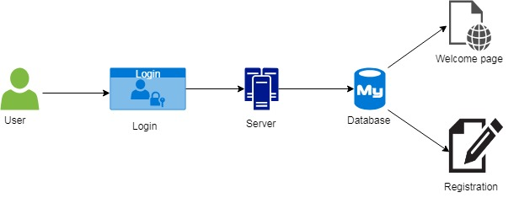

**AUTHOR LOGIN**

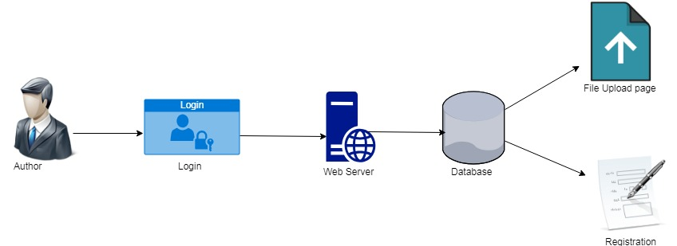**BOOK UPLOAD**



**CODING AND SCREENSHOTS:**

* **USER INTERFACE DESIGN**

**Userlogin.jsp**

<%@ page language="java" contentType="text/html; charset=ISO-8859-1"

pageEncoding="ISO-8859-1"%>

<!DOCTYPE html PUBLIC "-//W3C//DTD HTML 4.01 Transitional//EN" "http://www.w3.org/TR/html4/loose.dtd">

<html>

<head>

<meta http-equiv="Content-Type" content="text/html; charset=ISO-8859-1">

<meta name="viewport" content="width=device-width, initial-scale=1">

<link rel="stylesheet" href="css/bootstrap.css">

<script src="js/jquery.js"></script>

<script src="js/bootstrap.js"></script>

<title>Facebook Login</title>

<style>

body

{

background: -webkit-gradient(radial, center center, 0, center center, 460, from(#1a82f7), to(#2F2727));

/* Safari 5.1+, Chrome 10+ */

background: -webkit-radial-gradient(circle, #1a82f7, #2F2727);

/* Firefox 3.6+ */

background: -moz-radial-gradient(circle, #1a82f7, #2F2727);

/* IE 10 */

background: -ms-radial-gradient(circle, #1a82f7, #2F2727);

height:600px;

}

h3

{

font-family: Arial Black;

font-size: 40px;

color: white;

text-align: center;

}

</style>

</head>

<body>

<div class="container">

<div class="row">

<div class="col-sm-4"></div>

<div class="col-sm-4">

<h3>User Login</h3>

<div class="logo" style="margin-top: 120px"></div>

<form action="Login" method="post">

<div class="form-group">

<label class="control-label" for=""></label>

<input type="text" class="form-control" name="email" placeholder="Email Address" required="">

</div>

<div class="form-group">

<label class="control-label" for=""></label>

<input type="password" class="form-control" name="pass" placeholder="Password" required="">

</div>

<br>

<div class="form-group">

<input type="submit" value="Log In" class="btn btn-default btn-block" style="background-color: navy;color: white">

</div>

<br>

<br>

<br>

<center> <a href="userreg.jsp" style="color: white">Sing Up for Bookread</a>

<i class="fa fa-question" style="font-size:48px;color:red"></i>

</center>

</form>

</div>

<div class="col-sm-4"></div>

</div>

</div>

</body>

</html>

**SCREENSHOTS:**

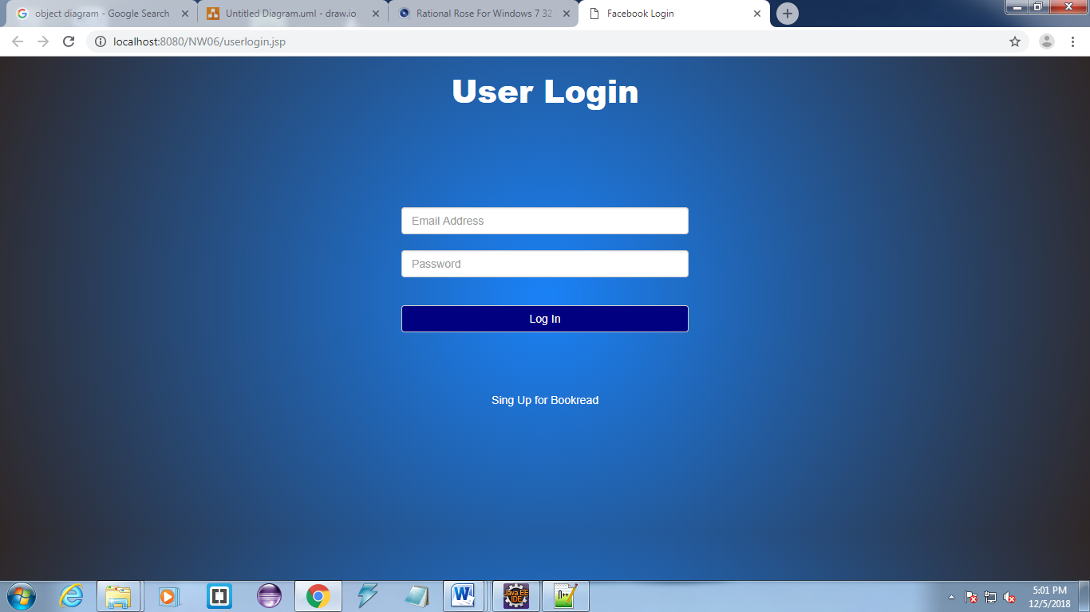

**AUTHOR LOGIN**

Authorlogin.jsp

<%@ page language="java" contentType="text/html; charset=ISO-8859-1"

pageEncoding="ISO-8859-1"%>

<!DOCTYPE html PUBLIC "-//W3C//DTD HTML 4.01 Transitional//EN" "http://www.w3.org/TR/html4/loose.dtd">

<html>

<head>

<meta charset="utf-8">

<meta charset="ISO-8859-1">

<meta http-equiv="Content-Type" content="text/html; charset=ISO-8859-1">

<meta name="viewport" content="width=device-width, initial-scale=1">

<link rel="stylesheet" href="css/bootstrap.css">

<script src="js/jquery.js"></script>

<script src="js/bootstrap.js"></script>

<title>Author Login</title>

<style>

body {

background-image: url("images/digital-currency.jpg");

background-repeat: no-repeat;

background-size: 100% 800px;

}

</style>

</head>

<body>

<div class="container" style="margin-top:40px">

<div class="row">

<div class="col-sm-6 col-md-5 col-md-offset-4">

<div class="panel panel-primary" style="margin-top: 120px;">

<div class="panel-heading">

<strong> Sign in Author</strong>

</div>

<div class="panel-body">

<form action="Authorlogin" method="post">

<div class="row">

<div class="form-group">

<center>

<img src="images/book-png-book.png" class="img-circle" alt="Cinque Terre" width="70px" height="70px">

</center>

</div>

<div class="col-sm-12 col-md-10 col-md-offset-1 ">

<div class="form-group">

<div class="col-sm-12 col-md-10 col-md-offset-1 ">

<div class="form-group">

<div class="input-group">

<span class="input-group-addon">

<i class="glyphicon glyphicon-user"></i>

</span>

<input class="form-control" placeholder="Username" name="email" type="email" autofocus>

</div>

</div>

<div class="form-group">

<div class="input-group">

<span class="input-group-addon">

<i class="glyphicon glyphicon-lock"></i>

</span>

<input class="form-control" placeholder="Password" name="password" type="password" value="">

</div>

</div>

<div class="form-group">

<input type="submit" class="btn btn-lg btn-primary btn-block" value="Sign in">

</div>

</div>

</div>

</div>

</div>

</form>

</div>

<div class="panel-footer panel-info">

Don't have an account! <a href="authorreg.jsp" onClick=""> Sign Up Here </a>

</div>

</div>

</div>

</div>

</div>

</body>

</html>

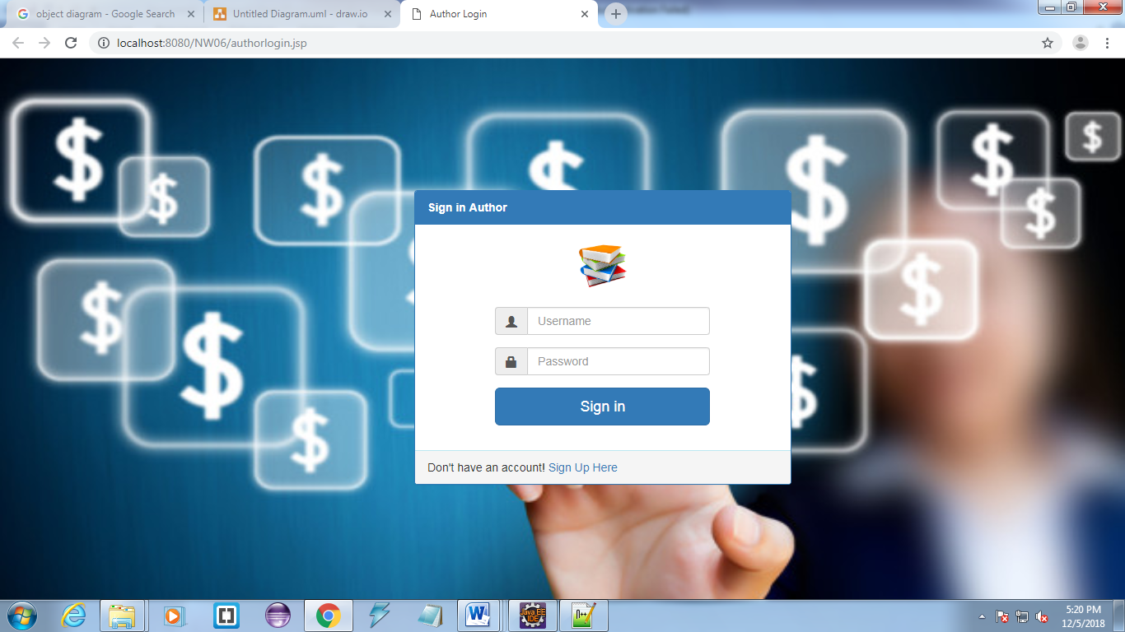

**BOOK UPLOAD**

Fileupload.jsp

<%@ page language="java" contentType="text/html; charset=ISO-8859-1"

pageEncoding="ISO-8859-1"%>

<!DOCTYPE html PUBLIC "-//W3C//DTD HTML 4.01 Transitional//EN" "http://www.w3.org/TR/html4/loose.dtd">

<html>

<head>

<meta charset="utf-8">

<meta charset="ISO-8859-1">

<meta http-equiv="Content-Type" content="text/html; charset=ISO-8859-1">

<meta name="viewport" content="width=device-width, initial-scale=1">

<link rel="stylesheet" href="css/bootstrap.css">

<script src="js/jquery.js"></script>

<script src="js/bootstrap.js"></script>

<title>File upload</title>

<style>

body

{

background-image: url("images/business1.jpg");

background-repeat: no-repeat;

background-size: 100% 800px;

}

</style>

</head>

<body>

<nav class="navbar navbar-inverse">

<div class="container-fluid">

<div class="navbar-header">

<button type="button" class="navbar-toggle" data-toggle="collapse" data-target="#myNavbar">

<span class="icon-bar"></span>

<span class="icon-bar"></span>

<span class="icon-bar"></span>

</button>

<a class="navbar-brand" href="#">BOOK READ</a>

</div>

<div class="collapse navbar-collapse" id="myNavbar">

<ul class="nav navbar-nav">

<li><a href="index.jsp">HOME</a></li>

<li class="active"><a href="#">FILE UPLOAD</a></li>

<li><a href="viewbooks.jsp">View Books</a></li>

<li><a href="viewuserlist.jsp">View User List</a></li>

</ul>

<ul class="nav navbar-nav navbar-right">

<li><a href="logout.jsp"><span class="glyphicon glyphicon-log-in"></span> LOGOUT</a></li>

</ul>

</div>

</div>

</nav>

<div class="container">

<div class="row">

<div class="col-md-4 col-md-offset-4">

<div class="panel panel-default" style="margin-top: 120px;">

<div class="panel-heading">

<h3 class="panel-title" style="color: red">Magazine</h3>

</div>

<div class="panel-body">

<form role="form" action="Magazineupload" method="post" enctype="multipart/form-data">

<fieldset>

<div class="form-group">

<input type="text" name="book" placeholder="Book Name" class="form-control" required="">

</div>

<div class="form-group">

<input type="text" name="author" placeholder="Author Name" class="form-control" required="">

</div>

<div class="form-group">

<input type="text" name="price" placeholder="Book Price" class="form-control" required="">

</div>

<div class="form-group">

<input type="text" name="month" placeholder="Month" class="form-control" required="">

</div>

<div class="form-group">

<input type="file" name="file" placeholder="file" class="form-control" required="">

</div>

<input class="btn btn-lg btn-success btn-block" type="submit" value="Magazine Update">

</fieldset>

</form>

</div>

</div>

</div>

</div>

</div>

</body>

</html>

