**STRIPE WORK FLOW:**

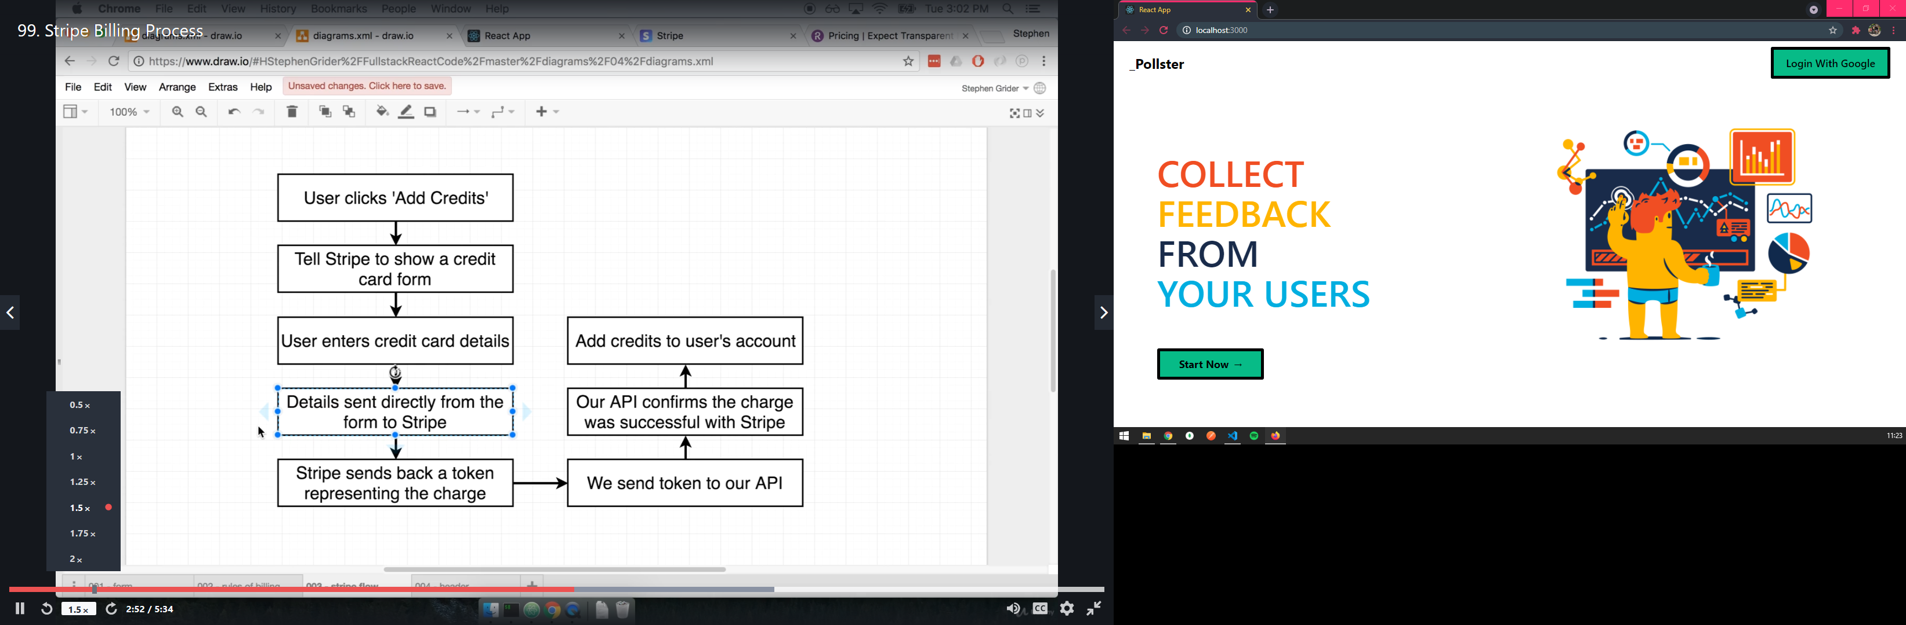

**DEPLOYMENT OPTIONS:**

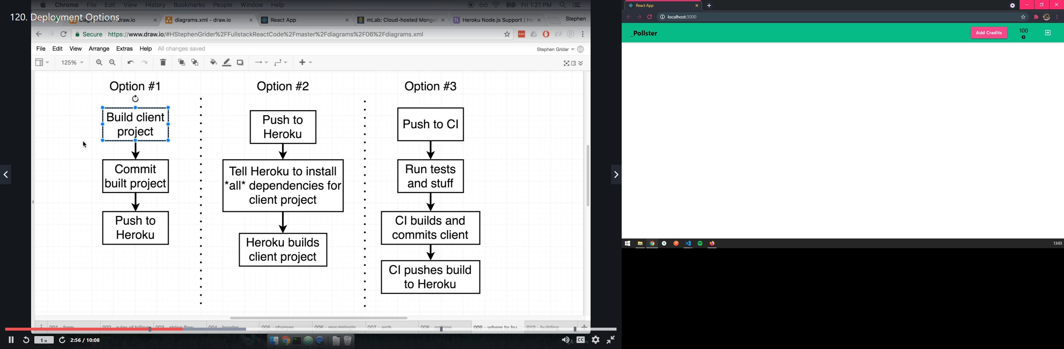

**SURVEY OVERVIEW:**

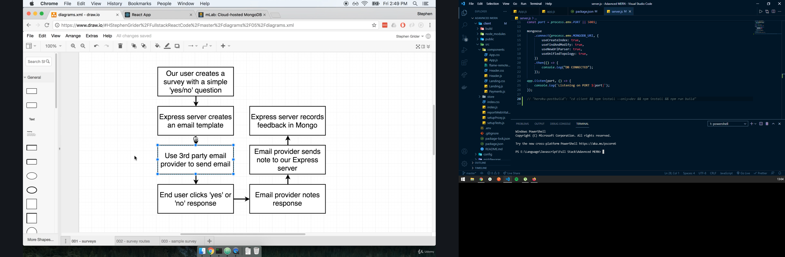

**EMAIL OVERFLOW:**

