AWS Task – 2

VPC Creation (Manual)
- Create the custom VPC by name “mycustomvpc”
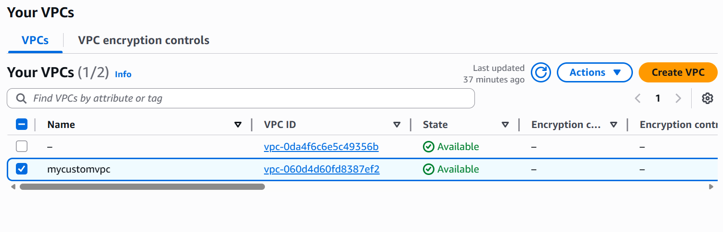
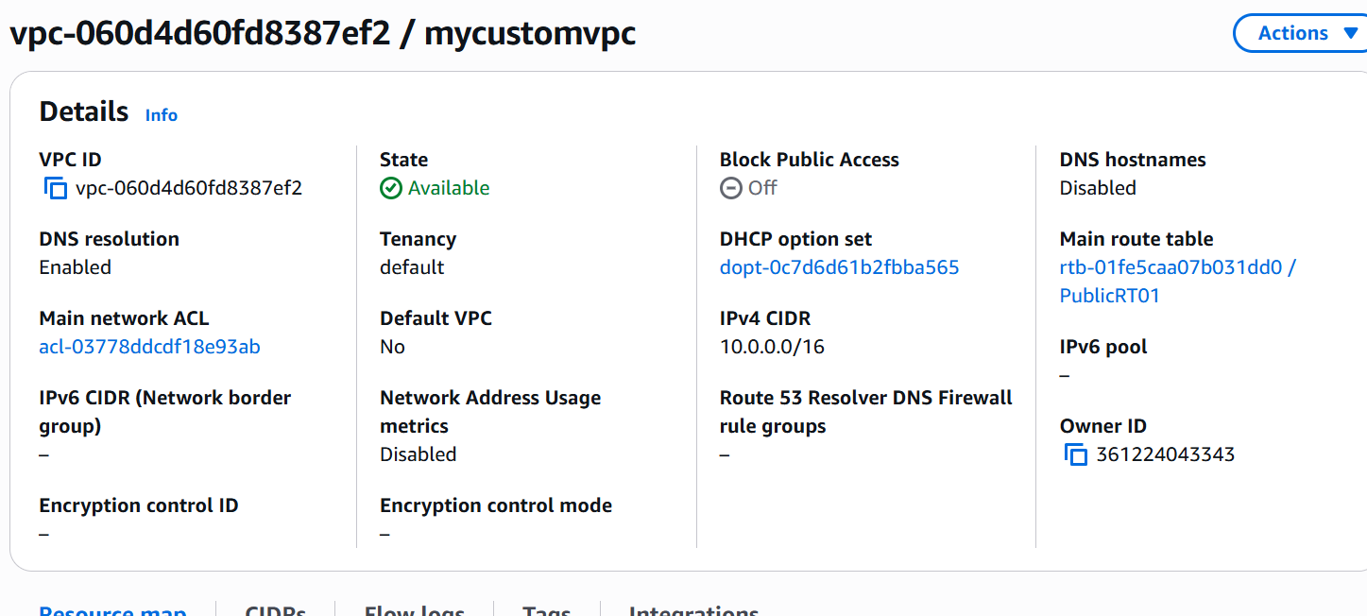

- Create the Subnets (Public & Private). PublicSubnet01 & PrivateSubnet02. Subnets are not created automatically.
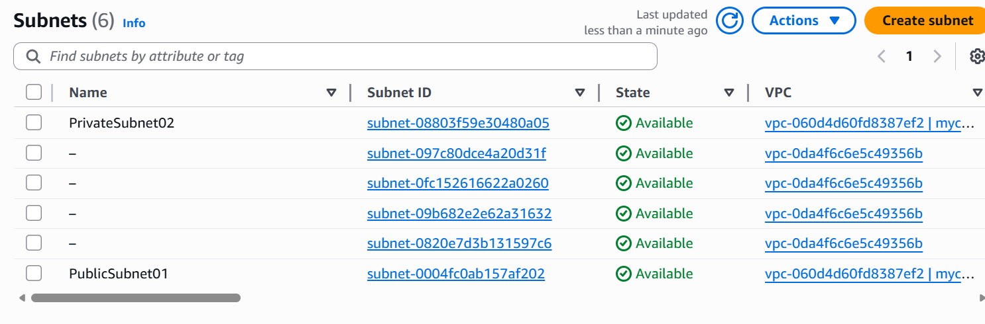
- One Route Table will be created automatically when you created the VPC.
- Edit the PublicRT01 Route Table and associate the Public subnet to that Route table.
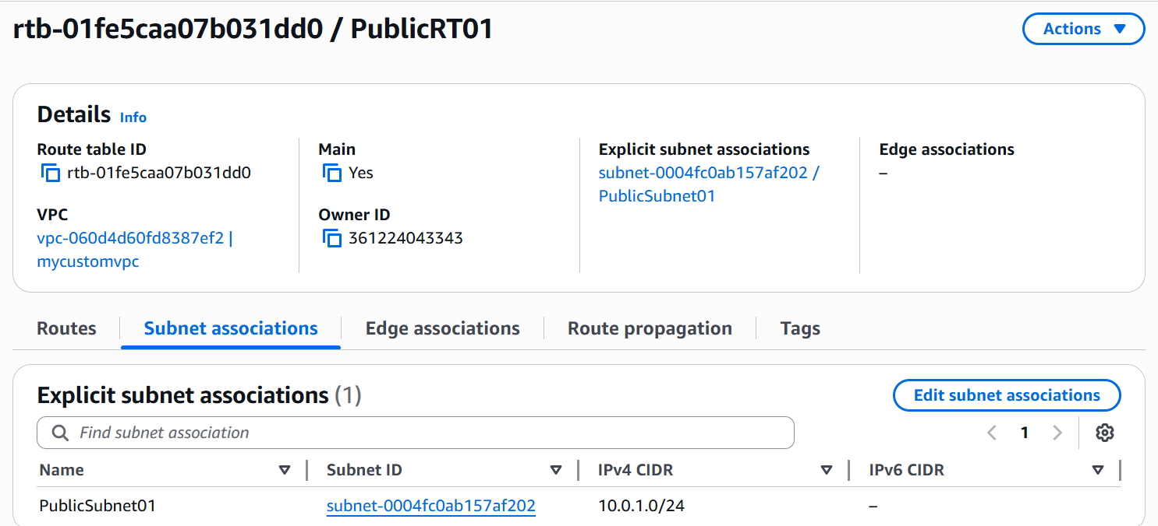

- Rename this Route table as PublicRT01.
- Create a new Route Table and name it as PrivateRT02.
- Edit the Route Table and associate the Private subnet to that Route table.
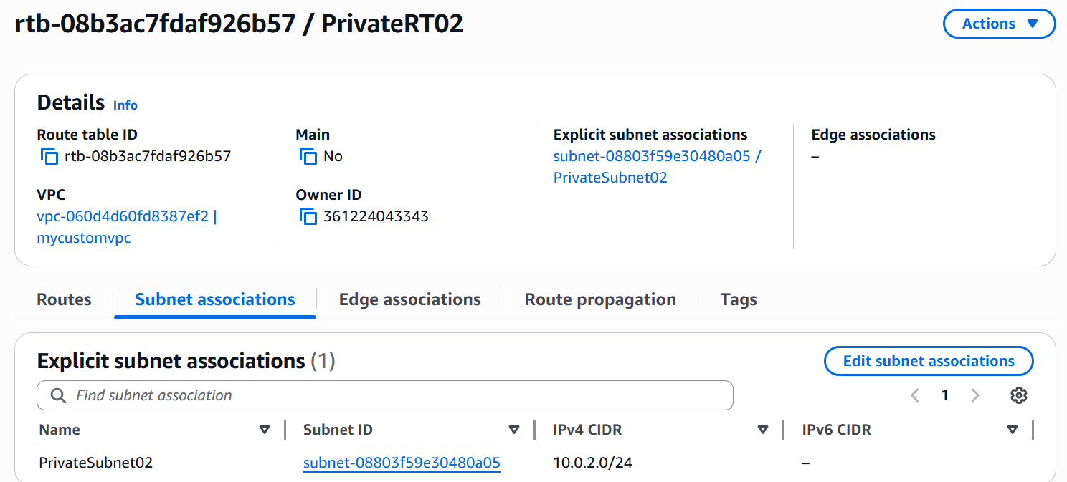
- Create an Internet Gateway “customVPCIGW01”
- Attach it to the CustomVPC.
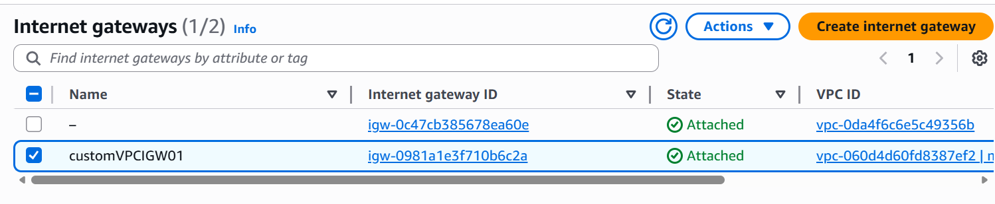
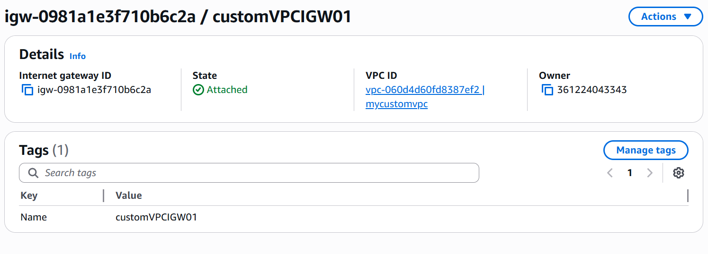
- Edit the Routes in the Public Route Table and attach the Internet Gateway to the Route Table.
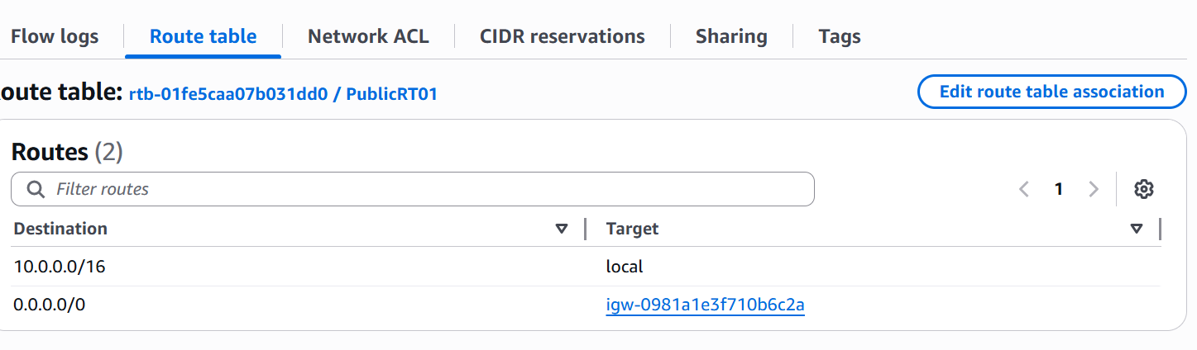
- This step will actually the Public Subnet reachable from the outside world.
- Create a Security group specifically for the Custom VPC by name “mycustomSG”
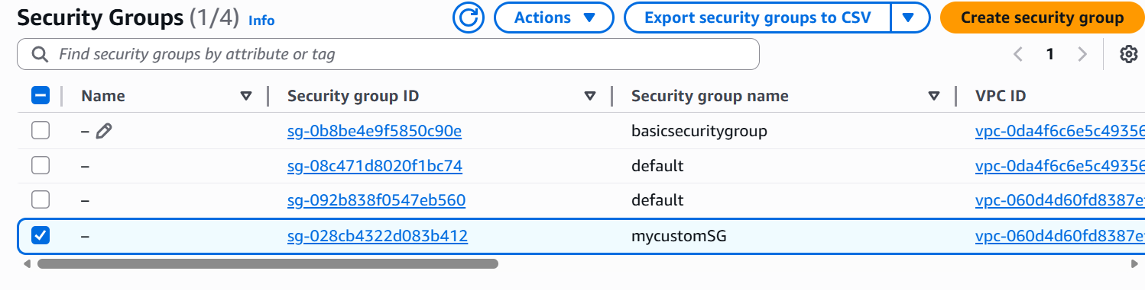

- Edit the inbound rules for the Security Group, so that outside traffic is allowed.
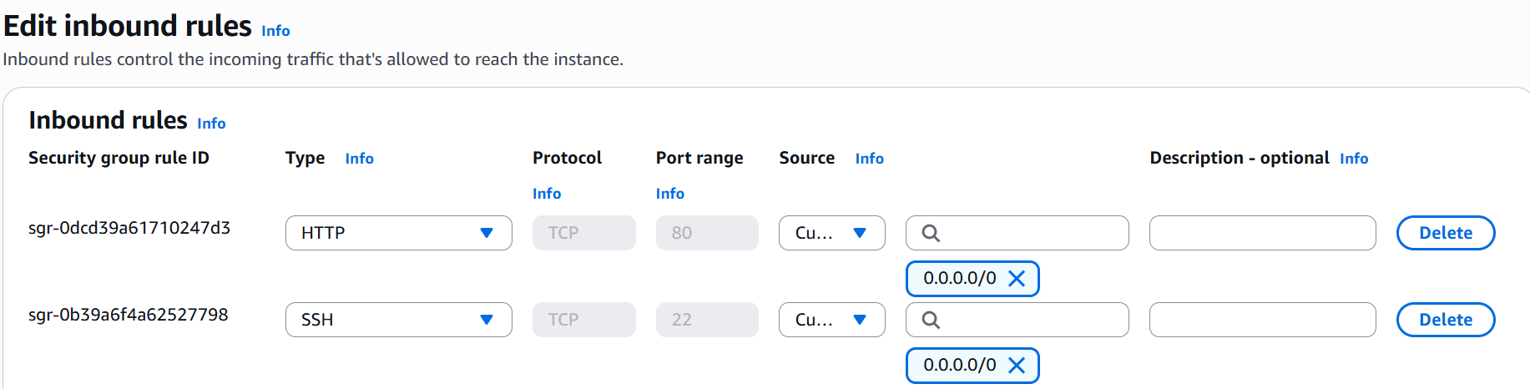
- NACL will be created automatically for our custom VPC.
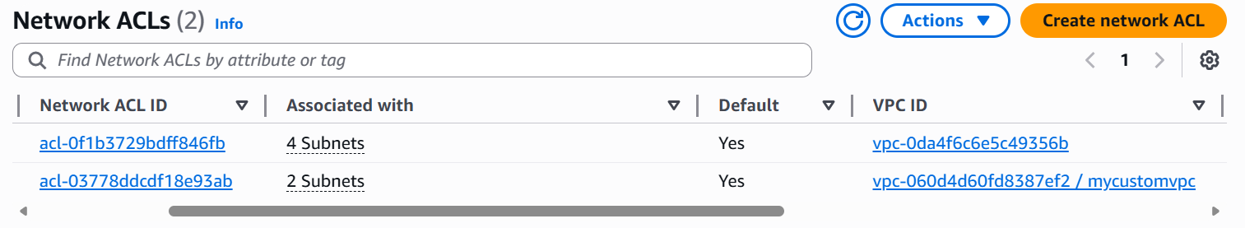
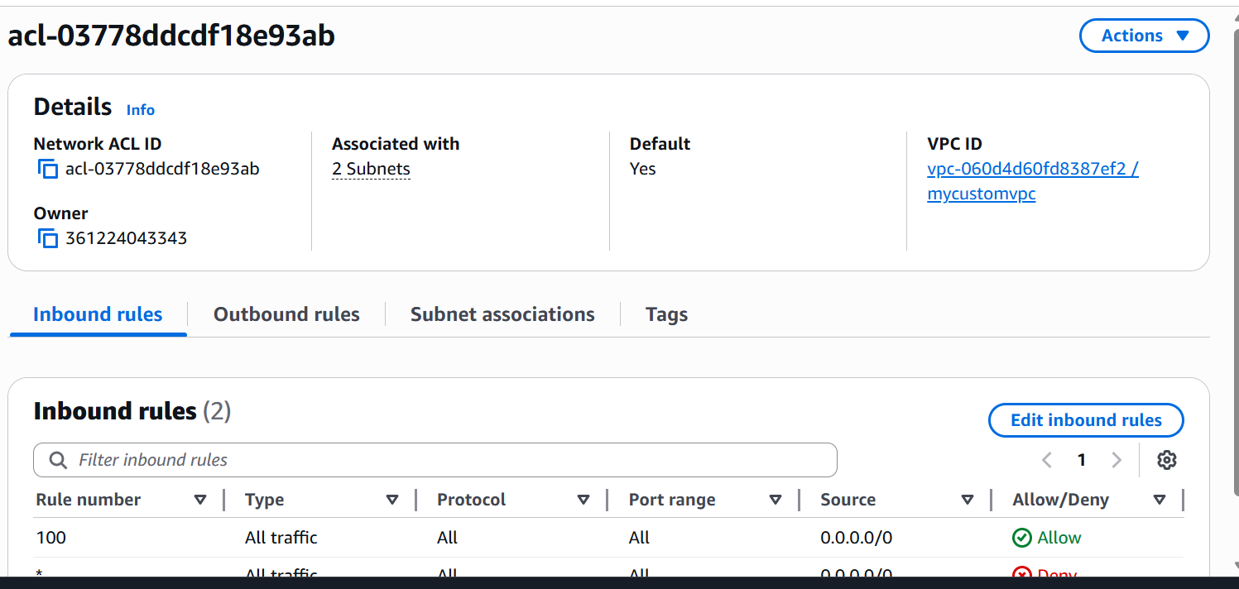
- Launch an EC2 instance in the custom VPC and the Public subnet after configuring the newly created security group.
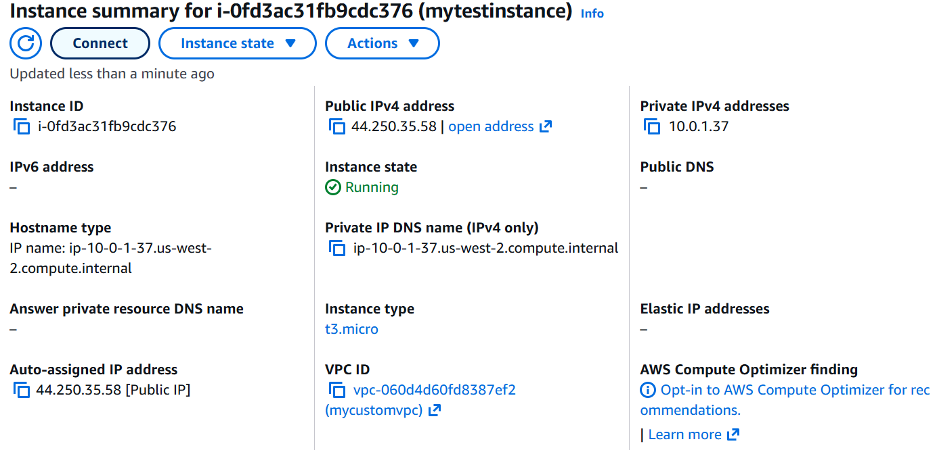
- Try accessing the Public IP of the EC2 instance from your browser.
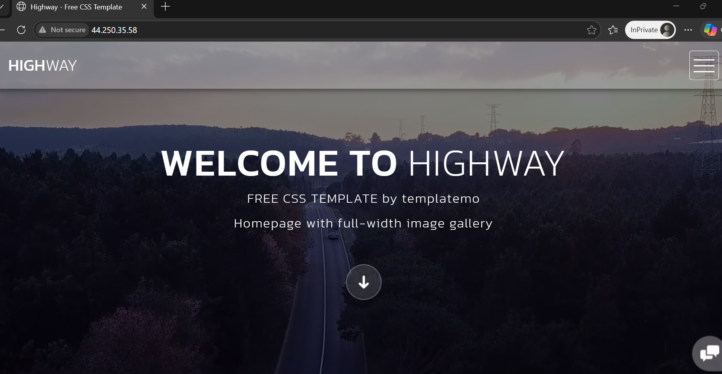

Security Group is at resource level.
NACL is at the VPC Level

