Docker Task

Task Description:
Install docker on EC2 and explore the docker commands (docker images, containers, volumes, network)
Step 1: First Let’s launch an EC2 instance in AWS Console.
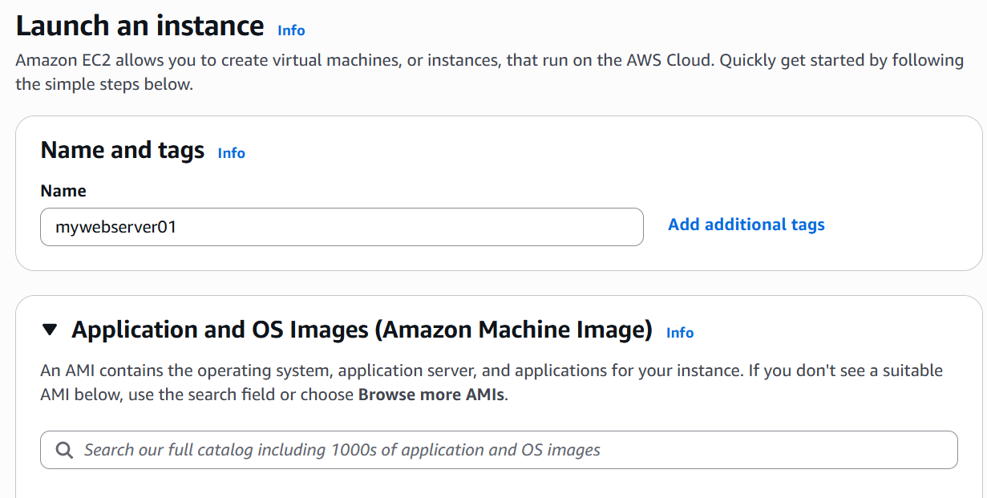

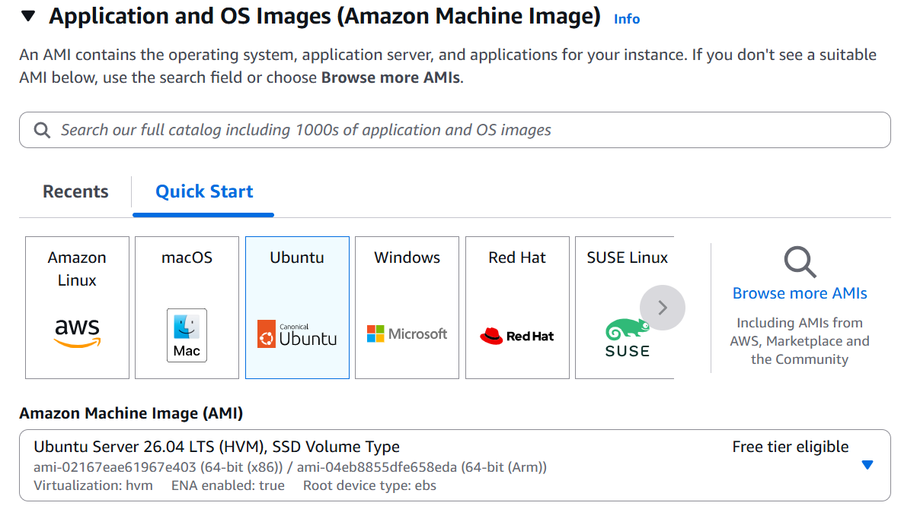
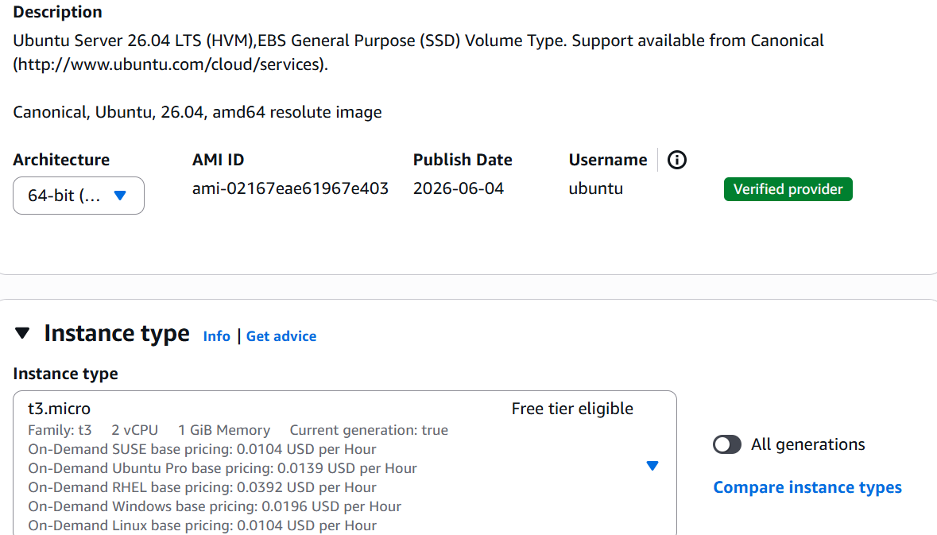

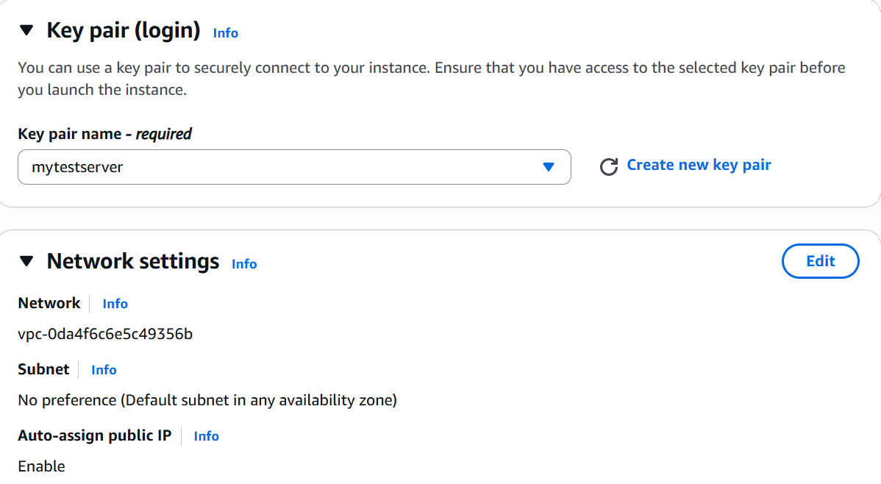
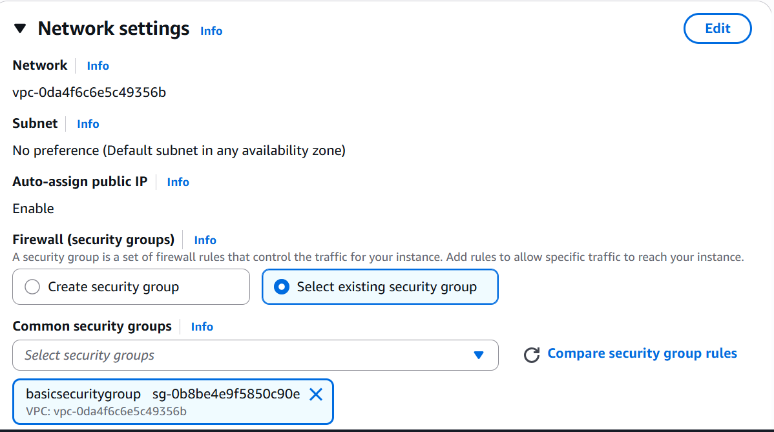

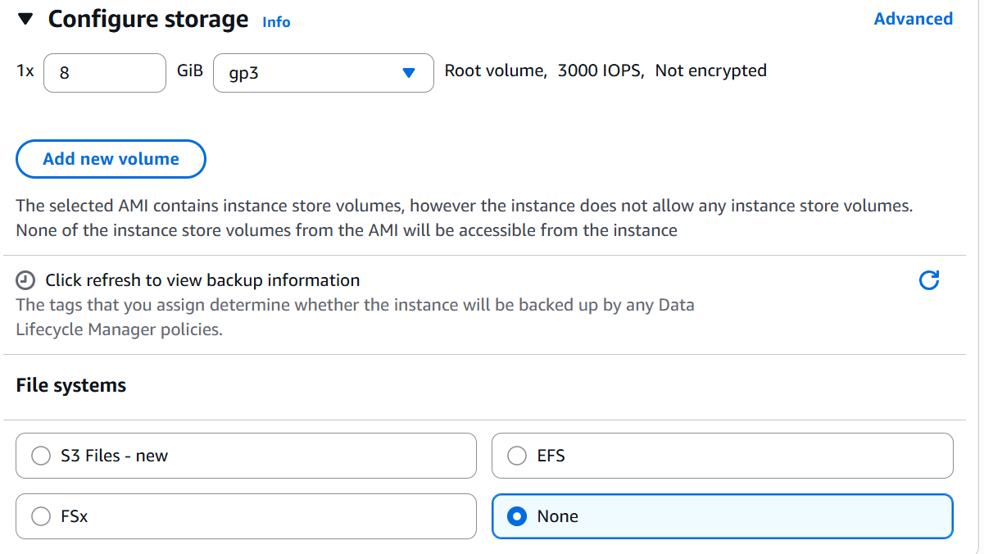
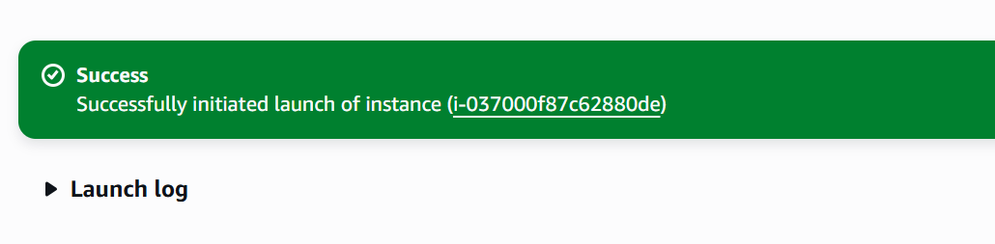
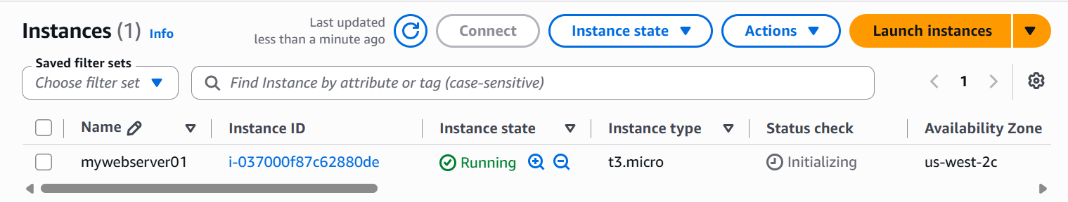
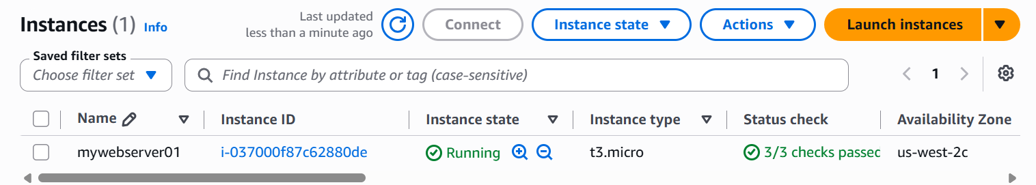

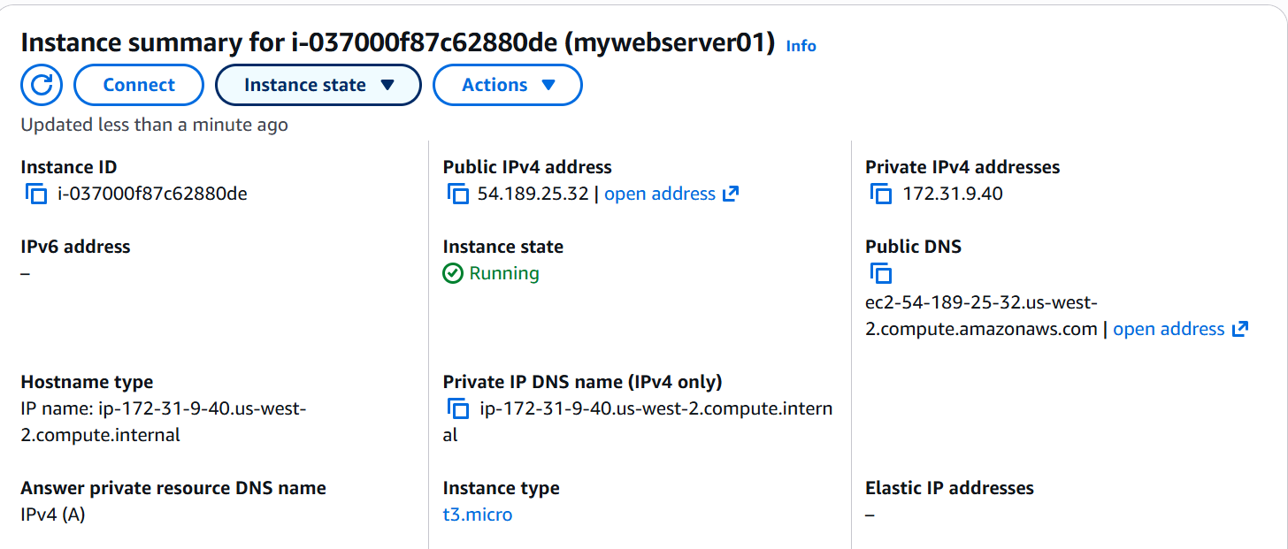

Now lets try to establish connection with the EC2 instance via the terminal Emulator (Putty)
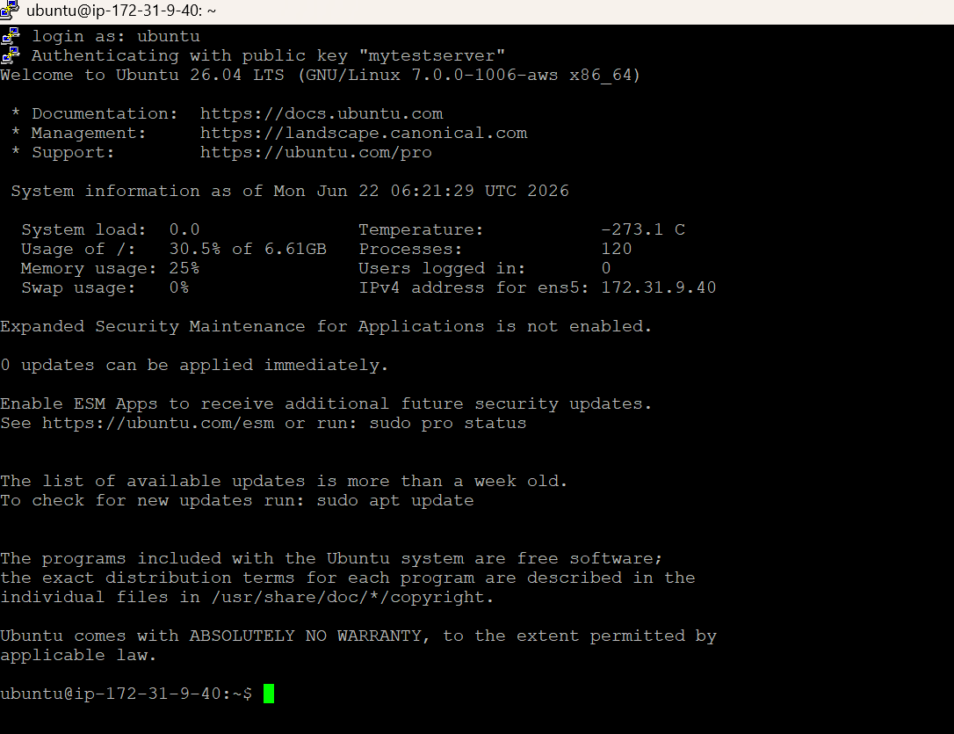
We have successfully established connection with the EC2 instance using the SSH Key Pair.
Step 2: Install Docker
sudo apt update
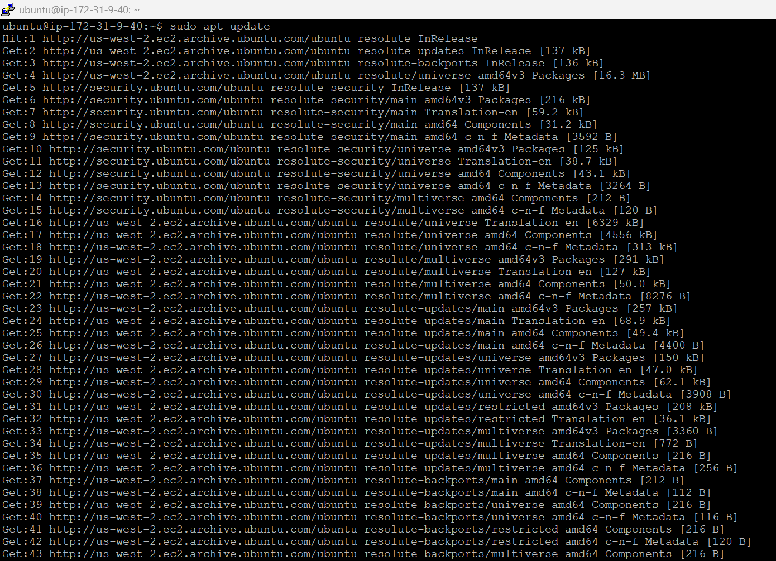
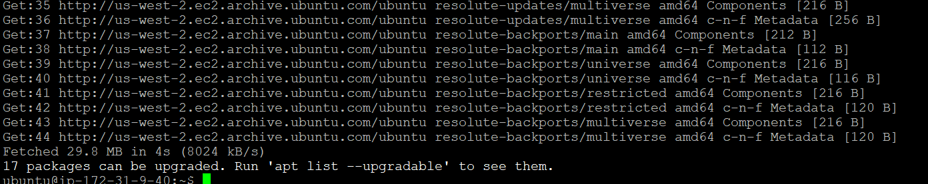
sudo apt install -y docker.io
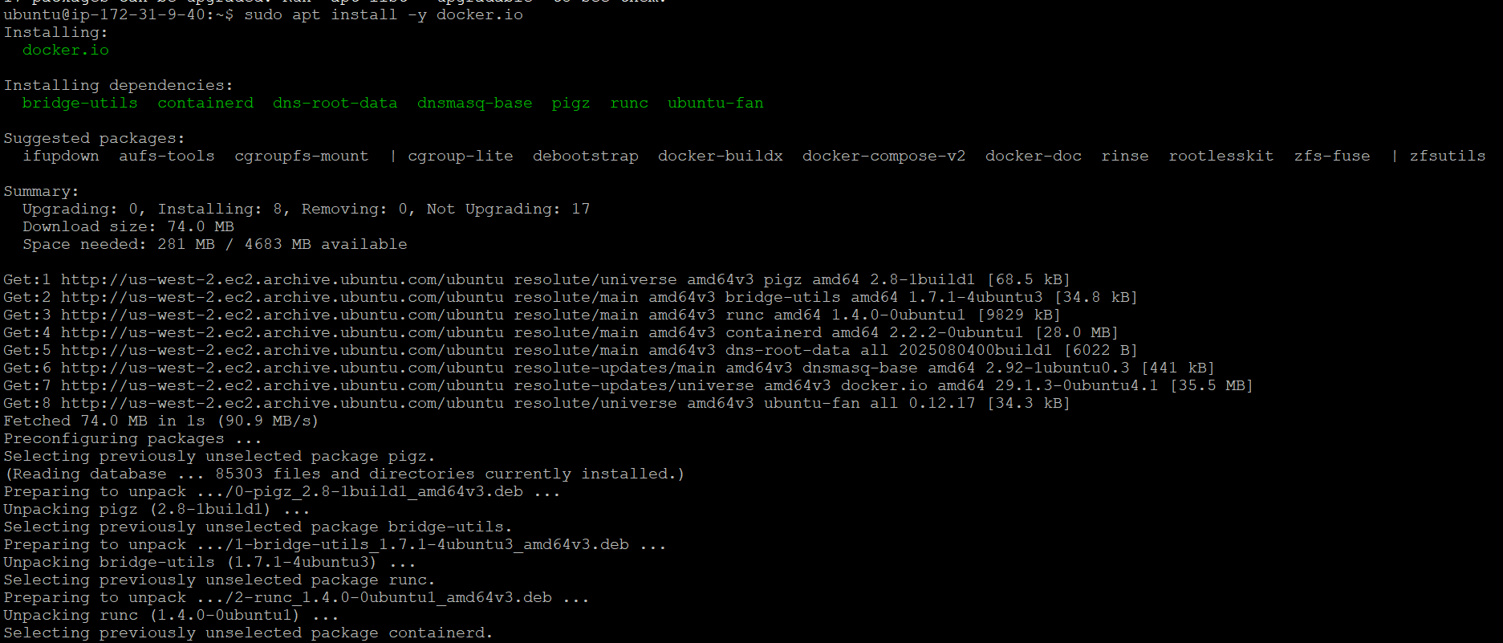
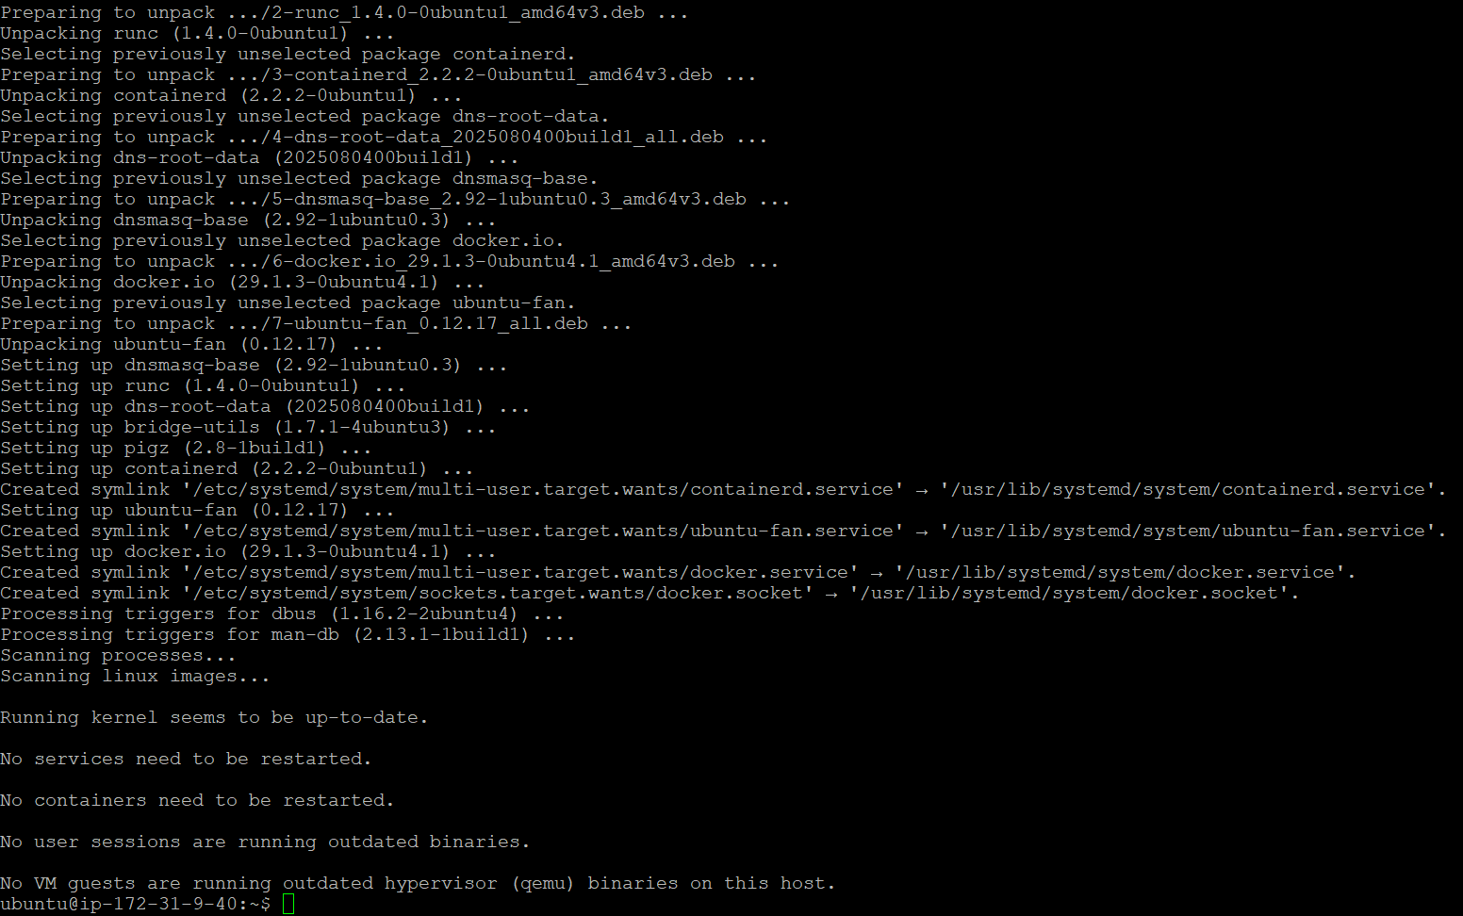
Lets start Docker
sudo systemctl start docker

Enable Docker
sudo systemctl enable docker
Now lets add the user to the group and then exit.
sudo usermod -aG docker $USER
exit

Let’s relogin for the changes to take effect.

Let’s check the Docker version
docker --version
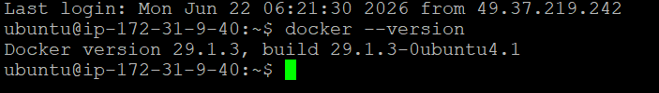
Let’s check whether Docker is working as expected or not.
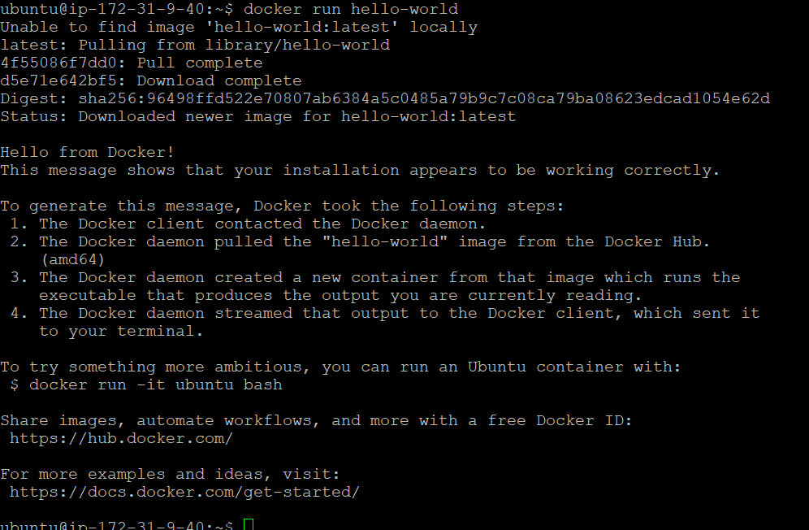
Yes it is working as expected.
Explore with Images:
# Pull an image from Docker Hub
docker pull nginx
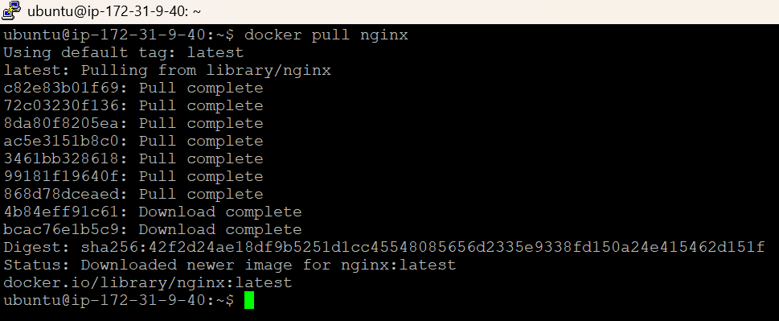

# List all images on this machine
docker images

# Inspect details of an image
docker inspect nginx:latest
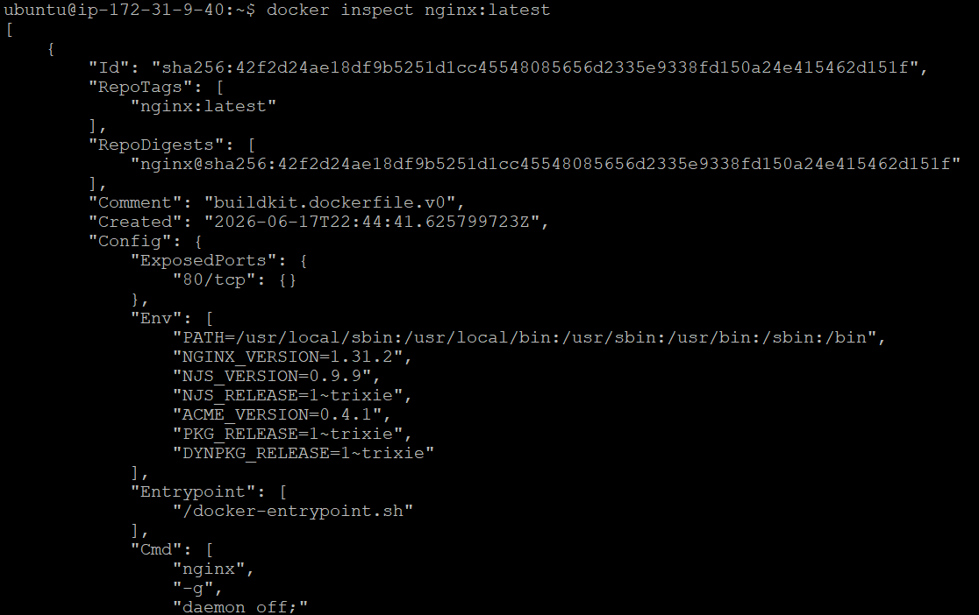
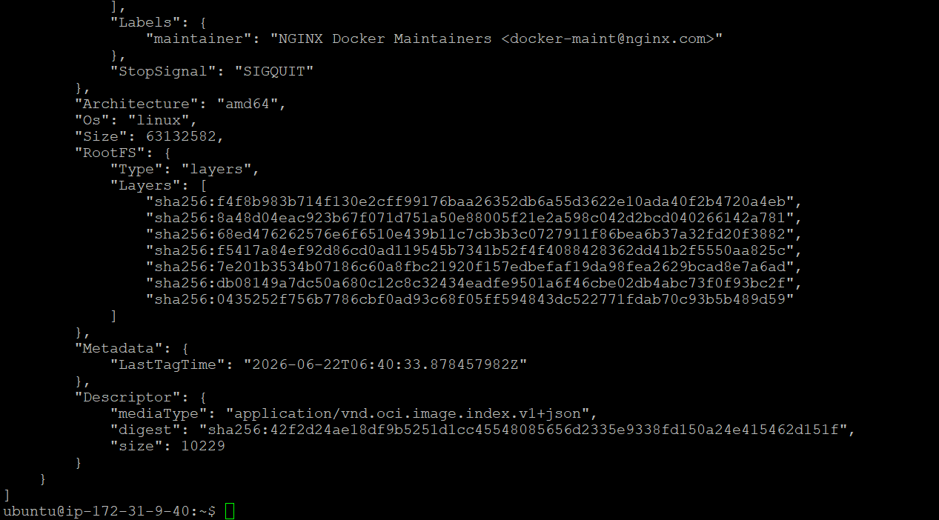

# Remove an image
docker rmi nginx:latest

Explore with Containers:
# Run a container in the background (-d), map port 8080 -> 80
docker run -d --name web -p 8080:80 nginx

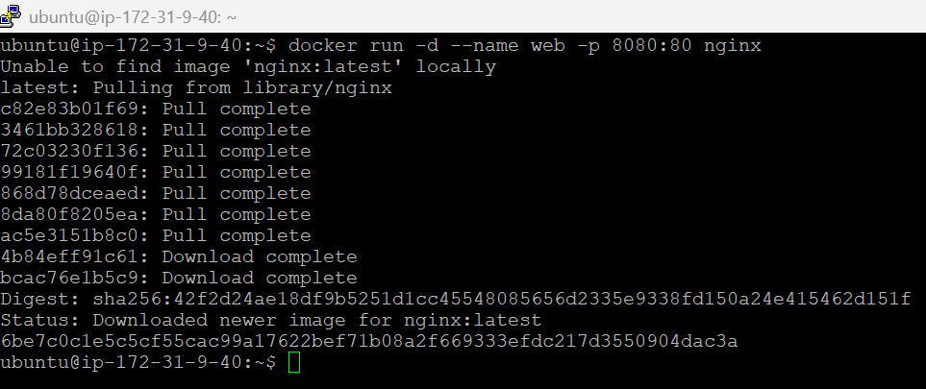

# List running containers
docker ps

# List all containers, including stopped ones
docker ps -a

# View logs
docker logs web
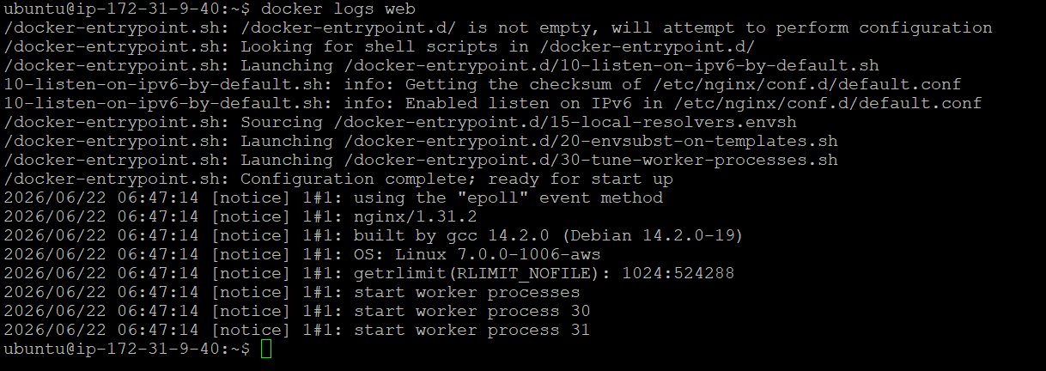

# Run a command inside a running container
docker exec -it web bash

# Stop / start / restart
docker stop web
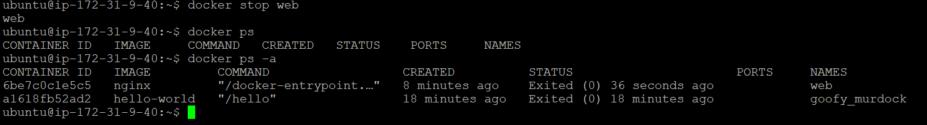

docker start web
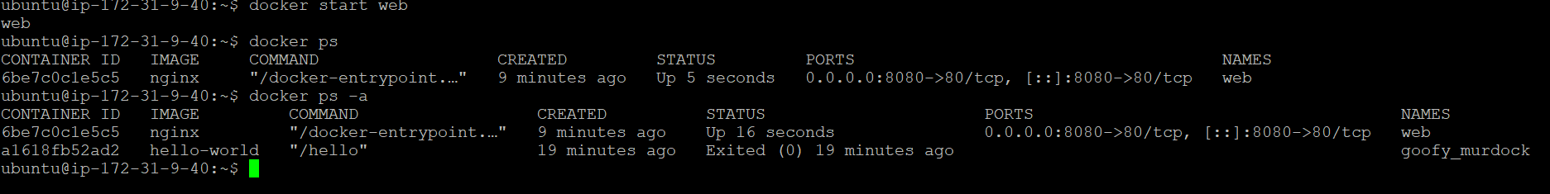

docker restart web
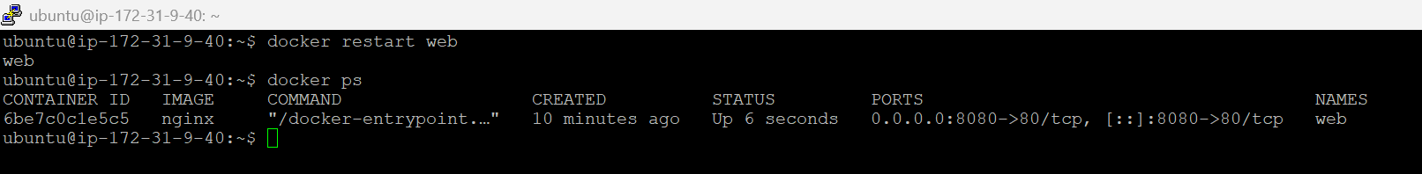

# Remove a container (must be stopped, or use -f to force)
docker rm web
docker rm -f web

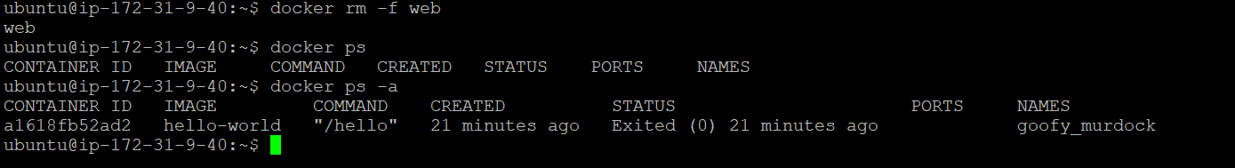

Explore: volumes (persistent data)

Containers are ephemeral - data inside them disappears when removed. Volumes solve that.
# Create a named volume
docker volume create mydata

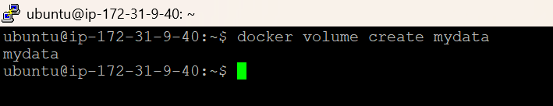

# List volumes
docker volume ls

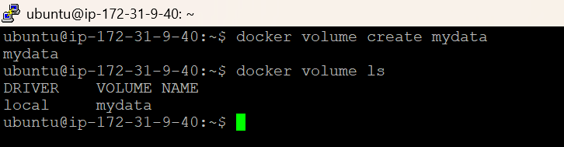

# Inspect a volume (shows its location on disk)
docker volume inspect mydata

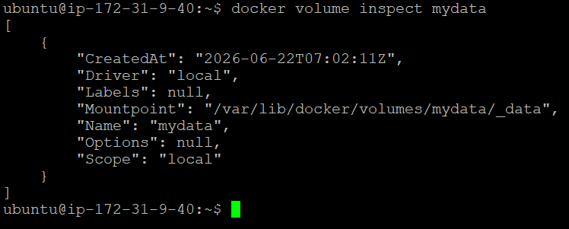

# Run a container using that volume
docker run -d --name web2 -p 8081:80 -v mydata:/usr/share/nginx/html nginx

# Remove a volume (container using it must be removed first)
docker rm -f web2
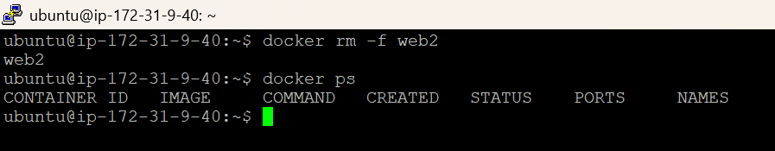

docker volume rm mydata
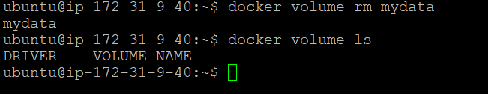

You can also do a bind mount (map a host folder directly):

mkdir ~/site-content
echo "<h1>Hello from EC2</h1>" > ~/site-content/index.html
docker run -d --name web3 -p 8082:80 -v ~/site-content:/usr/share/nginx/html nginx

Now we can access this from outside
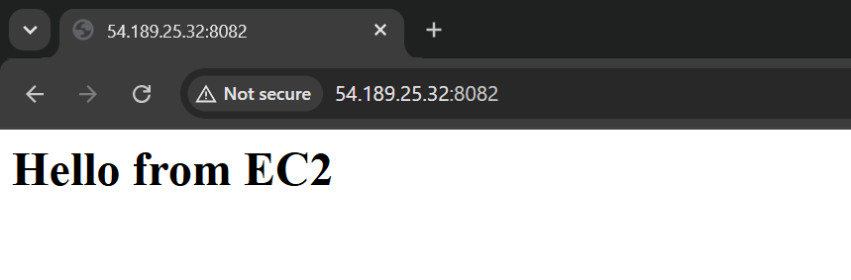
Explore: networks

# List networks
docker network ls

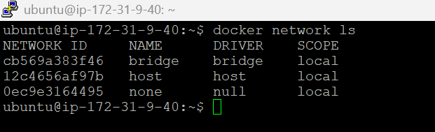

# Create a custom bridge network
docker network create my-network

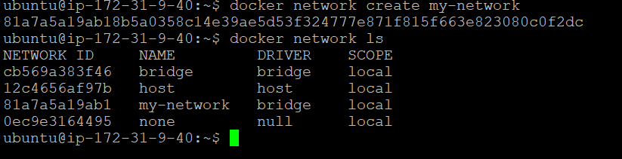

# Run two containers on that network
docker run -d --name app1 --network my-network nginx
docker run -d --name app2 --network my-network nginx
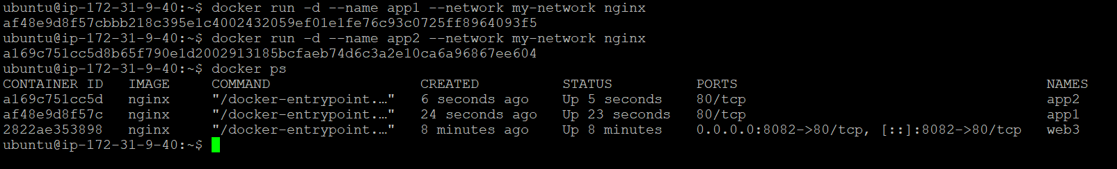

# Test connectivity from app2 to app1 (by container name, thanks to Docker's internal DNS)
docker exec -it app2 ping app1

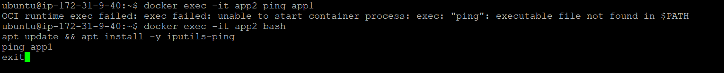

If Ping is not working, then install ping and then exit and relogin, it should work.

docker exec -it app2 bash
apt update && apt install -y iputils-ping
ping app1
exit

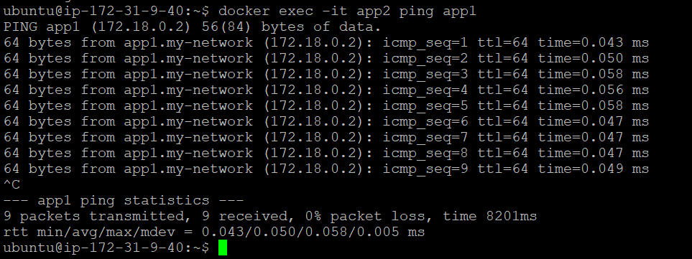

# Inspect a network (see connected containers, subnet, gateway)
docker network inspect my-network
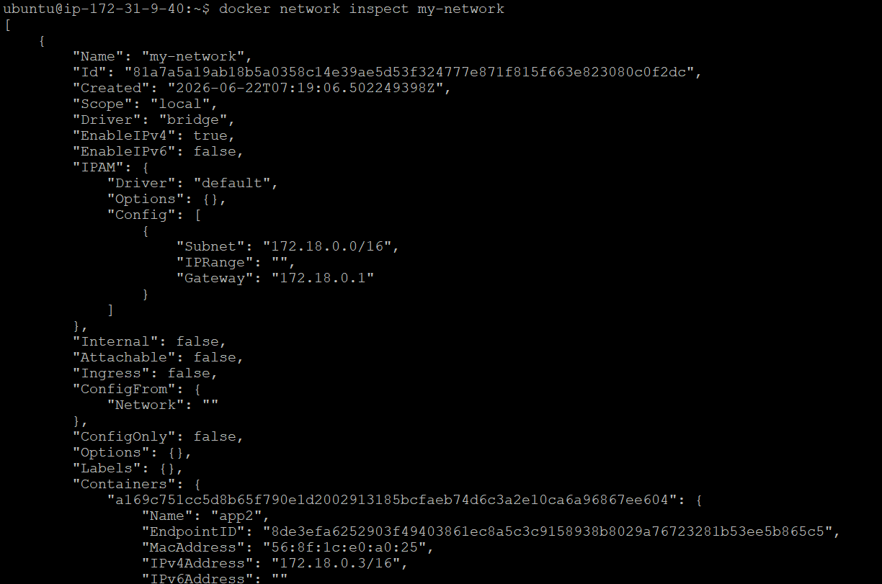

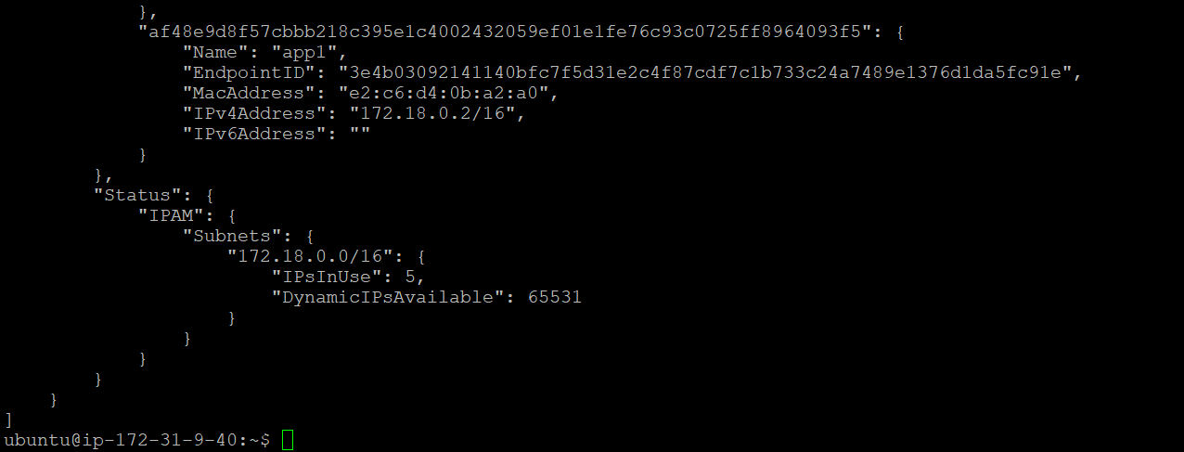

# Disconnect / remove
docker network disconnect my-network app2
docker network rm my-network

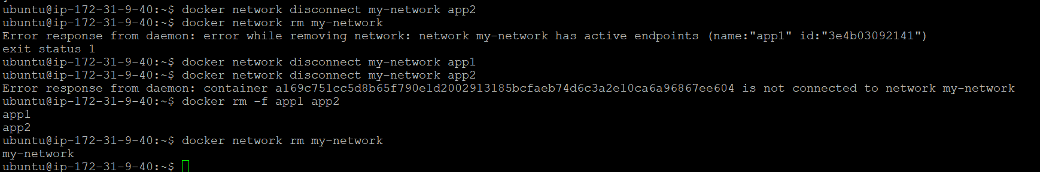

Cleanup Commands:

# stop all containers
docker stop $(docker ps -aq)
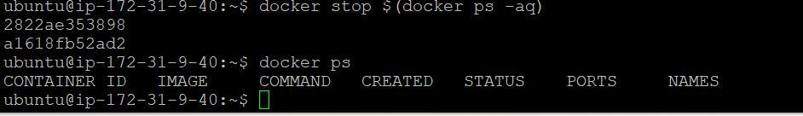

# remove all containers
docker rm $(docker ps -aq)
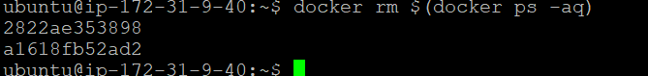

# remove unused images, containers, networks
docker system prune -a

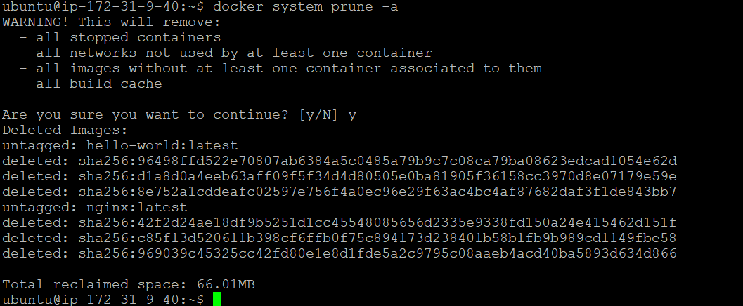

# remove unused volumes
docker volume prune
